COVER SHEET

SIMBIOSYS QUARTERLY REPORT

IONIC CHANNELS AS BIOSENSORS

Rush Medical Center
University of Illinois at Urbana-Champaign

Principal Investigators: N. R. Aluru, aluru@uiuc.edu, 217-333-1180
R. S. Eisenberg, beisenbe@rush.edu, 707-929-8907

CONTRACTOR: |  | AGREEMENT #:
 |  | CONTRACT PERIOD:
DATE: | REPORTING PERIOD: | SPONSOR:  AFRL | TECHNICAL POC:  Eisenberg & Aluru
REPORT PREPARED BY:

RS Eisenberg

- RESEARCH STATUS
Our project on “Ion Channels as BioSensors” started on May 1, 2001, and was transferred to Rush (as primary site) soon after, beginning in August. In this write up of July 19, 2002, we report on the progress since May. The goal of our project is to Demonstrate Ion Channels as Biosensors. Our work is designed to exploit the power of the engineering approach to devices, using models and experiments to design devices instead of trial and error experiments. In the engineering tradition great effort is spent constructing, simulating and testing models, because once a model is established that is useful in a reasonable domain of conditions, design is easy and efficient. Our goal to Demonstrate Ion Channels as Biosensors involves several tasks, summarized below:
- To demonstrate continuum equations that predict selectivity, sensitivity, and gating based on mean field theories. This task continues for all three years and is needed to satisfy milestones for all three years of biosensor development.
- To demonstrate multi-scale simulations that predict selectivity, sensitivity, and gating based on Langevin-Poisson simulations. This task extends over years two and three of biosensor development.
- To perform experiments showing how well porin and its mutants are described by continuum theories and by multi-scale simulations
- To show biosensor activity of porin in experiments
The highlights of our work are summarized below and in two attached reports, one from Narayan Aluru (coPI at UIUC) and one from Eric Jakobsson (coPI at UIUC):
Highlights
- Dr. Eisenberg in collaboration with Dr. Wolfgang Nonner and Dirk Gillespie have investigated DFT (Density Functional Theory) of the sodium channel. This is the first use of DFT to represent biomolecules that we know of. It is the first time (that we know about) in which DFT has been linked to the far electric field by combination with Poisson Drift Diffusion. This is the theory that will allow actual design of irregular structure. The theory has been developed and programmed and agrees (in overlapping domains of validity) with previous work to many7 significant figures. Interestingly, the theory shows clear signs of bistability, i.e., gating, in some parameter ranges.
The DFT theory has now been written up and accepted for publication in J Physical Chemistry. This paper will be presented at the Site visit. The work is in the process of being extended. Dr. Rosenfeld, the world leader in this field, spent two weeks at University of Miami and methods are being developed to describe electrostatics with more realism. This is necessary to deal with the enormously strong electrostatic fields in voltage gated channels and to extend our models towards gating.
- Dr. Eisenberg in collaboration with Uwe Hollerbach have submitted a paper showing the dramatic role of screening/shielding in determining the properties of a channel. This paper illustrates the necessity of careful treatment of the electric field, and continues our efforts to help educate the general community so they can design useful devices. This paper has appeared. Dr. Hollerbach is no longer able to spend much time on these projects but is happy to continue as a consultant.
- Dr. Eisenberg in collaboration with Zeev Schuss, Boaz Nadler and Amit Fisher have learned how to formulate the fundamental integral equations of physical chemistry in the language of trajectories. This is the crucial first step so the insights of p chem can be used to construct selfconsistent calculations and models. That will improve efficiency and understanding by many many fold. Even more importantly it will allow existing physical approximations which work well in pchem to be automatically extended to nonequilibrium and inhomogeneous systems.
This work is being written for publication. Dr. Schuss will present the material at
the site visit.

- Dr. Eisenberg and Dr. Tang have constructed and tested a revised experimental apparatus for studying large numbers of solutions on a single channel (e.g., calcium solutions). Experiments have continued.
- Prof. Hess has initiated the discussion on the usefulness of the concept of generation-recombination and how to include it in ion channels. There is a one to one correspondence of generation recombination into donors, acceptors and traps to possible processes in ionic channels that involve temporary capture of an ion in any potential minimum, especially at the interface to the protein. We are convinced that this correspondence can be used without change in the continuum picture. There is also literature existing on how to include this into Monte Carlo simulations without exorbitant problems which arise from the different time scales. Discussions have continued.
- Sameer Varma (Prof. Jakobsson’s student) parallelized the application of electrostatics calculations for channels on large Linux clusters, including electrostatic potential of mean force for one-dimensional Brownian dynamics and determination of ionization state of titratable residues of channels. (It should be noted that Sameer did not parallelize the core Poisson-Boltzmann calculation itself, but rather did a spatial decomposition of the many iterations of the calculation necessary in the channel application, and farmed the iterations out to multiple processors in an efficient fashion.)
- Sameer went on to apply the parallel calculational method to the Ompf porin channel, to calculate the ionization states over the full range of possible pH’s. Sameer also went on to deal with methodological issues, namely, the effects of using the linearized vs. the full nonlinear Poisson-Boltzmann equations and the effects of different assumptions about the dielectric constant of the protein on the computed results. This work is being written up for publication and will serve as input to both PNP and Brownian dynamics calculations of flux. A paper is being written. Other mutants have been computed.
- See-Wing Chiu (postdoc with Prof. Jakobsson) executed a molecular dynamics calculation of porin channels in a pseudo membrane (decane) between two potassium chloride solutions. From fluctuation analysis he was able to ascertain that the mean effective diffusion coefficient of ions in the channel was about 1/5 the value in bulk. A paper is being written. Other mutants have been computed.
- Jay Mashl (postdoc with Prof. Jakobsson) has efficiently parallelized the Gromacs 2 molecular dynamics program on the Platinum Linux cluster. He has shown that for large systems, the program can run very efficiently over 80 processors.
Details of the Varma and Mashl work are in the attached supplementary report.
- The work of Umberto Ravaioli, Trudy van der Straaten, and Narayan Aluru will be presented at the Site Visit.
- The work of Wim Meijberg and George Robillard is presented in a report and will be presented in person next month at Portland.
PLANS
Future plans for the UIUC groups are in their attached reports.
Future plans for the Rush group are as follows:
- Experimentally, we will concentrate on investigating the sensitivity of ompF and G119D to their differences in charge structure and seeing if we can understand and predict their properties in a range of divalent and monovalent solutions. If the channels prove viable in this range of solutions, we can test one or two solutions per week of work.
- Experimentally, we will extend our work to new mutant channels D113G and E117Q which have much less structural difference from wild type ompF or each other. If these channels insert and gate in a manageable way in the lipid bilayer, we will see how well the theory predicts their sensitivity to ions and charge structure.
- Theoretically, we will extend the DFT work to deal with K⁺ channels.
- We will begin construction of a model of gating.
- We will begin construction of a model of “active” transport of the coupled variety.

- DIFFICULTIES/PROBLEMS
- Experimental work on new channel proteins is inherently uncertain: difficulties in inserting the protein into the bilayer and in controlling its opening are likely to occur in at least a few of the solutions studied. We have much experience dealing with these pitfalls, but each pitfall takes time to hurdle!
- Extension of DFT theory to a new channel type requires mastery of a new structure, a new theoretical and simulation literature, as well as (in this case) of a huge experimental literature. It also requires dealing with single file flow for the first time. While we are confident these problems can be solved, and that solving them will be a significant contribution in itself, we cannot be sure of success until we do so.
- In Monte Carlo simulations, timesteps are limited to < 10 fs in order to resolve ion-water scattering processes. Simulations must be run for at least a microsecond in order to accumulate sufficient statistics on ion permeation through the channel. Solving Poisson’s Equation on a grid of ~ 200 000 points becomes very costly, even if done every 100 timesteps. Simulation times of 1ns on a DEC alpha (? MHz) currently required ~100 CPU hours. Poisson’s Equation is usually solved for systems with very large particle ensemble sizes, to reduce the O(N²) problem of evaluating the ion-ion Coulomb forces directly, to an O(N_{grid}) problem. However, for this particular system N² << N_{grid} and a direct evaluation of Coulomb forces would be cheaper than solving Poisson. The difficulty arises when trying to determine the Coulomb force between two charges separated by a medium with varying dielectric coefficient. This situation prevails in the simulation of ion channels because of the irregular geometry and small length scales of the protein. Put simply, two ions may often ‘feel each other through a medium that consists of protein, water or lipid, or a mixture thereof’. It is not yet clear how to efficiently evaluate the electrostatic forces in this situation using a direct evaluation of Coulomb’s Law.
- Representation of irregular protein geometry on a uniform rectilinear mesh remains a challenge in setting up a simulation using PROPHET (or any other existing device simulator). Although PROPHET can handle systems with arbitrary geometry the user must provide a customized mesh. There is no software for translating a PDB file (standard format for representing a protein’s molecular structure) into the mesh representation required by PROPHET. We have written a simple mesh generator to perform this task but it is currently limited to rectilinear meshes with uniform mesh spacing in all three directions. The restriction to uniform mesh spacing limits the spatial resolution and increases the number of nodes. A lot of computational power is thus wasted resolving regions of little interest (e.g., in the baths).
- The porin channel features a narrow constriction of the pore that occurs over a distance of X Angstroms. The electrostatic field in this constricted region is believed to play an important role in the permeation characteristics of the open channel. With the current limitations on the mesh resolution it is difficult to resolve the charge constellation in this region adequately. In addition, 1D PNP simulations indicate that the local friction experienced by the ions should increase from X in the wide section of the channel to Y in the narrow region. We have tried to model this by using a spatially varying diffusion coefficient but PROPHET becomes unstable, most likely the result of trying to represent a steep diffusion coefficient gradient on too few nodes.
- The flip side of the parallelization of the Gromacs code is that for the very large systems for which the code is most efficiently parallelized, we do not have the ability to store that much output data in places where it can be quickly analyzed. We are working with the NCSA to figure out how to do more efficiently retrievable data storage so that our analysis capability will match our simulation throughput capability.
- The irregular shape of the porin channel pore makes it harder to adapt our 1-dimensional Brownian dynamics program to this channel than to the potassium channel and the gramicidin channel that we have previously used it on. We are working on some method of volumetric analysis by which the 1-d approximation can reasonably be made so that we can adapt this software to calculation of fluxes in porin
Further difficulties and problems are described in the attached reports.
COVER SHEET

SIMBIOSYS QUARTERLY REPORT

COMPUTATIONAL, EXPERIMENTAL AND ENGINEERING FOUNDATIONS OF IONIC CHANNELS AS MINIATURIZED SENSORS, DEVICES AND SYSTEMS

University of Illinois at Urbana-Champaign
SubProject from Rush

Principal Investigator: N. R. Aluru, aluru@uiuc.edu, 217-333-1180

DATE:  01/02/02 | REPORTING PERIOD:  8/1/01 – 01/02/02 | SPONSOR:  AFRL | TECHNICAL POC:  Aluru
SUBREPORT PREPARED BY:

N. R. Aluru, E. Jakobsson

Ionic Membranes Progress Report

Wim Meijberg†, Maarten Vrouenraets†, Henk Miedema†,
Anita Meter-Arkema†, Barbara Lussenburg‡, Hans Hektor‡
and George Robillard

Biomade Technology Foundation
Nijenborgh 4
9747 AG Groningen
The Netherlands



19 July 2002

Table of Contents

1. Introduction 10
1.1 General Introduction 10
1.2 Outer Membrane Protein F 10
1.3 Why use OmpF? 12
1.4 Experimental approach 12
2. Results 14
2.1 Purification of OmpF. 14
2.2 Functionality of OmpF 15
2.2.1 Swelling assays 15
2.2.2 Electrophysiological characterisation 16
2.3 Membrane reconstitution and two-dimensional crystallisation 21
2.4 Cross-linking of OmpF containing membranes 24
2.4.1 A-specific cross-linking 24
2.4.2 Specific cross-linking 25
2.5 Manipulating the functionality of OmpF 29
2.5.1 Manipulating selectivity 30
2.5.2 Manipulating gating 30
3. Outlook 33
3.1 Cross-linking 33
3.2 Functionality 34
4. References 36

Introduction

General Introduction

Ion channels in biological membranes are protein molecules that conduct ions (e.g. Na⁺, K⁺, Ca²⁺, and Cl⁻) through a narrow tunnel of fixed charge formed by the amino acid residues of the protein. The channels open and close stochastically, allowing the rectangular pulses of current to flow, and form a nearly one-dimensional ‘reaction path’ for solute movement. Biological systems use such channels for a variety of purposes, of which maintenance of the proper distributions of ions necessary for life, transmission of pulses in the nervous system and generation of the ion gradients responsible for ATP synthesis are just a few examples. From a technological point of view they can be described as natural nanotubes that link the solutions on each side to the electric field in the membrane that separates them. The tunnel dimensions vary, depending on the specific type of channel and the ‘substrate’ (the ion that is flowing through the channel), but they are typically around 5 nm long and 0.4 to 1 nm wide at their narrowest point.
Biological ion channels are not mere open pores or molecular sieves permeable to whatever ion species is available in the solutions on either site of the membrane. Instead they often show ion selectivity, i.e. they are able to discriminate between different ion species on the basis of their size and charge. In addition, ion channels show the characteristic of gating, i.e. the channel switches between a closed or non-conducting state and an open or conducting state. The three-dimensional structure of several ion-channels is known, for example the bacterial outer membrane proteins OmpF and PhoE¹, the mechanosensitive channel of large conductance MscL², the KcsA K⁺-channel³. A growing body of theoretical, chemical and mutagenesis data is now being applied to developing a molecular understanding of ion selectivity, gating and transport rates (see for recent developments e.g. ⁴⁻¹²). Technological application of this newly acquired knowledge is hampered by the fact that the ion channels must be embedded in membranes that need to be both non-leaky (resistance in the GΩ range) and mechanically robust, a combination that is hard to attain. The main goal of the ionic membranes project is to develop such a mechanically strong, functional channel-containing membrane.
The potential of this new technology is large, since it would be possible to manipulate large ion flows on an atomic scale under the control of a macroscopic potential. Possible applications for ionic membranes include separation of anions and cations by a molecular monolayer to produce a nanometer scale battery for microelectronic and sensor technologies, ionic filters, molecular sieves for neutral molecules, filter components for artificial kidneys, or reaction vessels with specific binding sites whose accessibility and reactivity can be controlled by potential across the membrane.

Outer Membrane Protein F

To achieve our goal of a mechanically robust, ion-selective membrane we are using one of the most thoroughly studied channel proteins, the outer membrane protein F from E. coli to confer the desired selectivity to the membrane. Outer membrane proteins (collectively often referred to as porins) are found in the outer membrane of Gram-negative bacteria, mitochondria and chloroplasts. The dominant element of their three-dimensional structure is a large antiparallel β-sheet that closes on itself to form a β-barrel that traverses the membrane. The barrel can consist of as few as 8 transmembrane strands to as much as 22 (see for reviews ¹³⁻¹⁵) and their functions vary from transport (active or passive) to membrane bound hydrolase or defense against attack proteins. Many have been crystallized and their structure is known in detail, making them attractive objects for further study and technological application.
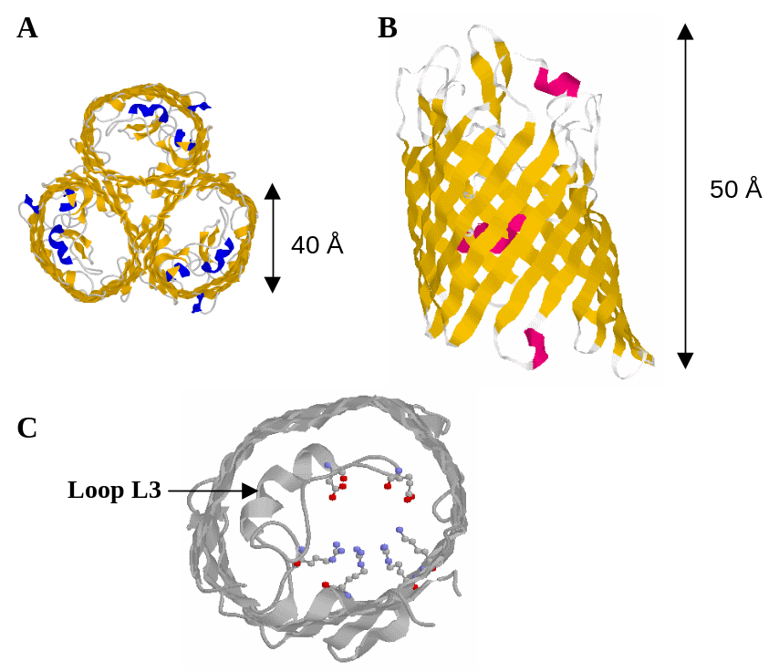
Outer membrane protein F (OmpF) is a β-barrel from Eschirichia coli and was one of the first porins to be crystallised. Its function is the exchange of nutrients, waste products and ions across the outer membrane of the bacterium via passive diffusion. The 340 amino acid polypeptide folds into a 16 stranded antiparallel β-barrel, forming a large, hollow, water-filled, transmembrane pore. Three monomers combine to form a trimer containing three more or less independent pores (Figure 1.1A). The monomers are approximately 50 Å in length and 40 Å in diameter at the widest point (Figure 1.1B). On the periplasmic side the β-strands are connected by tight turns, but on the extra-cellular side large loops exist between consecutive strands. Loop L3 folds back into the barrel, creating the eyelet region or constriction zone of the channel (Figure 1.1C). At its narrowest part halfway through the pore the cross-section of the channel is approximately 7 x 11 Å, effectively excluding substrates of >600 Dalton from transport.
Figure 1.1 Three dimensional structure of OmpF as determined by X-ray crystallography. A: top view from the extracellular side; the arrangement of the three monomers into a trimeris clearly visible. B: side view highlighting the 16 stranded β-barrel fold of the monomer. The periplasmic side of the protein is on the bottom C: top view showing the constriction zone in detail. The top part of the protein has been removed for clarity
The elementary properties of the channel such as selectivity, conductance and gating are determined by the size of the channel constriction, and the number, sign and distribution of charges in the proximity of the constriction zone^{16,17}. Therefore, factors that influence the electrostatic potential in the channel pore such as the ionic strength of the solution¹⁸ or the pH (¹⁹ on the related voltage dependent anion channel; ²⁰) affect channel behaviour. Among the most powerful tools to investigate structure-function relationships of proteins are site-directed and random mutagenesis methods since the substitution or deletion of one or more amino acids may significantly alter ion channel properties²¹⁻²⁴. In addition these methods allow the introduction of specific sites of attachment (e.g. sulfhydryls via cysteines) for ‘foreign’ functionalities such as binding motifs or molecular switches to influence gating. From a biophysical point of view these bacterial porin molecules seem to behave quite exceptional. Traditionally, gating and ion permeation are considered to be two independent phenomena, i.e. the flux of ions through the channel is thought not to influence the gating mechanism. Although this has been a paradigm in channel biophysics for more than five decades, a recent study on OmpC challenges this view²⁵.

Why use OmpF?

Several factors have been important in selecting OmpF as the ion channel of choice for the construction of ionic membranes. First of all, the three-dimensional structure of this protein is known in great detail (¹ and see Figure 1.1). Secondly, porins are remarkably stable; OmpF, for example, does not denature below 70 ºC in the presence of 1% SDS (see e.g. ²⁶), and consequently the protein is easy to handle. Moreover OmpF can reproducibly be crystallised in two dimensions using standard methods²⁷, ensuring that a high density of channels in the membrane can be reached with relative ease. In addition, it has a high specific conductivity (e.g. ²⁸, and see the section on electrophysiological characterisation (2.2.2) in this report), which makes it possible to pass microamps of current through a one micron squared area filled with porin molecules. The permeability and charge characteristics of the protein have been studied by a host of experimental and theoretical methods^{17,18,28-36} all of which can be used to our advantage. The protein can be readily modified using standard molecular biology methods so ‘custom-made’ proteins can be designed, produced and purified with comparative ease.

Experimental approach

There are a number of experimental approaches one can choose to create an ionic membrane of the type described above. One very important consideration, however, is that biological membranes consist of two main components, lipids and proteins, both of which are more or less mobile within the two-dimensional space defined by the membrane. It is exactly this mobility that allows the membrane to function as a highly effective barrier against the passage of ions other than through designated (and tightly controlled) channels, and therefore this property should be preserved as much as possible. With this condition foremost in our mind we have chosen to confer mechanical strength to the membrane by covalently cross-linking the least mobile component of the membrane, nl. the embedded protein molecules. This approach should allow the surrounding lipid to diffuse more or less freely around the protein scaffold, mimicking the architecture of the biological membrane as closely as possible. Nonetheless a thin sheet of foil created by this approach could in principle be as strong as the plastic film we buy in supermarkets (Saranwrap), since both are held together by the same molecular interactions.
On the experimental level a number of steps have to be taken to achieve the final goal of building a ion-selective membrane via protein cross-linking. These are:

- overexpression and purification in high yields of OmpF
- characterisation of the newly purified protein to ensure proper folding and functionality
- reconstitution in membranes and two-dimensional crystallisation
- development of cross-linking methods
- production of two-dimensional cross-linked sheets
- characterisation of the two-dimensional cross-linked membranes in terms of stability and ion transport.

Concomitantly the functional properties of the protein are manipulated by mutagenesis methods. Two strategies are being employed, rational design and random mutagenesis. In the first method specific changes are being made in the primary protein sequence to obtain the desired properties, based on the three-dimensional structure of the channel and/or results from calculations and simulation experiments. In the random method mutations are being introduced at random positions and the mutants with desired properties are selected from a large library by an appropriate screening procedure. The results of our investigations so far are described in the next section.

Results

Purification of OmpF.

Traditionally the purification of membrane proteins is achieved by expressing the protein in an appropriate host, separation of cell membranes and the cytosol, extracting the protein from the membranes and further purification of the extract, usually by column chromatography. A procedure following these general guidelines has been described for OmpF³⁷ and this seemed a good starting point to attempt to obtain the protein in pure form. An overexpression system, comprising of a plasmid bearing the OmpF gene under control of the T7 promoter (pGompF; ³⁸) and an especially adapted E. coli strain in which all known genes for outer membrane porins have been inactivated (E. coli Omp8; ³⁸) was kindly provided to us by Prof. Tilman Schirmer of the University of Basel, Switzerland. Using this system large amounts of protein could indeed be produced, but in our hands purification to homogeneity proved to be difficult. Two of the main components of the E. coli outer membrane, lipoprotein and lipopolysaccharide, co-purified with the protein and, despite our best efforts, proved to be very hard to separate from the native protein (Figure 2.1). The procedure yielded approximately 5 mg of pure protein per litre of bacterial culture, an amount that is not enough to meet our needs.
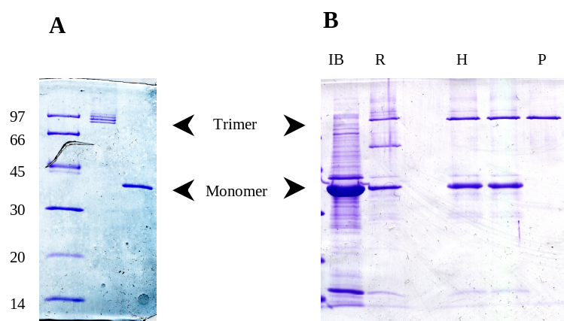
During the purification procedure it was noted that a large part of the overexpressed membrane protein was not associated with the membrane but appeared as aggregates in the cytoplasm of the cell. Aggregates of this kind are termed inclusion bodies and are not uncommon in bacteria if the production of overexpressed protein in the cell is very high. It was also noted that the size of the monomeric denatured protein in the inclusion bodies as determined from SDS PAGE is slightly larger than the size of the purified protein. This observation can be understood if the normal route of bacterial outer membrane protein processing is taken into account. To discern between membrane proteins destined to function in the inner and outer membranes, the latter are ‘tagged’ with a signal sequence of 20 amino acids on the N-terminal side of the mature protein. The sequence is recognised by a dedicated secretion system that in conjunction with a number of other proteins transports the polypeptide sequence to the periplasmic space and removes the signal sequence to yield the mature protein that can fold and insert in the outer membrane (see e.g. ³⁹ for a review). We concluded that the majority of the overexpressed protein is not being transported, most likely because the translocation machinery is overloaded, resulting in inclusion bodies containing unfolded polypeptide chains with the signal sequence still attached.
Figure ‎0.1 SDS PAGE analysis of the purification of OmpF from the outer membrane (A) and inclusion bodies (B). In the presence of 1% SDS the protein remains in the trimeric form unless the solution is heated to 100 ºC for several minutes, after which monomers are observed. The multiple bands observed for the trimer in A are caused by bound lipopolysaccharides that are not present in B. Molecular weight markers and trimer and monomer positions are indicated in the figureAbbreviations: IB, inclusion bodies; R, refolded; H, heat treated; P, protease treated.
On the basis of the results described above an alternative purification procedure was developed. To this end a new expression plasmid, pGompFmat, was constructed in which the sequence of the mature protein was placed directly behind the promoter (i.e. the DNA sequence coding for the signal peptide was removed) resulting in expression of large amounts (>300 mg OmpF per litre of culture) of the mature protein in inclusion bodies. The inclusion bodies can be separated easily from the rest of the cellular components and are already approximately 80% pure, but unfortunately the expressed protein is in an aggregated and unfolded form and therefore needs to be regenerated. To this end the inclusion bodies are dissolved in buffer containing 8M urea at a final protein concentration of 2 mg/ml and diluted 10-fold into a solution containing the detergent dodecylmaltoside (see ⁴⁰). Approximately 30% of the protein forms native trimeric structures as determined from SDS-PAGE, the rest forms non-native monomeric and dimeric structures. The dimeric structures are converted to monomers by heating the solution to 70 ºC for 30 minutes, after which the monomeric structures are degraded by treatment with protease. Although both procedures are harsh treatments in terms of protein chemistry, they leave the native trimeric from of the protein completely unharmed (Figure 2.1 and see below). Concentration and final purification of the protein preparation is achieved by anion-exchange chromatography. The final yield is ca 50 mg per litre of culture medium.

Functionality of OmpF

Swelling assays

As indicated in the previous paragraph the purification procedure exposes the protein to harsh conditions and therefore it needs to be established whether the protein is still functional. In nature OmpF mainly functions as a passive diffusion pore embedded in the outer membrane, i.e. it allows the passage of molecules and ions across the outer membrane by diffusion through the channel. Two methods have been applied to test for this functionality, swelling assays and electrophysiological measurements in planar lipid bilayers.
The use of swelling assays to test the functionality porins was developed in the late 1970’s and early 1980’s^{35,41-43}. The method is based on the formation of multilamellar proteoliposomes that are filled with a solution containing a high concentration of a solute (dextran) that is too large to diffuse through the pore. These liposomes are diluted into an iso-osmotic solution of a compound that is small enough so that it can pass through the channel. This solute diffuses down the concentration gradient into the interior of the liposomes, resulting in an increase of the osmotic value on the inside. Consequently water is taken up, mostly directly through the membrane, causing the liposomes to swell. This process can be followed by simply monitoring the light scattering properties of the liposome containing solution in a spectrophotometer, where the rate of change in apparent absorption is a measure of the rate of transport through the protein pore. Unfortunately the method does not yield absolute results, since the rate of change varies with protein concentration and the exact composition of the liposomal solution (size, number and multilamellarity of the liposomes, reconstitution efficiency of the protein etc.), a variable that is hard to control. The relative rates of transport of compounds of similar structure but different size, however, are reproducible between preparations, and therefore results are compared in this way.
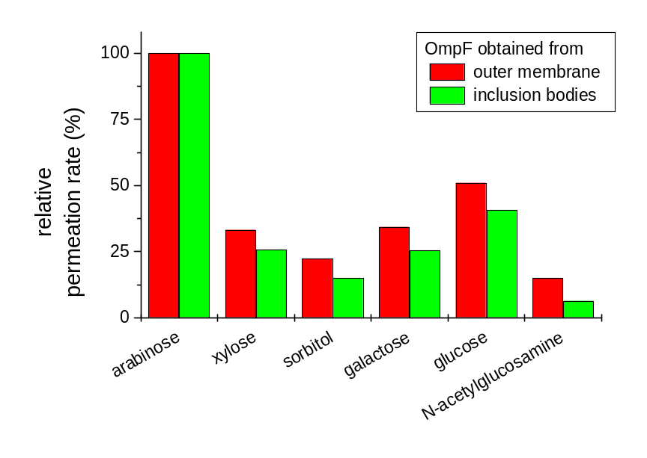
The functionality of the OmpF protein from inclusion bodies was determined by comparison with the same protein obtained directly from the outer membrane of E. coli. To this end the rates of swelling after exposure to iso-osmotic solutions of carbohydrates with molecular weights ranging from 150.1 to 221.2 Da were determined and normalised with respect to the result obtained for the smallest of the range, arabinose (Figure 2.2). Although there are small differences, the trend in both sets of data is clearly the same, leading us to the conclusion that OmpF from inclusion bodies and the bacterial outer membrane are functionally very similar.
Apart from non-charged molecules, OmpF also allows the diffusion of charged species through the lumen of its pore, i.e. it functions as an ion channel. This opens up the possibility to analyse functionality using electrophysiological techniques such as planar lipid membranes. This is discussed in some detail in the next section.
Figure ‎0.2 Permeation rates of a number of carbohydrates, relative to arabinose (MW 150.1). The Other molecular weights are 150.1 (xylose), 180.16 (sorbitol, galactose), 182.17 (glucose), 221.2 (N-acetylglucosamine).

Electrophysiological characterisation

Ion channels mediate fluxes of one or more ion species across biological membranes. Today’s electronic amplifiers are high precision instruments that allow the measurement of currents smaller than 1 pA (10⁻¹² ampere, corresponding to a flux of 10⁶ monovalent ions per second). This high resolution implies that even the ionic currents through individual channel molecules can easily be detected and from this point of view, these measurements belong to the most sophisticated techniques in molecular biology currently available. One way to study ion channels is to, first, isolate the channel, followed by the reconstitution of the channel in an artificial membrane or planar lipid bilayer (PLB). The advantage of this approach is an advanced level of control as far as lipid bilayer composition, choice of the solutions on either side of the membrane and chemical modification of the channel are concerned. It is this approach that we use here to characterise OmpF.
A schematic representation of a PLB set-up is shown in figure 2.3. The lipid bilayer, containing the reconstituted ion channel of interest, separates two electrically isolated compartments, by convention defined as the Cis and Trans compartment. The Cis compartment is connected to the measuring electrode and to the pre-amplifier in the headstage of the patch-clamp amplifier while the Trans compartment is electrically grounded. Most commonly, ionic currents through the ion channel in the PLB are measured at a constant voltage (V). However, current flow (I_{K}) arising from channel opening changes V. To actually voltage-clamp the potential at a certain desired or command potential (V_{com}) requires an electronic circuit as indicated with a central role for the operational amplifier (OA). The measuring electrode and V_{com} are connected to the - and + inputs of OA, respectively. Any difference between the two inputs causes a feedback current (I_{f}) through the feedback resistor (R_{f}). This ‘correcting current’ I_{f} is equal in magnitude but of opposite polarity to the current passing the membrane (I_{K}). The circuit operates like a current-to-voltage or IV-converter and the output of OA (V_{out}) is directly proportional to the current across the bilayer. Typically, R_{f} has a value of 1 GΩ; then, an input of 1 pA corresponds to a 1 mV output. By convention, potentials are referenced to the potential of the Cis compartment and a positive current (upward deflection) is defined as a net flux of positive charge from Cis to Trans.
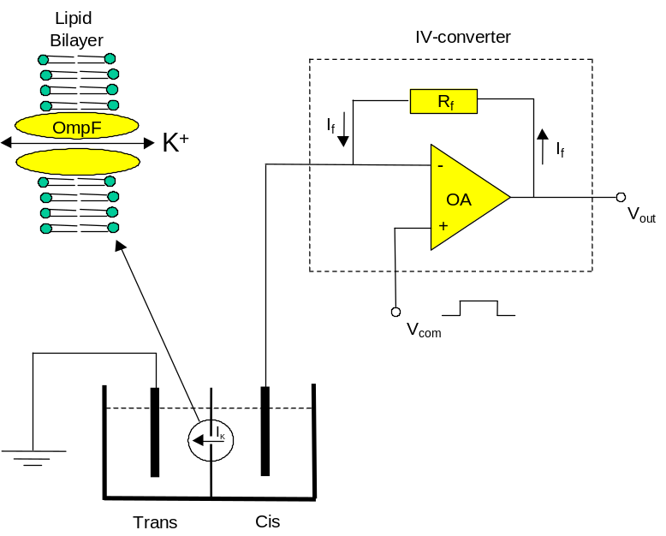
Essential to the use of the set-up described above is the ability to assemble a lipid bilayer in the hole that separates the two compartments, and to insert a channel into this membrane. This is done by dipping a ‘brush’ in an solution of lipids in organic solvent (we use mixture of phosphatidylethanolamine and phosphatidylcholine in an 8:2 ratio, dissolved in n-decane at 10 mg/ml) and ‘painting’ this solution over the aperture that is below the surface of the surrounding solution. In a few seconds, the lipid film thins out, a process that is thermodynamically controlled and results in the formation of a true lipid bilayer. The process can be followed by monitoring the electrical capacitance of the bilayer, since the specific capacity of a decane containing bilayer is around 0.4 μF/cm², about half the specific capacitance of a solvent free bilayer⁴⁴. Furthermore, after thinning the capacitance is a direct measure of its surface area, which is an important parameter because the larger the membrane surface area, the better the chances for ion channel reconstitution. A typical bilayer has a surface area of 0.005 mm² and a capacitance of 200 pF. Note that just part of the aperture (with a total surface area of 0.02 mm²) is covered by a bilayer but that most of the surface area is taken up by the so-called lipid annulus⁴⁵. The protein is reconstituted by adding a minute amount (final concentration < 1 ng/ml) to the Trans compartment while stirring. The channel inserts spontaneously into the membrane, but nonetheless the reconstitution is under experimental control, since turning off the stirring device effectively terminates the incorporation of more channels.
Figure ‎0.3 Schematic representation of a planar lipid bilayer set-up. For a detailed description see text
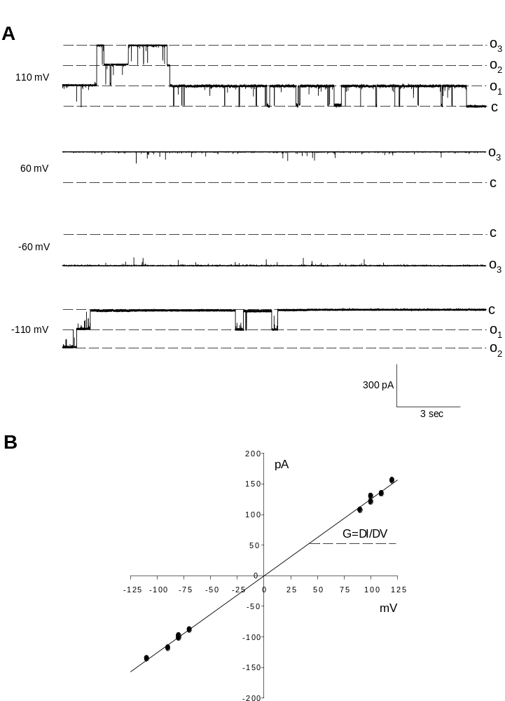

Following the procedures described above single channel current recordings of OmpF (purified as described above) can be obtained routinely. Figure 2.4A shows four current recordings under voltage-clamp condition with 1 M KCl in both the Cis and Trans compartments. The potential difference is indicated on the left hand side of the traces. At –110 and 110 mV the gating of the channels is obvious from the current jumps back and forth from the closed state (c) to current levels corresponding to one (o₁) or more open states (o₂ and o₃). Plotting these current jumps as a function of the potential renders the so-called
Figure ‎0.4 Single molecule current recordings of OmpF (A) under voltage clamp conditions. The different levels of conductance are indicated in the figure (C: closed, O₁ to O₃ open). The I-V curve was determined as described in the text

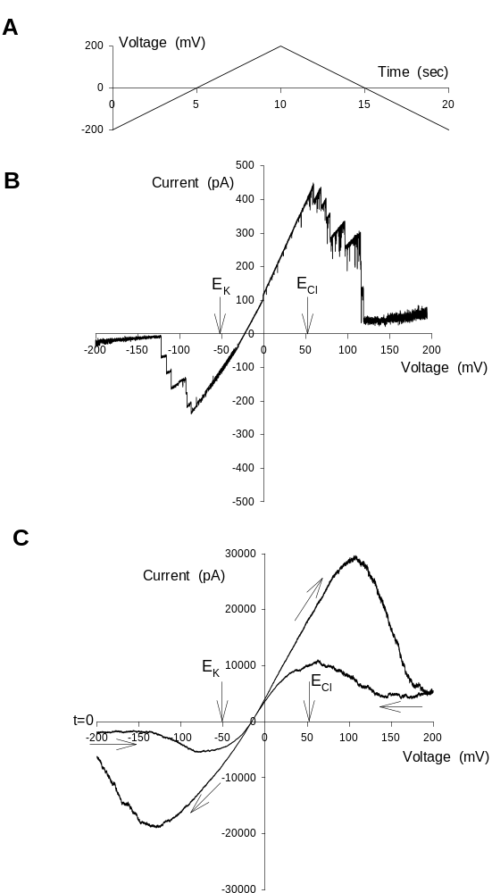

current-voltage or IV-curve in Fig. 2.4B. The single channel or monomeric conductance (G), defined as the slope of the IV-plot, was, on average, 1.2 nS. Equating ion channels to transport proteins (i.e. enzymes, see ⁴⁶), the conductance can be seen as analogous to the turnover number.
Figure ‎0.5 Current recordings obtained using the volta the voltage ramp protocol indicated in A with either a few channels embedded in the membrane (B) or a large number (C).
As is obvious from Fig. 2.4A, the recordings at 60 and –60 mV show hardly any gating and all three monomers remain open. Apparently, the gating process is sensitive to the applied potential. Figure 2.5 shows current recordings in response to a slightly different voltage protocol as the one applied in Fig. 2.4. Instead of clamping the potential at one particular level the potential was gradually increased from –200 to 200 mV, followed by a voltage ramp back to –200 mV, all in 20 seconds time. The voltage ramp protocol is shown in Fig. 2.5A. With only a limited number of OmpF channels reconstituted, the current trace in Fig. 2.5B shows channel openings and closings, as in Fig. 2.5A. At the start of the voltage ramp at –200 mV, channels are closed. Upon the change of potential in the positive direction, channels open but start to close again at potentials more positive than approximately 50 mV. (Note: for reasons of clarity, the current trace during the ramp back to –200 mV is not shown). To obtain a statistically more reliable picture of the voltage dependence of the gating process, one can either analyse multiple recordings on one or a few reconstituted channels or, alternatively, measure the response of many channels simultaneously. An example of the last option is shown in Fig. 2.5C. Note the difference in current magnitudes in Figs. 2.5B and C. By comparing the current levels at 110 mV in both panels, we can estimate the minimum number of reconstituted monomers in Fig. 2.5C to be around 30000/75=400, i.e., approximately 133 OmpF trimers. The recording of Fig. 2.5C started at –200 mV, indicated by t=0, and because this figure shows the entire trace, the direction of the current trace is indicated by arrows. Qualitatively, this figure shows the same voltage sensitivity of OmpF gating as Fig. 2.5B but single channel gating is no longer visible. As holds for an (ideal) electrical resistance (R) and according to Ohm’s law (V=IR or, with G=1/R, G=I/V), the IV-plot in Fig. 2.7B shows linearity. In contrast, the IV-plots of Figs. 2.5B and C are clearly non-linear. One should realise that the IV-plot of Fig. 2.4B refers to the IV-characteristic of an open channel. When recording on an ensemble of channels, the voltage-dependent gating may cause the IV-plot to be non-Ohmic and the recordings of Figs. 2.5B and C are outspoken examples. Despite an increase of driving force for ion movement at more negative and more positive potentials, the overall current magnitude decreases because channels tend to close in these voltage ranges and this is translated into a negative slope conductance. Both the activation (opening) and deactivation (closing) of OmpF might be voltage sensitive. The hysteresis observed in Fig. 2.5C is most likely an artificial effect due to the slow speed at which the ramp was applied ^{47,48}.
The voltage-dependent gating of OmpF can be used to demonstrate the fact that the protein is a trimer composed of three monomers which gate separately (but not independently). An example is shown in Figure 2.6. At a holding potential of 0 mV the trimer was fully open. A voltage step to 100 mV induced channel closure in three distinctive steps, reflecting the individual closure of the monomers (note that the initial current increase at the onset of the 100 mV pulse is caused by the instantaneous increase of the driving force for cation efflux from Cis to Trans). The current trace in Figure 2.6 nicely demonstrates the stochastic nature of the gating process. Despite the bias towards channel closure, two temporal openings of a single monomer were observed after the trimer had already completely closed.
Apart from the conductance and gating, another important aspect of the functionality of OmpF is the ion selectivity, i.e. which ions are preferentially allowed to flow through the lumen of the pore. The recordings described above were all obtained in symmetrical 1M KCl solutions, but in order to determine the ion selectivity of the channel, OmpF was exposed to an ion gradient of 1 M KCl in the Cis compartment and 0.1 M KCl in the Trans compartment. Under these conditions the potential of zero current is a measure of the ion selectivity of the channel or, in terms of ordinary enzymology, the substrate specificity of the channel. The zero-current potential is the also called the reversal potential (E_{rev}) because the current reverses its direction from outward or positive (upward deflections) to inward or negative (downward deflections). In electrophysiology, an ion selectivity measurement is nothing but a comparison of the measured E_{rev} with the calculated Nernst or equilibrium potentials of all permeable ion species. Based on ion activities, these solutions resulted in equilibrium or Nernst potentials for K⁺ and Cl⁻ of –52.7 and 52.7 mV, respectively. In Fig. 2.5, the equilibrium potentials of K⁺ (E_{K}) and Cl⁻ (E_{Cl}) are indicated. The fact that E_{rev} is located closer to E_{K} than to E_{Cl} already indicates that OmpF is more permeable to K⁺ than to Cl⁻. Note that the value of E_{rev} is independent of the number of open channels but only depends on the number of ion channels with different ion selectivity. A quantitative measure of the ion selectivity of an ion channel is the permeability ratio P_{a}/P_{b} for ion species a and b. An expression of P_{a}/P_{b} can be derived from the Goldman-Hodgkin-Katz or GHK-current equation for electro diffusion:

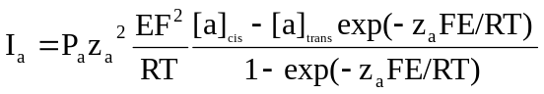 (1)

where E is the electrical potential and RT/F equals 25.3 mV at 20 °C. By definition, the total current at E_{rev} equals zero. Assuming that the current is explicitly carried by ion species a and b, implying I_{a}+I_{b}=0, P_{a}/P_{b} is given by:

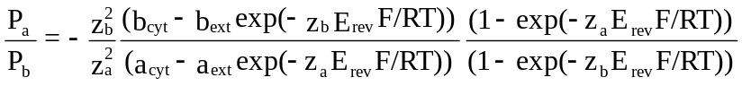 (2)

After substituting an average value for E_{rev} of –33 mV, we calculate a P_{K}/P_{Cl} of 6.6.
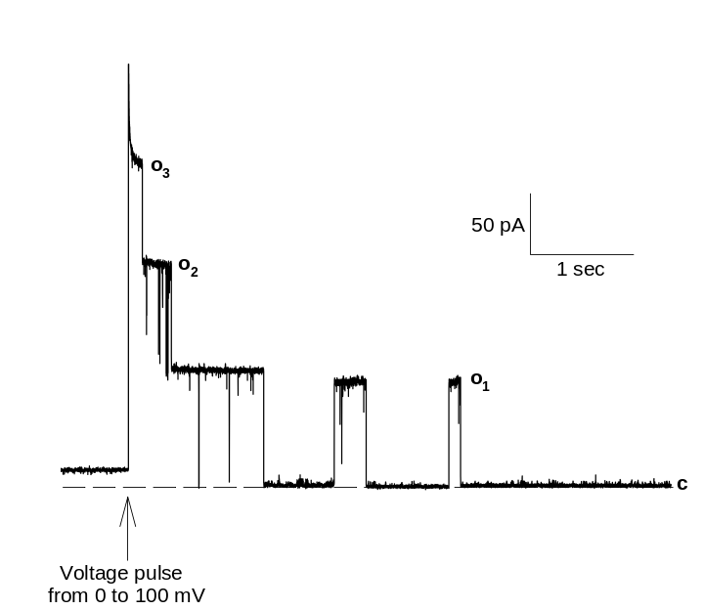

Membrane reconstitution and two-dimensional crystallisation
Figure ‎0.6 Current measurement of a single OmpF molecule. The stochastic opening and closing of the three channels from the trimer can be clearly observed

Ion channels normally function embedded into lipid bilayers, and therefore, after purification, they have to be put back in a similar environment to properly asses their properties. This process is called membrane reconstitution and several commonly used methods exist to achieve the goal (for a review see e.g. ⁴⁹). In most cases the methods consist of preparation of a mixture of membrane protein, detergent and lipid in an aqueous solution, followed by selective removal of the detergent. The remaining lipid and protein start to form aggregates during this process and eventually under the right conditions self-assemble into proteoliposomes, i.e. spherical structures where a single bilayer separates the inside from the outside and the membrane proteins are embedded in this bilayer. The selective removal of the detergent from the mixture is most commonly performed by a dialysis step. The tripartite mixture is dialysed against a large volume of buffer using a dialysis membrane with a molecular weight cut-off below the molecular weight of the protein, precluding passage of the protein to the other side. Because the critical concentrations for aggregation of the detergent and lipid are very different (mM and nM range, respectively) a sizeable part of the total amount of detergent will be present in monomeric form, whereas essentially all the lipid will be in some aggregated form. Only the monomeric species can pass through the dialysis membrane, leading to reduction of the detergent concentration, which in turn leads to further monomerisation of detergent micelles, and eventually removal of all detergent from the solution.
The method described above was also used to reconstitute OmpF using a protocol originally described by Dorset et al.²⁷, who studied the reconstitution process and determined the optimal conditions for two-dimensional crystallisation of OmpF. In short, OmpF and lipid (usually 1,2-dimyristoyl-L-α−phosphatidylcholine (DMPC)), were solubilised in 20 mM HEPES, pH 7.4, containing 10 mM MgCl₂, 100 mM NaCl and 1% (v/v) of the detergent n-octyl-oligo-poly-oxyethylene (OPOE). This solution was dialysed at 37ºC for 16 h against the same buffer without detergent using a dialysis membrane with a molecular weight cut-off of 8 kD. The buffer was then changed and dialysis was continued for 8 h. Subsequently, dialysis was continued for 16 h against water. After changing the water and continuation of the dialysis for 2 h, water was cooled to 10ºC and the dialysis was ended. Depending on the intended use, samples were stored at 4 ºC or aliquoted and stored at –20 ˚C.
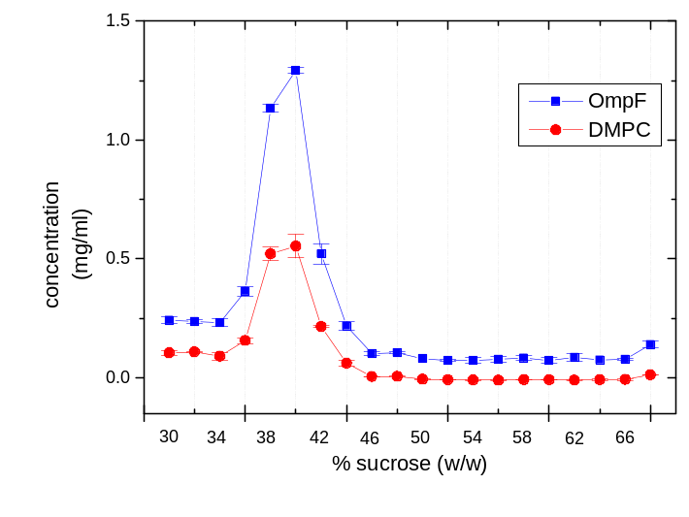
After reconstitution, samples were analysed using sucrose gradient centrifugation, a method that allows separation of particles on the basis of their density. Since protein in general, and OmpF in particular (calculated density from the primary sequence ρ = 1.4 kg dm⁻³), has a higher density than lipid (ca 1 kg dm⁻³), the density of proteoliposomes increases with increasing protein content, and therefore a good indication of the result of a reconstitution experiment can be obtained from this method. In short, a centrifugation tube is filled with successive layers of sucrose solutions of decreasing concentration (and therefore density) so that a density gradient is formed in the tube. A sample is applied on top and a gravitational field is applied via centrifugation at high speed. Over time the particles (liposomes in this case) will position themselves in the sucrose layer with matching density.
Figure ‎0.7 Sucrose gradient analysis of a reconstitution of OmpF in 1,2-dimyristoyl-L,a-phosphatidylcholine lipids. Protein and lipids colocalize on the gradient
Figure 2.7 shows a typical example of a sucrose gradient analysis of a sample of OmpF reconstituted into DMPC at high protein to lipid ratio. In this case a gradient with a total volume of 10 ml and a sucrose content ranging from 30 (at the top of the tube, equivalent to 1.11 kg dm⁻³) to 66% w/w (bottom; 1.32 kg dm⁻³) was used. After centrifugation the gradient was fractionated and the concentration of lipid and protein in each of the layers was determined and plotted as a function of the position in the gradient. It is clear that protein and lipid are found in the same fractions of the sucrose gradient, and since the density of these fractions is somewhere between the density of pure lipid and pure protein, this is good evidence that proteoliposomes have been formed.
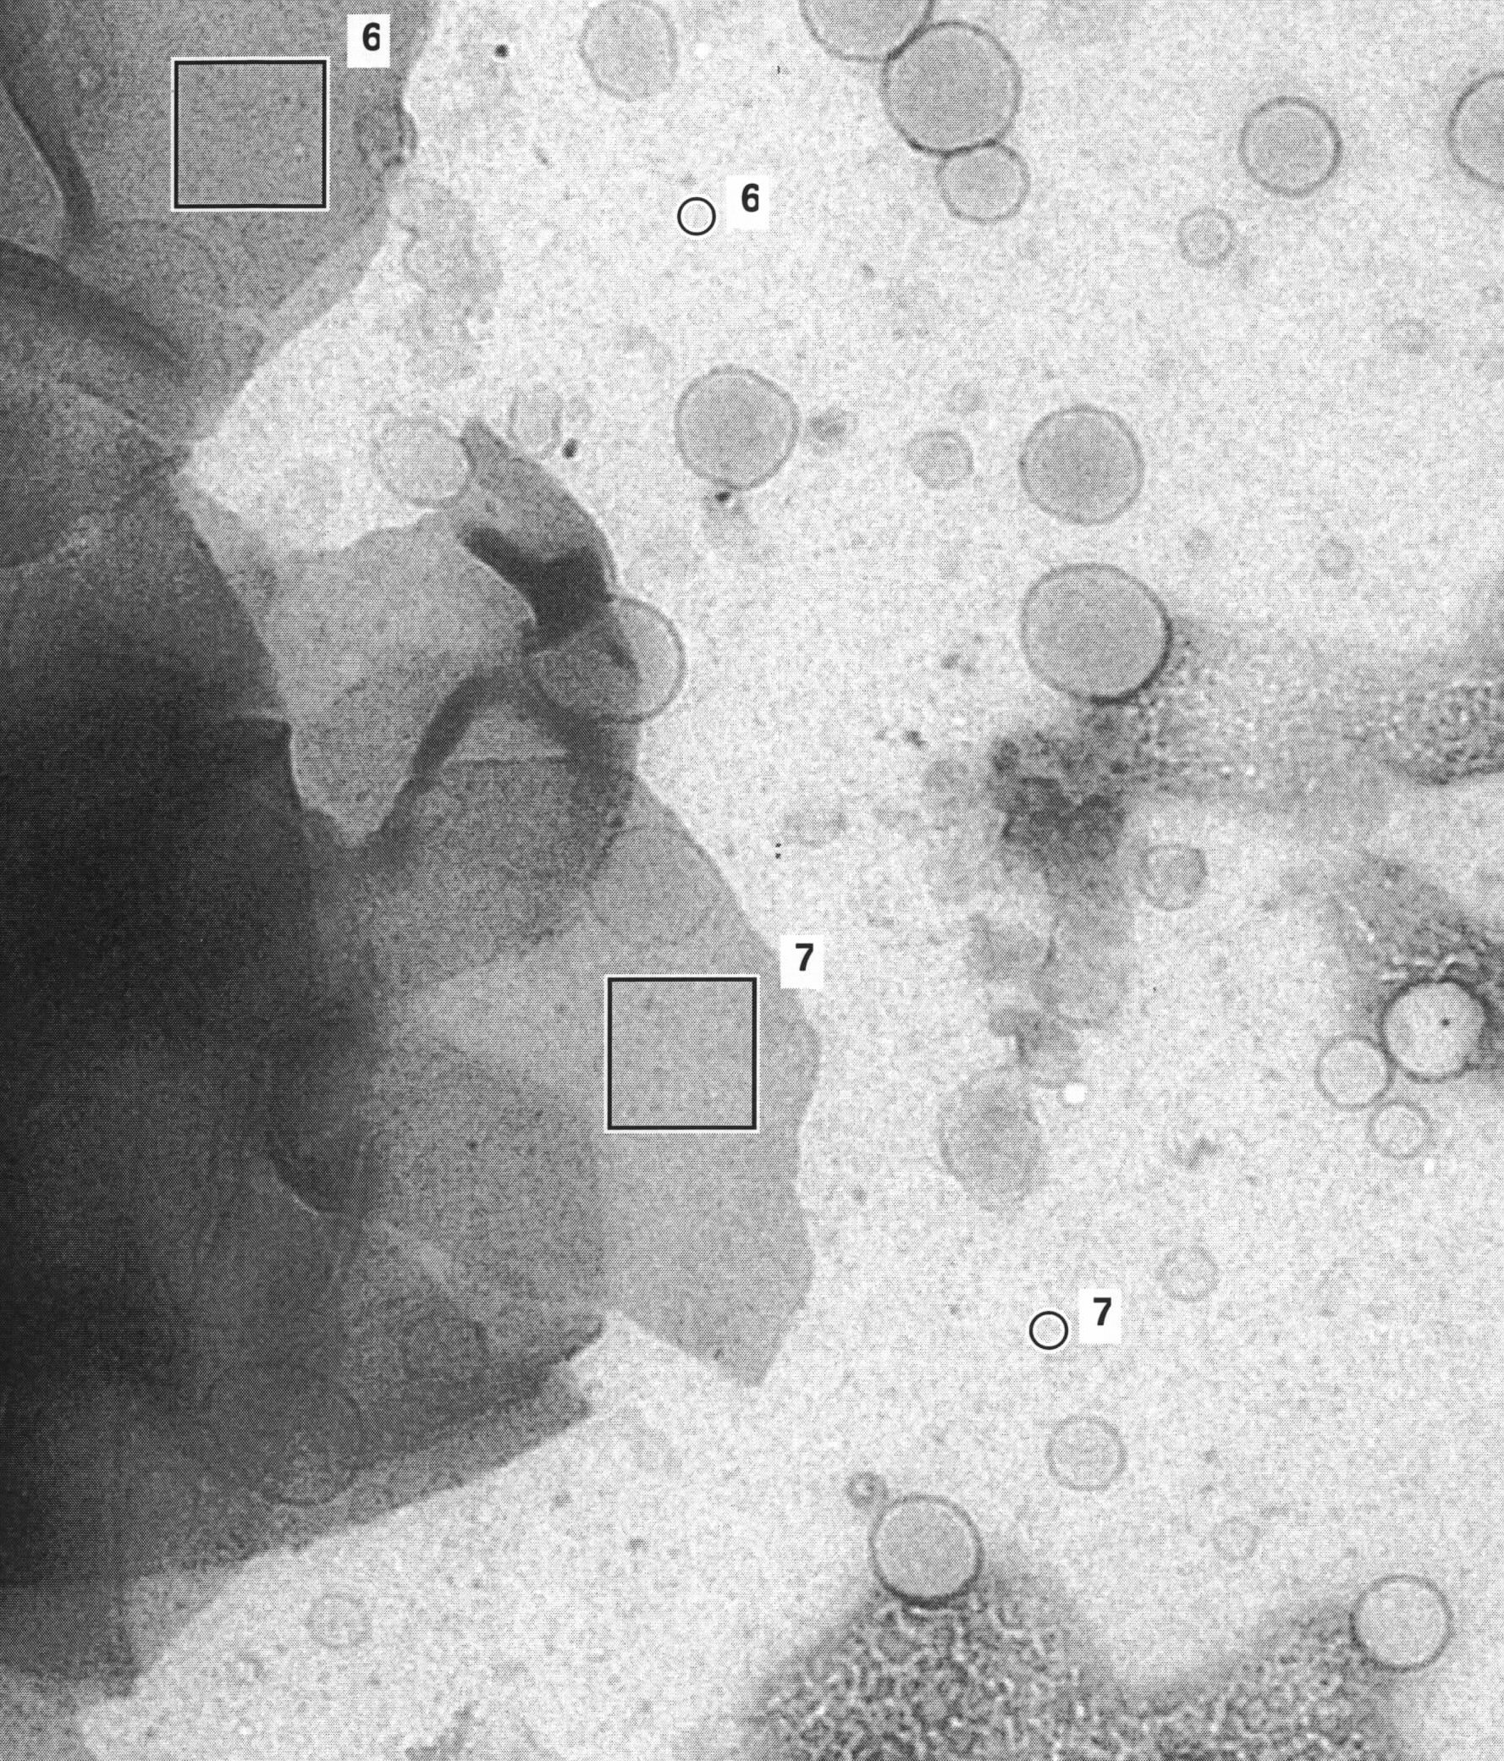
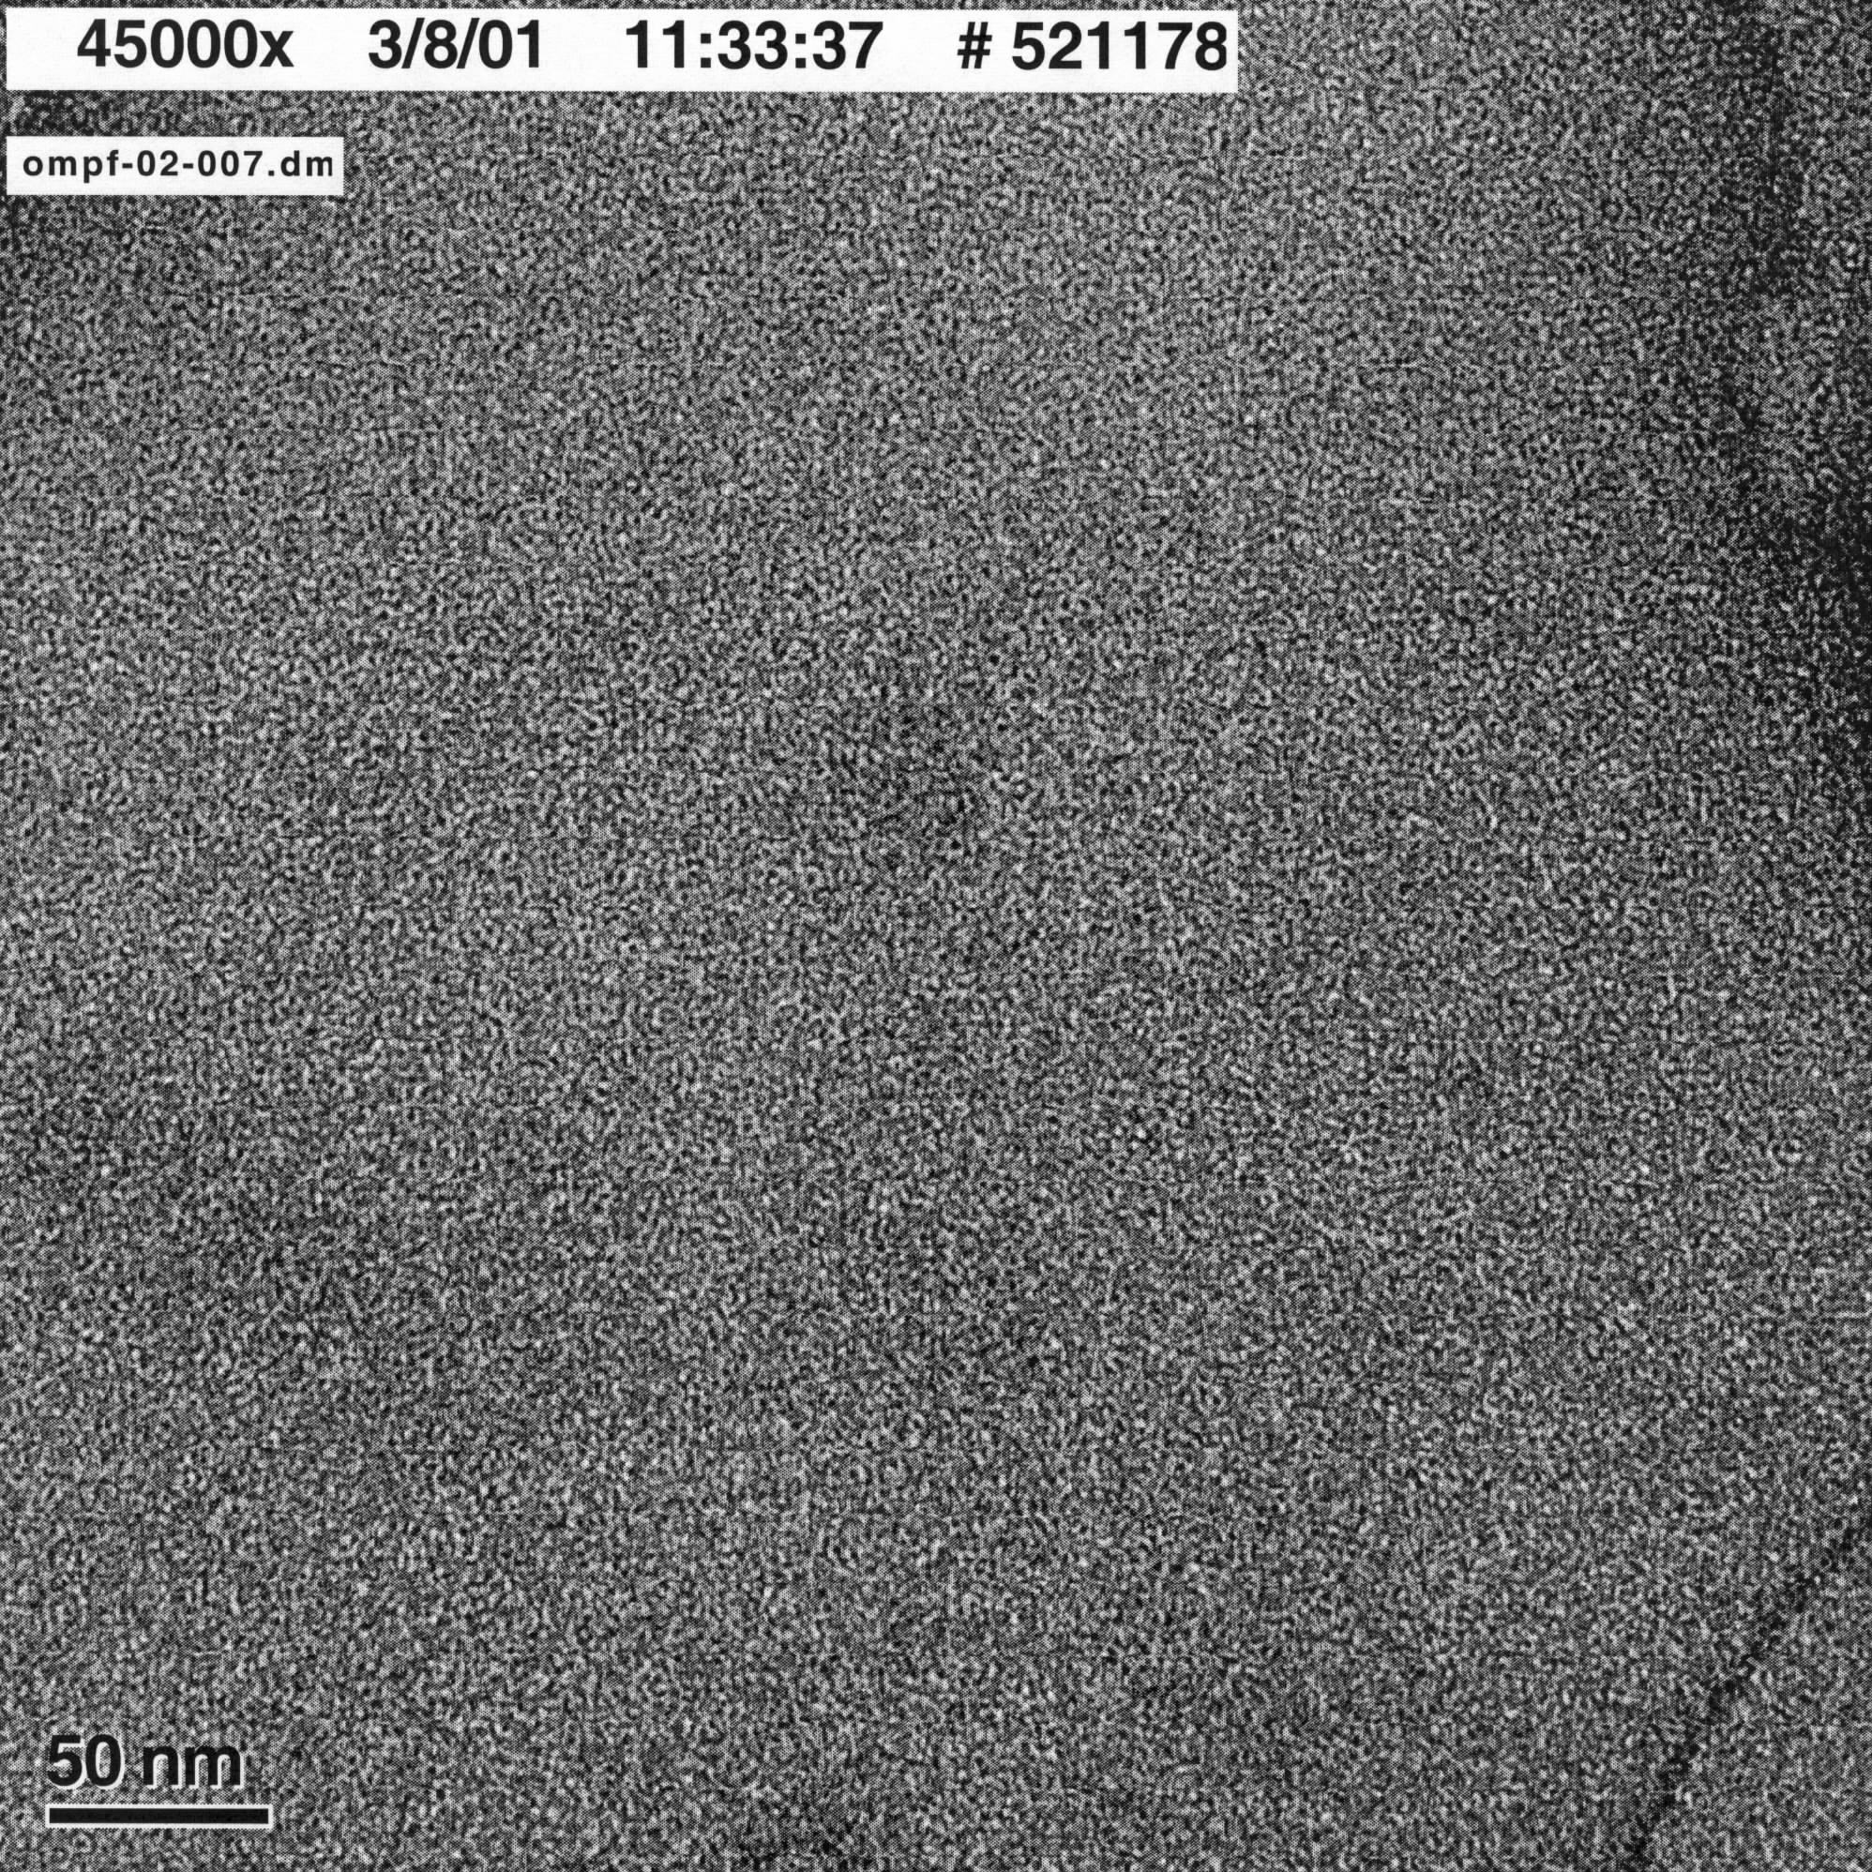
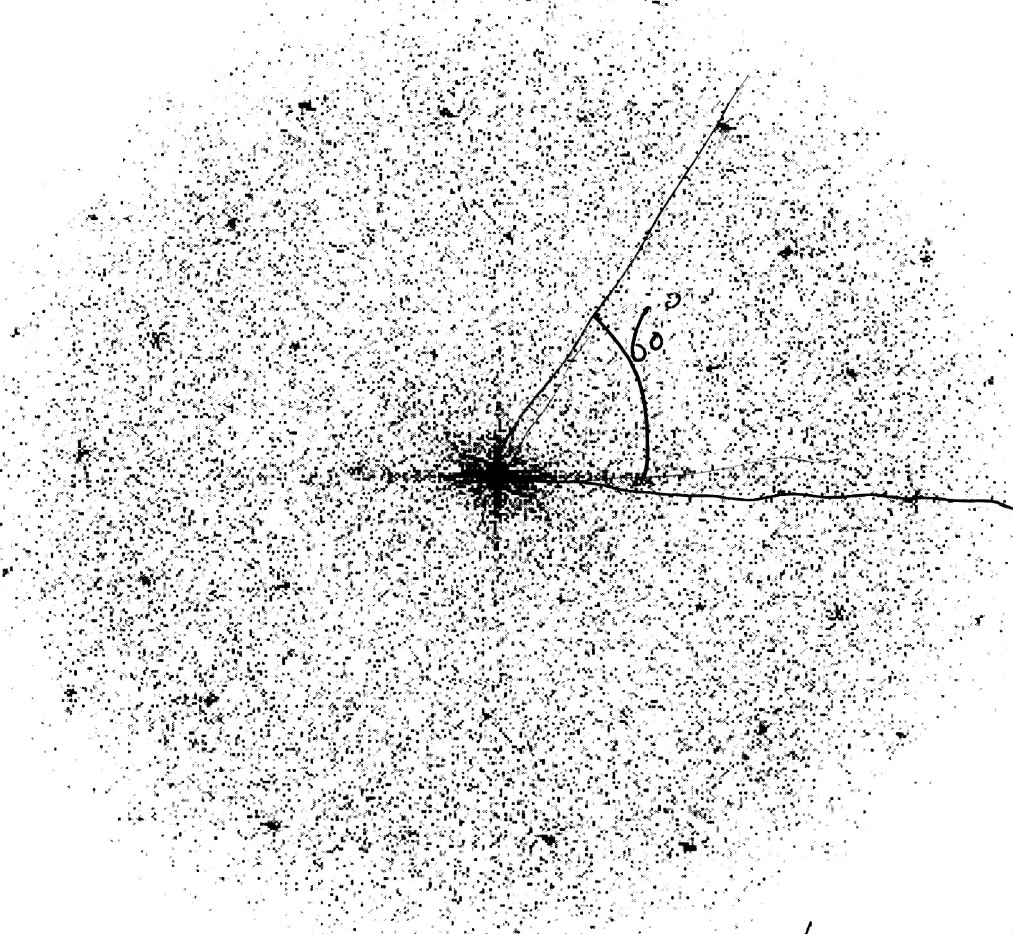
Further evidence for proper reconstitution was obtained from electron microscopy studies. Two methods were employed to obtain images, freeze-fracture and negative stain. In the former method the samples are rapidly frozen, fractured and stained with a heavy metal derivative. The fracture will seek the path of least resistance, which for bilayer membranes is between the two leaflets and therefore it is possible to observe transmembrane proteins directly, either as holes when the protein has remained associated with the leaflet that has been removed, or as protrusions in the opposite case. We obtained several images of this kind which showed large area’s covered with ice as well as irregular aggregates containing protein and lipid (not shown). The results improved when a cryo-protectant such as glycerol was added prior to the freezing step, although not to such a degree that a proper representation of the sample was obtained. Similar observations have been made for bacteriorhodopsin reconstituted into DMPC where freezing at a rate smaller than 10⁴ K s⁻¹ led to formation of protein rich and protein free patches⁵⁰. Therefore we conclude that the critical step in obtaining good images is the flash freezing of the sample, rather than the reconstitution protocol that we employ.
To solve the problem described in the preceding paragraph a different method to prepare EM samples was employed, nl. negative staining. In this method the sample is briefly exposed to a solution containing a heavy metal salt (e.g. uranyl acetate) resulting in an imprint (or negative) of the surface of the vesicles that can be investigated by electron microscopy. Figure 2.8 shows the result of such an experiment. The reconstitution procedure leads to the formation of very large structures, up to 10 μm or even larger that exhibit sharp edges and folds, and also some smaller vesicles (A). Enlargement of the large assemblies (B) indicates that these are regularly ordered, a fact that is confirmed by the calculated diffraction pattern analysis (C). In this case a hexagonally ordered two-dimensional crystal with a lattice constant of 9 nm is formed, but other crystal forms are possible²⁷.
Figure ‎0.8 Electron microscopy images of OmpF 2D crystals, obtained after negative staining with uranyl acetate. On the left an overview of a preparation is shown; the large structures containing OmpF can clearly be seen. In the middle a magnification of one the squares (no. 7) is shown, which was used to calculate the diffraction pattern shown on the right. In this case the protein forms a hexagonal lattice with a = 9 nm.

Cross-linking of OmpF containing membranes

A-specific cross-linking

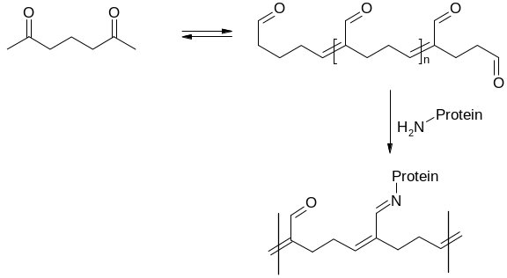
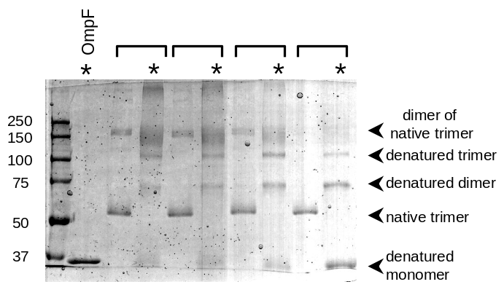
The two-dimensional crystals of OmpF are an ideal starting point for the formation of mechanically robust cross-linked membranes because of their very high density of protein. One of the oldest and best-known methods to covalently cross-link proteins is the use of glutardialdehyde (see e.g. ⁵¹). This small bi-functional compound readily polymerises in aqueous solutions and forms a range of molecules with different lengths and one reactive group (e.g. a keto moiety) per repeating unit. This reactive group can reacts with terminal amine groups such as those present in lysine residues to form a conjugated Schiff base (Figure 2.9). Using this method reconstituted OmpF membranes were cross-linked at room temperature (50 mM NaP_{i}, pH 7.0) for 3 h. The OmpF concentration was kept constant at 0.5 mg/ml (4.5 µM trimer), but glutardialdhyde was varied between 0.025-0.25% (4-40 mM). After incubation the samples were analysed by SDS-PAGE using 7.5% polyacrylamide gels as shown in figure 2.10. At 0.025% glutardialdehyde in untreated samples only native trimers are observed but after boiling for 10 min in 1% SDS unfolded monomers, dimers and trimers were observed. Apparently, intramolecular cross-linking occurred without formation of intermolecular bonds under these conditions. Similar observations have been made for glutardialdehyde cross-linking of porins in the detergent solubilised state⁵². At higher cross-linker concentrations intermolecular cross-linking are also formed, as can be concluded from the presence of dimers and trimers of trimers (all folded) in the non-boiled samples. After boiling, unfolded trimers and even higher molecular weight compounds were observed, although the resolution of the method goes down and bands became fuzzy.
Figure ‎0.9Protein cross-linking via glutardialdehyde
Figure ‎0.10 A-specific cross-linking of OmpF analyzed on SDS PAGE. Reconstituted OmpF was treated with increasing amounts (from right to left) of glutaraldehyde. The samples were split and one half was boiled in the presence of SDS (labeled with a *), whereas the other half was left at room temperature. Samples originating from the same reaction mixture are indicated with a bracket. At low glutaraldehyde concentrations only intramolecular cross-linking occurs, at higher concentrations also intermolecular bonds are formed

Although the above described results are encouraging, the use of glutardialdehyde for cross-linking of OmpF has several major limitations. Since OmpF contains as much as 54 lysine residues per trimer, some of which are in the channel lumen, reaction with this moiety could easily lead to impairment of the functionality of the OmpF channel. Furthermore, the chemistry of glutardialdehyde is strongly dependent on the conditions of the experiment and therefore the reproducibility of this approach will be low. In conclusion, an approach where the cross-linking reaction is directed towards specific pre-determined sites is the method of choice.

Specific cross-linking

Protein cross-linking strategies in general use three moieties to attach a cross-linker to the protein, nl amines, sulfhydryls and carboxylates. Of these three both amines and carboxylates are abundant in OmpF and therefore not really suitable for site-specific attachment, but no sulfhydryl groups occur in the wild type protein. These can be easily introduced into the protein sequence (in the form of cysteines) using standard molecular biology techniques, and in combination with sulfhydryl-specific cross-linkers (many of which are commercially available), this approach allows exact control over the site of attachment.
Detergent mediated reconstitution and two-dimensional crystallisation of OmpF yields large vesicles in which the protein is uni-directionally embedded. The side of the protein that is exposed to the exterior of the vesicles and therefore readily accessible for cross-linkers is the periplasmic side, i.e. the side of the protein that contains the short β-turns between the strands that form the barrel. Of these four are pointing outward, i.e. away from the three-fold symmetry axis of the trimer (Figure 2.11). Single site mutants were created by introducing a cysteine residue in each of these, replacing leucine 147, glutamate 183, asparagine 223 or phenylalanine 267 in turns 4 to 7, respectively. All mutations were confirmed by DNA sequencing of the entire OmpF gene, and the proteins were purified as before, but dithiothreitol (DTT) was included in all buffers to avoid formation of disulphide bridges during the procedure.
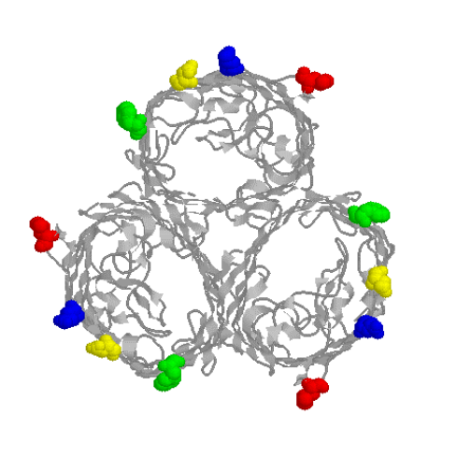
Initially reconstitution of the cysteine containing mutants was performed as for wild type OmpF in the presence of 1 mM DTT, but this resulted in aggregates of different morphology than the large vesicles normally observed. SDS-PAGE analysis after reconstitution revealed that dimers, trimers and higher molecular weight aggregates were formed, most likely due to disulphide bridge formation between different vesicles in the preparation. Apparently DTT is not potent enough to keep the cysteines reduced; in addition the two sulfhydryl moieties of DTT interfere with subsequent cross-linking and therefore a more suitable reductor had to be found. Tris(2-carboxyethyl)phosphine (TCEP) appeared an appropriate candidate, since according to the manufacturer and some early reports in the literature it is unreactive towards thiol-reactive compounds such as maleimides. Indeed no disulphide bridge formation was observed after reconstitution in the presence of 1 mM TCEP, but unfortunately preliminary experiments already showed that also the cross-linking reaction did not proceed. This is in agreement with more recent publications^{53,54}, that describe the interference of TCEP with reactions of protein thiols. To further our insight in the reaction we incubated TCEP with the dye 2-(4’-maleimidylanilino)napthalene-6-sulfonic acid (MIANS), a compound that exhibits an increase in fluorescence after reaction of the maleimido moiety. In the absence of protein we observed a rapid and large increase of fluorescence, strongly indicating covalent attachment of MIANS to TCEP. Since the reactive groups of the dye and the thiol-specific cross-linkers are the same, and TCEP is present in large excess in the cross-linking reaction mixture, this explains why the cross-linking reactions did not proceed. The problem was solved by decreasing the TCEP concentration in the dialysis buffers to 15 μM, a concentration that is still sufficient to keep the cysteines reduced during the reconstitution, even though the sulfhydryl concentration is around 25 μM. This apparent discrepancy can be explained by the large reservoir of TCEP provided by the large volume(at least 100-fold larger than the sample volume) and frequent changes of dialysis buffer that are used during the procedure.
Figure ‎0.11 The positions that were chosen to introduce single cysteines in the sequence: Leu147 (red), Glu183 (blue), Asn223 (yellow) and Phe267 (green).
In order to test the accessibility and reactivity of the cysteine residues of both solubilised and reconstituted mutants OmpF L147C and E183C were treated with MIANS as described above. Subsequent analysis on SDS-PAGE yielded a clearly visible fluorescent band at the position of trimeric OmpF, which was confirmed by staining with Coomassie Brilliant Blue. We can conclude that the cysteines are both accessible and reactive towards sulfhydryl specific reagents.
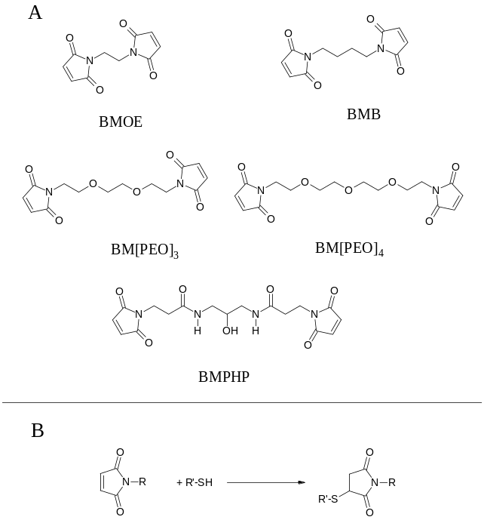
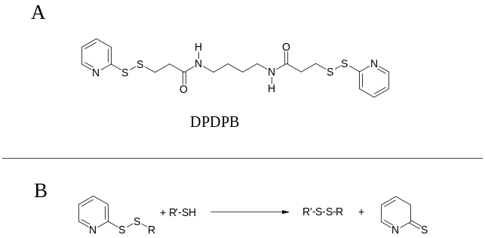
The results described above set the stage for site-directed cross-linking of OmpF to obtain robust membranes. The proteins can be reconstituted in high protein to lipid ratios in membranes and the chemistry is under control. For the cross-linking reactions, a set of homo-bifunctional sulfhydryl-specific cross-linkers was selected that varied in spacer arm length and water solubility. Five water soluble maleimide derivatives were used (Figure 2.12A): 1,2-bis-maleimidoethane (BMOE, spacer arm length 8.0 Å), 1,4-bis-maleimidobutane (BMB, 10.9 Å), 1,8-bis-maleimidotriethyleneglycol (BM[PEO]₃, 14.7 Å), 1,11-bis-maleimidotetraethyleneglycol (BM[PEO]₄, 17.8 Å), and N,N’-bis(3-maleimidopropionyl)-2 –hydroxy-1,3-propanediamine (BMPHP, about 18 Å). The use of maleimide derivatives for protein modification is described extensively in literature. Reaction with sulfhydryl groups at pH 6.5-7.5 generates a stable 3-thiosuccinimidyl ether linkage (Figure 2.12B). The 2-pyridyl-disulfide derivative 1,4-di[3’-2’-pyridyldithio)propionamido]butane (DPDPB, 19.9 Å, Figure 2.13A) is insoluble in aqueous buffers, and is therefore dissolved in ethanol. This cross-linker reacts with free sulfhydryl groups at pH 6.5-7.5 to form mixed disulphide conjugates with release of 2-pyridylthione (Figure 2.13B). The use of this compound has the advantage that the cross-linking product can be cleaved back to the original sulfhydryl groups with reducing agents such as DTT, and therefore offers an extra tool for cross-linking analysis. The cross-linker 1,6-hexane-bis-vinylsulfone (HBVS, 14.7 Å, Figure 2.14A) is also insoluble in water, and is dissolved in DMF before use. Conjugation chemistry is based on a Michael addition of the free sulfhydryl to the vinylsulfone moiety at pH 8.0 (Figure 2.14B), which is a slightly weaker electrophile than maleimide.
Figure ‎0.12 Chemical structures of maleimide-based homobifunctional sulfhydryl-specific cross-linkers (A) and their cross-linking chemistry (B).
Figure ‎0.13 Chemical structures of maleimide-based homobifunctional sulfhydryl-specific cross-linkers (A) and their cross-linking chemistry (B).
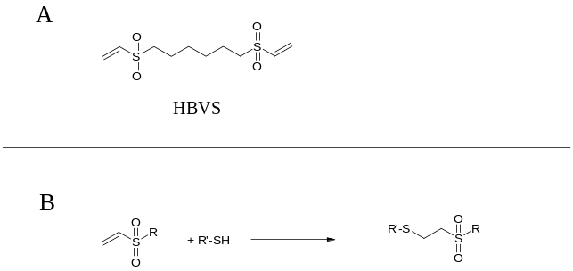
The general procedure for the cross-linking reactions was as follows: 20 μM of the bi-functional cross-linker was incubated with 0.5 mg/ml OmpF (corresponding to 13 μM of free sulfhydryls) in the presence of 25 μM TCEP at 37 °C for 3 h. Except for HBVS (pH 8.0), all reactions were carried out in 0.1 M NaP_{i} buffer, pH 7.0. After incubation, samples were analysed on 10% SDS-PAGE gels. This procedure was adopted after initial optimisation with two of the mutants, OmpF L147C and E183C.
Figure ‎0.14 Chemical structure of 2-pyridyl disulfide-based homobifunctional sulfhydryl-specific cross-linker DPDPB (A) and its cross-linking chemistry (B).
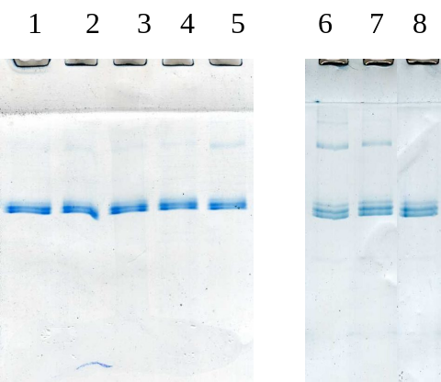
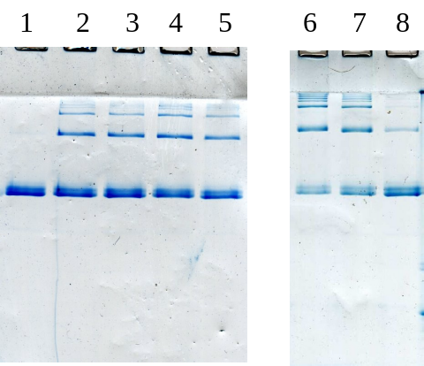
Figure 2.15 shows the results of cross-linking reactions of OmpF L147C and E183C mutants using the set of 7 cross-linkers. Data obtained with OmpF L147C mutant clearly showed that, except for the cross-linkers with a relatively short spacer arm (BMOE and BMB), cross-linking did not succeed. For the OmpF E183C mutant, results were significantly better. Reaction with all cross-linkers, except HBVS, resulted in the formation of higher molecular weight compounds (dimers of trimers, trimers of trimers, etc.). For OmpF N223C and F267C mutants, results were similar to those obtained with E183C (data not shown).
Further information on the nature of the cross-linking was obtained from determining the kinetics of the reaction and comparing the results before and after boiling in 1% SDS to break the non-covalent interactions that hold the trimers together. After cross-linking the mutants for 3 h, a significant amount of unreacted trimers is still present in the cross-linking mixture, but longer reaction times (up to 24 h) did not increase the cross-linking yield (not shown). Figure 2.16 shows the effect of boiling for 10 min in 1% SDS of cross-linked OmpF E183C mutant (reacted with BMOE, BMB and HBVS) before SDS-PAGE analysis. Both unfolded monomers and dimers can be observed, with the former being present in concentrations equal to the concentration unreacted trimers prior to boiling. This shows that no intramolecular cross-linking (i.e. between chains in the same trimer) occurs, since in that case a higher concentration of unfolded dimer would be expected. This is in agreement with the fact that the distances between individual cysteines in the trimer molecule (ca. 6 nm) are much larger than the length of the linker (≤ 2 nm)
Figure ‎0.15 Cross-linking of the OmpF L147C (left) and E183C (right) mutants, analyzed on SDS-PAGE. The mutant (0.5 mg/ml) was treated with 20 µM of BM[PEO]₃ (lane 2), BM[PEO]₄ (lane 3), BMPHP (lane 4), DPDPB (lane 5), BMOE (lane 6), BMB (lane 7), and HBVS (lane 8). Lane 1 shows the control incubation.
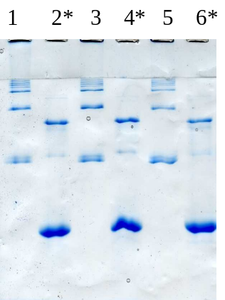
The effects of varying the concentration of cross-linker was tested using cross-linkers with either a relatively short (BMOE) a long spacer arm (BM[PEO]₄). Cross-linker concentrations ranging from 10 to 450 μM were used and the results were unexpected. Figure 2.17 shows the results obtained with BMOE. The cross-linking yield was about the same for 20-450 μM cross-linker (i.e. excess cross-linker), whereas 10 μM (excess sulfhydryl) clearly resulted in a lower yield, independent of the length of the linker. Apparently, the reaction kinetics are such that after reaction of a sulfhydryl with one maleimide of the bi-functional cross-linker, the second maleimide reacts much faster with a sulfhydryl in close proximity, excluding reaction with another cross-linker molecule. The effects of varying protein (or rather, aggregate) concentration on the cross-linking yield was studied over the interval 0.25–0.75 mg/ml protein. SDS-PAGE analysis revealed that the yields were not significantly altered. Although the concentration interval is small, this is still an important observation, since higher yields at higher protein concentrations could indicate that unwanted intermembrane cross-linking occurs during the reaction.
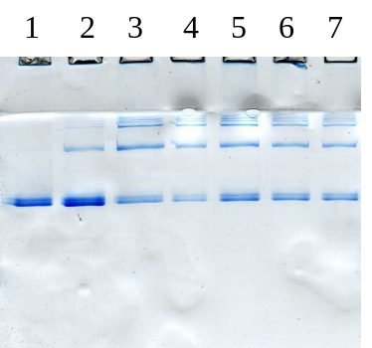
In theory it is possible that the aggregates we observe after the cross-linking reaction result from oxidation of sulfhydryls to disulphide bridges, occurring after the reductor TCEP has reacted with the cross-linker. To eliminate this possibility, OmpF E183C was cross-linked with BM[PEO]₃, BM[PEO]₄, BMPHP and DPDPB and subsequently incubated with a large excess of DTT (100 μM). SDS-PAGE analysis (Figure 2.18) of these samples showed that only in the case of DPDPB, i.e. the covalent attachment via disulphide bridging, DTT was able to break the covalent links between the trimers. These results strongly suggest that in the case of the other three compounds thio-ethers have been formed between the protein and the cross-linker, a connection that is stable towards DTT.
Figure ‎0.16 Effect of boiling for 10 min in 1% SDS (labelled with a *) on BMOE- (lanes 1 and 2), BMB- (lanes 3 and 4), and HBVS-cross-linked OmpF E183C mutant, analyzed on SDS-PAGE.

Figure ‎0.17 Effect of BMOE concentration on cross-linking of OmpF E183C mutant, analyzed on SDS-PAGE. Lane 1: control, lane 2: 10 µM, lane 3: 20 µM, lane 4: 50 µM, lane 5: 112 µM, lane 6: 225 µM, lane 7: 450 µM BMOE.
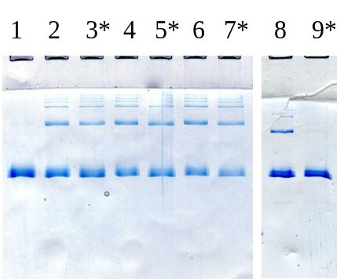
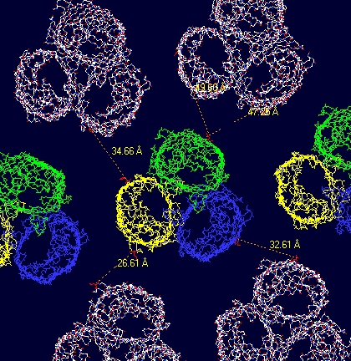
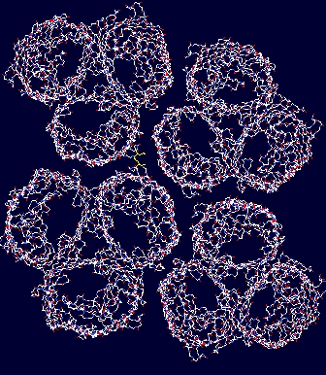
The results described above can be understood if the orientation and position of the trimer with respect to other trimer molecules in the two-dimensional crystal is taken into account. OmpF is known to crystallise in a number of different crystal forms of which the 9 nm hexagonal form we have found in our EM studies (see section 2.3) is only one (²⁷, ⁵⁵, ⁵⁶). Other crystal forms that have been observed are hexagonal crystals with lattice parameters of 8 and 7 nm respectively and a rectangular lattice with a = 7.9 nm and b = 13.7 nm. We have modelled a number of these and determined the distances between the different cysteines in the crystal. In the 9 nm hexagonal crystal the shortest cysteine-cysteine distance is 2.7 nm (Fig 2.19 A) and is found for the mutant at the 147 position. Nonetheless we find that this mutant is the most difficult to cross-link, and then only when we use short linkers (0.8 or 1.1 nm). Distances for the other mutants in this crystal form are all longer than 3 nm, so we conclude that cross-linking OmpF in this crystal form using these mutants and cross-linkers is impossible. However, it is known that under the conditions we use for the crystallisation a second, rectangular, lattice is also formed but at lower occurence²⁷ (Fig. 2.19 B). In this crystal the distances between cysteines are not the same in all directions (like they are in the hexagonal lattices) but the shorter distances are roughly between 0.5 and 2 nm, i.e. in the range that can be bridged by the cross-linkers given their length. Moreover, the shortest distance (0.5 nm) is again found between positions 147 in different molecules, and this explains why cross-linking this mutant is more successful using the shorter rather than the longer linkers: the longer linkers are simply to long and bulky to sample the immediate surroundings of their primary attachment site efficiently enough to give a high yield for the secondary reaction to occur at high yield. On the basis of these considerations and results obtained by ourselves and others we tentatively conclude that the cross-links we observe occur in the rectangular crystal form. Unfortunately this lattice form is only present in a minority of the crystals being formed, but experimental methods to control the lattice formation are available to remedy this.
Figure ‎0.18 SDS-PAGE analysis of the effect of 100 µM DTT after cross-linking of OmpF E183C mutant with BM[PEO]₃ (lanes 2 and 3), BM[PEO]₄ (lanes 4 and 5), BMPHP (lanes 6 and 7), and DPDPB (lanes 8 and 9). Lane 1: control.
In conclusion, the above experiments have shown that we are able to cross-link OmpF reconstituted in membranes, using specific sites in the protein and commercially available sulfhydryl-specific -functional cross-linkers. The extent of cross-linking depends mainly on the position of the sulfhydryl in the protein structure, the type of chemistry, the length of the linker and (in all likelihood) the crystal form of the two-dimensional protein lattice. This evaluation is based mainly on results obtained by SDS-PAGE, but we are currently gathering more detailed information using different techniques.
Figure ‎0.19 Models of the hexagonal (a = 9 nm, left) and rectangular crystal forms of (a= 7.9 nm, b = 13.7 nm, right) formed by OmpF. The distances between the individual molecules are are clearly larger in the hexagonal crystal form.

Manipulating the functionality of OmpF

Apart from the stability and robustness of the membranes we are developing, we are also aiming for control of their functionality. This can be achieved by gaining control over the functionality of the channel, i.e. conductance, selectivity and gating. We are focusing on the last two of these issues, and although a separate section is devoted to each, in reality these aspects can not be separated so easily. For example, mutations that alter selectivity will also change the conductance and might very well affect the gating transition. The current layout of the text is however convenient since it reflects the rationale behind the experimental design and the methods that are used to reach the goal.

Manipulating selectivity

Recent calculations and simulations have yielded strong indications that selectivity of ion channels is to a large extent determined by the charge carried by the protein in the constriction area and the volume available to counterions in the same area to balance the total charge (see e.g. ^{12,57,58}). For example, the first clues were obtained on a simplified model of L-type Ca²⁺-channels that have a very distinctive EEEE-locus, i.e. an area where four negative charges are packed together closely. Eight oxygens bearing a combined total charge of –4 where brought together in a limited volume comparable to the volume found in the lumen of naturally occurring channels. Four positive charges are needed to balance these in a very limited space, and since only two Ca²⁺-ions are needed to achieve this (which fits in the available space) but four Na⁺-ions (which doesn’t fit), the ‘channel’ can discriminate between these two species. To compare the results from these theoretical studies with an actual channel protein, we have designed an OmpF mutant based on this principle that is expected to have an increased selectivity for Ca²⁺.
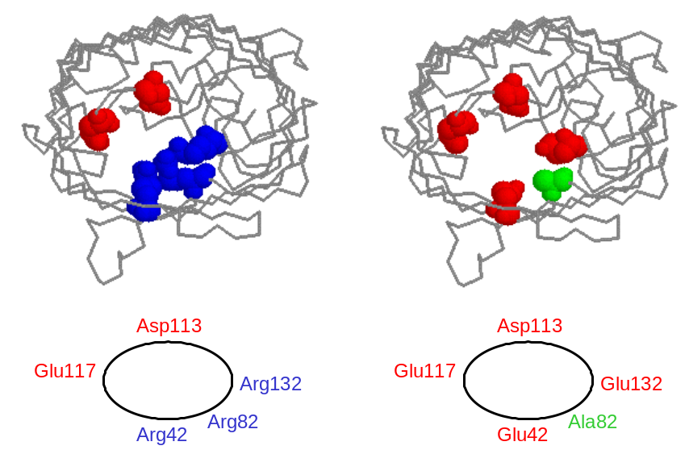
The constriction zone of OmpF is a highly charged area where three arginines (positively charged, at positions 42, 82 and 132), an aspartate (113) and a glutamate (117) (Figure 2.20) are present in close proximity. To increase the selectivity of the channel for Ca²⁺ the three arginines are replaced by two glutamates (positions 42, 132) and an alanine (82) to create a constellation with an expected net charge of –4 and reminiscent of the EEEE-locus in Ca²⁺-channels mentioned above. In addition a mutant with a net charge of –2 (alanines at positions 42, 82 and 132) was designed for reasons of comparison.
Figure ‎0.10 Arrangement of charged groups in the constriction zone of wild type (left) and mutant OmpF designed for increased Ca²⁺-selectivity

The constructs for the expression and purification of these proteins have been obtained and the mutations were confirmed by DNA sequencing. Purification of these proteins by the method described in section 2.1 has so far been difficult, mainly due to problems with the expression system we are employing. We are currently in the process of solving these problems and expect to be able to test the selectivity and conductivity of the channels very soon.

Manipulating gating

Although both the structure of OmpF and the gating transitions (cf. Figure 2.6) have been known for a long time, the structural basis for the transition has remained elusive. A large number of mutants have been constructed and tested by electrophysiological means, focusing on three important areas: the constriction zone (^{18,20,23,24}), the interface between the eyelet loop and the β-barrel²³ and loop L2 in the subunit interface²⁶. In all of these cases the critical voltage for closing V_{c}, i.e. the potential difference where the conductivity of an ensemble of OmpF molecules starts to deviate clearly from Ohmic behavior, is above 100 mV and largely unaltered from the WT.
The only structural information on the gating transition of OmpF comes from atomic force microscopy studies of the extracellular side of two-dimensional OmpF crystals^{59,60}. Large changes in the morphology of the crystal surface were observed at low pH or after applying a large transmembrane potential compared to neutral pH. Reconstruction of the surfaces on the basis of the X-ray structure of the protein suggest a conformational change that can best be described as a rotation of the extracellular domain of the porin around a hinge on the rim of the barrel. In its new position the extracellular domain covers the access to the channel, much like the lid on a pedal bin, and presumably blocks solute transport through the protein.
Antibiotic resistance of Gram-negative bacteria (such as E. coli) is in general a combination of two factors: a permeability barrier separating the drug from its intended target, and when this barrier is breached, a degradation and/or efflux mechanism to neutralise or export the harmful compound⁶¹. In the case of E. coli in combination with β-lactam class antibiotics the barrier is the outer membrane (β-lactams interfere with cell wall synthesis in the periplasmic space) and permeability is regulated through the embedded porins. Since the kinetics of efflux or degradation of the antibiotic are usually much slower than transport across the outer membrane (i.e. removal of the antibiotic is the rate-determining step), selection of permeability mutants on the basis of antibiotic resistance is not possible. However, if the degradation or efflux is very efficient, as is the case for enzymatic degradation of many β-lactams, permeation of the outer membrane becomes the rate determining step that dictates the effective concentration of the antibiotic in the periplasmic space. So by using an E.coli strain that expresses OmpF as the only porin in the outer membrane in combination with a suitable antibiotic, conditions can be manipulated such that the viability of the cells depends critically on transport of the antibiotic through the lumen of OmpF, with a higher chance of survival if transport is impaired. This property can be used to select those molecules that have a high probability of being in a closed state (as opposed to open state normally encountered for the WT protein) from a library of randomly mutated clones of OmpF.
The method described above was implemented with the specific aim of finding mutants that are in the closed conformation, i.e. where the ‘lid’ is closed. The antibiotic we selected as most suitable for screening OmpF mutants is cephalotin (Figure 2.25). The minimum concentration of this antibiotic that blocks growth of E.coli (the minimal inhibitory concentration or MIC) decreases from 128 mg/ml for strains not expressing OmpF in the outer membrane to 4 mg/ml for strains expressing the protein⁶². Unfortunately the resistance marker we use on the plasmid carrying the ompF gene in our system is for another antibiotic of the β-lactam class, ampicillin, and thus encodes for a β-lactamase. This fact complicates the implementation of the method and interpretation of our results to a large extent and therefore the ampicillin marker was exchanged for a tetracycline resistance marker, resulting in the plasmid pGompF-Tet. Selection is now performed in media containing both tetracycline (to ensure expression of OmpF) and cephalotin (to check the permeation), conditions for which the MIC of cephalotin were unknown. This was determined by plating out 5 μl of cell cultures of E.coli with (i.e. expressing OmpF) and without the plasmid (i.e. not expressing OmpF) on plates containing various concentrations of cephalotin, and counting the number of colonies that are able to grow. The results are shown in table 2.1 and clearly indicate that expression of OmpF in the outer membrane results in an increased sensitivity towards the antibiotic cephalotin and that media containing between 5 and 20 μg/ml cephalotin can be used for selection of OmpF mutants with the desired properties.

cell | Concentration cephalotin (μg/ml)
cell | 0 | 5 | 10 | 20 | 30 | 40 | 50
Omp8 | nd | lawn | 20 | 5 | 0 | 0 | 0
Omp8 + pGompF-Tet | lawn | 0 | 0 | 0 | 0 | 0 | 0
Table ‎0.1 Sensitivity of E. coli Omp8 cells towards the antibiotic cephalotin in the presence and absence of OmpF in the outer membrane

Random mutations were introduced into the OmpF sequence using error prone PCR. In this method the DNA encoding the protein sequence of OmpF is amplified using a DNA polymerase that has been tuned (by a combination of mutagenesis and reaction conditions) to make random errors during replication. These errors result in mutations in the DNA sequence that in turn, depending on the position of the nucleotide and the nature of the change, can lead to mutations in the primary protein sequence. The mutation frequency, but not position, can be controlled to some extent by varying the concentration of template and primers in the reaction, the number of amplification cycles, reaction temperature etc. The final result is a mixture of DNA molecules, some of them mutated in random (and unknown) positions
The initial procedure we employed to arrive at the desired mutants consisted of five major steps:

- generate a mutation library by error prone PCR on the Ompf gene isolated from the expression plasmid,
- re-introduction (ligation) of the library into the expression plasmid pGompF-Tet,
- transformation of Omp8 cells with the plasmid library,
- selection of surviving clones on plates containing 5-20 μg/ml cephalotin and
- DNA sequencing to identify the mutations.

This method was used to screen clones obtained after one, two or three rounds of error prone PCR (in a consecutive round DNA obtained from the preceding round was taken as the template rather than WT-encoding DNA). The results indicated that there was a problem with our method, originating from the fact that cells that do not express OmpF in their outer membrane will also survive the screen. Consequently, the clones that were identified contained stop codons early in the sequence or were otherwise incomplete, so that full length protein was not produced and ‘gain of function’ mutants could not be identified.
To remedy the problem outlined above we introduced an additional step that allows us to select clones that express functional protein in the outer membrane. The method is based on the specific recognition of OmpF by antibodies raised against the protein in rabbits. The library of cells is treated with these antibodies and then magnetic beads coated with a secondary antibody are added. Only cells expressing OmpF will attach to the beads via the primary-secondary antibody interaction, and these can be simply separated from the rest by introduction of a magnetic field to hold the beads and removal of the supernatant. These cells can then be replated on selective plates, i.e. plates containing cephalotin, and mutants identified.
The first results of this method are currently becoming available. Seven selected mutants have been sequenced, but as a result of the extra selection step that was necessary not all colonies are unique. So far we have identified three unique sequences containing 9, 6 and 6 mutations, respectively, compared to the WT. Of these mutations 5, 2 and 2 were ‘silent’, meaning a mutation in the DNA, but not the protein sequence, arising from the redundancy in the genetic code. A preliminary analysis indicates that in all three cases at least one mutation is near the constriction zone of the channel, introducing bulky groups into the channel lumen to block the flow of the antibiotic. It is interesting to note that one of the mutations we found, Gly119Asp, is a well known modification influencing channel conductivity and was in fact also selected in an earlier and similar random mutagenesis and screening experiment³¹. Although this is not the result we are aiming for, it clearly shows that mutants with impeded flow of solutes through the OmpF channel can be selected by this method. We are currently sequencing other clones to obtain further information on the amino acids that are important for the permeability and gating transitions of the channel.

Outlook

The research goal within this project is to prepare a robust and controllable ion-selective membrane based on naturally occurring channel proteins and therefore the results described in the previous chapter should be considered in this light. The research efforts fall apart in two major directions, nl stabilising the membrane via protein cross-linking and control of the functionality of the channel protein. Both aspects will be discussed below.

Cross-linking

The experimental approach we have chosen towards building a robust and ion-selective membrane based on channel proteins as outlined in section 1.4 is

- overexpression and purification in high yields of OmpF
- characterisation of the newly purified protein to ensure proper folding and functionality
- reconstitution in membranes and two-dimensional crystallisation
- development of cross-linking methods
- production of two-dimensional cross-linked sheets
- characterisation of the two-dimensional cross-linked membranes in terms of stability and ion transport.

Of these, steps 1 to 4 have been completed successfully and we are currently working towards achieving 5 and 6. One of the main problems we have to contend with is the low yield of the cross-linking reaction (see e.g. figure 2.16). This result is largely independent of the specific mutant and cross-linker being used in the reaction and probably reflects the fact that in the majority of the two-dimensional crystals the distances between individual OmpF molecules embedded in the lattice are too large for the cross-linkers to span. A number of different strategies are possible to solve this.
The simplest solution for the low yields is the use of longer cross-linkers that are able to sample at a larger distance for a complementary reactive group. There are however a number of drawbacks on this: longer cross-linkers increase the risk of unwanted side-reactions, such as intramolecular or intermembrane cross-links. Furthermore, these cross-linkers are not commercially available and therefore will have to be custom-designed, synthesised and tested before they can be used with the membranes. A related strategy is to use a two-step reaction: in the primary reaction a cross-linker is attached to the proteins in such a way that one reactive group is left free and, after removal of the excess cross-linker, two of these free groups are cross-linked via a complementary bi-functional compound. This approach however suffers from the same shortcomings, and therefore other methods need to be considered.
An alternative strategy to using longer cross-linkers is to bring the individual molecules in the crystal lattice closer together. This process can occur spontaneously, e.g. when large hexagonal crystals are stored at 4 ºC. Over a period of months the hexagonal lattice slowly changes to the rectangular form, a crystal that has a tighter packing⁵⁵ and thus shorter distances between the molecules. A much faster method to achieve a similar transition is lipid digestion by phospholipase, a process that is typically finished after overnight incubation of the preparation with the enzyme⁶³. In the case of OmpF crystals this invariably leads to hexagonal crystals with a lattice parameter of 7 nm, independently from the crystal form that is initially present, and therefore probably represents the crystal form with the closest possible packing. Modelling of this crystal form indicated for example that Leu147 (or Cys147 in the mutant) is within 0.5 nm of two other Leu147 on other molecules, a distance that can be overcome easily by the cross-linkers we are using. Because of its generality and ease of use this method is probably the best way of going forward and is therefore currently being implemented in the lab.
An OmpF molecule embedded in a two-dimensional crystal of hexagonal symmetry has six neighbours, all removed by the same distance from the three-fold symmetry axis in the centre of the molecule (see e.g. figure 2.19). In the ideal case (with respect to stabilisation) a cross-link is formed with each of these molecules, meaning that a total number of six cross-links need to protrude from one OmpF molecule. If cysteine-specific cross-linkers are being used, this means that at least six mutations per molecule are needed, which, since OmpF is a trimer, corresponds to two cysteines per polypeptide chain. So far we have only used single-site mutants, and therefore an obvious way to further increase the cross-linking yield is to introduce second cysteines at positions that will be close in the crystal to the sulfhydryls already introduced in an earlier stage of the project. An alternative and elegant approach based on the same principle, i.e. one chain of the trimer cross-links to two other monomers in different molecules, is to use tri-functional cross-linkers for identical sites on three different proteins that come together closely, such as the 147 position mentioned above.
In conclusion, further progress in this direction will be achieved by manipulating the crystal lattice to our advantage in combination with increasing the potential for cross-linking introducing cysteines at strategic positions. This will increase the number of sites of attachment and decrease the distance between them and as a result the yield of the cross-linking reaction will increase. The resulting membranes can then be analysed for stability using thermal denaturation and membrane rupture measurements and for ion transport and selectivity properties by electrophysiological techniques such as patch clamping.

Functionality

Apart from being able to construct a robust membrane, control over the function of the membrane, in the current context defined as selectivity and gating, is essential to build a useful device. For the membranes we are building this means gaining control of the function of the embedded protein by mutagenesis or chemical modification of the channel. So far we have been focussing on the former of the two.
The selectivity mutant we have designed and constructed is based on the results of theoretical studies on Ca²⁺-selectivity in ion channels. Unfortunately the Arg42Glu/Arg82Ala/Arg132Glu (EAE) triple mutant is not yet available in sufficiently pure form to be able to analyse the electrophysiological properties of the channel, and further progress in this area awaits this. The same goes for the related Arg42Ala/Arg82Ala/Arg132Ala (AAA) mutant, designed for reasons of comparison. The combination of electrophysiological characterisation of these mutants and further theoretical studies (e.g. PNP) should further our insight in the determinants of ion selectivity in OmpF, and how to manipulate this in our favour.
The issue of the structural basis of the gating of OmpF is still not resolved, even though the structure of the protein has been known for nearly 10 years. Several hypotheses have been put forward and tested but none has been proven conclusive. We have developed a random mutagenesis and screening procedure to attempt to address this problem. The method works by coupling viability of the E.coli cell to a reduced permeability of the OmpF channel. The first results show that proteins with mutations introducing bulky groups in the constriction zone of the channel lumen, known to impede solute flow, are indeed being selected. This proves the method works and now needs to be optimised to deliver the desired result, meaning impeded flow of solutes caused by mutations structurally far removed from the constriction zone.
The method we have chosen to introduce the mutations, error prone PCR, allows precise manipulation of the part of the polypeptide chain that is susceptible to random mutations. The part of the gene that is being amplified in the reaction is determined through the primers, pieces of complementary DNA that function as a starting point of the DNA polymerase. These pieces are custom made for every reaction and are thus under complete experimental control. By choosing a part of the gene that excludes the eyelet region (L3 loop) and the opposing wall of the β-barrel for mutagenesis, something that can be done readily in the Ompf gene, constriction zone mutants can be excluded and the search for the desired mutants simplified.
In conclusion, the studies into the structure-function relations of OmpF, and how to manipulate these are in progress. Definite results are not yet available but are expected in the near future. An alternative method for functionalising OmpF is chemical modification, an activity we are also planning to set-up. Based on the experience we have gained from the cross-linking reactions, modification is expected to be straightforward and allows the introduction of ‘foreign’ functionalities, e.g. binding moieties, preferably at positions that will modulate the conductivity of the channel.

References

1. Cowan,S.W. et al. Crystal structures explain functional properties of two E. coli porins. Nature 358, 727-733 (1992).
2. Chang,G., Spencer,R.H., Lee,A.T., Barclay,M.T. & Rees,D.C. Structure of the MscL homolog from Mycobacterium tuberculosis: a gated mechanosensitive ion channel. Science 282, 2220-2226 (1998).
3. Doyle,D.A. et al. The structure of the potassium channel: molecular basis of K+ conduction and selectivity. Science 280, 69-77 (1998).
4. Berneche,S. & Roux,B. Energetics of ion conduction through the K+ channel. Nature 414 , 73-77 (2001).
5. Zhou,M., Morais-Cabral,J.H., Mann,S. & MacKinnon,R. Potassium channel receptor site for the inactivation gate and quaternary amine inhibitors. Nature 411, 657-661 (2001).
6. Morais-Cabral,J.H., Zhou,Y. & MacKinnon,R. Energetic optimization of ion conduction rate by the K+ selectivity filter. Nature 414, 37-42 (2001).
7. Zhou,Y., Morais-Cabral,J.H., Kaufman,A. & MacKinnon,R. Chemistry of ion coordination and hydration revealed by a K+ channel- Fab complex at 2.0 A resolution. Nature 414, 43-48 (2001).
8. Sun,Y. et al. Mechanism of glutamate receptor desensitization. Nature 417, 245-253 (2002).
9. van der Straaten,T.A., Eisenberg,R.S., Tang,J.M., Ravaioli,U. & Aluru,N. Three-dimensional Poisson-Nernst-Planck simulation of OMPF porin. Biophysical Journal 80, 519 (2001).
10. Eisenberg,R.S. From structure to function in open ionic channels. Journal of Membrane Biology 171, 1-24 (1999).
11. Hollerbach,U., Chen,D.P., Busath,D.D. & Eisenberg,B. Predicting function from structure using the Poisson-Nernst- Planck equations: Sodium current in the gramicidin A channel. Langmuir 16, 5509-5514 (2000).
12. Nonner,W., Catacuzzeno,L. & Eisenberg,B. Binding and selectivity in L-type calcium channels: A mean spherical approximation. Biophysical Journal 79, 1976-1992 (2000).
13. Schulz,G.E. beta-Barrel membrane proteins. Curr. Opin. Struct. Biol. 10, 443-447 (2000).
14. Schirmer,T. General and specific porins from bacterial outer membranes. J. Struct. Biol. 121, 101-109 (1998).
15. Schulz,G.E. Porins: general to specific, native to engineered passive pores. Curr. Opin. Struct. Biol. 6, 485-490 (1996).
16. Samartzidou,H. & Delcour,A.H. E-coli PhoE porin has an opposite voltage-dependence to the homologous OmpF. Embo Journal 17, 93-100 (1998).
17. Van Gelder,P. et al. Voltage sensing in the PhoE and OmpF outer membrane porins of Escherichia coli: role of charged residues. J. Mol. Biol. 269, 468-472 (1997).
18. Schirmer,T. & Phale,P.S. Brownian dynamics simulation of ion flow through porin channels. J. Mol. Biol. 294, 1159-1167 (1999).
19. Ermishkin,L.N. & Mirzabekov,T.A. Redistribution of the electric field within the pore contributes to the voltage-dependence of mitochondrial porin channel. Biochim. Biophys. Acta 1021, 161-168 (1990).
20. Saint,N. et al. Structural and functional characterization of OmpF porin mutants selected for larger pore size. II. Functional characterization. J. Biol. Chem. 271, 20676-20680 (1996).
21. Van Gelder,P., Saint,N., van Boxtel,R., Rosenbusch,J.P. & Tommassen,J. Pore functioning of outer membrane protein PhoE of Escherichia coli: mutagenesis of the constriction loop L3. Protein Eng 10, 699-706 (1997).
22. Saxena,K., Drosou,V., Maier,E., Benz,R. & Ludwig,B. Ion selectivity reversal and induction of voltage-gating by site- directed mutations in the Paracoccus denitrificans porin. Biochemistry 38, 2206-2212 (1999).
23. Phale,P.S. et al. Voltage gating of Escherichia coli porin channels: role of the constriction loop. Proc. Natl. Acad. Sci. U. S. A 94, 6741-6745 (1997).
24. Phale,P.S. et al. Role of charged residues at the ompf porin channel constriction probed by mutagenesis and simulation(,). Biochemistry 40 , 6319-6325 (2001).
25. Liu,N., Samartzidou,H., Lee,K.W., Briggs,J.M. & Delcour,A.H. Effects of pore mutations and permeant ion concentration on the spontaneous gating activity of OmpC porin. Protein Eng 13, 491-500 (2000).
26. Phale,P.S. et al. Stability of trimeric OmpF porin: the contributions of the latching loop L2. Biochemistry 37, 15663-15670 (1998).
27. Dorset,D.L., Engel,A., Haner,M., Massalski,A. & Rosenbusch,J.P. Two-dimensional crystal packing of matrix porin. A channel forming protein in Escherichia coli outer membranes. J. Mol. Biol. 165, 701-710 (1983).
28. Schindler,H. & Rosenbusch,J.P. Matrix protein from Escherichia coli outer membranes forms voltage- controlled channels in lipid bilayers. Proc. Natl. Acad. Sci. U. S. A 75, 3751-3755 (1978).
29. Bainbridge,G., Mobasheri,H., Armstrong,G.A., Lea,E.J. & Lakey,J.H. Voltage-gating of Escherichia coli porin: a cystine-scanning mutagenesis study of loop 3. J. Mol. Biol. 275, 171-176 (1998).
30. Iyer,R. & Delcour,A.H. Characterization of molecular properties of modulators of the E-coli OmpF porin. Biophysical Journal 74, A320 (1998).
31. Jeanteur,D. et al. Structural and functional alterations of a colicin-resistant mutant of OmpF porin from Escherichia coli. Proc. Natl. Acad. Sci. U. S. A 91, 10675-10679 (1994).
32. Karshikoff,A., Spassov,V., Cowan,S.W., Ladenstein,R. & Schirmer,T. Electrostatic properties of two porin channels from Escherichia coli. J. Mol. Biol. 240, 372-384 (1994).
33. Lou,K.L. et al. Structural and functional characterization of OmpF porin mutants selected for larger pore size. I. Crystallographic analysis. J. Biol. Chem. 271, 20669-20675 (1996).
34. Nestorovich,E.M., Winterhalter,M. & Bezrukov,S.M. Ampicillin translocation through OmpF studied on a single channel level. Biophysical Journal 80, 576 (2001).
35. Nikaido,H. & Rosenberg,E.Y. Porin channels in Escherichia coli: studies with liposomes reconstituted from purified proteins. J. Bacteriol. 153, 241-252 (1983).
36. Philippsen,A. et al. Imaging the Electrostatic Potential of Transmembrane Channels: Atomic Probe Microscopy of OmpF Porin. Biophys. J. 82, 1667-1676 (2002).
37. Garavito,R.M. & Rosenbusch,J.P. Isolation and crystallization of bacterial porin. Methods Enzymol. 125, 309-328 (1986).
38. Prilipov,A., Phale,P.S., Van Gelder,P., Rosenbusch,J.P. & Koebnik,R. Coupling site-directed mutagenesis with high-level expression: large scale production of mutant porins from E. coli. FEMS Microbiol. Lett. 163, 65-72 (1998).
39. Driessen,A.J., Fekkes,P. & van der Wolk,J.P. The Sec system. Curr. Opin. Microbiol. 1, 216-222 (1998).
40. Surrey,T., Schmid,A. & Jahnig,F. Folding and membrane insertion of the trimeric beta-barrel protein OmpF. Biochemistry 35, 2283-2288 (1996).
41. Luckey,M. & Nikaido,H. Specificity of diffusion channels produced by lambda phage receptor protein of Escherichia coli. Proc. Natl. Acad. Sci. U. S. A 77, 167-171 (1980).
42. Luckey,M. & Nikaido,H. Diffusion of solutes through channels produced by phage lambda receptor protein of Escherichia coli: inhibition by higher oligosaccharides of maltose series. Biochem. Biophys. Res. Commun. 93, 166-171 (1980).
43. Nikaido,H., Nikaido,K. & Harayama,S. Identification and characterization of porins in Pseudomonas aeruginosa. J. Biol. Chem. 266, 770-779 (1991).
44. Hanke,W. & Schlue,W.R. Planar lipid bilayers. Methods and applications. Academic Press, London, (1993).
45. Miller,C. Ion channel reconstitution. (1986).
46. Eisenberg,R.S. Channels as enzymes. J. Membr. Biol. 115, 1-12 (1990).
47. Mathes,A. & Engelhardt,H. Voltage-dependent closing of porin channels: analysis of relaxation kinetics. J. Membr. Biol. 165, 11-18 (1998).
48. Mathes,A. & Engelhardt,H. Nonlinear and asymmetric open channel characteristics of an ion- selective porin in planar membranes. Biophys. J. 75, 1255-1262 (1998).
49. Rigaud,J.L., Pitard,B. & Levy,D. Reconstitution of membrane proteins into liposomes: application to energy-transducing membrane proteins. Biochim. Biophys. Acta 1231, 223-246 (1995).
50. Watts,A. Bacteriorhodopsin: the mechanism of 2D-array formation and the structure of retinal in the protein. Biophys. Chem. 55, 137-151 (1995).
51. Peters,K. & Richards,F.M. Chemical cross-linking: reagents and problems in studies of membrane structure. Annu. Rev. Biochem. 46, 523-551 (1977).
52. Azem,A., Shaked,I., Rosenbusch,J.P. & Daniel,E. Cross-linking of porin with glutardialdehyde: a test for the adequacy of premises of cross-linking theory. Biochim. Biophys. Acta 1243, 151-156 (1995).
53. Shafer,D.E., Inman,J.K. & Lees,A. Reaction of Tris(2-carboxyethyl)phosphine (TCEP) with maleimide and alpha-haloacyl groups: anomalous elution of TCEP by gel filtration. Anal. Biochem. 282, 161-164 (2000).
54. Getz,E.B., Xiao,M., Chakrabarty,T., Cooke,R. & Selvin,P.R. A comparison between the sulfhydryl reductants tris(2- carboxyethyl)phosphine and dithiothreitol for use in protein biochemistry. Anal. Biochem. 273, 73-80 (1999).
55. Dorset,D.L., Massalski,A.K. & Rosenbusch,J.P. In-plane phase transition of an integral membrane protein: nucleation of the OmpF matrix porin rectangular polymorph. Proc. Natl. Acad. Sci. U. S. A 86, 6143-6147 (1989).
56. Hoenger,A., Gross,H., Aebi,U. & Engel,A. Localization of the lipopolysaccharides in metal-shadowed reconstituted lipid porin membranes. Journal of Structural Biology 103, 185-195 (1990).
57. Nonner,W. & Eisenberg,B. Ion permeation and glutamate residues linked by Poisson-Nernst- Planck theory in L-type calcium channels. Biophysical Journal 75, 1287-1305 (1998).
58. Nonner,W., Gillespie,D., Henderson,D. & Eisenberg,B. Ion accumulation in a biological calcium channel: Effects of solvent and confining pressure. Journal of Physical Chemistry B 105, 6427-6436 (2001).
59. Schabert,F.A., Henn,C. & Engel,A. Native Escherichia coli OmpF porin surfaces probed by atomic force microscopy. Science 268, 92-94 (1995).
60. Muller,D.J. & Engel,A. Voltage and pH-induced channel closure of porin OmpF visualized by atomic force microscopy. J. Mol. Biol. 285, 1347-1351 (1999).
61. Nikaido,H. Prevention of drug access to bacterial targets: permeability barriers and active efflux. Science 264, 382-388 (1994).
62. Curtis,N.A., Eisenstadt,R.L., Turner,K.A. & White,A.J. Porin-mediated cephalosporin resistance in Escherichia coli K-12. J. Antimicrob. Chemother. 15, 642-644 (1985).
63. Mannella,C.A. Mitochondrial outer membrane channel (VDAC, porin) two-dimensional crystals from Neurospora. Methods Enzymol. 125, 595-610 (1986).

