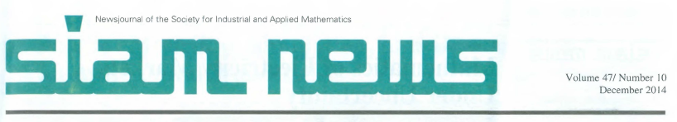

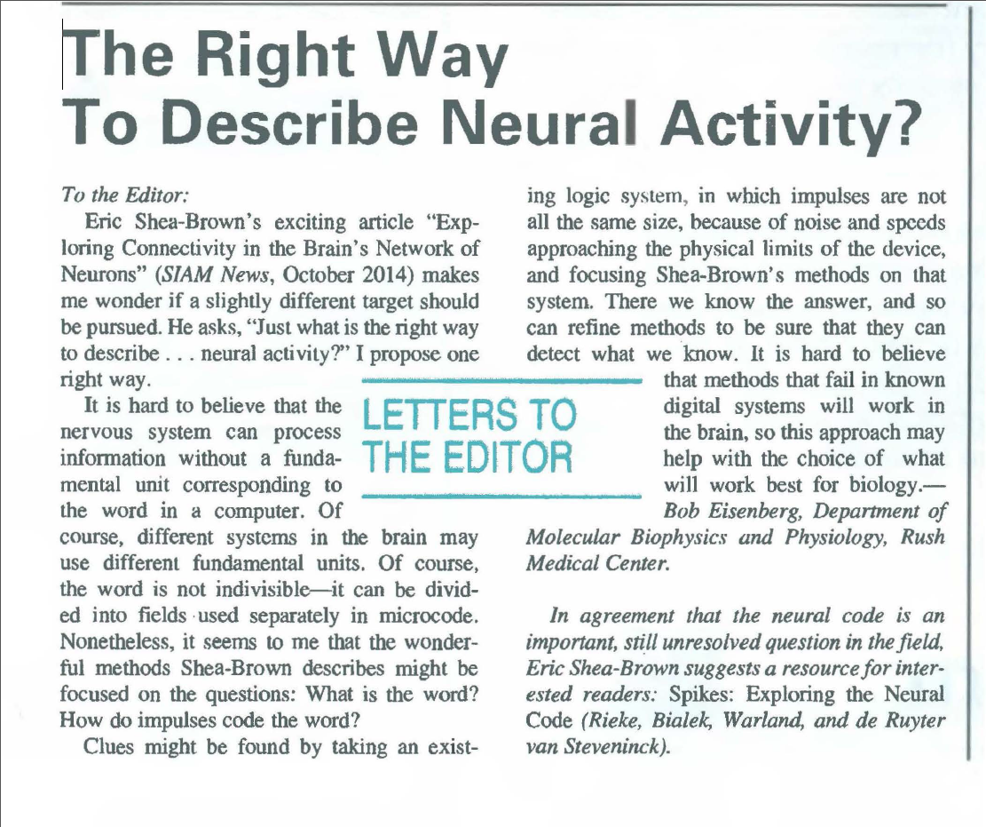

Ss

DECEMBER 2014 SIAM NEWS p.5