There are laws, ….. and there are laws
The Laws of Science can be vague, precise, or even wrong

Scientific laws are sometimes vague, sometimes precise. Scientific laws are often landmarks of scientific revolutions, marking new knowledge of the world around and within us, as our measurements get better, and our ability to analyze them. Scientific laws are usually learned early in our careers before critical skills mature, before we learn to referee grants and papers. It is easy to use scientific laws uncritically that have been learned when we are young, even if they have been outgrown.
I write to discuss two scientific laws: conservation of charge, and conservation of mass. Both seem precise laws of science—not limited landmarks—and in historical context certainly were precise laws. Both laws are so widely used they might be called part of the foundations of their fields, chemistry and physics. Chemistry uses mass conservation in the form of the law of mass action to describe chemical reactions and binding. Physics uses conservation of charge almost everywhere, including in the form of Kirchoff’s current law that the flow of charge is continuous. Current flows without loss. Electrical engineering, and circuit analysis and design of the digital devices make continual use of Kirchoff’s laws. Without Kirchoff’s laws, no integrated circuits, no digital devices, none of the computers, smart phones, and digital video devices that have remade our world
Biological systems involve both chemical reactions and charge and so must deal with both the law of mass action and the continuity of current. Biological systems are always embedded in ionic solutions, and nearly always involve chemical reactants and enzymes with electrical charge. Substrates that react catalyzed by enzymes are usually charged and are always embedded in solutions containing the ‘bio-ions’ Na⁺, K⁺, Ca²⁺, and Cl⁻. But there is a problem. Conservation of matter does not imply conservation of charge.
The laws conflict. Charge does not appear in the law of mass action so charge cannot be conserved by the law of mass action (when used as usual, with rate constants that are constant, or even when rate ‘constants’ are functions that depend only on local conditions). In my view, the law of mass action must be extended before it can deal with charges nearly always present in biological systems.
The reasons for the conflict of laws are both historical and logical. Historically, the law of mass action was developed with perfect gases in mind, in which infinitely dilute uncharged atoms are the chemical reactants. Charge does not appear as a variable in such equations. Logically, flow of charge cannot be continuous, without loss, if charge does not appear as a variable at all. Charge is not conserved by the law of mass action.
Biochemical reactions occur in sequence in one dimension in the schemes. Conservation of charge implies that the current flowing through these schemes is identical in each reaction: the flow of charge is continuous without loss. Interruptions in current flow in one place must be able to interrupt a chemical reaction somewhere else, even if those places are far apart. This is a property of Kirchoff’s current law familiar to all who have wired up a circuit. Chemical reaction reactions in sequence are independent of each other in the sense that the rate constants of one reaction are independent of those in another. The flows of mass in reaction schemes are independent of flows in other reactions or at other locations. If those masses are charged, flow of charge cannot be continuous. Kirchoff’s current law is violated.
The law of mass action needs to be extended so current flow in sequential reactions are equal, so interrupting current flow in one reaction in the sequence will stop current flow in all of them. I argue that the law of mass action needs to include the global properties of the electric field, using appropriately general mathematics, for example, field theories and variational principles.
Conservation of Charge. Physicists teach that conservation of charge is universally true, exact from very small to very large scales and very small times to very large times. Even the Casmir effect of quantum physics {Reynaud, 2014 #25157} is seen as a property of Maxwell’s equations by some {Jaffe, 2005 #25156}. What physicists often do not teach clearly is that charge is an abstract idea. Charge in one physical system is quite different from charge in another. Charge flow is not simply the physical movement of particles of definite mass and charge. Current is not just the movement of ions or electrons.
The essential idea is that charge flow is continuous (without loss) no matter what the physical nature of the charge.

Charge Is Abstract, with Different Physics In Different Systems
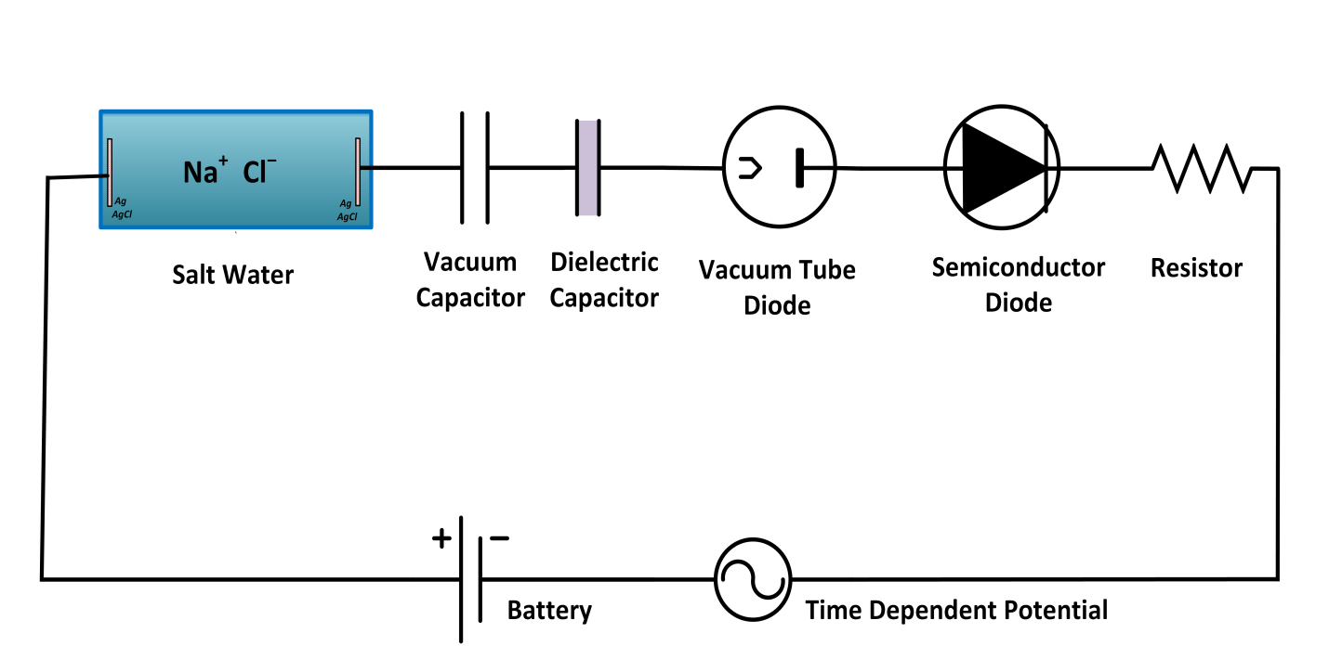

Consider Fig. 1. Here we study time varying currents in a sequence of devices.
Let’s start at low frequencies with the ionic conductor, shown as a cylinder containing Na⁺Cl⁻. Here current flow (at a frequency say of 1 Hz) is indeed almost entirely the physical movement of charged particles, of ions, say sodium and chloride ions in the example shown.
Now, let’s move to a vacuum capacitor, in which the space between the two plates is completely empty of matter (as it would be in outer space for example). The current flow through this capacitor is just as real as the movement of ions in the cylinder of Na⁺Cl⁻ even though no mass moves at all. The displacement current between the plates of the capacitor is a property of the electric field itself, as explained in textbooks of electricity and magnetism (e.g., {Zangwill, 2013 #24847}{Joffe, 2010 #25161}). This current is just as real as current carried by ions; it induces a magnetic field. Indeed, without such current Maxwell’s equations cannot account for the propagation of sunlight through the vacuum of space.
If we move along to the real capacitor in Fig. 1 (involving a material dielectric), current flow is more complex involving the effect of an applied electric field on the distribution of electric charge intrinsic to the dielectric. (‘Intrinsic’ here means the distribution of charge present when there is no applied electric field.) Electric fields applied to dielectrics are strong enough to reorient asymmetrical molecules and distort the distribution of electrons inside molecules and atoms. Charges only move a small amount, reminiscent of the ocean tides on the earth created by the moon’s gravitational field but those small movements produce large forces. Intrinsic charges do not move from plate to plate in a real capacitor. The current that flows from plate to plate and within the dielectric is a displacement current, the sum of the vacuum displacement current and the material displacement current produced by the distortion of intrinsic charges. Calculating this material displacement current involves the solution of a nonequilibrium time dependent version of the Schrödinger equation that is often approximated by an ideal dielectric with properties independent of field strength. (The reader should note however that few materials, and nothing in water solutions, have dielectric coefficients constant over the time range from atomic motion 10⁻¹⁵ sec to the biological time scale of say 10⁻³ sec.
The physical nature of displacement current is very different indeed from the movement of ions in water and from the vacuum displacement current carried by the change (with time) of the electric field. The ionic conductor, the vacuum capacitor and the dielectric capacitor have different forms of charge and charge movement through it. Charge is indeed an abstraction with different physical meaning and description (following different ‘laws’) in each device. Charge is an abstraction with a different relationship between current, voltage, and time in each case, a different ‘constitutive’ equation. In each different constitutive equation, charge is conserved. Charge always flows without loss. These abstract properties of charge are always true, but the ‘laws’ describing current as a function(al) of time and potential (for example) depend on the physical nature of the charge and its movement. The laws of course incoporate the cardinal fact that interrupting current flow in one reaction (of a sequence of reactions) will interrupt current flow in every other reaction (in that sequence) even if the atomic scale reaction (scale = 100 Å picometers) is meters away from the interruption.

NOTES: practical consequences, in models involving multiple pathways of current, flowing in parallel across a membrane limited cell or organelle, Kirchoff’s current law will itself INDEPENDENT OF MECHANISTIC DETAILS force correlations of fluxes that have been used to characterize transporters for many years (Hodgkin, 1951).

