LOYOLA UNIVERSITY CHICAGO

RYANODINE RECEPTOR FUNCTION IN INTRACELLULAR
CALCIUM SIGNALING

A DISSERTATION SUBMITTED TO
THE FACULTY OF THE GRADUATE SCHOOL
IN CANDIDACY FOR THE DEGREE OF
DOCTOR OF PHILOSOPHY

PROGRAM IN NEUROSCIENCE

BY

YIWEI LIU

CHICAGO, ILLINOIS

AUGUST 2008

Copyright by Yiwei Liu, 2008
All rights reserved.

ACKNOWLEDGEMENT

I give my deep thanks to my advisor, Dr. Michael Fill, for his mentorship and leadership in my Ph.D. education. During these past years, he has been of guidance and example both in science and life. His dedication to science and the continuous pursuit of knowledge are indeed inspiring and admirable, and his guidance and encouragement are essential to the completion of this dissertation.
I would also like to thank Dr. Charles Webber for his kind advice and encouragement through these years. His kindness and generosity is truly a blessing. I would also like to thank other members of my committee, Dr. Edward J. Neafsey, Dr. Julio Copello and Dr. Josefina Ramos-Franco for their time, efforts and invaluable expertise.
I also give special thanks to the people in Dr. Fill’s lab. It was a great pleasure to work with Alma, Maura, Jia Qin and Sarah. I thank them for providing me a scientific environment and a warm family. Without their inspiration this research would not have been possible. My most sincere appreciation is extended to my Chinese friends at Loyola University Medical Center for all their support and friendship.
Finally, I would like to thank my parents, Bingzheng Liu and Hui Yang, my wife, Zhihong Hu, my parents-in-law, Zhichun Hu and Yongling Qian, and my children Jinghan Joshua and Jingchun Matthew, for their unconditional love and continuous support.

To my parents, my wife Zhihong and my two wonderful sons,
Jinghan Joshua and Jingchun Matthew.

TABLE OF CONTENTS

ACKNOWLEDGEMENT iii
TABLE OF CONTENTS vi
LIST OF FIGURES x
LIST OF TABLES xii
LIST OF ABBREVIATIONS xiii
I. INTRODUCTION 1
II. REVIEW OF RELATED LITERATURE 6
A. Ca²⁺ channels and their characters 6
B. Neuronal Ca²⁺ signaling 8
1. Ca²⁺ is a key second messenger 8
2. The sources of intracellular Ca²⁺ signals 9
C. Intracellular calcium stores 11
D. Ryanodine receptors 13
Structure of RyR channel 15
E. Regulation of RyR channel 19
1. Cytosolic Ca²⁺ 19
2. Lumenal Ca²⁺ 21
3. ATP/Mg 23
4. Calmodulin 25
5. Calsequestrin 25
6. FKBP 27
F. Pharmacological modulators of RyRs 28
1. Ryanodine and ryanoids 28
2. Caffeine 30
3. Scorpion Toxins 32
4. Other Agents 32
G. Permeation of ryanodine receptor single channel 33
H. Subconductance state properties of single RyR channel 38
III. MATERIALS AND METHODS 42
A. Reagents and Drugs 42
B. Sarcoplasmic reticulum vesicles preparations 42
C. Phospholipid bilayers technique 44
D. Chambers and Septum 46
E. Phospholipids 47
F. Recording setup 48
G. Solutions 49
H. Data Analysis 51
1. Po analysis 52
2 Dwell open and close time analysis 53
3. Recurrence quantification analysis (RQA) 54
IV. Ca²⁺ SENSITITY OF RYR CHANNEL UNDER DIFFERENT CONDITIONS 59
A. Introduction 59
B. Specific Materials & Methods 60
Single RyR2 Channel Recording 60
C. Results 61
D. Discussion 68
V. FLUX DEPENDENT LUMENAL Ca²⁺ REGULATION 70
A. Introduction 70
B. Specific Materials & Methods 71
1. Microsome Preparation and single channel recording 71
2. Recurrence quantitative analysis (RQA) 72
3. Modeling of Ca²⁺ Permeation & Diffusion 73
C. Results 74
1. Flux-Dependent RyR2 Regulation 74
2. Flux Dependent Inhibition of Single RyR2 Channel Activity 82
3. Flux-Dependent RyR2 Regulation at Physiological Flux Amplitudes 87
D. Discussion 90
1. Regulation by a Luminal RyR2-resident Ca²⁺ Regulatory Site 93
2. Flux-Dependent Regulation of Single RyR2 Channels 94
3. Nonlinear dynamics analysis of open dwell time series of RyR channel 97
4. Cytosolic Buffer Alters Flux-Dependent Regulation 99
5. Distance of Cytosolic Inhibition & Activation Sites from RyR2 Pore 101
6. Physiological role of flux regulation in cells 101
VI. SIMILAR ALTERATION RYR2 SELECTIVITY FILTER 104
INDUCED BY DIVERSE PHARMACOLIGICAL AGENTS 104
A. Introduction 104
B. Specific Materials and Methods 107
C. Results 108
1. Conductance of drug modified channel 108
2. Reversal potential of drug modified channel 111
VII. SUMMARY 116
A. Cytosolic single RyR2 channel Ca²⁺ sensitivity at quasi-physiological condition 117
B. Flux-dependent regulation of single RyR2 channels 119
REFERENCE LIST 123
VITA 137

LIST OF FIGURES

Figure 1 The structure of Ryanodine and Ryanodol 30
Figure 2 Cartoon depicting the pore structural features of the KcsA K+ channel and RyR channel 37
Figure 3 The bilayer setup 47
Figure 4 Example of open probability analysis using half-amplitude threshold method adapted and modified from (Laver 2001). 52
Figure 5 Example of a dwell time series. 56
Figure 6 Example of constructing recurrence plot 57
Figure 7 Channel function was modified by ryanodol. 62
Figure 8 RyR channel activity at different Ca²⁺ concentration when lumenal Ca²⁺ is 50 mM. 63
Figure 9 RyR channel activity at different Ca²⁺ concentration when lumenal Ca²⁺ is 10 mM 64
Figure 10 Cytosolic RyR2 Ca²⁺ Sensitivity Depends Mg/ATP and lumenal Ca²⁺ level. 65
Figure 11 Effect of Ca²⁺ current on Ryanodine receptor channel activity. 75
Figure 12 Example of recurrence plot of dwell open time series and shuffled open dwell time 77
Figure 13 RQA of Dwell time of RyR channel 80
Figure 14 Flux Dependent Inhibition of Single RyR2 Channel Activity. 83
Figure 15 Cytosolic Ca²⁺ Inhibition Site is 4.1 nm from the Pore. 85
Figure 16 Flux Dependent regulation at Physiological Flux Amplitudes. 88
Figure 17 Structure of agents modifying conductance. 107
Figure 18 Example of subconductance induced by different agents at 0 mV holding potential. 109
Figure 19 Reversal potential of modified conductance by different agents. 113
Figure 20 Reversal potentials of subconductances induced by ryanodol and IpTx 114
Figure 21 Summary of selectivity of different conductances induced by agents 114

LIST OF TABLES

Table 1: Properties at a Mid-Range Cytosolic Ca²⁺ (3 μM) 67
Table 2: Cytosolic Ca²⁺ Titrations (Hill Parameters) 67

LIST OF ABBREVIATIONS

ADP adenosine diphosphate
AMPA alpha-amino-3-hydroxy-5-methyl-4-isoxazolepropionic acid
AMFE anomalous mole fraction effect
AMP adenosine monophosphate
ATP adenosine triphosphate
AMT Amitriptyline
BAPTA 1,2-Bis (2-aminophenoxy) ethane- N,N,N’,N’ -tetraacetic acid
BK channel large conductance Ca²⁺-activate K⁺ channel
Ca²⁺ calcium
[Ca]_{i} intracellular calcium concentration
CaM calmodulin
CaMKII calcium/calmodulin-dependent protein kinase II
CSQ Calsequestrin
CHO cells Chinese Ovary cells
CICR calcium-induced-calcium-release
DAG diacylglycerol
DHP 1,4-dihydropyridines
DHPR dihydropyridine receptor
DiBrB di-bromo 1,2-Bis (2-aminophenoxy) ethane- N,N,N’,N’ -tetraacetic acid
DMSO dimethyl sulfoxide
DTT dithiothreitol
EC₅₀ half effective concentration
E-C coupling excitation-contraction coupling
EGTA ethylene glycol bis (β-aminoethyl ether)-N,N,N⁺,N⁺-tetra acetic acid
ER endoplasmic reticulum
FKBP FK-506 binding protein
HEPES [2-Hydroxyethylpiperazine-N-[ethanesulfonic acid]
IP3 inositol 1,4,5-trisphosphate
IP3R Inositol triphosphate receptor
IC₅₀ half maximal inhibitory concentration
I_{Ca} sarcomlemmal L-type calcium current
I_{m} membrane currents
K_{d} dissociation constant
LTP Long-Term Potentiation
LTD Long-Term Depression
Mg²⁺ Magnesium
NMDA N-methyl-D-Aspartic Acid
PKA protein kinase A
P_{o} open probability
%DET Percent determinism
%LAM Percent laminarity
PC phosphatidylcholine
PKC cAMP-dependent protein kinase C
PE phosphatidylethanolamine
PLB phospholamban
PS phosphatidylserine
RP reversal potential
RQA Recurrence quantification analysis
RyR ryanodine receptor
SEM standard error of mean
SERCA sarcoplasmic/endoplasmic reticulum calcium-ATPase
SR sarcoplasmic reticulum
TFP Trifluoperazine
t-tubule transverse tubule
VDCC Voltage-dependent calcium channels

CHAPTER I

INTRODUCTION

Ca²⁺ is a very important intracellular signal that regulates many different cellular processes. Many reactions within brain and in excitable cells generally are regulated, directly or indirectly, by Ca²⁺. A rise in the concentration of Ca²⁺ in the cytosol triggers many types of events such as muscle contraction, exocytosis (e.g. secretion of hormones like insulin) and a variety of biochemical changes mediated by Protein Kinase C (PKC). Ca²⁺ also plays an important role both in fertilization (Stricker 1999), cell proliferation (Berridge 1995) and cell apoptosis. In neurons, Ca²⁺ can regulate excitability, neuronal motility, such as axonal guidance, dendrite arborization and synaptic plasticity such as Long-Term Potentiation (LTP) and Long-Term Depression (LTD) (Collin, Marty et al. 2005).
In many cases, Ca²⁺ entering through either voltage-gated Ca²⁺ channels or receptor-operated channels at the surface membrane, acts as a trigger for the activation of Ca²⁺ release from the internal Ca²⁺ store (primarily specialized regions of the smooth ER). This process is called Ca²⁺ induced Ca²⁺ release (CICR). In neurons, Ca²⁺ can enter through different voltage gated Ca²⁺ channels and receptor operated channels, such as N-methyl-D-Aspartic Acid (NMDA) receptor or alpha-amino-3-hydroxy-5-methyl-4-isoxazolepropionic acid (AMPA) receptor. Intracellular Ca²⁺ signals can also arise from Ca²⁺ released from intracellular Ca²⁺ stores - endoplasmic reticulum (ER) or sarcoplasmic reticulum (SR) through ryanodine receptor (RyRs) and/or inositol 1,4,5-trisphosphate (IP3) receptors Ca²⁺ release channels.
Ryanodine receptors are large, high conductance Ca²⁺ release channels that control the level of intracellular Ca²⁺ by releasing Ca²⁺ from the intracellular compartment. The RyRs are ubiquitously expressed in the body and are involved all the myriad of phenomena briefly described above. Ryanodine receptor are regulated by many agents, including divalent cations, adenine nucleotides, calmodulin (CaM), caffeine, oxidation, FK-506 binding protein (FKBP), Calsequstrin, Homer and phosphorylation/dephosphorylation (Fill and Copello 2002).
The Ca²⁺ sensitivity of RyR is a key factor in the initiation and propagation of many intracellular Ca²⁺ signals. Single RyR channel attributes are generally defined in simple solutions designed to optimize the signal-to-noise ratio of the measurement. However, they are rarely defined in salt solutions like those found in cells. Nevertheless, the RyR mediated CICR is an intuitively a self-reinforcing process, with inherent positive feedback, and should ultimately empty the intracellular Ca²⁺ store. But this never happens in cells. There must be some negative–feedback mechanisms which counter the inherent positive feedback and stops Ca²⁺ release. In 1985, Fabiato proposed that high affinity Ca²⁺ dependent inactivation is the negative feedback which stabilizes the CICR process (Fabiato 1985) . To date, the existence and/or role of Ca²⁺ dependent inactivation is actively debated (Bers 2001; Fill and Copello 2002).
The ability of the RyR channel to mobilize intracellular Ca²⁺ depends on both its permeation and gating properties. Its key permeation properties include unitary conductance and ion selectivity. The permeation properties of the different RyR channel isoforms are quite similar and similar to that of IP3R channels. Knowledge gained about the permeation characteristics of one of these channels will likely apply to all of them. The RyR channels are permeable to many different divalent and monovalent cations. However, in comparison with surface membrane channels, such as Ca²⁺, sodium or potassium channels, our understanding of these permeation properties in RyR is inadequate.
The overall objective of this study is to define some basic properties of ryanodine receptor channels such as their Ca²⁺ regulation in physiological conditions, how (or if) a Ca²⁺ flux passing through an open RyR pore feeds back and modulates gating of the channel as well as the potential functional consequences of the channel’s selectivity/permeability. This is important because these RyR properties are points where RyR-mediated Ca²⁺ release may be modulated and are therefore potential sites of pathological failure and therapeutic intervention. The hypotheses of my project are: 1.Single RyR2 channels are modulated by Ca²⁺ feeding though their own pore. 2. Pharmacological agents that can alter the permeation of ryanodine receptor do so by changing the RyR pore to one of two conformations with different ion selectivity.
To test these hypotheses, t

he first part of this dissertation defines the Ca²⁺ sensitivity of single type-2 RyR channels under quasi-physiological condition. Specifically, steady state RyR Ca²⁺ sensitivity is defined in solutions that more closely mimic the cellular condition. This information is ultimately used to provide the experimental context and explore the feed-through mechanism of RyR channels. The type-2 isoform is the predominant isoform of RyR in brain
, especially in hippocampus and cerebellum (Bouchard, Pattarini et al. 2003). It happens that the type-2 RyR is enriched in heart and is thus easy to isolate to isolate from cardiac muscle. I therefore used RyR2 channels isolated from heart in my studies here. Single RyR2 channels were incorporated into planar lipid bilayers and unit Ca²⁺ currents measured. In order to better understand the Ca²⁺ regulation, I defined cytosolic Ca²⁺ sensitivity in the presence of physiologically relevant concentrations of adenosine triphosphate (ATP) & Magnesium (Mg) (agents known to modulate RyR channels.)
The second part of this dissertation determines if the Ca²⁺ flux passing through an open RyR pore feeds back and modulates gating of the channel. Specifically, this study defines whether (or not) the Ca²⁺ passing through the channel (SR lumen-to-cytosol direction) interacts with cytosolic Ca²⁺ activation and/or inhibition sites. If cytosolic activation sites can be activated by Ca²⁺ efflux from SR lumen, then this would represent the most robust (difficult to counter) form of CICR. Therefore, defining its existence (and if it exists, its extent) is key to ultimately understanding the mechanisms that counter the RyR-mediated CICR process. My studies not only establish the existence of Ca²⁺ feed through regulation but also define its strength.
The third part of this dissertation determines the selectivity of drug-induced subconductance states of single RyR2 channels. The RyR channel is poorly selective compared to surface membrane voltage-dependent Ca²⁺ channels. Its poor selectivity means that multiple ions (not just Ca²⁺ but also Mg²⁺ and K⁺ which are abundant in cells) can pass through the pore. Since multiple ions can pass through the pore, these ions also compete for the occupancy of the pore and ultimately influence the permeation of each other. Consequently, changes in selectivity of the pore will influence how much Ca²⁺ passes through the pore (when these other permeable ions are present). Ryanodine is a pharmacological agent known to change RyR selectivity. When it binds to the RyR channel, it induces long-lived subconductance states. The list of agents that induce long-lived RyR subconductance states seems to be ever growing. Thus, I tested whether or not these rather diverse pharmacological agents have a common action on the permeation properties of the RyR pore. Specifically, I determined ion selectivity and conductance of the substates evoked by several pharmacologically diverse agents
. I found that the RyR2 has two conformations with different selectivity. The drugs tested (all the drugs tested) stabilize one of the two conformations. The other conformation is associated with the normal (not drug modified) channel.
The hope is that these results (as well as others not mentioned here) will increase our understanding of what defines the RyR Ca²⁺ flux and how this flux may modulate the activity (opening/closing) of the RyR channel.

CHAPER II

REVIEW OF RELATED LITERATURE

A. Ca²⁺ channels and their characters
Ca²⁺ is essential for living organisms, particularly in cell physiology, where movement of the Ca²⁺ ion into and out of the cytoplasm functions as a signal for many cellular processes, such as muscular contraction, excitation of neurons, up-regulation of gene expression, or release of hormones or neurotransmitters. A Ca²⁺ channel is an ion channel that displays selective permeability to Ca²⁺ ions. There are two types of Ca²⁺ channels, voltage and receptor-operated.
Voltage-dependent Ca²⁺ channels (VDCC) are a group of voltage-gated ion channels found in excitable cells (e.g., muscle, glial cells, neurons, etc.) with high selectivity for the ion Ca²⁺. The selectivity ratio of Ca²⁺/Na⁺ is more than 1000, which means Ca²⁺ is 1000 times more than sodium (Na⁺). Monovalent ions are more abundant than Ca²⁺, it is very important that Ca²⁺ channel have high selectivity of Ca²⁺ to assure that the channel conduct most Ca²⁺. The conductance of Ca²⁺ is much smaller than Na+, which means that Ca²⁺ ions pass through the pore at a lower rate than Na⁺ do. This can be explained by ion binding, so that ions with higher affinity for binding in the pore travel through it more slowly. Ca²⁺ has μM affinity with pore of VDCC, the higher affinity to the pore, the higher selectivity of channel to that ion (by comparison RyR pore has mM Ca²⁺ affinity) (Almers and McCleskey 1984; Matsuda and Noma 1984). At physiologic or resting membrane potential, VDCCs are normally closed, and opened at depolarized membrane potentials. Ca²⁺ channel operation generates 2 types of signals, changes in membrane potential and local elevations of [Ca²⁺]. Both of these signals control neurotransmitter release and activate intracellular responses.
Classic electrophysiological and cloning studies indicate that there are at least six functionally distinct types of voltage-gated Ca²⁺ channel, L-, N-, P-, Q-, R- and T-type (Tsien, Lipscombe et al. 1988; Varadi, Mori et al. 1995; Fletcher, Copeland et al. 1998; Catterall 2000). L-type Ca²⁺ channels are characterized by a large conductance, long lasting openings sensitivity to 1,4-dihydropyridines (DHPs) and activation at larger depolarization; T-type channels are characterized by a tiny conductance, transient openings, insensitivity to DHPs, and activation at more negative membrane potentials. N-type Ca²⁺ channels, predominantly found in neurons, are neither T nor L, and are intermediate in conductance and voltage dependence.
The receptor-operated Ca²⁺ channels are membrane glycoprotein complexes acting as Ca²⁺ channel activated by agents, including two main categories of intracellular Ca²⁺ channels: Inositol triphosphate receptor (IP3R) and Ryanodine receptors (RyRs). IP3R has a broad tissue distribution but is especially abundant in the cerebellum. Most of the IP3R's are found in the cell integrated into the endoplasmic reticulum. RyRs form a class of poorly Ca²⁺ selective channels in various forms of muscle and other excitable animal tissue, which is the major cellular mediator of Ca²⁺-induced Ca²⁺ release in animal cells. This study will focus on the Ryanodine receptor, and this type of Ca²⁺ channel will be discussed in detail below.

B. Neuronal Ca²⁺ signaling

1. Ca²⁺ is a key second messenger
Like in other cells, Ca²⁺ is a very important intracellular signal that regulates many different cellular processes in neurons. Generally speaking, within the brain and in excitable cells, Ca²⁺ regulates many reactions, such as skeletal muscle contraction; excitation-contraction coupling (E-C coupling), exocytosis, (e.g. secretion of hormones like insulin) and cell proliferation. Ca²⁺ also plays an important role both in cell proliferation (Berridge 1995), and apoptosis.
In neurons, Ca²⁺ regulates excitability by activating Ca²⁺ activated K⁺ channel and/or Ca²⁺ activated Cl⁻ channel, which ultimately modifies resting membrane potential. It has been shown that N-type Ca²⁺ channels, ryanodine receptor and large conductance Ca²⁺-activated K⁺ channels (BK channels) co-localize. It is thought that Ca²⁺ entry through N-type Ca²⁺ channels triggers Ca²⁺ release from RyR and activates BK channel to modulate post-spike after hyperpolarization. Ca²⁺ is also involved in regulation of neuronal motility, such as axonal guidance and dendrite arborization. In fact, the intracellular Ca²⁺ signals relevant for neurite outgrowth are produced by both Ca²⁺ entry and Ca²⁺ release more specifically via CICR (see below) process (Kocsis, Rand et al. 1994; Lankford, Rand et al. 1995). Still other results show that local CICR stabilizes dendrite formation during development and inhibition of this local Ca²⁺ release results in rapid retraction of dendrites (Lohmann, Myhr et al. 2002). In synapse, neurotransmitter release requires a large (up to 100 µM) local [Ca²⁺]_{i} concentration, and plasmalemmal Ca²⁺ entry (Bennett 1999). However, intracellular Ca²⁺ signals appears to be essential for synaptic plasticity such as LTP and LTD (Verkhratsky 2005). Lauri et al. reported that bath-applied ryanodine blocks the induction of an NMDA-independent form of LTP at mossy fiber–CA3 synapses, in which Ca²⁺ influx through presynaptic kainate receptors is proposed as the major trigger for CICR (Lauri, Bortolotto et al. 2003). Unni et al. (2004) showed directly the necessary role of presynaptic, but not postsynaptic, ryanodine-sensitive Ca²⁺ stores in the induction of NMDA receptor dependent LTD. They used two-photon laser scanning microscopy and found that release from the ryanodine-sensitive stores during prolonged synaptic stimulation generates a slowly rising Ca²⁺ signal in the presynaptic terminal that is required for the induction of LTD (Unni, Zakharenko et al. 2004). Specifically, intracellular Ca²⁺ signals may be involved in regulation of gene expression, neuronal plasticity and neuronal apoptosis (as elevated Ca²⁺ is associated with some neurodegenerative diseases) (Verkhratsky 2005).

2. The sources of intracellular Ca²⁺ signals
Ca²⁺ plays an important role in regulating a great variety of neuronal processes. Like other cells, neurons use both extracellular and intracellular sources of Ca²⁺. Ca²⁺ can enter neurons through different voltage gated Ca²⁺ channels. The N-type and P/Q-type Ca²⁺ channels play a predominant role in transmitter release at hippocampal synapses (Wu and Saggau 1994; Scholz and Miller 1995; Wheeler, Randall et al. 1996; Reid, Clements et al. 1997; Reid, Bekkers et al. 1998; Qian and Noebels 2001), cerebrocortical synapses (Mintz, Sabatini et al. 1995; Millan, Lujan et al. 2002) and calyx-type synapses (Wu, Westenbroek et al. 1999). R-type channels make a small contribution to evoked transmitter release in some preparations (Iwasaki and Takahashi 1998; Gasparini, Kasyanov et al. 2001) but play a more important role in synaptic plasticity (Dietrich, Kirschstein et al. 2003). Neuronal L-type Ca²⁺ channels play established roles in regulating gene expression, cell survival, and synaptic plasticity (Christie, Schexnayder et al. 1997; Deisseroth, Heist et al. 1998; Mao, Bonni et al. 1999; Weisskopf, Bauer et al. 1999). T-type Ca²⁺ channel mediates neuronal rebound burst firing, such as alpha rhythms (Llinas and Jahnsen 1982) and spindle waves (McCormick and Bal 1997). T-type Ca²⁺ channel is also believed controlling membrane excitability and occurs in thalamic reticular cells by activating Ca²⁺ gated potassium channel. In addition, T-type currents may strengthen local synaptic potentials and modulate synaptic efficacy (Magee, Christofi et al. 1995). Ca²⁺ can also enter neurons through receptor-operated channels, e.g. NMDA and some types of AMPA receptors preferring glutamate receptors.
Intracellular Ca²⁺ signals can arise from Ca²⁺ released from intracellular Ca²⁺ stores through ryanodine receptor and/or IP3 receptors Ca²⁺ release channels. As mentioned before, Ca²⁺ can be triggered to release through CICR process. The diffusion of Ca²⁺ within cells is greatly retarded by the presence of endogenous Ca²⁺ buffers. Then, the CICR process provides a means to amplify the buffer-damped intracellular Ca²⁺ signal from a microscopic localized event into a propagating global Ca²⁺ transient. This is important for Ca²⁺ to control many cellular activities because it has to reach targets that may be quite distant from the Ca²⁺ signaling initiation site (e.g. synapse to nucleus). Without CICR, cells would have to rely on the slow and highly dissipative process of Ca²⁺ diffusion.
Intracellular Ca²⁺ signals can also arise from the hydrolysis of phosphatidylinositol 4,5-bisphosphate which forms the second messengers diacylglycerol (DAG) and IP3. The latter compound acts by releasing Ca²⁺ from ER via the IP3 receptors (IP₃Rs). These Ca²⁺ release channels are widely distributed throughout the brain. More details about CICR, IP3, RyR and IP₃R are provided below.

C. Intracellular Ca²⁺ stores
The endoplasmic reticulum is the largest single intracellular organelle, which appears as a three-dimensional network formed by an endomembrane and organized in a complex system of microtubules and cisternae. In neurons, the ER extends from the nucleus and the soma to the dendritic arborization and, through the axon, to presynaptic terminals. The endoplasmic reticulum is a highly dynamic organelle that performs two major functions. In addition to synthesizing and packaging proteins, it also plays a central role in many signaling processes. A particularly important factor for neuronal function is the ability of the ER to actively accumulate Ca²⁺ and release them in response to physiological stimulation.
The general physiological properties of the ER Ca²⁺ store have been extensively characterized in a variety of excitable and non-excitable cells. The ER acts as a dynamic Ca²⁺ store due to concerted activity of Ca²⁺ channels and transporters residing in its membrane, the active Ca²⁺ pumps in its membrane and the Ca²⁺ -binding proteins in its lumen. These binding proteins serve as a high-capacity Ca²⁺ buffering system. The Ca²⁺ efflux from the ER is mediated by two families of intracellular Ca²⁺ release channels, which includes two kinds of primary Ca²⁺-gated Ca²⁺ channels: ryanodine receptors and InsP₃-gated channel -InsP₃ receptor (as mentioned before). Ca²⁺ accumulation into the ER lumen results from the activity of Ca²⁺ pumps from the Ca²⁺-ATPase (SERCA) family.
The coordinated function of ER Ca²⁺ channels, transporters and intra-ER Ca²⁺ storage proteins generates the dynamic Ca²⁺ signaling properties of the ER. Ca²⁺ accumulation in the ER lumen creates a large trans-ER Ca²⁺ driving force favoring Ca²⁺ efflux from the lumen into the cytosol. Thus, opening of Ca²⁺ channels in the ER membrane results in a fast Ca²⁺ efflux from the ER. The ER channels are subject to positive Ca²⁺ feedback due to their sensitivity to cytosolic Ca²⁺ and this can lead to a regenerative opening of RyRs and/or InsP₃Rs beyond a certain [Ca²⁺]_{i} threshold. This regenerative process underlies propagating Ca²⁺ waves along the ER membrane, and this process is somehow analogous to the propagating wave of opening and closing of Na⁺ and K⁺ channels associated with the plasmalemmal action potential. This similarity has led to the suggestion that neuronal function is an interplay of two “excitable” membranes, an outer and an inner, which are coupled to each other through a multitude of reciprocal signaling cascades. This has lead to the concept that ER acts as a neuron in neuron (Berridge 1998). In this view, plasmalemma is mostly specialized for integrating extracellular information while the ER, using Ca²⁺, couples plasmalemmal signals to cytosolic/intracellular like transport of proteins or changes in gene expression within the nucleus.

D. Ryanodine receptors
The Ca²⁺ release channels, the RyRs and the InsP₃Rs, are large tetrameric channel proteins that are located in ER (or SR in muscle) membrane. Here I will only focus on the ryanodine receptor. There are 3 isoforms of RyR, which were historically classified as "skeletal", "cardiac" and "brain" isoforms. These are also referred to as RyR1, RyR2, and RyR3, respectively. The historic classification had a certain physiological sense, as the RyR1 isotype is the predominant form in skeletal muscle. The RyR2 protein is the most abundant isoform in cardiac muscle, and the RyR2 protein is often referred to as the cardiac RyR isoform. RyR3 was first found in brain, but it is found in many other tissues, such as striated muscles and smooth muscles. The RyR1 in muscle possesses a rather unique activation mechanism as it can be activated by membrane depolarization through a direct physical linkage with a plasmalemmal voltage-dependent Ca²⁺ channel. However, all 3 RyR isoforms can be activated by Ca²⁺ from the cytosolic side. Although RyR3 was referred as the “brain” isoform, which is misleading, all 3 types of RyRs have been detected in neurons. The RyR1 is heavily expressed in cerebellar Purkinje neurons. The RyR3 is found in relatively high densities in the hippocampal structures, the corpus striatum, and the diencephalon (Ouyang, Deerinck et al. 1993; Furuichi, Furutama et al. 1994; Giannini, Conti et al. 1995). In general, the RyR2 isoform is the most widely expressed RyR isoform in neurons.
Many neurons coexpress either 2 or all 3 RyR isoforms. RyRs are found in high densities in neuronal somatas; in axons of hippocampal, cerebellar, and cortical neurons; in cerebellar mossy fibers; and in presynaptic terminals (Sharp, McPherson et al. 1993; Ouyang, Martone et al. 1997; Bouchard, Pattarini et al. 2003). The RyRs are also widely expressed in the dendritic tree; their expression is particularly high in dendritic spines of hippocampal CA1 neurons, where they are the dominant Ca²⁺ release channels (Sharp, McPherson et al. 1993).
The amplitude of single RyR channel current reveals the number of Ca²⁺ passing through the channel per second. The Po (P_{o}) of single RyR channels is an indication of how certain agonists and antagonists regulate the channel’s general opening and closing (gating). Dwell-open or close time analysis of single RyR channel activity reveals the durations of individual open and closed events. Kinetic studies of single RyR channel activity reveal how rapidly it can respond to a ligand stimulus (i.e., time constants and first latencies) as well as specific patterns of channel opening (i.e., modal gating or bursting behavior) (Fill and Copello 2002).
In order to study single RyR channel behavior, the most common way to incorporate the isolated RyR channel protein into artificial planar lipid bilayers. The artificial planar bilayer is formed across a small aperture that separates two solutions. A patch-clamp amplifier is used to monitor electrical signals that arise from the bilayer. The RyR channel protein is generally isolated from cells using a combination of homogenization and differential centrifugation. This generates microsomes that contain the RyR channels. These RyR-containing microsomes are then added to one side of the planar lipid bilayers in the presence of a trans-bilayer osmotic gradient. Over a period of time, one or more of these microsomes will spontaneously fuse with the planar lipid bilayers. This event is visualized as the sudden appearance of single RyR channel activity in the bilayer. This methodology is now widely used and has been described in detail elsewhere.

Structure of RyR channel
Mammalian RyR1, RyR2 and RyR3 protein share 66–70% of homology of overall amino acid sequence (Takeshima, Nishimura et al. 1989; Nakai, Imagawa et al. 1990; Hakamata, Nakai et al. 1992). Although the overall percentage identity of the three mammalian isoforms of RyR is high, their similarities are not equally distributed along the protein. There are 3 regions of marked divergence. These three regions are: D1 encompasses residues 4254 to 4631 in RyR1, 4210 to 4562 in RyR2 and 4100 to 4400 in RyR3. D2 is between 1342 and 1403 in RyR1 and between 1353 and 1397 in RyR2. D2 is absent in RyR3. D3 is between 1872 and 1923 in RyR1 and between 1852 and 1890 in RyR2. These regions are likely to correspond to isoform-specific regulatory sites, which are responsible for the specific properties of these channels and in fact many of the binding sites of modulators of RyR channel function have been mapped near or within them (Sorrentino, Barone et al. 2000). Splice variants have been described for the 3 isoforms and it is expected that these could further generate functional diversity between channels (Nakai, Imagawa et al. 1990; Zhang, Chen et al. 1993; Futatsugi, Kuwajima et al. 1995; Marziali, Rossi et al. 1996; Tunwell, Wickenden et al. 1996). However, the various isoforms of RyR exhibit extremely high percentage identity in the region running from the carboxyl-terminal end of D1 to the carboxyl-terminus of the molecule.
Sequence analysis shows that RyR proteins contain at least two functional domains. N-terminal cytoplasmic domain (about 4000 amino acids) is highly hydrated and is thought to have numerous cavities containing many of the regulatory/ligand binding sites. So this region is very important in the regulation of RyR function. C-terminal (about 1000 amino acids) region contains several hydrophobic domains, four of which form the transmembrane domains (M1–M4). One region located between M3 and M4, contributes to form the putative channel pore. Using site directed antibodies, it has been shown that the N- and C-terminal domains of RyR1 are localized in the cytoplasm and that two luminal segments are localized between transmembrane segments M1–M2 and M3–M4 (Takeshima, Nishimura et al. 1989; Grunwald and Meissner 1995).
Biochemical studies had initially shown that the functional RyR channel is a homotetramer composed of four monomers in a quatrefoil shape with a size of 22 to 27 nm on each side, and each subunit with a molecular weight of ~ 560 kDa. Four RyR1 monomers assemble as a homotetrameric complex with a molecular mass of 2.3 MDa, which makes it one of the largest ion channels. RyR has a vast tetrameric hydrophilic portion exposed to the cytosol and a smaller domain, which spans the SR membrane. This has been confirmed by cryoelectron microscopy and 3-D reconstruction studies (Radermacher, Rao et al. 1994; Serysheva, Orlova et al. 1995). These studies also revealed that RyR has a cylindrical domain of low density in the transmembrane region, with a diameter of about 2–3 nm. This region is considered as the Ca²⁺-conducting pore (Lai, Misra et al. 1989; Serysheva, Orlova et al. 1995; Sharma, Penczek et al. 1998). Electron cryomicroscopy observed some of the conformational change the RyR channels undergo during E-C coupling. The ice-embedded channels have been studied in conditions that promote the open state (Ca²⁺/ATP or Ca²⁺/ryanodine) or the closed state (Ca²⁺ /EGTA) (Orlova, Serysheva et al. 1996; Sharma, Jeyakumar et al. 2000). In the open conformation, the 4 clamp domains appear unlocked and the transmembrane region displays a central cavity that instead is absent in the close conformation. Also, in the ryanodine modified configuration the transmembrane domain is twisted by ~4° with respect to the position in the closed state and the total height of the channel increases by 10. Thus, RyR’s appear to open like an iris of a camera (Serysheva, Schatz et al. 1999). The 30-Å 3D reconstruction indicates that the activation of RyR channels takes place through larger scale conformational change rather than local changes. This is confirmed by the fact that mutation affecting channel gating (such as malignant hyperthermia and central core disease) occur not in the pore region, but in the N-terminal domain (McCarthy et al., 2000; Serysheva, 2004). A conserved sequence (GVRAGGGIGD) located between M3 and M4 transmembrane domains has been proposed to be part of the pore-forming segment of RyRs (Zhao, Li et al. 1999; Du, Guo et al. 2001). In particular, it has been shown that mutations of specific amino acid residues in this domain can modify channel conductance and result in altered pharmacological regulation of the channel with lack of ryanodine binding and altered caffeine response (Gao, Balshaw et al. 2000)
The cytoplasmic assembly, corresponding to the N-terminal region of the RyRs is constructed from 10 or more domains that are loosely packed together and some of them are themselves multidomain structures (Radermacher, Rao et al. 1994; Serysheva, Orlova et al. 1995; Wagenknecht, Radermacher et al. 1997; Sharma, Penczek et al. 1998). At corners of large cytoplasmic domain are the modulatory region of the receptor and contains several binding sites for nucleotide, calmodulin, FKBP12, high and low affinity binding sites for Ca²⁺, as well as phosphorylation sites. Indeed, electron microscopy reconstructions have identified the three dimensional location of calmodulin and FKBP12 on the cytoplasmic assembly of RyR, close to the transmembrane ion channel region (Wagenknecht, Radermacher et al. 1997).
Different evidence has shown that the C-terminal region of RyRs is important for the correct localization and functional activity of these channels. It has been shown that the last 656 amino acids of RyR1 are able to localize on the membranes of the endoplasmic reticulum of transfected Chinese Hamster Ovary cells (CHO cells) (Bhat, Zhao et al. 1997). Further studies have shown that a putative intracellular membrane retention signal is present in the fourth transmembrane segment and is conserved among RyR and InsP₃R isoforms (Bhat and Ma 2002). Deletion of amino acids 183–4006 of RyR1 does not affect formation of a functional Ca²⁺-release channels, further supporting the idea that the carboxy-terminal 20% of the RyR1 contains structures that support tetramer formation and allow Ca²⁺ channel activity of RyRs (Bhat, Zhao et al. 1997; Du and MacLennan 1998).

E. Regulation of RyR channel
The RyR channels are modulated by numerous factors, including a number of physiological agents (e.g., Ca²⁺, ATP, and Mg²⁺), various cellular processes (e.g., phosphorylation, oxidation, etc.), and several pharmacological agents (ryanodine, caffeine and Imperatoxin A). Some associated proteins also can modify RyR channel activity, such as Calmodulin, calsequestrin
,
and homer et al. Regulation of RyR ion channel activity has been studied in vitro by three complementary methods. Ca²⁺ efflux, ryanodine binding and single channel recording can provide the averaged kinetic behavior of a large number of channels or direct information of a single channel.

1. Cytosolic Ca²⁺
Lipid bilayers single channel recordings show that, in steady state conditions, RyR channel activity is a bell-shaped function of cytosolic Ca²⁺ concentration (Fill and Copello 2002). At Ca²⁺ concentrations in the range 1-10 μM, the RyR channels are activated. At Ca²⁺ concentrations in the range 1-10 mM, the RyR channels are inhibited. It has been observed that skeletal RyR1 response to cytosolic Ca²⁺ is distinct from that of RyR2 and RyR3 (reviewed in Fill and Copello). RyR1 channels are much more sensitive to cytosolic Ca²⁺ inhibition than RyR2 and RyR3. At 1 mM cytosolic Ca²⁺ , RyR2 and RyR3 are still open, while RyR1 is almost completely inhibited. Actually, cytosolic Ca²⁺ levels do not rise to values much higher than 1 mM in living cells, so it is not clear the physiological role of this very high Ca²⁺ inhibition (Fill and Copello 2002).
There is the paradox that if Ca²⁺ released by a RyR2 channel should feedback and further activate the channel or its neighbors, because this self-regeneration of CICR is not observed in cells. Fabiato (Fabiato 1985) suggested that the inherent positive feedback associated with CICR in heart is countered by the negative feedback of Ca²⁺ dependent inactivation. The proposed negative feedback involves Ca²⁺ binding to a cytosolic site on the SR Ca²⁺ release channel and terminating release by making the channel Ca²⁺ refractory. It is now known that two different Ca²⁺ binding sites (activating and inhibitory, respectively) to regulate the Ca²⁺ release channels. The Ca²⁺ activation site has fast action and a relatively high affinity. In contrast, the Ca²⁺ inactivation process had a slower action but a relatively low Ca²⁺ affinity. Consequently, a fast Ca²⁺ stimulus transiently activates the channel because the channel would be "turned on" as Ca²⁺ occupies the activation site and then "turned off" as Ca²⁺ more slowly acts at the inactivation site. A slow Ca²⁺ stimulus would not effectively activate the channel because inactivation would "keep pace" with the activation process. At very high Ca²⁺ levels (>1000 µM), the inactivation sites would be saturated, leaving the channel in an inactivated state. Fabiato implied this steady state inhibition of channel becomes refractory (unable to respond to further Ca²⁺ stimulation) However, there is little evidence that this inhibition renders the channel refractory (Laver, Roden et al. 1995; Fill, Zahradnikova et al. 2000; Fill and Copello 2002) . Recovery from the refractory state would require removal of the Ca²⁺ stimulus and enough time for some sort of recovery process to occur. This scheme is still widely discussed and is often applied to explain the complex Ca²⁺ regulation of many RyR-mediated Ca²⁺ signaling events. Sitsapesan and Williams (Sitsapesan and Williams 1995) have evaluated single RyR2 channel gating in the presence of different luminal Ca²⁺ concentrations. They concluded that P_{o} and open/closed lifetimes of Ca²⁺-activated, Ca²⁺-conducting RyR1 channels are independent of the Ca²⁺ flux through the channel. In contrast, Tripathy and Meissner (Tripathy and Meissner 1996) reported that the duration of single RyR1 channel openings is significantly longer in the presence of even a relatively small Ca²⁺ flux through the pore. They go on to predict that the RyR1 channel's Ca²⁺ activation site must be ~75 nm from the pore to explain their results. Interestingly, the RyR channel complex is only ~25 nm square. This may indicate that the RyR1 channel's Ca²⁺ activation site may be in some sort of protected pocket that shields the site from the Ca²⁺ coming through the pore. In any event, it is clear that additional data are required to establish whether or not feedback Ca²⁺ regulation occurs.

2. Luminal Ca²⁺
A number of studies including cellular and single channel studies reveal that luminal Ca²⁺ levels can also modulate the RyR channel function.
Fabiato (Fabiato 1992) showed that mechanically skinned cardiac myocytes exhibit spontaneous Ca²⁺ release, which requires a SR Ca²⁺ overload. High cytosolic Ca²⁺ did not inactivate this release. Fabiato suggested that this release is the result of binding of Ca²⁺ to luminal regulatory sites of the SR. Later many studies found that that SR Ca²⁺ release increases steeply with the increase in the SR Ca²⁺ content. Shannon showed that the highly non-linear relationship between Ca²⁺ release and SR Ca²⁺ content suggested that the effects of load may not be simply due to the increased amount of Ca²⁺ available for release but modification in RyR channel (Shannon, Ginsburg et al. 2000).
The direct effects of luminal Ca²⁺ on RyR2 function have been studied in RyR2 channels reconstituted in planar lipid bilayers. These results have shown that increasing Ca²⁺ on the luminal side of the RyR leads to an increase in RyR channel Po (Sitsapesan and Williams 1994; Sitsapesan and Williams 1995; Lukyanenko, Gyorke et al. 1996; Sitsapesan and Williams 1997; Gyorke and Gyorke 1998; Ching, Williams et al. 2000). Increased luminal Ca²⁺ leads to increased open times or an increased frequency of events of RyR channel (Gyorke and Gyorke 1998).
Two mechanisms of luminal Ca²⁺ regulation have been proposed. One is that Ca²⁺ interacts directly at luminal regulatory sites (true luminal regulation). The other one is that Ca²⁺ flowing through the open RyR channel activates the channel by interacting with its cytosolic Ca²⁺ activation sites (‘feed-through” regulation, see cytosolic Ca²⁺ regulation).
So it is complicated to interpret the luminal Ca²⁺ regulation results because of the existence of at least the three potential mechanisms: 1) luminal Ca²⁺ moving through the channel feeds back and interacts with cytosolic Ca²⁺ binding; and 2) luminal effects mediated by distinct luminal Ca²⁺ sensing sites on the RyR 3) luminal Ca²⁺ interacts with associated proteins and regulates RyR function. It is likely the coexisting of these two mechanisms (Fill and Copello 2002; Gyorke, Gyorke et al. 2002).

3. ATP/Mg
Mg²⁺ and ATP are physiological components of the cell milieu. The total ATP concentration in cell cytosol is ~5 mM, the free Mg²⁺ is ~1 mM, a concentration that is probably matched inside the SR lumen (Sonnleitner et al., 1997). Most ATP is in its Mg²⁺-bound form. Free ATP (~300 µM in the cytosol) is the species that binds to and activates the RyR channel.
ATP increases ryanodine-binding activity to RyR (Campbell et al., 1987) and enhances Ca²⁺ release from isolated SR (Smith, Coronado et al. 1985; Copello, Barg et al. 2002). In single channel experiments, millimolar concentration of adenosine monophosphate (AMP) and micromolar Ca²⁺ together elicited persistent channel opening (Smith et al., 1985). It has been reported that ATP is a much more effective activator of RyR1 than RyR2 or RyR3 (Smith et al., 1988; Sonnleitner et al., 1997; Coronado et al., 1994; Xu et al., 1996; Copello et al., 2002). Activation by ATP likely occurs via its binding to a site(s) on the RyR protein itself and via ATP-dependent phosphorylation of the RyR (Meissner 1984). Cyclic adenosine diphosphate (ADP)-ribose has been shown to promote Ca²⁺ release in cells (Lee, 1997, Lukianenko et al., 2001). However, single channel studies have not confirmed this (reviewed in Fill and Copello, 2002). Cyclic ADP-ribose action could depend on the presence of some intracellular component such as calmodulin or FKBP (Lee et al., 1997; Copello et al., 2001) that is missing in bilayer studies or its action could be indirect, perhaps involving the SERCA (Lukianenko et al., 2001).
Mg²⁺ competes with Ca²⁺ for the high- and low-affinity Ca²⁺ binding sites of RyR1 and RyR2 (Meissner, Darling et al. 1986; Laver, Baynes et al. 1997). At the cytosolic Ca²⁺-activation site, Mg²⁺ competition is thought to result in reduced Ca²⁺ sensitivity. The high Ca²⁺ inhibition site does not discriminate between different divalent cations. Mg²⁺ simply increases site occupancy (Laver et al., 1997; Copello et al., 2002).
Since most ATP in cells is bound to Mg²⁺. It is therefore likely that MgATP, rather than free ATP, is a major physiological modulator of the RyR ion channels. However, the regulation of the channel complexes by MgATP is complicated by the presence of free Mg²⁺ ions that inhibit RyRs by binding to the high-affinity and low-affinity Ca²⁺ binding sites. Additionally, CaATP complexes may form near the release site during SR Ca²⁺ release. Ca²⁺ release studies with skeletal muscle SR vesicles showed that at μM range [Ca²⁺], Mg²⁺ and adenine nucleotide strongly potentiated Ca²⁺ release when present at concentrations approximating those in muscle (5 mM each, 0.7 mM free Mg²⁺ and ATP each) (Meissner et al., 1986). An increase in free Mg²⁺ from 0.1 to 4 mM inhibited SR Ca²⁺ release, which supports that free Mg²⁺ in muscles is an important determinant of RyR1 activity. In the presence of both physiological levels of Mg²⁺ and ATP, the RyR1 channel requires less Ca²⁺ to activate than the RyR2 or RyR3 channel (Fill and Copello 2002).

4. Calmodulin
Calmodulin (CaM) is a 148 amino acid protein with a molecular mass of ~17kDa and ubiquitously expressed cytosolic Ca²⁺ binding protein that modulates the function of several target proteins.
Calmodulin modifies RyR gating through a direct interaction with RyRs as well as other proteins that regulate SR Ca²⁺ release such as the sarcolemmal voltage DHPR, calmodulin dependent protein kinase (CaMKII), and calmodulin stimulated protein phosphatase (calcineurin) without altering conductance (Meissner 2002; Meissner 2004). Its effects vary with the different RyR isoforms. In RyR1, apo-CaM (Ca²⁺ free) is a partial agonist at nanomolar Ca²⁺ concentrations, whereas at higher Ca²⁺ concentrations, Ca²⁺ -bound CaM functions as an inhibitor (Tripathy, Xu et al. 1995). In contrast to RyR1, CaM inhibits the cardiac RyR2 channel at all Ca²⁺ concentrations (Meissner and Henderson 1987). It has been proposed that CaM decreases the RyR2 channel Ca²⁺ sensitivity. In contrast, calmodulin has a biphasic effect on skeletal RyR1 gating. The RyR1 channel is inhibited at high Ca²⁺ levels (> 1 μM) when CaM is Ca²⁺ bound and activated at low Ca²⁺ levels (< 100nM) when CaM is Ca²⁺ free (Fuentes et al., 1994; Rodney et al., 2000).

5. Calsequestrin
Calsequestrin (CSQ) is the major intra-SR Ca²⁺-binding protein and it is localized at the junctional face membrane in the SR. Calsequestrin was identified in skeletal muscle (CASQ1) as a major Ca²⁺ binding protein with an estimated molecular weight of 44 kDa which is localized to the interior of the SR membrane (MacLennan and Wong 1971). Calsequestrin has low affinity for Ca²⁺ (Km ~500 μM) but has high Ca²⁺ binding capacity. One molecule of this protein is capable of binding 20-40 Ca²⁺ ions (Mitchell et al., 1988). Upon Ca²⁺ binding, CSQ undergoes major changes in structure. At low luminal Ca²⁺, CSQ is present as a monomer (M) and it is bound to triadin and junctin; as Ca²⁺ is increased above 3 mM, dimers are formed through front-to-front interactions between monomers; tetramerization (T) and polymerization (P) occur through back-to-back interactions at Ca²⁺ concentrations above 3 and 5 mM, respectively (Wang, Trumble et al. 1998; Park, Park et al. 2004). Under such conditions, two thirds of the total bound Ca²⁺ is associated with Ca²⁺-CSQ polymer, while one third is associated with the monomeric form of CSQ. Thus, formation of Ca²⁺-protein complexes appears to be required for high capacity Ca²⁺ binding by CSQ. When the luminal Ca²⁺ concentration is higher than ~5 mM, CSQ dissociates from the RyR in bilayers (Gyorke, Hester et al. 2004; Beard, Casarotto et al. 2005). The transmembrane proteins triadin and junctin are thought to physically connect calsequestrin to the RyR channel (Caswell et al., 1991; Knudson et al., 1993; Knudson et al., 1993). Some studies in lipid bilayers suggest that calsequestrin activates the RyR channel (Kawasaki and Kasai 1994; Szegedi, Sarkozi et al. 1999), but others reported that CASQ1 is an inhibitor of RyR1 activity when applied to the luminal side of channels, and this inhibition is found at all luminal Ca²⁺ concentrations and the effect is particularly apparent when luminal Ca²⁺ is depleted (Beard, Sakowska et al. 2002). This regulation of RyR1 by CASQ1 depends on the presence of triadin and junctin. Similarly, CASQ2 inhibits RyR2 only when triadin and junctin are associated with the channel at low luminal Ca²⁺ (Gyorke, Hester et al. 2004).

6. FKBP
FK506-binding protein 12 (FKBP12) also called calstabin1 and FKBP12.6 also called calstabin2 are a family of immunophilin proteins that have prolyl isomerase activity and binds the immuno-suppressant molecule tacrolimus (originally designated FK506). FKPB are widely expressed in eukaryotic cells and other tissues, predominantly in the cytosol (Schreiber 1991).
FKBP12 and FKBP12.6, 12 and 12.6-kDa protein, respectively are tightly associated with highly purified RyR1 and RyR2, but FKBP12 also expresses in cardiac muscle (Timerman, Onoue et al. 1996).. The molar ratio of FKBP12 to RyR1 in highly purified RyR1 preparations is ~1:1 (Timerman, Ogunbumni et al. 1993), indicating that one FKBP12 molecule binds to each subunit of the Ca²⁺-release channel. Cryo-electronmicroscopy studies of the RyR1 complex also show that FKBP12 binds to RyR1 on the outer surface of the cytoplasmic domain (Wagenknecht, Radermacher et al. 1997). FKBP can modulate the function of the ryanodine channels, possibly by enhancing cooperativity among its four subunits (Brillantes, Ondrias et al. 1994; Kaftan, Marks et al. 1996).
Depletion of FKBP from RyR by Rapamycin and FK-506 increases channel Po and induces subconductance states, indicating that FKBP is required for stabilizing the closed state of the channel (Ahern, Junankar et al. 1994; Brillantes, Ondrias et al. 1994). In ventricular myocytes, application of FK-506 increases spark frequency and reduces resting SR Ca²⁺ content (McCall, Li et al. 1996; Xiao, Valdivia et al. 1997). It has been reported that protein kinase A (PKA) phosphorylation can transiently dissociate FKBP from RYR complex, which induces subconductance states and may contribute to the greater increase in Po (Wehrens, Lehnart et al. 2004). Mutated RyR2 leads to both sudden cardiac death and also seizures due to the decreased binding of FKBP12.6 and resulted in Ca²⁺ leak. The compound that enhances the binding of FKBP to mutated RyR2 could prevent cardiac arrhythmias and raised the seizure threshold (Lehnart, Mongillo et al. 2008). So Marks suggested that Ca²⁺ leaky induced by dissociation of FKBP from RyR may be associated with certain diseases and Ca²⁺ leaky may due to the subconductance. But FKBP dissociation by phosphorylation and subconductance induced by dissociation of FKBP were not observed by some other researchers (Barg, Copello et al. 1997; Xiao, Jiang et al. 2005; Xiao, Tian et al. 2007). So dissociation of FKBP from RyR inducing subconductance needs further investigation.

F. Pharmacological modulators of RyRs

1. Ryanodine and ryanoids
Ryanodine is a natural poisonous alkaloid found in the South American plant Ryania speciosa, which grow as shrubs or slender trees in several tropical locations. It was originally used as an insecticide. Ryanodine and related compounds have complex effects on the conductance and the gating of single RyR channels by binding with its high affinity-binding site. This property can be used to identify and purify RyR channels (Sutko, Airey et al. 1997; Fill and Copello 2002).
Single channels studies in lipid bilayers showed that ryanodine and its derivatives modifies both the gating and permeation (conductance) properties of RyR channels. At submicromolar concentrations, ryanodine has been reported to increase channel activity with openings to a full conductance state (Pessah and Zimanyi 1991). Also, at submicromolar concentrations, ryanodine causes the channel to exhibit subconductance states (Rousseau, Smith et al. 1987). Multiple subconductance levels have been observed, but one that is ~ 50% of the full conductance level is the most common. This property is generally used to identify RyR channel in bilayer experiments. At micromolar or greater concentrations, ryanodine produces a closed state of the channel. The mechanism of this dual concentration-effect remains to be fully understood (Besch, Shao et al. 2005). One explanation is the two-site binding assumption. Nanomolar range ryanodine interacts with high affinity binding sites on RyR. The K_{D} at this high affinity site is about 2-200 nM range (Buck et al., 1992; Pessah et al., 1991; Chu et al., 1990). Millimolar range ryanodine interacts with low affinity binding sites which are believed to be multiple. The K_{D}’s on these sites are greater than 1μM (Lai et al., 1989; Chu et al., 1990; McCrew et al., 1989; Pessah et al., 1991).
Ryanodine can modify channel permeation. For the normal channel, P_{DIVALENT}/P_{K} ratios are ~6.5 and the P_{MONOVALENT}/P_{K} ratios are ~1.0. On the other hand, ryanodine modified pore (i.e., long-lived subconductance state) has P_{Divalent}/P_{K} ratios about half that of the normal pore (~3 vs. ~6.5). (Lindsay, Tinker et al. 1994)

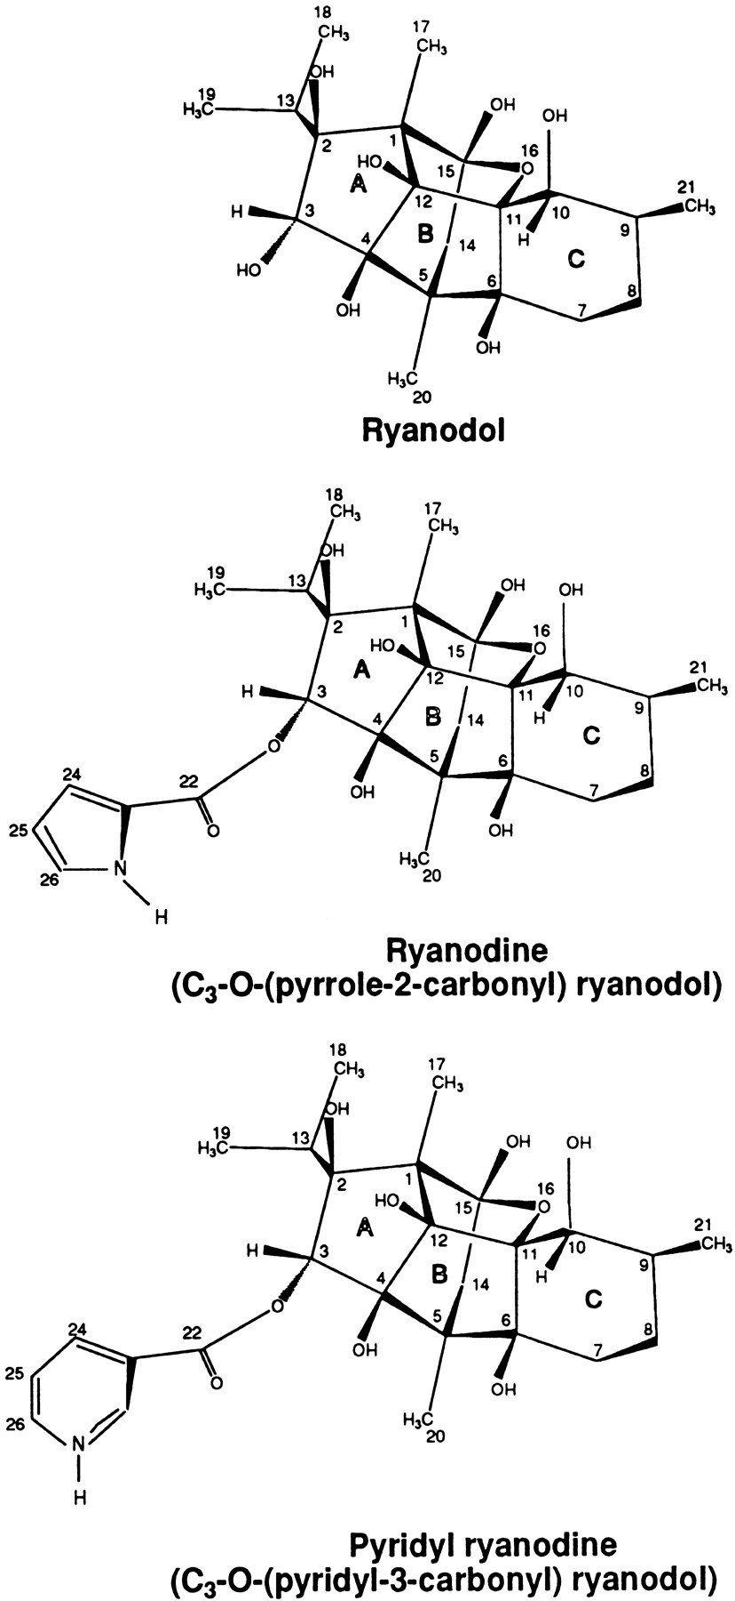

Figure 1 The structure of Ryanodine and Ryanodol

Ryanodol can be obtained by removing the C₃ hydroxyl substitute from ryanodine using the alkaline de-esterification procedure. Ryanodol can also modify the gating and permeation of single RyR channels. Ryanodol has a K_{D} of ~40 µM and considerably faster binding kinetics. It induces the same subconductance as ryanodine (40-50% of normal full conductance). But unlike ryanodine, the subconductance induced by ryanodol is intermittent. In addition, the Ryanodol action is reversible such as channel can go back to normal open and close state and the effect of ryanodol can be washed out, but ryanodine action is essentially irreversible (Tinker, Sutko et al. 1996).

2. Caffeine
Caffeine is one of the most widely used tools to investigate RyR-mediated Ca²⁺ signaling. Caffeine is a bitter white crystalline xanthine alkaloid found in many plant species. It is probably the most popular tool that has been extensively used for pharmacological activation of CICR mechanism in various tissues. Its ability to induce Ca²⁺ release from internal pools was first discovered on muscle preparations, where it activated contraction in a low Ca²⁺ solution (Blinks, Olson et al. 1972)
Caffeine increases the RyR Ca²⁺ sensitivity by increasing its Po without changing its conductance in single-channel planar lipid bilayers experiments in both cardiac (Rousseau and Meissner 1989; Sitsapesan and Williams 1990) and skeletal muscles (Rousseau, Ladine et al. 1988). Submillimolar concentrations of caffeine affect the frequency of channel openings and leave the mean open times unchanged, thus leading to an increased Po of RyR channels. The activating effect of caffeine at submillimolar concentrations is dependent on a minimal activating concentration of cytosolic-free Ca²⁺ of around 0.1 µM. However, increasing the caffeine concentration to 5 mM or higher leads to a Ca²⁺ -independent RyR channel activation (Sitsapesan and Williams 1990). This property combined with its receptor specificity and its well-characterized mechanism of action make caffeine an important tool for the analysis of RyR function. The specific binding site of caffeine on the RyR has not yet been known. However, it is unlikely to be that of adenine nucleotides, although these molecules have the structural similarity (Zucchi and Ronca-Testoni 1997). The pharmacological action of caffeine on the RyR is similar as Ca²⁺ and adenine nucleotides (Zucchi and Ronca-Testoni 1997); they all increase RyR Po without altering its conductance, and they increase its affinity for [3H]ryanodine. It has been proposed that their binding sites are distinct but interacting synergistically (Pessah, Stambuk et al. 1987).

3. Scorpion Toxins
Imperatoxin A (IpTx A), a 33 amino acid peptide with molecular weight = 3,759 Da isolated from the venom of a scorpion, has been shown to have RyR isoform-specific effects in that it can selectively activate the RyR channel. It increases ryanodine binding in RyR1 and RyR3 but not in RyR2. It shows sequence similarity to a portion of the skeletal muscle dihydropyridine receptor that activates RyR1 through protein-protein interaction (Valdivia, Kirby et al. 1992; el-Hayek, Antoniu et al. 1995; el-Hayek, Lokuta et al. 1995; Tripathy, Resch et al. 1998). Imperatoxin A can also induce subconductance with about 1/3 of regular normal current (Tripathy, Resch et al. 1998). Some other toxins such as Maurocalcin (Mca), Imperatoxin I, and Ryanotoxin are also found to interact with RyR and regulate its activity.

4. Other Agents
There are many other known agents that alter RyR channel activity. Suramin, a polysulfonated naphthylamine derivative of urea, has been used as an antiparasitic agent for many years. Suramin is also an antagonist of ATP at P₂ purinergic receptors. It had been reported that it activates both the rabbit skeletal muscle RyR1 and sheep cardiac RyR2 isoform channels reconstituted into planar lipid bilayers (Sitsapesan and Williams 1996). The increase in channel activity is primarily due to a large increase in the mean open time of the channel. A 20 to 25% increase in conductance is also observed. Trifluoperazine (TFP) is a typical antipsychotic drug of the phenothiazine group. It exerts its actions through a central adrenergic-blocking, a dopamine-blocking, and minimal anticholinergic blocking. It is a potent calmodulin inhibitor. It also has been reported that this agent can interact with calsequestrin(Park, Kim et al. 2005). Addition trifluoperazine to homogenate-activated RyR reduces channel activity considerably (Lokuta, Darszon et al. 1998). Amitriptyline (AMT) is a tricyclic antidepressant drug. It inhibits serotonin and noradrenaline reuptake. AMT binds to CASQ2 and decreases its Ca²⁺ buffering capacity in vitro. Hence, AMT binding to CASQ2 may render RyR2 channels leaky and cause ventricular arrhythmias akin to CASQ2 mutations. Chopra et al. reported that AMT causes Ca²⁺ release in CASQ2 null myocytes and decreased SR Ca²⁺ content in a concentration dependant fashion. AMT also activates native RyR2 channels isolated from CASQ2 null hearts in lipid bilayers (Chopra, Laver et al. 2007). AMT can induce 2 type of subconductance. One is 70% of full opening and the other is 30% of normal conductance. Halothane had been shown that it could block both skeletal and cardiac RyR channels (Morrissette, Kratzschmar et al. 1995). Some common inhibitors of RyR channel activity include ruthenium red (Xu et al., 1998) and some local anesthetics such as procaine and tetracaine (Lee et al., 1991; O'Brien et al.)

G. Permeation of ryanodine receptor single channel
Two processes contribute to the efficiency of RyR as a Ca²⁺-release channel. The first is the control and modulation of the probability of channel opening; channels must open and close in response to appropriate stimuli. Of equal importance, once open, the channel must provide a suitable pathway for the rapid and selective translocation of Ca²⁺ down its electrochemical gradient.
Ca²⁺ channels are higher permeable to Ca²⁺ than other ions, especially to monovalent ions, which can be called high Ca²⁺ selective. Selectivity is usually quantified experimentally as the ratio of the permeabilities of pairs of ions based on the thermodynamic theory. Consider the case of two monovalent ions. Suppose there are only two ions X (luminal side) and Y (cytosolic side) are permeable through the membrane and suppose also that there is only one active channel in the membrane. Based on the Goldman-Hodgkin-Katz equation (Goldman, 1943; Hodgkin and Katz, 1949), the reversal potential RP across the membrane when there is zero net current through the membrane can be written as:
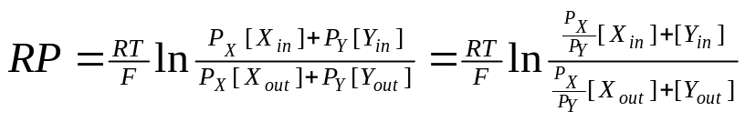 (1)
Where P is the permeability of the ion, R is gas constant; T is absolute temperature and F is Faraday constant.
If originally there is not X and Y in other side and volume is bigger enough, then ion passing through the channel can be omitted in equation:
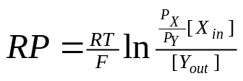 (2)
Then equation (2) can be derived to:
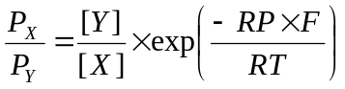 (3)

P_{X}/P_{Y} is the permeation ratio, and can be used to describe selectivity.
However, if ion Y is monovalent such Cs⁺ and ion X is divalent, like Ca²⁺ (a situation of plasmalemma Ca²⁺ channel), a more complex expression results. I use the equation given by Fatt and Ginsborg (1958):
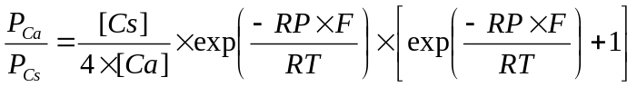 (4)
[Cs⁺] is concentration of Cs⁺ in cis side and [Ca²⁺] is luminal Ca²⁺ concentration. RP is the reversal potential.
The higher the permeation ratio, the higher selectivity the channel has. The RyR channel is a poorly selective channel compared to others surface channels because of its lower permeation ratio. One way to describe the unique permeation properties of RyR channels is to compare them to studies of voltage-dependent Ca²⁺ channels that are found in the surface membrane. These surface membrane Ca²⁺ channels have relatively small conductance and high selectivity. When they open, their job in the cells is to change of membrane potential and often not to change local Ca²⁺ concentrations. In contrast, RyR channels have very high conductance but relatively poor selectivity. Thus, these two types of Ca²⁺ channels have different jobs and use quite different permeation characteristics to accomplish them.
Experiments showed that the RyR channel is permeable to many different monovalent and divalent cations, but not to anions (Williams, West et al. 2001). The RyR channels show very little selectivity between different monovalent cations and very little selectivity between different divalent cations. However, the RyR channels are selective, albeit poorly, between mono- and divalent cations (P_{Ca}/P_{K} ~6; more permeable to Ca²⁺ than K⁺) (Fill and Copello 2002). Unitary conductance of the RyR channel is very high, approaching 1 nS at saturating activities of K⁺ (Lindsay, Manning et al. 1991) and 200 pS at saturating activities of Ba²⁺ (Tinker and Williams 1992). By comparison, the voltage-dependent Ca²⁺ channels in the surface membrane typically have P_{Ca}/P_{K} ~3000 and conductances smaller than 9-85 pS for different cations (Bers 2001; Sather and McCleskey 2003).
Understanding of the mechanisms involved in cation translocation and selection in membrane channels in general has been advanced dramatically by the determination of the structure of the pore of bacterial K⁺ channels at atomic resolution (Morais-Cabral, Zhou et al. 2001; Zhou, Morais-Cabral et al. 2001; Zhou, Morais-Cabral et al. 2001). This bacterial K⁺ channel pore is formed along the longitudinal axis of a homotetrameric protein structure which contributes two transmembrane helices and extracellular protein loops. The channel has, starting from the cytoplasmic entrance, an 18-Å long tunnel termed the internal pore, a cavity 10 Å in diameter, a selectivity filter 12 Å in length and 3 Å in diameter, and an extracellular mouth (See Figure 2A). Sequence comparison (Balshaw, Gao et al. 1999) has also suggested that the RyR channels have a pore architecture similar to that identified by X-ray crystallography in the bacterial KcsA potassium channel but with an extended C-terminal linker, wider pore and the eight negative charges of D4899 and E4900 in and near the selectivity filter, see Figure 2B (Doyle, Morais Cabral et al. 1998; Wang, Xu et al. 2005). The length of selectivity filter is ~10 Å long, 3 to 7 Å wide at the luminal side of the channel (Williams, West et al. 2001).
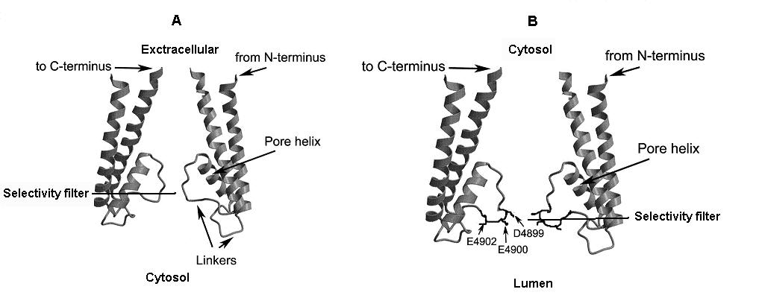
Figure 2. Cartoon depicting the pore structural features of the KcsA K+ channel and RyR channel
A. Selectivity filter of KcsA K+ channel is about 12 Å long and 3 Å wide on the extracellular side of the channel. B. The putative RyR selectivity filter ~10 Å long, 4 to 7 Å wide at the luminal side of the channel. Data of selectivity filter is from Williams 2001. Figure adapted from (Wang, Xu et al. 2005).

Ion permeation through the RyR channel has been modeled with barrier models (Tinker, Lindsay et al. 1992) and with Poisson-Nernst-Planck theory (Chen, Xu et al. 1997). Williams’ group modeled RyR as a single-ion channel. The evidence supporting this proposal is: saturation of conductance with increasing ion activity; concentration independent bi-ionic reversal potentials if bath ion activity ratios are constant; and the lack of an anomalous mole fraction effect (AMFE). More recently, Gillispie et al.(Gillespie, Xu et al. 2005) proposed a reduced electrodiffusion-based permeation model that describes RyR as a multi-ion channel with approximately 3 monovalent cations in the selectivity filter at all times. In addition, this latter model predicts an AMFE for Na+/Cs⁺ mixtures, which was later experimentally verified. Combining these results, the binding selectivity of RyR appears to be driven by the same charge/space competition mechanism of other highly charged channels (Gillespie, Xu et al. 2005).

H. Subconductance state properties of single RyR channel
Historically, 4 equal size RyR conductance substates have been reported (Liu, Lai et al. 1989). An early interpretation based on the existence of these substates and an initial 3-D structural RyR reconstruction suggested that the different substates represented permeation through 4 different pathways. The implication was that the RyR was a large multi-barrel ion channel. Several subsequent studies, including higher resolution reconstructions, do not support this early interpretation. Now, the consensus opinion is that the RyR has a single central pore and that the substates reflect different structural configuration of this pore.
Recently, the potential physiological relevance of RyR channel substates has taken center stage in describing the etiology of end stage heart failure and sudden cardiac death (Wehrens, Lehnart et al. 2003; Lehnart, Wehrens et al. 2004; Wehrens, Lehnart et al. 2004). Specifically, there is substantial data suggesting that RyR phosphorylation can cause dissociation of FK506-binding protein from the RyR and this structurally destabilizes the channel complex. It appears that this FKBP-dissociation may occur in certain types of heart failure or arrhythmias because of increased levels of catecholamine. The resulting RyR destabilization leads to substates and these substates generate a pathological SR Ca²⁺ leak that is destructive to the cell. Thus, defining whether RyR channel substates are simply biophysical artifacts or represent physiologically important RyR conformations has renewed interest (also see FKBP part).
Substating of single RyR channels is often observed and almost just as often ignored. Substates can be induced by different pharmacological manipulations. For example, application of rapamycin or FK506 promotes FKBP dissociation and consequently substating. Ryanoids (e.g. ryanodine, ryanodol, etc.) bind to the RyR channel and induce long sojourns into a subconductance state (Tanna, Welch et al. 2005). Exactly why bound ryanoid reduces conductance is not well understood. The ryanoids are thought to, 1) bind to the open configuration of the channel, 2) have a binding site near the pore, 3) physically increase the diameter of the pore and interestingly, 4) reduce the P_{Ca}/P_{K} selectivity ratio of the pore. Ryanodol, a non-commercially available derivative, has a K_{D} near ~40 µM and considerably faster binding kinetics. At the single RyR channel level, ryanodine is applied at super-K_{D} concentrations (e.g. 1-10 µM) and its action is essentially irreversible on the typical experimental time frame. Ryanodol can be applied at concentrations around its K_{D} and it binds (modifies) and unbinds (unmodifies) repeatedly during the typical experimental time frame. A scorpion peptide toxin (Imperatoxin; IpTx) binds to the RyR channel and also induces long sojourns into a subconductance state (Tripathy, Resch et al. 1998). This is action is qualitatively similar to that of the ryanoids. The impact of IpTx on the P_{Ca}/P_{K} selectivity ratio is unknown, but our preliminary data suggest it is also reduced (similar extent as for the ryanoids). The qualitative similarity of ryanodol and IpTx actions is curious because IpTx is a peptide toxin and its binding site is thought to be far from the pore. It is possible that the apparently common actions may be the result of similar alterations in how the RyR pore selects and discriminates between ions but that alterations may be generated by entirely different mechanisms. Thus, these agents may represent pharmacological probes that can be used to experimentally probe the structure-function of the RyR pore.
RyR conductance substates also occur spontaneously in the absence of any of these pharmacological manipulations. One interpretation of spontaneous substates is that they are a normal naturally occurring phenomenon. However, it is important to remember that the substates are only observed after the RyR channel has been isolated from the cell and reconstituted into an artificial lipid bilayer. Thus, there is always the alternative possibility that RyR isolation and subsequent reconstitution somehow artificially promotes these spontaneous substates.
Subconductance induced by ryanodol is voltage dependent(Tinker, Sutko et al. 1996), which means the binding and unbinding of ryanodol are influenced by membrane potential. Williams explained that even Ryanodol carries no net charge, but it does have a fixed dipole. If the positively charged part of the dipole had to lie in the voltage drop for interaction, while the negative pole lay outside, the effect would show an overall voltage dependence. Similar voltage dependent feature was also reported in subconductance induced by IpTx A (Tripathy, Resch et al. 1998).

CHAPTER III

MATERIALS AND METHODS

A. Reagents and Drugs
BAPTA (1,2-Bis(2-aminophenoxy) ethane- N,N,N’,N’ -tetraacetic acid), 5,5´-Dibromo-BAPTA (1,2-Bis(2-amino-5-bromophenoxy) ethane- N,N,N’,N’- tetraacetic acid), Ca(OH)₂, Mg(OH)_{2,} CsOH, CsCl, HEPES (4-(2-Hydroxyethyl)piperazine-1-ethanesulfonic acid) and Tris (Tris(hydroxymethy)-aminomethane) are obtained from Fluka (Milwaukee, WI). The CaCl₂ standard for calibration is from Word Precision Instruments Inc (Sarasota, FL). Ryanodol is made from our lab; Imperatoxin A (IpTx A), Trifluoperazine (TFP), amitriptyline (AMT)
, Suramin, Adenosine-5'-triphosphate (ATP) and all other chemical reagents and pharmacological compounds are from Sigma-Aldrich (Milwaukee, WI).

B. Sarcoplasmic reticulum vesicles preparations
Microsomes enriched type-2 RyR channels in my studies were prepared from ventricle of adult rat hearts using established procedures (Chamberlain, Levitsky et al. 1983). Briefly, the fat and connective tissue were removed from rat ventricles, then sliced and homogenized in 5 volumes (v/w) of solution with sucrose, 0.5 mM dithiothreitol, 3 mM NaN3, and 10 mM imidazole-HC1, pH 6.9. This first homogenization with a VirTis 45 was done in a 250 ml flask at 21,500 rpm for 15 s. A second homogenization at 35,800 rpm for 35 s was performed using a VirTis45 homogenizer with two perpendicular blades set 5 mm from the flask bottom. The homogenates were then centrifuged 15 min at 5,000 rpm (3,800 x G_{max}) in a Beckman JA-14 rotor. The supernatant was filtered through four layers of cheesecloth, adjusted to 140 ml with fresh homogenization solution, and centrifuged at 13,500 rpm for 15 min (27,900 x G_{max}) in the JA-14 rotor. After filtration through cheesecloth, the supernatant from the second spin was centrifuged at 32,000 rpm (119,200 x G_{max}) for 2 h in a Beckman Type 35 rotor. The supernatant from this centrifugation was removed by aspiration, and the centrifuge tube was stayed in ice for a few minutes. The soft pellet was re-suspended for salt washing in Solution A (0.29 M sucrose, 0.65 M KCI, 0.5 nm dithiothreitol, 3 nm NaN3, 10 nm imidazole-HCI, pH 6.7) by hand homogenization (15 strokes) in a Potter-Elvehjem tissue grinder with Teflon pestle. After 30 minutes incubation on ice, the solution was centrifuged at 6,000 rpm for 10 min (4,400 x G_{max}) to remove large aggregates. The supernatant was then centrifuged at 50,000 rpm (251,800 X G_{max}) for 100 minutes. After removal of the supernatant and addition of small amounts of Solution A, the centrifuge tubes were agitated to free the softer opaque pellets from the bottom clear pellets. These pellets were re-suspended in Solution A by hand homogenization (15 strokes) in a Potter-Elvehjem tissue grinder, and the volume was adjusted to 5.5 ml/VirTis homogenization. Membrane preparations were quickly frozen and stored in liquid nitrogen. Aliquots of 15 μl-each of vesicles were prepared every month and stored at –80°C. When needed, these aliquots were quickly defrosted in water, kept on ice, and used within 5 hours.

C. Phospholipid bilayers technique
Patch clamp allows recording currents through surface membrane channels preserving much of their original environment, and thus it is commonly used to study single ion channels. However, due to the intracellular location and complex ultra-structure of membranes, it is impractical to apply patch-clamp to record SR membrane channel function. Until now, a good alternative technique is to reconstitute SR ion channels into artificial phospholipids bilayers and this method was developed by Mueller (Mueller, Rudin et al. 1962; Miller 1986)
Native vesicles rich in RyR2 channels were fused in bilayers painted across a microscopic hole between two otherwise electrically isolated chambers. In my studies, one chamber (trans) corresponded to the luminal side and the other chamber (cis) for the cytosolic side (to which the vesicles were added). The cis and trans chambers contain experimenter defined solutions. A standard patch-clamp amplifier was used to monitor electrical activity in the bilayer. Before channel incorporation, no current was detected. To promote fusion of vesicles into the planar bilayer an osmotic gradient was established between the cis and trans chamber. The gradient was obtained by adding osmotic effectors (CsCl was often used) to the cis chamber. Stirring of the solution in the cis chamber also increased the rate of fusion.
When a vesicle fused with a bilayer the ion channels embedded in that vesicle membrane become incorporated into the bilayer and connect the two chambers. Ions can flow through this channel from one side to the other side of the bilayer. The amplifier detects this ion flux as a small current. Current will be detected each time the channel opens. Thus, spontaneous single channel activities were observed as a series of discrete current deflections from a zero current baseline.
The advantage of this technique is that one can study the channel in a very controlled environment (although it may be different from the physiological one). It is a controlled environment because the content of the solutions on both sides of the bilayer(cis and trans compartments) can be easily manipulated. Working with simplified solutions in an in vitro system enables one to clearly identify the response of the channel to a variety of ionic conditions. This control comes at a price. First, many regulators such proteins, ions and/or other molecules associated with the channel in vivo may be lost in this in vitro system. In the bilayer, the RyR2 channels has been removed from this native medium and thus their function there may not reflect their function in cells. Another common obstacle associated with the planar lipid bilayer technique is the simultaneous fusion of multiple channels into the bilayer. Another experimental obstacle associated with this technique is the relatively large electrical and mechanical noise that requires filtering to overcome. This filtering inevitably limits the temporal resolution of the recording system. Thus, signals from fast-gating low-conductance currents mediated by channels like the DHPR are not as easily detected by the planar lipid bilayer technique.

D. Chambers and Septum
The chambers in my experiments were composed of two halves of a cylindrical block of Teflon. Each block had a 1 ml solution well. One wall at the chamber-septum interface had a ~5 mm hole that was covered with a Teflon septum as shown in Figure 3. The septum was comprised of three thin layers of Teflon sheets fused together. The two external layers had a ~5 mm (or so) hole at center, corresponding to the chamber lateral aperture, and their role was to support the thinner (7-10 μm thick) middle layer. The middle layer had a central 80-100 μm hole, across which the bilayers were painted. The dimensions of the septum hole were a balance between the effort to limit noise levels and the need to promote channel incorporation to bilayer. Most bilayer noise comes from capacitance. Bilayer-generated capacitance was related to the diameter of the hole (i.e. the area of the bilayer). We found out that 100 μm holes proved a good compromise between noise level and chance of channel incorporation.
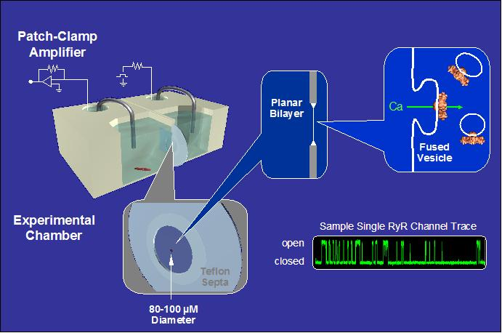
Figure 3: The bilayer setup

E. Phospholipids
Artificial planar lipid bilayer was a 5:4:1 mixture of phosphatidylethanolamine (PE), phosphatidylserine (PS), and phosphatidylcholine (PC).
Individual phospholipids were separately dissolved in chloroform. Lipids were mixed and aliquoted in vials. Before storing at –80° C, the chloroform was evaporated from each vial by highly pure nitrogen. Once needed, the phospholipids were dissolved in decane (50 mg/mL of decane). Decane was the solvent choice because it generated bilayers that were more prone to fuse SR vesicles.
Before assembling the chamber and the septum for the experiments, a drop of the solution was deposited on each side of the septum around the hole. The lipid was allowed to sit for two minutes, during which most of the decane evaporated. After this period, the excess liquid was removed by a burst of air. After the chambers had been filled with solution, the bilayer was painted with a Drummond 10 μm micropipette.

F. Recording setup
Septum and chambers were carefully assembled and tighten together in order to avoid solutions leak. Once the solutions were added, the chamber was placed gently inside a grounded metal box. The mental box was mounted on an air table to avoid mechanical vibrations.
Channels activity was measured using an I/V converter (usually in the 1mV/pA mode) to amplify very small currents. This was part of the headstage of a patch clamp amplifier Axopatch 200B (Axon Instruments, Foster City, CA). The signal input of the Axopatch 200A was connected to the trans chamber, the ground was connected to the cis chamber. To avoid electrode polarization, the electrodes used were silver coated (Ag+/AgCl) and immersed in a 3 M KCl solution. This solution was linked to cis and trans solutions via agar bridges.
Data was filtered through a low-pass Bessel filter at 1 kHz, digitized at 20 kHz with a 12-bit analog to digital converter, and stored on an optical disk for computer analysis, using the pClamp9 software (Axon Instruments). A Hum Bug notch filter removed persistent 60 Hz noise. Four minutes recordings were usually acquired in each experimental condition (except for ramp recording).

G. Solutions
At the beginning of each experiment, the trans chamber was filled with solutions of (unless otherwise stated) HEPES-Ca [containing 250 mM HEPES ([2-Hydroxyethylpiperazine-N-[ethanesulfonic acid])/50 mM Ca²⁺ pH7.4), 0.6 mM DTT (dithiothreitol), and 0.25 mM BAPTA. High Ca²⁺ concentration was used to visualize the RyR-mediated ion currents. At 0 mV, Ca²⁺ ions flowed from the trans to the cis chamber down their electrochemical gradient. Response to selected diagnostic agents (caffeine, ryanodol, Mg²⁺, Ca²⁺, and ATP) was used to confirm the identity and orientation of the fused RyR channel. Channels were always oriented with their cytosolic side in the cis chamber. The anion was HEPES and pH was always 7.4. The antioxidant DTT was added to protect both channel and bilayer from oxidation. The solution in the cis chamber usually contained only 250 mM HEPES /140 mM Tris (Tris(hydroxymethy)-aminomethane). The cation Tris was used because RyR2 is not very permeable to Tris (Coronado, Morrissette et al. 1994).
Incorporation of RyR2 channels was promoted by adding to the cis solution (while stirring), first 500–1000 mM CsCl and 1 mM CaCl₂ and then 1–2 µg of RyR2-rich SR vesicles. Vesicles spontaneously fused with the bilayer in the presence of the osmotic gradient created by the added Cs⁺. After incorporation, the cis chamber was perfused with HEPES/Tris for 5 min at 4 ml/min to remove CsCl and extra Ca²⁺. Since the cytosolic surface of the active channels faces the cis chamber, BAPTA (1 mM), DiBr-BAPTA (1 mM), and/or EGTA (1mM), and various amounts of CaCl₂ were added, to buffer cytosolic (cis) free [Ca²⁺] to the desired value.
In general, BAPTA and its derivative DiBr-BAPTA were used instead of EDTA or EGTA, because of their high selectivity for Ca²⁺ over Mg²⁺. Also, EGTA is sensitive to pH in the range of 7.4, while BAPTA is not affected by pH values above 4. The combination of BAPTA and DiBr-BAPTA allowed for fine control of Ca²⁺ concentrations over a wider free [Ca²⁺] range. Amounts of Ca²⁺ and buffer added was calculated with the MaxChelator software v3.2 (Bers, Patton et al. 1994) http://www.stanford.edu/~cpatton/maxc.html). Unless otherwise stated, all testing drugs were added to the cis chamber (i.e. cytosolic side of the channel).

H. Data Analysis
Results in my experiments were expressed as means±SEM. Where applicable, ANOVA t test was used to evaluate the significance of difference of sample means between groups. Statistical significance was defined as p < 0.05.
Single channel analysis was done using pCLAMP9 software (Axon Instruments). Open times, closed times, and open probability (Po) were defined using the half-amplitude threshold method. The half-amplitude threshold method is briefly described below. By using an estimate of the single-channel current amplitude derived from the amplitude distribution, a transition threshold (event discriminator) is placed halfway between the zero and single channel current levels of the recording. Samples exceeding the threshold level are deemed as being in an open state, points less than the threshold indicate a closed state. By scanning through the digitized recording sample by sample, noting the points at which the signal crosses the threshold, an idealized list of intervals spent in the open and closed states was compiled. The dwell times within each state was computed noting the periods of time between the 50% transition points, determined by interpolating between the samples on either side of the transition threshold. This method is influenced by sample frequency. If frequency is too low, some points will be missed and some fast transient states may not be detected by this process.

1. Po analysis
Open probability, open-close time distributions were generated using Axopatch pClamp 9 software. Open probability (Po) was defined as the time one channel spends in the open state over the total recording time (Po = 0, completely closed channel; Po = 1, completely open channel).
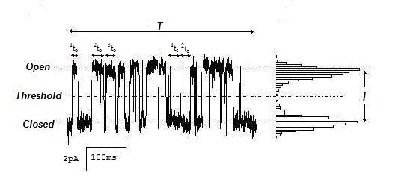

Figure 4 Example of open probability analysis using half-amplitude threshold method adapted and modified from (Laver 2001).

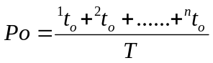 (4)
Where ¹t_{o} to ^{n}t_{o} is the time spent on open state. T is the total recording time.
In the case of bilayers containing more than one channel, nPo was calculated according to the formula:
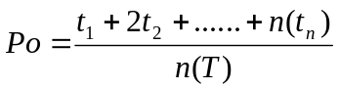 (5)
Where t₁ is the time spent at open level 1, t₂ is the time at open level 2, etc. T is the total recording time and n is the number of channels in the bilayer.

2 Dwell open and close time analysis
Channel activity was also analyzed from the statistics of durations of open state or state (i.e. dwell-times: the times spent at each current level before it jumps to a new value). An overall picture of channel gating rates are evident in the mean open and closed dwell-times (To and Tc).

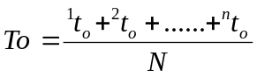 (6)
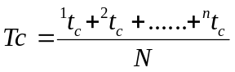 (7)

Where T_{o} is the dwell open time and T_{c} is the dwell close time. ¹t_{o} to ^{n}t_{o} is the time spent on open state. ¹t_{c} to ^{n}t_{c} is the time spent on close state .N is total number of events.
Plotting and statistical analysis were conducted with Excel, SigmaPlot and Origin software.

3. Recurrence quantification analysis (RQA)
RQA was introduced by Zbilut and Webber (Zbilut and Webber 1992; Webber and Zbilut 1994) as a modification of qualitative recurrence plots devised by Eckmann et al (Eckmann, Kamphorst et al. 1987). RQA is a geometrical technique that searches for repeated event sequences. A mathematical technique known as embedding in N-dimensional Euclidean space allows the data to be reconstructed as a time-ordered sequence of vectors. The resulting vectors are then indexed and compared on all possible i, j vector coordinate combinations, producing the recurrence plot. Two vectors are considered recurrent if their separation distance is less than a preset radius. The 45° (diagonal) lines in the plot denote parallel trajectories: two vectors (data sequences) close in N-space remain close together over subsequent time periods. In other words, the trajectory of one vector parallels the second vector at different points in time.
There are seven quantitative variables in recurrence quantification analysis, five defined by Webber and Zbilut (1994) (%recurrence, %determinism, maxline, entropy and trend) and two defined by Marwan et al. (2002) (laminarity, trapping time). For channel dwell times analysis the three, %determinism, Entropy and %laminarity, are used here. Percent determinism (%DET) quantifies the percentage of recurrence points that form upward diagonal line segments. Diagonal lines consist of two or more adjacent points that are parallel to the ubiquitous central diagonal. This important variable distinguishes between individually dispersed recurrent points, and those that are organized into specific patterns (deterministic) (Webber and Zbilut, 1994). Percent laminarity (%LAM) refers to percent of recurrent points forming vertical lines.

To illustrate these issues, consider the contrived discrete time series (dwell time) in Figure 5 consisting of 10 points. On close inspection it can be noticed that three points (1, 5, 6) have identical amplitudes of 2 ms and two points (2, 7) have identical amplitudes of 5 ms. All points with identical amplitudes (at an embedding dimension of 1) are, by definition, perfectly recurrent. If the definition of recurrence is relaxed to include points within 1 ms, it can be noticed that point 9 (1 ms) is close to points 1, 5 and 6 (2 ms), and point 10 (4 mV) is close to points 2 and 7 (5 ms). Thus, these combinations would score as approximate recurrences.
It is instructive to understand the construction of the recurrence plot in Figure 6. The same time series (Fig. 5) is lined up along both the horizontal (i-index) and vertical (j-index) axes. The sequential amplitudes are scored just outside the 10 x 10 recurrence matrix (2, 5, 9, …). Black dots (•) denote 18 exact recurrences where 2ms match 2ms, 5ms match 5ms, etc. at each orthogonal intersection.
A long central diagonal is formed since every point in the 10-point signal matches itself (trivial). Increasing the cutoff distance from 0 ms to 1 ms includes 8 additional recurrence plot is symmetrical across the diagonal axis. This is necessarily so for if point-i is close to point-j, then point-j is equally close to point-i (also trivial). For this reason, all computations are performed in the upper triangle and exclude the central diagonal itself. In the case at hand: %REC = 8 points / 45 points = 17.8%; %DET = 6 points / 8 points = 75.0%. Percent determinism falls short of 100% because 2 of the 8 points are isolated and do not form diagonal line segments. Finally, if the cutoff distance were increased to 18 ms, the entire recurrence plot would be filled with recurrent points (%REC = 100%). The reason for this is that the largest difference in amplitudes of between individual time-series points is 18 ms (point 9 to point 8).

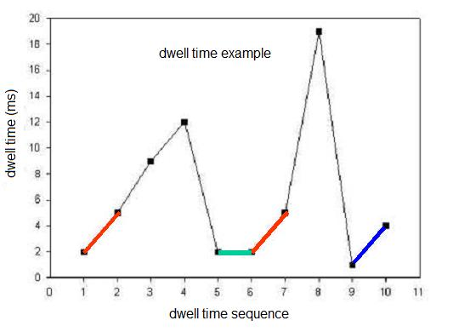
Figure 5. Example of a dwell time series.

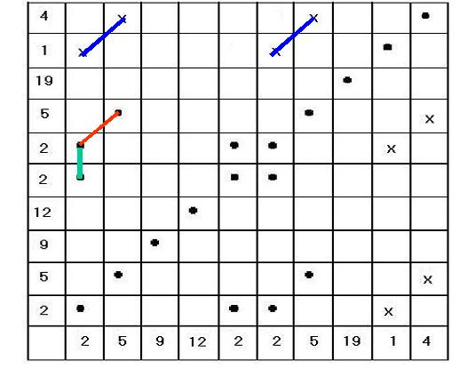
Figure 6. Example of constructing recurrence plot

Here, RQA was applied to the sequential series of single RyR2 channel open and closed dwell times that occurred in selected experimental conditions. Our goal was to quantitatively establish whether or not there are recurring patterns (or structure) in sequential RyR2 dwell times and if this is dependent on unitary Ca²⁺ flux. An RQA program was obtained from (Webber 2004; http://homepages.luc.edu/~cwebber/) and the RQA parameter settings were set according to the README.TXT file distributed with the RQA software. For our analysis, window length (N) was 1000 points (1000 open or close dwell time) and the delay was set to 1. The embedding dimension (m, or data segment size) was 5 points. Care was taken not to set this value too low (m < 3) or high (m > 20) to avoid either underestimating the number of major variables in the system or inflating the noise processes in the signals, respectively. The rescaling parameter was set to maximum distance and the Euclidean distance between each pair of 5-point vectors within the N-point window was computed and placed within an N×N recurrence matrix. The matrix was then rescaled over the unit interval by dividing each distance by the maximum distance. Relative distances thus ranged from 0% to 100%. The radius was set from 0% to 80% of the maximum distance in the rescaled recurrence plots. In other words, a recurrence was defined as value which repeats itself within an assigned tolerance (or radius). A radius of 10 means that values are considered recurrent if their Euclidean distance is below 10% of the average distance between all value pairs in the data series. The RQA method nimbly reveals recurrent patterns by extending a one-dimensional time series into a higher dimensional space (e.g. generating recurrence plots). The RQA software then analyzes these plots for patterns (that may or may not be visually obvious). In our studies, percent determinism and the Shannon entropy within our single RyR2 channel open or closed dwell time sequences were calculated. Determinism refers to the percentage of recurrent patterns in the data. Entropy is a measure of the “richness” of deterministic structure in the data.

CHAPTER IV

CALCIUM SENSITITY OF RYR CHANNEL UNDER DIFFERENT CONDITIONS

A. Introduction
The Ca²⁺ sensitivity of RyR channel is a key factor in the initiation and propagation of many intracellular Ca²⁺ signals. Single RyR channel attributes are generally defined in simple solutions designed to optimize the signal-to-noise ratio of the measurement, and they are rarely defined in salt solutions like those found in cells. RyR channel will not operate the same way in simple solution as in real cell. In real cell, intracellular environment is much more complicated than the experiment condition in bilayer. For example, Mg²⁺ and ATP are two common regulators of RyR in cytosolic side. What I am most interested is how the RyRs function in real cell. And my premise is that the RyR function defined in simple conditions does not represent physiological reality.
Here, the steady state of RyR Ca²⁺ sensitivity is defined in solutions that more closely mimic the cellular condition. Single RyR2 channels will be incorporated into planar lipid bilayers and unit Ca²⁺ currents measured. Modulation of cytosolic Ca²⁺ sensitivity by ATP/Mg and luminal Ca²⁺ levels will be explored.

B. Specific Materials & Methods

Single RyR2 Channel Recording
Heavy SR microsomes were prepared from rat ventricle as mentioned before and incorporated into planar lipid bilayers (see Materials and Methods) One of these compartments (cis) was virtually grounded and filled with a HEPES-Tris solution (250 mM HEPES, 120 mM Tris, pH 7.4). The other chamber was filled with 50 mM or 10 mM HEPES-Ca²⁺ solution. Then, 500 mM CsCl and 5-15 μg heavy SR microsomes were added to the cis chamber to help incorporation. After incorporation, the Cis compartment was washed by 250mM HEPES-Tris solution at a rate of 4 ml/min (for 5 min) to establish the desired test conditions. Unless otherwise specified, the holding potential was always held constant at 0 mV and recordings were made at room temperature (20-22 °C).
Open times, closed times, and open probability (Po) were defined using the half-amplitude threshold method as mentioned in data analysis.
A mixture of BAPTA and dibromo-BAPTA (Maxchelator program) was used to buffer free [Ca²⁺] in the cis compartment to 1 µM. The required Ca²⁺ buffered solution was calculated using WinMAXC 2.05 (Stanford University, CA) and subsequently verified by Ca²⁺ electrode.

C. Results
First, I tested the incorporated channel to bilayer to see if it is indeed ryanodine receptor. Several kinds of pharmacological agents were used to test the channel properties.
Basically, ryanodol or caffeine was used in the experiments. Figure 7 shows channels activity before, adding and washout of Ryanodol (a neutral, low affinity ryanodine derivative
). After adding 40mM ryanodol into cytosolic sides, it induces intermittent induces intermittent long-lived subconductance states (Figure 7B). After 5 min washout of the ryanodol-containing solution, channel exhibits normal channel activity. 10mM caffeine was also used to test the channel property, and it significantly increases the channel activity (data not showed here). These results demonstrated that the incorporated channels are indeed Ryanodine receptor.

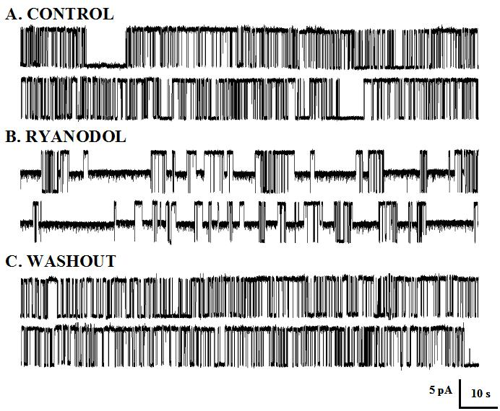
Figure 7 channel function was modified by ryanodol.

A. Sample single RyR2 channel recordings in the absence (control) of ryanodol. Openings are upward deflections. B. Same channel after addition of 40 μM ryanodol. C. Same channel after washout of the ryanodol-containing solution.

Single channel function with either 50 mM (Figure 10A) or 10 mM (Figure 10B)
luminal Ca²⁺ as charge carrier were compared. In each case (50 & 10 mM), channel activity (open probability, Po) was measured in the absence and presence of physiological levels of Mg-ATP (5 mM total ATP & 1 mM free Mg) over a range of cytosolic free Ca²⁺ concentrations. Sample single channel recordings 3 selected cytosolic Ca²⁺ concentrations with 50 mM or 10 mM luminal Ca²⁺ are shown Figure 8 and Figure 9 respectively. In all cases (50 & 10 mM; with & without Mg-ATP), addition of cytosolic Ca²⁺ activated the
A B
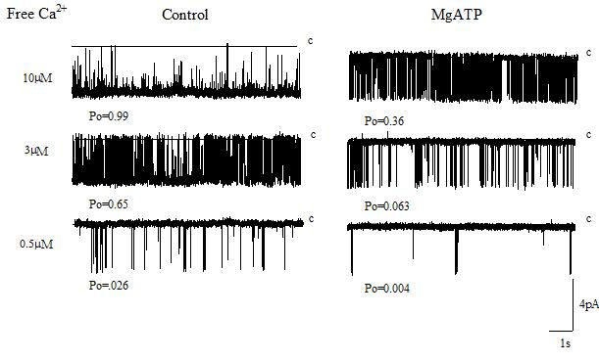
Figure 8. RyR channel activity at different Ca²⁺ concentration when luminal Ca²⁺ is 50 mM.
Channel activity is decreased by reducing cytosolic Ca²⁺ concentration in both conditions. Channel activity significant reduces in presence of Mg/ATP compared to control. Open probability measurements were made from 4 minute recordings at 0 mV at different steady state cytosolic free Ca²⁺ concentrations. Sample single channel recordings at 3 cytosolic Ca²⁺ levels with or without cytosolic Mg/ATP (5 mM ATP total; 1 mM free Mg²⁺ free). A. Control without cytosolic Mg-ATP, B. With adding 1mM Mg²⁺ and 5mM ATP in cytosolic side.

A B
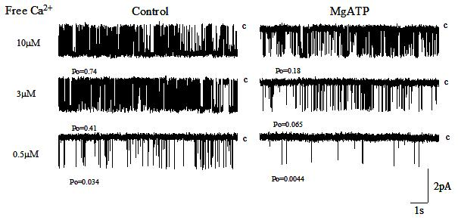

Figure 9. RyR channel activity at different Ca²⁺ concentration when luminal Ca²⁺ is 10 mM
Channel activity is decreased by reducing cytosolic Ca²⁺ concentration in both conditions. Channel activity significant decreases in presence of Mg/ATP compared to control. Open probability measurements were made from 4 minute recordings at 0 mV at different steady state cytosolic free Ca²⁺ concentrations. Sample single channel recordings at 3 cytosolic Ca²⁺ levels with or without cytosolic Mg/ATP (5 mM ATP total; 1 mM free Mg²⁺ free). A. control without cytosolic Mg-ATP, B. with adding 1mM Mg²⁺ and 5mM ATP in cytosolic side.

A B
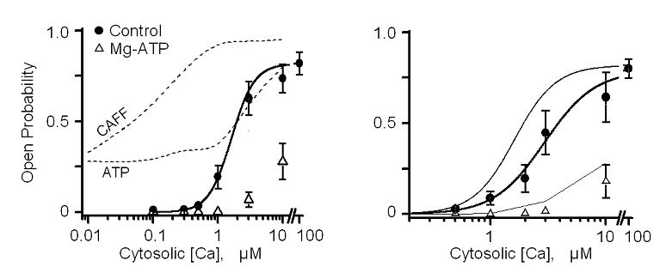

Figure 10. Cytosolic RyR2 Ca²⁺ Sensitivity Depends Mg/ATP and luminal Ca²⁺ level.
Filled circles and open triangles indicate average Po measured from 8-10 different channels without (control) or with Mg/ATP present, respectively. (A) 50 mM luminal Ca²⁺ as charger carrier. The dashed line indicates Po with Mg/ATP when 10 mM caffeine or 20mM ATP was present. (B) 10 mM luminal Ca²⁺ as charger carrier. Thin lines are the 50 mM Ca²⁺ data reproduced here from panel A.

channel. Cytosolic Mg-ATP, however, reduced the absolute Po over the tested range of cytosolic Ca²⁺ concentrations Figure 10 (open triangles). Mean values were plotted and error bars are standard error. Because RyR is ligand-gated receptor and Ca²⁺ acts as a ligand, Hill equation was used to fit dose-response curve. Caffeine and ATP are commonly used by others in single RyR studies and these agents dramatically alter the cytosolic Ca²⁺ sensitivity of the channel. Defining RyR function with these agents present is not very physiological or likely very representative of how these channels behave in cells. So the action of caffeine and ATP were added to compare with our results (dash line in Figure 10). The actions of cytosolic caffeine (CAFF) and ATP (only, no Mg²⁺) are shown for comparison in Figure 10. The ATP data (dotted line) reflect the RyR2 cytosolic Ca²⁺ reported recently by Laver (2007) in a work exploring flux-dependent regulation.
The caffeine data (dashed line) represent data collected in our laboratory. Note that ATP (alone) or caffeine potentiate the cytosolic Ca²⁺ sensitivity of the RyR2 channel (particularly at Ca²⁺ levels < 1 μM. This action of ATP is more than overcome by the presence of cytosolic Mg²⁺ (Figure 10; triangles). The change in luminal Ca²⁺ concentration from 50 mM to 10 mM caused a shift it the cytosolic Ca²⁺ sensitivity (Figure 10B). The cytosolic Ca²⁺ sensitivity when 10 mM luminal Ca²⁺ is present is represented by the thick line (filled circles). Noticed that inure 8 and 9, the driving force of 50 mM luminal Ca²⁺ is larger than 10 mM condition, so the current of 50 mM luminal Ca²⁺ (~4pA) is larger than the 10 mM one (~2pA). The cytosolic Ca²⁺ sensitivity when 50 mM luminal Ca²⁺ present is the thin line (reproduced here from Figure 10A). There is an apparent cytosolic Ca²⁺ affinity shift associated with the luminal Ca²⁺ change (50 to 10 mM). Table 1 compares channel attributes at 3 µM cytosolic Ca²⁺ in the different experimental conditions presented in Figure 10. There was no significant difference in any of the measured parameters (Po, mean open/closed times & event frequency) in the absence or presence of Mg-ATP induced by the change in luminal Ca²⁺ level. The only significant differences identified were those associated with addition of cytosolic Mg-ATP. Parameters from the Hill fits to the cytosolic Ca²⁺ sensitivity data (Figure 10) are presented in Table 1. There was a minimally significant difference in the cytosolic Ca²⁺ EC₅₀, but not in the Po maximum or Hill coefficient, associated with the change in luminal Ca²⁺ level.
Table 1: Properties at a Mid-Range Cytosolic Ca²⁺ (3 μM)

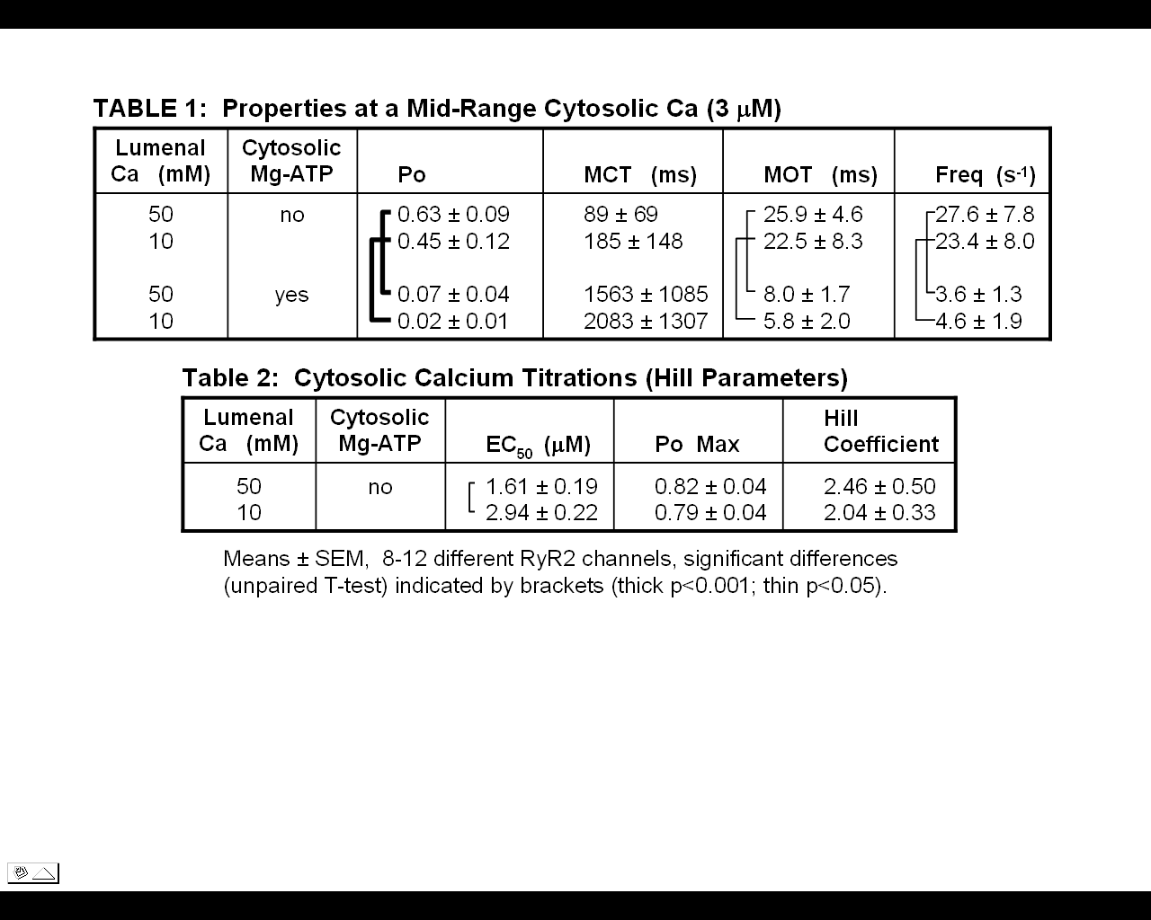

Table 2: Cytosolic Ca²⁺ Titrations (Hill Parameters)

D. Discussion

In cells, cytosolic Mg²⁺ and ATP regulate RyR channel activity. I examined the cytosolic Ca²⁺ sensitivity with physiological Mg²⁺ and ATP in the presence of different luminal Ca²⁺ concentrations. With cytosolic Mg²⁺ and ATP present, RyR2 channel activity (Po) was significantly reduced at all steady state cytosolic Ca²⁺ concentrations tested. The overall cytosolic Ca²⁺ sensitivity curve was shifted to the right. This means that a larger cytosolic Ca²⁺ stimulus is needed to generate the same degree of channel activity. In neuron, this means that to reach such a higher concentration (1~10μM) of Ca²⁺, ryanodine receptor must be very close to the source of Ca²⁺, such as plasma-membrane voltage-gated or receptor-gated Ca²⁺ channel. And Ca²⁺ must very localize to accumulated to such a higher level. Once stimulated to open, the RyR2 channels can mediate a larger longer lasting and more widespread cytosolic Ca²⁺ elevation that can modulate other cellular processes. It would also be consistent with the relatively sparse single channel data (Smith et al., 1986; Rousseau et al., 1988). Laver et al. (Laver, Baynes et al. 1997) reported that Mg²⁺ reduces Po by competing with Ca²⁺ for the activation site (Type-I) or binding to low affinity inhibition sites which do not discriminate between Ca²⁺ and Mg²⁺ (Type-II). At inhibition site, Mg²⁺ has an identical efficacy to Ca²⁺. The IC₅₀ of Mg²⁺ on inhibition site is about 5.3 mM, so 1 mM Mg²⁺ will bind to this site and inhibit RyR2 channel. Cytosolic ATP is an effective RyR channel activator (Smith, Coronado et al. 1985; Copello, Barg et al. 2002). But the inhibition of Mg/ATP occurs because the stimulatory ATP action may not be sufficient enough to compensate for the inhibitory Mg²⁺ action, especially for RyR2 channel.
The data also show that at the same cytosolic Ca²⁺ concentration, when the higher luminal Ca²⁺ was present, the cytosolic Ca²⁺ sensitivity was shifted to the left. The whole curve shifts to right. This result implies that luminal Ca²⁺ may regulate channel activity. The question then becomes “how does luminal Ca²⁺ regulate the RyR activity”? There are 3 possibilities. First, luminal Ca²⁺ can bind to CSQ which acts as a luminal RyR2-remote Ca²⁺ sensor, Second, Ca²⁺ bind to a luminal RyR2-resident Ca²⁺ regulatory site directly regulating channel activity. Third, Ca²⁺ acts on cytosolic Ca²⁺ regulatory sites after permeating through the open channel. From Figure 8 and 9, 50 mM luminal Ca²⁺ condition has a larger lumen to cytosol flux comparing 10 mM condition. So it is possible that more Ca²⁺ flux through the channel and bind to the cytosolic activation site. I am going to discuss and test this third possibility in next part.

CHARPTER V

FLUX DEPENDENT LUMENAL Ca²⁺ REGULATION

A. Introduction
Native cardiac RyR Ca²⁺ release channels are incorporated into planar lipid bilayers and their single channel function recorded primarily with 50 mM luminal Ca²⁺ or Mg²⁺ as the charge carrier (unless otherwise specified). With 50 mM luminal divalent present, the unitary Ca²⁺ or Mg²⁺ conductance was 103 or 80 pS, respectively. The Ca²⁺ or Mg²⁺ currents are in the lumen-to-cytosol direction.
It is well established that cytosolic Ca²⁺ activates the RyR at low levels (less than ~10 μM) and inhibits at higher levels (greater than ~1 mM) (Bull and Marengo 1993; Laver, Roden et al. 1995; Copello, Barg et al. 1997; Fill and Copello 2002). Cytosolic Mg²⁺ inhibits the RyR by either competing with cytosolic Ca²⁺ for the cytosolic high affinity Ca²⁺ activation site or binding Ca²⁺/Mg²⁺ non-selective cytosolic low affinity inhibition site (Laver, Baynes et al. 1997). Several studies have shown that function of RyR2 channels, when their cytosolic Ca²⁺ sensitivity potentiated by ATP or caffeine, are altered by the Ca²⁺ passing through the open pore and acting at cytosolic Ca²⁺ regulatory sites (Tripathy and Meissner 1996; Xu and Meissner 1998). Flux-dependent regulation of single RyR2 with normal (unpotentiated) cytosolic Ca²⁺ sensitivity has not been systematically studied.

B. Specific Materials & Methods

1. Microsome Preparation and single channel recording
Heavy SR microsomes were prepared as mentioned in material and method part above. Planar lipid bilayers were formed across a 100 μm hole in a thin (~12 μm) Teflon partition separating two aqueous compartments and were prepared as same as mentioned before. The chamber was set as same as in previous study. Initially, the trans compartment was filled with HEPES-Ca²⁺ (250 mM / 50 mM) or HEPES-Mg²⁺ at pH 7.4. The cis compartment was filled with a HEPES-Tris solution (250 mM / 115 mM) at pH 7.4. In some cases, the solution in the trans compartment was also changed. The membrane potential across the bilayer was controlled by using a patch-clamp amplifier (Axopatch 200B; Axon Instruments, Union City, CA). Bilayers with an electrical capacitance of 200-300 pF were used in these experiments. Net unitary (single channel) current moving in the lumen-to-cytosol direction are shown here as upward deflections from the zero current level. The rest conditions were same as previous study.

2. Recurrence quantitative analysis (RQA)
RQA is a relatively new technique to qualititate recurring patterns within a sequential data series (Webber and Zbilut 2005). Here, it is applied to the sequential series of single RyR2 channel open and closed dwell times that occurred in selected experimental conditions. Our goal is to quantitatively establish whether or not there recurring patterns (or structure) in sequential RyR2 dwell times and if this structure is a function of the unitary Ca²⁺ flux. An RQA program was obtained from Dr. Webber at Loyola University Chicago (Webber 2004; http://homepages.luc.edu/~cwebber/) and the RQA parameter settings were set according to the README.TXT file distributed with the RQA software. For our analysis, window length (N) was 1000 points (1000 open or close dwell time) and the delay was set to 1. The embedding dimension (m, or data segment size) was 5 points. Embedding dimension should be care not to set this value too low (m < 3) or high (m > 20) to avoid either underestimating the number of major variables in the system or inflating the noise processes in the signals, respectively. The rescaling parameter was set to maximum distance and the Euclidean distance between each pair of 5-point vectors within the N-point window was computed and placed within an N×N recurrence matrix. The matrix was then rescaled over the unit interval by dividing each distance by the maximum distance. Relative distances thus ranged from 0% to 100%. The radius was set from 0% to 80% of the maximum distance in the rescaled recurrence plots. The RQA method nimbly reveals recurrent patterns by extending a one-dimensional time series into a higher dimensional space (e.g. generating recurrence plots). The RQA software then analyzes these plots for patterns (that may or may not be visually obvious). All our single RyR2 channel dwell time sequences were converted to log files and then rescaled over the range from 0.0 to 1.0 (e.g. minimum to maximum of the log file) to generate new open or close sequence. In our studies, percent determinism, percent laminarity and the Shannon entropy within converted open or closed dwell time sequences were calculated. Same analysis was applied to shuffled dwell time series for 10 times, and mean results were compared to the same native dwell time results. The differences of above 3 variables were calculated.

3. Modeling of Ca²⁺ Permeation & Diffusion
The four-barrier permeation model of Tinker et al. (1992) has been used in previous studies of Ca²⁺ flux-dependent RyR2 regulation. Here, the permeation model of Gillespie et al. (2005) was used. The ion flux through the RyR2 pore was predicted assuming ions are charged, hard spheres (not a simple point charge). The model describes ion and water movement through the pore by diffusion and electrostatic drift (not as instantaneous jumps over theoretical barriers). The narrowest region of the pore (i.e. selectivity filter) was assumed to be 1 nm long with 0.8 nm diameter. Vestibules on both sides of the pore were simply assumed to be angled at 45° and 2 nm long. Concentration and potential boundary conditions were applied far (1 µm) from the pore. The pore contained experimentally defined point charges (Gillespie, Xu et al. 2005). This model has accurately predicted RyR2 permeation in a wide variety of experimental conditions.
Ion diffusion from a point source was predicted using the “pore” program kindly provided by Dr. J. Kenyon (Dept. Physiol. & Cell Biol., Univ. of Nevada). The diffusion coefficient for Ca²⁺ and Mg²⁺ was 3x10⁻⁶ cm²s⁻¹. The diffusion coefficient for free and bound EGTA or DiBr-BAPTA was 10⁻⁵ cm²s⁻¹. The k_{on} for EGTA was 1.5x10⁶ M⁻¹s⁻¹ with a Ca²⁺ K_{D} of 1.58x10⁻⁷ M. The k_{on} for DiBr-BAPTA was 1.7x10⁹ M⁻¹s⁻¹ with a Ca²⁺ K_{D} of 1.8x10⁻⁶ M and Mg²⁺ K_{D} of 1.1x10⁻¹ M. These values are consistent with those used previously by Xu & Meissner (1998).

C. Results

1. Flux-Dependent RyR2 Regulation
The unit Ca²⁺ current with 10 mM luminal Ca²⁺ is 2.21 ± 0.04 pA (n=45) which is significantly smaller than the unit Ca²⁺ current with 50 mM luminal Ca²⁺ (3.49 ± 0.03 pA; n=67; unpaired t-test, p<0.0001). Is this difference in unit current what causes the shift in cytosolic Ca²⁺ EC₅₀ (see Figure 10 in Part I). Experimental conditions were changed to explore this possibility. The cytosolic bath Ca²⁺ was set at 0.5 μM so that the cytosolic Ca²⁺ activation site would be free to respond to local Ca²⁺ fluctuations. The luminal Ca²⁺ was set at 50 mM assuring no CSQ is present and saturate the luminal

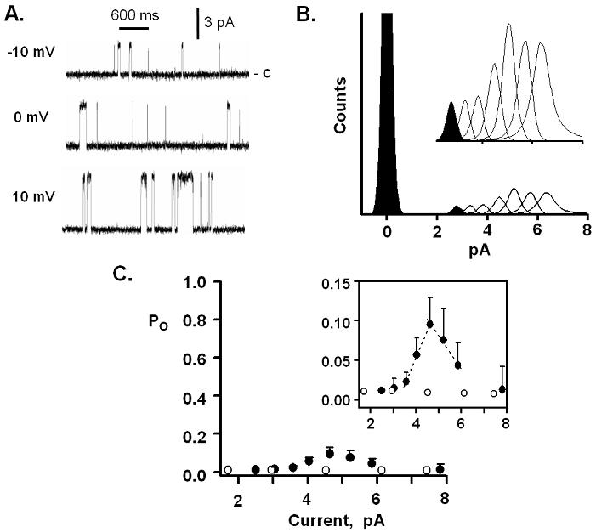
Figure 11. The effect of Ca²⁺ current on Ryanodine receptor channel activity.
Luminal-to-cytosolic Ca²⁺ flux amplitude was varied by changing membrane potential. Cytosolic free Ca²⁺ was 0.5 µM and luminal free Ca was 50 mM. A. Example of single channel recordings of channel activity at different voltage. Opening are upward from the marked closed state. B. all-points histograms. Each histogram reflects 4 minute recordings at one potential. C. Summary Po results collected from 7-15 different channels Filled circle show how Po varies with luminal-to-cytosolic Ca²⁺ flux amplitude. Opened circles show Po when there was luminal-to-cytosolic Cs⁺ (instead of Ca²⁺) current. The Cs⁺ current was supported by 100 mM luminal Cs²⁺. Linear regressions slopes are 0.069 and -0.042 Po/pA.

RyR2-resident process. Amplitude of the luminal-to-cytosolic Ca²⁺ flux was varied by changing membrane potential. Sample recordings from the same single RyR2 channel at -10, 0 and 10 mV are shown in Figure 11A. Sample all points histograms from 4 minute recordings at 7 different membrane potentials (-10, -5, 0, 5, 10, 15, 20 mV) are superimposed in Figure 11B. The family of open current peaks are shown on an expanded vertical scale in the inset. The Po (relative peak area) increased with membrane potential but so did the unit Ca²⁺ current.
The summarized Po data collected from on 7-15 channels with either 50 mM luminal Ca²⁺ (filled circles) or 100 mM luminal Cs⁺ (open circles) as charge carrier are shown in Figure 11C. These data were collected at potentials between -10 and 40 mV. The inset shows the same data on an expanded Po scale. The Po did not change substantially when Cs⁺ was the charge carrier. This means the Po did not vary across the membrane potential range used here. The Po, however, did vary when Ca²⁺ was the charge carrier. The Po increased at small Ca²⁺ currents and then decreased as the current got larger. Lines were fit to the rising and falling phases of the Po vs. pA relationship as a means of quantitation. The rising Po phase had a slope of 0.069 Po/pA and falling phases a slope of -0.042 Po/pA.

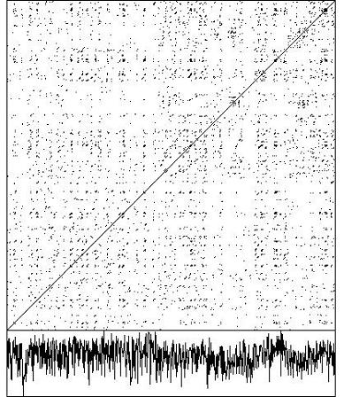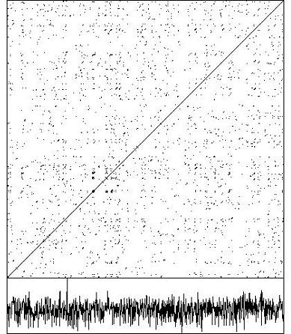
Native open time Shuffled open time
Figure 12 Example of recurrence plot of dwell open time series and shuffled open dwell time

If Ca²⁺ flux through the channel is feeding back and regulating at cytosolic sites, then flux should influence the future opening events and the RyR gating should be non-Markovian, which means future openings/closings would not be stochastic and/or independent of previous events. This flux-dependent regulation should be evident in dwell time analysis. To establish if there is a flux dependent deterministic component to RyR2 gating, individual open and closed event dwell times were collected in different experimental conditions. Unlike classical dwell time analysis, the temporal sequence of open and closed dwell times was preserved and subjected to the RQA process. To our knowledge, this the first time RQA analysis has been used to analyze dwell times in RyR.
Luminal Ca²⁺ was set to 50mM and cytosolic Ca²⁺ was set to 1μM by slow buffer EGTA (as control) or by 3mM fast buffer DiBr-Bapta, both open time and close dwell time were analyzed by RQA. Also 100mM CsHEPES as charge carrier was used to test if there is difference between Cs⁺ and Ca²⁺ as charge carrier by RQA analysis.
The RQA analysis revealed that patterned sequences of single RyR2 channel open dwell times reoccur when Ca²⁺ was charge carrier but not when a fast cytosolic Ca²⁺ buffer is present or when Cs⁺ (instead of Ca²⁺) was charge carrier (Figure 13). RQA analysis of single RyR2 open and closed dwell times was performed on data collected in 3 different experimental conditions (Control, DiBr-BAPTA & Cesium). In the Control condition, Ca²⁺ was the only charge carrier present (net current in lumen-to-cytosol direction) using slow buffer EGTA as buffer to adjust cytosolic Ca²⁺ to 1 μM. The DiBr-BAPTA condition was like the Control condition but with 3 mM cytosolic dibromo-Bapta (a fast Ca²⁺ buffer) present. In the Cesium condition, Cs⁺ was the only charge carrier present (net current in lumen-to-cytosol direction).

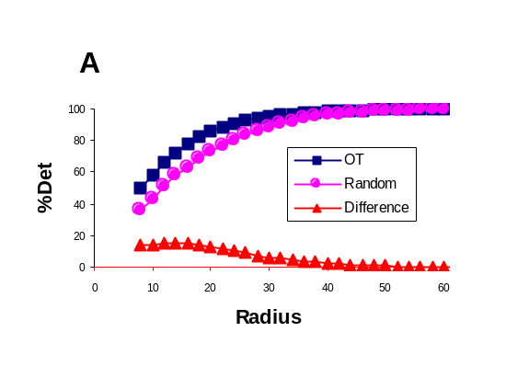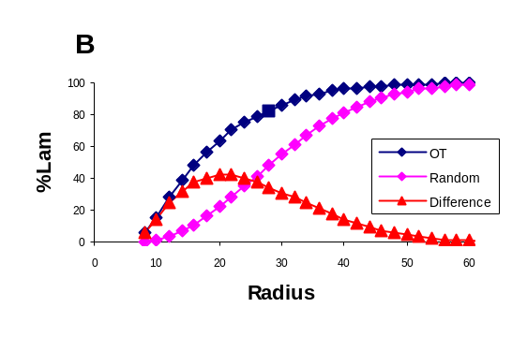
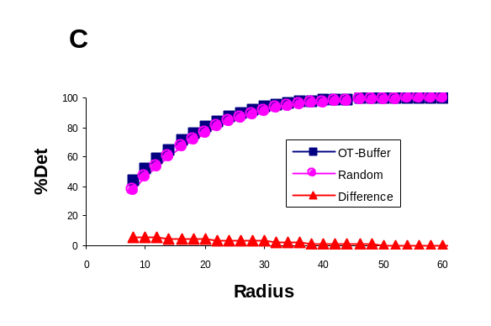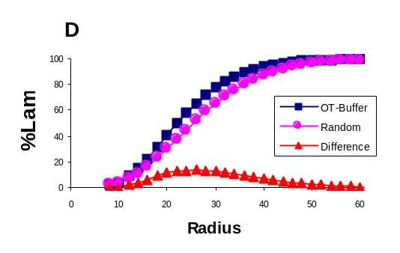

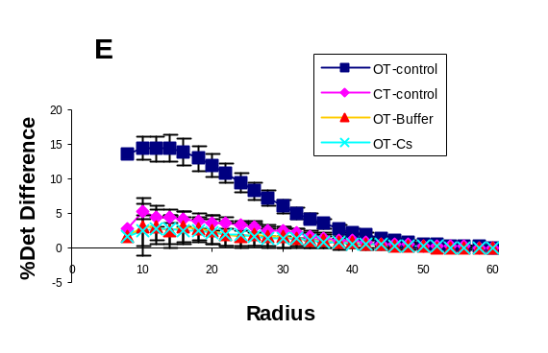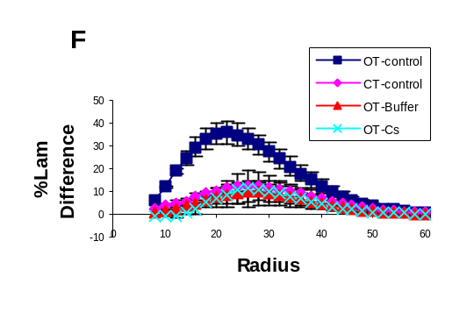
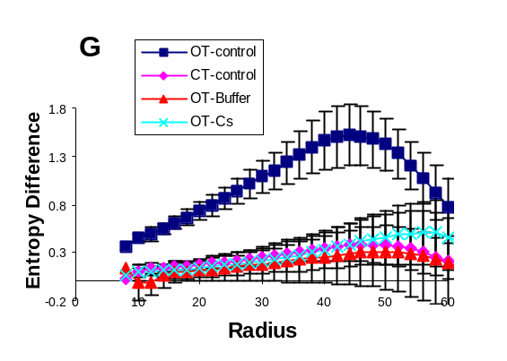
Figure 13 RQA of Dwell time of RyR channel
Cytosolic free Ca²⁺ was 1 µM, luminal Ca²⁺ was 50 mM and recordings were made at 0 mV. Net Ca²⁺ current was in the lumen-to-cytosol direction. Only recordings with a stationary Po ~0.2 were used. Open and closed dwell times were measured and their sequences preserved. A. %DET vs. radius plots generated from open dwell time sequences. Squares represent analysis of the raw sequences. Diamond represents mean analysis of same sequence after it was 10 times randomized. Triangles represent the raw-randomized difference. B. %LAM vs. radius generated from open dwell time sequences. Analysis and symbol notation used here is like that for part A. C. %DET vs. radius plots from open dwell time sequences recorded in the presence of 3 mM cytosolic DiBrB (a fast Ca²⁺ buffer). Analysis and symbol notation used here is like that for part A. D. %LAM vs. radius plots from open dwell time sequences recorded in the presence of 3 mM cytosolic DiBrB (a fast Ca²⁺ buffer). Analysis and symbol notation used here is like that for part A.E. Summary difference plots of raw data and randomized data reflecting dwell time sequences collected from 3-6 different RyR2 channels. Squares and diamonds represent average %DET difference generated from open and closed dwell time sequences, respectively. Triangles and crosses represent averaged results from open time sequences recorded with cytosolic DiBrB present or with Cs⁺ (instead of Ca²⁺) current, respectively. F. Summary %LAM difference plots of raw data and randomized data reflecting dwell time sequences. Analysis and symbol notation used here is like that for part E. G. Summary Entropy difference plots of raw data and randomized data reflecting dwell time sequences. Analysis and symbol notation used here is like that for part E. Error bars are standard errors.

Figure 12A shows the example of recurrent plot of native open dwell time series when Ca²⁺ was charger carrier. Figure 12B shows the recurrent plot of same open dwell time series after shuffling. Figure 12A has more structure than that of Figure 12B. So next I quantify the difference of deterministic structure.
Figure 13A (left) shows a sample raw determinism calculation (squares) from an open time (OT) sequence collected in the control condition. This OT sequence was then shuffled (10 times) and the calculation repeated (diamond labeled shuffled). The difference between the raw and randomized %determinism (triangles) is presented to better illustrate how the data set (raw vs. shuffled) differ. Figure 13B (right) is similar analysis as A, but %LAM as analyzing variable. Figure 13C and 13D are analogous analysis of %determinism and %LAM from an OT sequence collected in the DiBrB condition. The raw-shuffled difference (triangles) also shown. The deterministic structures in the raw data present in the control OT’s (Figure 13A and 13B, triangles) was not present in the DiBrB condition (Figure 13C and 13D, triangles).
%DETerminism, %LAM and entropy differences were pooled and averaged results are presented in Figure 13E, 13F and 13G. Figure 13E shows that the %determinism difference was substantially greater in the open time (squares) compared to closed time (CT, diamonds) sequences. This indicates that there are deterministic structures of OT’s, but not CT’s. Figure 13E also shows the average OT determinism difference from channels recordings done in the DiBrB (red triangles) and Cesium (blue cross) conditions. The OT determinism difference in the DiBrB and Cesium conditions were also reduced. Figure 13F and 13G shows that %LAM and the average entropy difference in the same 3 experimental groups. The %LAM and entropy in the OT control group were substantially greater than in the CT, OT-DiBrB or OT-Cs⁺ groups. These recurrence results indicate that the deterministic component present in the open time sequence is Ca²⁺ flux dependent. In other words, Ca²⁺ flux passing the open RyR2 channel somehow influences (or determines) the duration of future open events and this makes RyR2 gating non-Markovian.

2. Flux Dependent Inhibition of Single RyR2 Channel Activity
Xu and Meissner (1998) argued that fast cytosolic buffering (20 mM BAPTA) increases Po of caffeine-activated RyR2 channels by protecting the cytosolic Ca²⁺ inhibition site, but not the cytosolic Ca²⁺ activation site, from Ca²⁺ fluxing through the channel. Conductances of Ca²⁺ and Mg²⁺ through an open RyR2 pore are similar (103 and 80 pS, respectively) when 50 mM luminal Ca²⁺ or Mg²⁺ are the only charge carrier present. These two ions also act with similar IC₅₀’s the RyR2 cytosolic inhibition site (6.2 and 5.3 mM, respectively). The capacity of a lumen-to-cytosol Ca²⁺ or Mg²⁺ flux to inhibit single RyR2 channels is shown These observations were used to help design the following experiments to quantify influence of Ca²⁺ or Mg²⁺ flux (lumen-to-cytosol direction) on the cytosolic inhibition site (Figure 14). First, cytosolic Ca²⁺ and Mg²⁺, in our hands, inhibits single RyR2 channels by acting at the cytosolic inhibition site
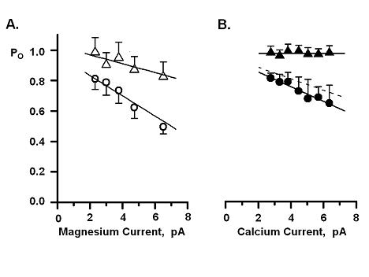
Figure 14. Flux Dependent Inhibition of Single RyR2 Channel Activity.
Cytosolic free Ca²⁺ was 7 µM and luminal divalent (Ca²⁺ or Mg²⁺) was 50 mM. Net lumen-to-cytosol divalent current was varied by changing membrane potential. Measurements of Po were made from 4 minute recordings, results are plotted as means±SEM and each value represents 6-9 RyR2 channels. A. Increasing Mg²⁺ flux reduced Po in the absence (open circles) and to a smaller extent in the presence of 3 mM cytosolic DiBrB (open triangle). Linear regressions shown had slopes of -0.064 and -0.027 Po/pA. B. Increasing Ca²⁺ flux reduced Po in the absence (filled circles) but not in presence of 3 mM cytosolic DiBrB (filled triangle). Linear regressions shown had slopes of -0.048 and -0.00007 Po/pA.

nearly equal IC₅₀’s, 6.2 and 5.3 mM respectively. To isolate the action of Ca²⁺ /Mg²⁺ fluxes on the cytosolic inhibition site, the cytosolic bath Ca²⁺ was set at 7 μM. This is >4 times more than the Ca²⁺ EC₅₀ of the cytosolic activation site (1.6 μM) but >800 times less than the Ca²⁺ IC₅₀ the cytosolic inhibition site. Thus, Ca²⁺ or Mg²⁺ passing through the channel will find the activation site largely occupied and the inhibition site largely empty.

The luminal Ca²⁺ was set at 50 mM so that the luminal RyR2-resident process was saturated. The amplitudes of the luminal-to-cytosolic Mg²⁺ flux and Ca²⁺ flux (Figure 14B) was varied by changing membrane potential (-10 to 40 mV). The Po decreased with increasing Mg²⁺ flux both in the absence (Figure 14A, open circles; -0.064 Po/pA) and presence (Figure 4A, open triangle; -0.027 Po/pA) of 3 mM cytosolic DiBrB. Note that cytosolic buffering did change the slope of the relationship. The Po also decreased with increasing Ca²⁺ flux in the absence of DiBrB (Figure 15B, filled circles; -0.048 Po/pA). In the presence of cytosolic buffer (Figure 14B, filled triangle) essentially no flux-dependent inhibition was detected (-0.00007 Po/pA). Thus, fast cytosolic buffering reduced the rate of flux-dependent Mg²⁺ and Ca²⁺ inhibition but increased Po. This is consistent with previous observations with Ca²⁺ flux action on caffeine activated channels (Tripathy and Meissner, 1996; Xu and Meissner, 1998).
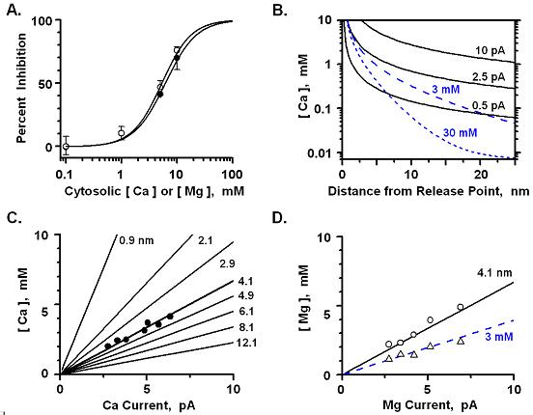
Figure 15. Cytosolic Ca²⁺ Inhibition Site is 4.1 nm from the Pore.
The pore program was used to calculate concentration profile as function of distance from a Ca²⁺ current point source (pore). A. Steady state cytosolic Ca²⁺ (filled circles) or Mg²⁺ (open circles) percent inhibition. Initial Po measured in 100 µM cytosolic Ca²⁺. Cesium was the charge carrier and all measurement made at 0 mV. B. Local free Ca²⁺ concentration profiles for different Ca²⁺ currents (pA) without (solid lines) and with two concentrations of a diffusible buffer present (DiBrB; dashed lines). Buffer profiles were generated assuming a 2.5 pA Ca²⁺ current. C. Calculated concentration profiles re-plotted as function of Ca²⁺ current amplitude (no buffer present) at set distances from the pore. Distances are labeled. The Ca²⁺ flux dependent inhibition (Po/pA) shown initially in Figure 3A were transformed into [Ca]/pA units using the steady state cytosolic Po inhibition relationship presented in panel B. The transformed points were then plotted here (filled circles) and fall on the concentration profile which represents a point 4.1 nM from the Ca²⁺ release point. D. Transposed Mg²⁺ flux dependent inhibition from Figure 3B without (open circles) and with 3 mM cytosolic DiBrB present (open triangles). Lines represent the calculated Mg²⁺ concentration profiles for the 4.1 nm point without (solid) and with 3 mM cytosolic DiBrB present (dashed).

Figure 14B suggests that the cytosolic 3 mM DiBrB used here can completely eliminates Ca²⁺ flux influence on the cytosolic inhibition site. Assuming Ca²⁺ & Mg²⁺ and k_{on}’s are essentially diffusion limited, the “Pore” program (applied in Figure 15) predicts that DiBrB should buffer local Mg²⁺ almost as effectively as Ca²⁺. The DiBrB, however, did not completely eliminate Mg²⁺ flux-dependent inhibition. The reason could be that Mg²⁺ is also inhibiting by competing with bath Ca²⁺ at the cytosolic activation site and it has been suggested that the cytosolic Ca²⁺ activation site is buffer inaccessible (Xu and Meissner 1998). The buffer sensitive Mg²⁺ flux-dependent inhibition was estimated by subtracting the slopes in Figure 14A. The result is plotted as the dashed line in Figure 14A. This implies that the rate and degree of buffer sensitive flux-dependent inhibition was similar regardless of whether the charge carrier was Ca²⁺ or Mg²⁺. In other words, Ca²⁺ or Mg²⁺ flux have similar actions at the cytosolic inhibition site.
The buffer sensitive flux-dependent inhibition data (Figure 14) was used to estimate the distance of the cytosolic inhibition site from the cytosolic point source of the Ca²⁺ /Mg²⁺ flux. First, I measured the effectiveness of Ca²⁺ (closed circles) and Mg²⁺ (open circles) to inhibit single RyR2 channels when the ions are applied directly to the cytosolic side of the channel when Cs⁺ was charge carrier (Figure 15A). Second, the “Pore” program was used to estimate the theoretical local free Ca²⁺/Mg²⁺ profiles from a Ca²⁺/Mg²⁺ point source. Assuming the point source is the RyR2 pore, profiles for 3 different unit Ca²⁺ currents (0.5, 2.5 & 10 pA) and 2 different DiBrB concentrations (3 & 30 mM with 2.5 pA) are shown in Figure 15B. Third, the flux-dependent inhibition (Po/pA) shown in Figure 14 was then transformed using the Po/[ion] results shown in Figure 16A to predict the relationship between effective [ion] and current amplitude (pA). The transformed Ca²⁺ flux data (no buffer present) are compared to “Pore” program estimates in Figure 15C. The results are consistent with the cytosolic inhibition site being 4.1 nm from the RyR2 pore. The transformed Mg²⁺ flux data (with and without buffer present) are compared to “Pore” program estimates (for 4.1 nm) are shown in Figure 15D. The Ca²⁺ (no buffer), Mg²⁺ (no buffer) and the Mg²⁺ (with 3 mM buffer) results are all consistent with the cytosolic inhibition site being 4.1 nm from the RyR2 pore.

3. Flux-Dependent RyR2 Regulation at Physiological Flux Amplitudes
The unit Ca²⁺ current carried by a single RyR2 channel in cells is just less than 0.5 pA (Mejia-Alvarez et al., 1998; Kettlun et al., 2003). Signal-to-noise considerations make it difficult to accurately measure Po at unit current is less than 0.75 pA. Consequently, flux dependent activation here was the presence of multiple current carriers (Ca²⁺ and Cs⁺). Sample single channel recordings made during voltage ramps are shown at Figure 16A, when 50 mM luminal Ca²⁺ was the only charge carrier present (red) and then after addition of 200 mM Cs⁺ to the cytosolic side of the channel (black). Multiple long open
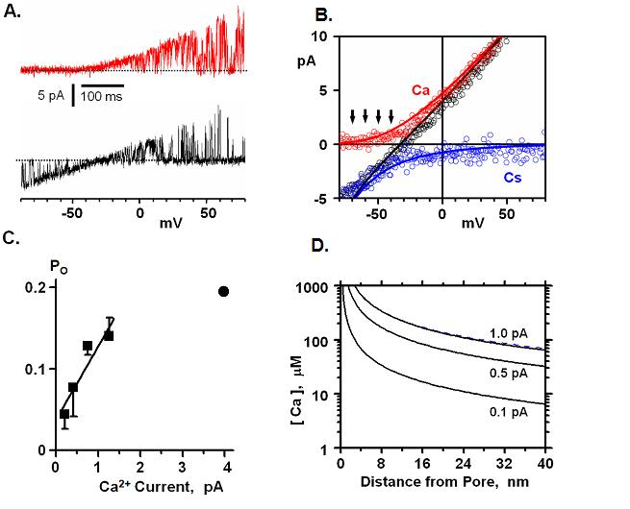
Figure 16. Flux Dependent regulation at Physiological Flux Amplitudes.
A. Sample single channel sweeps are recorded during membrane potential. These recordings were made when Ca²⁺ was the only charge carrier (top) and after addition of 200 mM cytosolic Cs⁺ (50 mM luminal Ca²⁺ still present). Cytosolic Ca²⁺ was 1 µM and zero current level is marked by a dotted line. B. Corresponding current-voltage plots is generated from part A. Large circles represent Ca²⁺ only current. Small circles represent the measured Ca-Cs net current. Black line is the predicted (not fit) current for these ionic conditions using the Gillespie et al. (2005) RyR permeation model. Red and blue lines are the predicted unidirectional Ca²⁺ and Cs⁺ current components. Arrows indicate potentials at which Po determinations were made. C. Average Po values (filled squares; n=4 to 8 channels) are plotted at right as a function of unidirectional Ca²⁺ current. Linear regression slope is 0.09 Po/pA. Filled circles represents the 1 µM cytosolic

Ca²⁺ (no Mg/ATP) point from Figure 8A. D. Local free Ca²⁺ concentration profiles for different Ca²⁺ currents (pA) including the physiologically relevant unit current.

events from multiple recordings like these were combined to generate the color coded current-voltage (I-V) plots shown in Figure 16B. The lines represent predictions (not fits) from the Gillespie et al. (2005) model of RyR permeation. The predicted unidirectional Cs⁺ current contribution is shown in blue. The arrows indicate voltages where the unidirectional (lumen-to-cytosol) Ca²⁺ flux is 0.22, 0.42, 0.76 and 1.2 pA, respectively. At all these points, the overall net current is in the opposite direction (-5.1, -3.5, -2.1 and -0.85 pA, respectively). These small lumen-to-cytosol Ca²⁺ fluxes do activate the channel and this is shown in Figure 16C (squares). Here, the steady state cytosolic free Ca²⁺ was 1 μM and the average Po values determined from long recordings on multiple channels is shown. The Po increased as the unidirectional Ca²⁺ flux increased (0.089 Po/pA). The circle represents the 1 μM Ca²⁺ steady state point from Figure 8A.
Figure 16D shows how Ca²⁺ concentration should change with distance from the open pore over a range including the physiologically relevant unit current. The cytosolic domain of the RyR2 channel is ~30 nm wide. If its pore is at its geometric center, then clearly all of the protein must be within 20 nm of the pore. The predicted Ca²⁺ diffusion profiles shown in Figure 16D show that even small unit Ca²⁺ currents should elevate local Ca²⁺ to more than 7 μM within 40 nm of the pore. However, our study shows that 7 μM cytosolic Ca²⁺ almost maximally activates the RyR2 channel (Po > 0.75) when there are small unit Ca²⁺ currents (<3 pA; Figure 14B). Thus, the cytosolic Ca²⁺ activation sites appears to “see” the flux but appears to “see” from a distance much greater than the known physical dimensions of the entire RyR2 channel structure. The simplest explanation for this is that the RyR2’s cytosolic Ca²⁺ activation site is kind of protected from its own Ca²⁺ flux. Lastly, the physiological Ca²⁺ flux (0.5 pA) should elevate local free Ca²⁺ to 330 μM at 4.1 nm, the estimated distance of the cytosolic Ca²⁺ inhibition site from the pore (see Figure 15C & 15D). The Ca²⁺ IC₅₀ of this inhibition site measured in this study was 6.2 mM.

D. Discussion
I studied the effect of luminal Ca²⁺ feedback on cytosolic regulatory site at single-channel level. Our present studies show that the SR luminal to cytosolic Ca²⁺ fluxes can regulate the activity of RyR2 channel by accessing to the cytosolic regulatory sites (both activation and inactivation sites).
Single RyR2 channels are subject to flux dependent regulation. The Ca²⁺ flux passing through an open RyR2 channel (direction) acts on both cytosolic Ca²⁺ activation and inhibition sites. This makes RyR2 gating dependent on previous events (i.e. non-Markovian). The degree of flux dependent regulation depends on the amplitude of the unit Ca²⁺ current and presence of diffusible fast Ca²⁺ buffers. Flux dependent activation was observed at physiologically relevant Ca²⁺ currents. The results indicate the cytosolic inhibition site is 4.1 nm from the cytosolic Ca²⁺ current point source (i.e. the pore) and Ca²⁺ arriving at this site from the cytosolic bath or via the lumen-to-cytosol flux are equally effective. In contrast, the cytosolic activation sites seem to be substantially less sensitive to fluxed Ca²⁺ compared to the steady state bath Ca²⁺.
Fabiato (1985) suggested that the inherent positive feedback associated with CICR in heart is countered by the negative feedback of Ca²⁺ dependent inactivation. The negative feedback proposed involves Ca²⁺ binding to a cytosolic site on the SR Ca²⁺ release channel and terminating release by making the channel Ca²⁺ refractory. This possibility is still debated. The release channel is now known to be the RyR2 and several single RyR2 channel attributes have been defined in planar lipid bilayer studies. One well-defined attribute is the channel’s bell-shaped steady-state cytosolic Ca²⁺ sensitivity. Micromolar cytosolic Ca²⁺ activates it (EC₅₀ ~2 μM) while millimolar cytosolic Ca²⁺ levels inhibit it (IC₅₀ ~5 mM). This steady state inhibition is often referred to as inactivation. However, there is little evidence that this inhibition renders the channel refractory (Gyorke and Fill 1993; Valdivia, Kaplan et al. 1995; Fill, Zahradnikova et al. 2000; Fill and Copello 2002) and such inhibiting Ca²⁺ levels in cells would only exist very close to the open RyR pore (Stern 1992). A second well known attribute of the RyR2 channel is that it is activated by cytosolic ATP or caffeine and inhibited by cytosolic Mg²⁺ (Xu, Mann et al. 1996; Donoso, Aracena et al. 2000; Copello, Barg et al. 2002; Fill and Copello 2002; Zahradnikova, Dura et al. 2003). The combined action of Mg²⁺ and ATP (at their normal physiological levels) is to shift the cytosolic Ca²⁺ EC₅₀ to ~10 μM and increased occupancy of the cytosolic inhibition site because this site does not discriminate between Ca²⁺ and Mg²⁺. A third established single RyR2 attribute relevant here is that RyR channels are poorly selective and conduct both divalent and monovalent, such as Cs⁺, Ca²⁺ and Mg²⁺ well (Tinker, Lindsay et al. 1992; Tinker and Williams 1992; Tinker, Lindsay et al. 1993; Chen, Xu et al. 1997; Gillespie, Xu et al. 2005). The influence of Mg²⁺ on RyR function is often ignored but likely substantial particularly considering that it is present at millimolar level inside and outside the SR. Also, the high dehydration energy of Mg²⁺ (compared Ca²⁺) to implies that ion dehydration is not a rate limiting step in the RyR ion permeation mechanism.
Recently, the possible roles of luminal (intra-SR) Ca²⁺ on single RyR2 channel function have been a popular target of study (Beard, Laver et al. 2004; Gyorke, Hester et al. 2004; Beard, Casarotto et al. 2005; Kubalova, Terentyev et al. 2005; Terentyev, Nori et al. 2006; Laver 2007). Intra-SR Ca²⁺ may alter single RyR2 function by, 1) binding to calsequestrin (CSQ) which acts as a luminal RyR2-remote Ca²⁺ sensor, 2) binding to a luminal RyR2-resident Ca²⁺ regulatory site on the channel itself and/or, 3) acting on cytosolic Ca²⁺ regulatory sites after permeating through the open channel. The second possibility had been defined by our lab’s previous results. Here my study defines features of the last possibility. The potential significance of this work may be appreciated by considering the following. The most fundamental form of CICR positive feedback would be Ca²⁺ coming through the open RyR2 and binding/acting at the cytosolic Ca²⁺ activation site. On the other hand, preferential access of permeating Ca²⁺ to the cytosolic inhibition site would represent a form of Ca²⁺ negative feedback a Ca²⁺ dependent inactivation. Defining local RyR2 Ca²⁺ regulation is clearly important to understanding control of the CICR process in heart (Bers 2001; Stern and Cheng 2004).

1. Regulation by a Luminal RyR2-resident Ca²⁺ Regulatory Site
The RyR2-remote (CSQ) and Ca²⁺ feed-through possibilities need to be controlled in order to define the regulation by a luminal RyR2-resident site. In our studies, native RyR2 channels may have had some CSQ associated. Other labs have clearly shown that CSQ dissociates from the RyR in bilayers when the luminal Ca²⁺ concentration is higher than ~5 mM (Gyorke, Hester et al. 2004; Beard, Casarotto et al. 2005). All of our studies were done with either 10 or 50 mM luminal Ca²⁺ present and thus any CSQ present would have dissociated shortly after channel incorporation into the bilayer. One of our lab’s previous result showed that RyR channel activity is regulated by a luminal RyR2-resident Ca²⁺ regulatory site. In that study, both Ca²⁺ and Mg²⁺ activate RyR channel by activating a luminal RyR2-resident regulatory site (Qin, Valle et al. 2008). The results from that experiments indicate that, 1) the RyR2 channel does have a RyR2-resident (CSQ-independent) luminal Ca²⁺ regulatory site, 2) the site’s EC₅₀ is within the physiologically relevant luminal Ca²⁺ concentration range and, 3) the site does not discriminate between Ca²⁺ and Mg²⁺. 4) this site would be ~70% occupied in the normal resting condition (1 mM Ca²⁺/Mg²⁺) but ~90% occupied if intra-SR Ca²⁺ is increased to 5 mM Ca²⁺. So the luminal regulation cannot explain the difference results showed in Figure 8, 9 and 10. The only possibility to explain the difference is feed through mechanism.

2. Flux-Dependent Regulation of Single RyR2 Channels
Several single RyR2 studies have reported that Ca²⁺ flux in the lumen-to-cytosolic direction can alter channel function by acting on cytosolic Ca²⁺ regulatory sites. These studies were done with either caffeine or ATP present. It is well established that caffeine or ATP potentiates the cytosolic Ca²⁺ sensitivity of the channel. This does make detection of a flux-dependent regulation easier. It also complicates the physiological interpretation of the results obtained. Here, flux-dependent regulation is systematically defined (for the first time) without the cytosolic Ca²⁺ sensitivity of the channel potentiated. The results demonstrate that, 1) Ca²⁺ or Mg²⁺ flux in the lumen-to-cytosolic can influence RyR2 regulation by acting at both the cytosolic Ca²⁺ activation and inhibitions sites, 2) the flux has preferential access to the inhibition site and, 3) the net influence of the flux is limited to a relatively small change in the overall cytosolic Ca²⁺ sensitivity of the channel.
First, one could argue that ATP is a physiological ligand and thus it is not fair to categorize it as an “abnormal” Ca²⁺ sensitivity agonist. In cells, cytosolic Mg²⁺ and ATP operate in concert (never in the absence of the other). In previous bilayer studies addressing flux-dependent regulation (Tripathy and Meissner 1996; Xu and Meissner 1998; Laver 2007), cytosolic ATP was applied alone (in absence of Mg²⁺). The action of ATP on cytosolic Ca²⁺ sensitivity from one of these works (Laver 2007) is presented in Figure 10A (bottom, dotted line). In cells, it is clear that the RyR2 channel is largely closed (Po<0.05) at resting cytosolic Ca²⁺ levels (0.1 μM). Figure 10A shows Po at 0.1 μM is > 0.25 if caffeine (5 mM) or ATP alone are present. This is an “abnormal” Ca²⁺ sensitivity agonist if it is applied in the absence of cytosolic Mg²⁺ (as it has been in previously (Tripathy and Meissner 1996), in that determines the effective cytosolic Ca²⁺ sensitivity of the RyR2 channel. Indeed, Mg²⁺ and ATP when added together reduce, not potentiates, the cytosolic Ca²⁺ sensitivity of the channel (Figure 8 and 9). When ATP is applied alone (without Mg²⁺), it results in abnormal potentiated Ca²⁺ sensitivity. The activation site gating properties are strongly affected by cofactors such as ATP, caffeine and sulmazole (Laver 2007). On their own, these cofactors do not trigger channel openings; instead, they function to enhance RyR response to cytoplasmic Ca²⁺. Our experimental conditions eliminate this abnormal potentiation and reflect more realistic microenvironment near the cytosolic regulatory sites.
There is now some evidence that the Ca²⁺ flux through the RyR pore is sufficient to raise the local [Ca²⁺] enough to cause activation of RyRs. But all experimental conditions had cofactors in cytosolic site, such as ATP and caffeine. I did not include these cofactors in cis chamber to eliminate impact of these cofactors. Our results showed that an increase in the luminal Ca²⁺ fluxes from 0 to 8 pA led to biphasic change of RyR channel activity. Channel activity reached maximum at an estimated Ca²⁺ flux of 4 pA and declined slowly as the Ca²⁺ fluxes increased further (Fig 13). But maximal Po is only 10%, which is much less than the maximal activity that RyR can reach. This result is consistent with Tripathy and Meissner’s result. In the study of Tripathy and Meissner (1996), Channel activity was at a maximum (25-30%) at an estimated Ca²⁺ flux of - 1.25 pA and declined slowly as the Ca²⁺ fluxes increased further. The reason that the peak Po at different luminal Ca²⁺ fluxes may be due to different cytosolic Ca²⁺ concentration and ATP application. In Tripathy’s study, they used 2mM ATP and 45nM cytosolic Ca²⁺. Different cytosolic Ca²⁺ concentration may change the local Ca²⁺ concentration at cytosolic Ca²⁺ regulatory sites. ATP application may shift the Ca²⁺ sensitivity curve (see Figure 10A). All these different experimental conditions may lead the different local environment at regulatory sites of RYR channel and cause the different reaction of channel to local environment.

3. Nonlinear dynamics analysis of open dwell time series of RyR channel
If Ca²⁺ flux through the channel is feeding back and regulating at cytosolic sites, then earlier open times should have impact on later open times, which means future openings/closings would not be stochastic and/or independent of previous events. So the flux-dependent regulation should be evident in dwell time analysis. In our hands, inherent channel-to-channel variability in dwell time determinations makes it difficult to consistently detect statistically significant differences between different dwell time classes using traditional linear methods. And other reason is that feedback regulation will not be linear regulation at this point. Thus, nonlinear dynamics method recurrence quantification analysis (RQA) is an ideal alternative. Recurrence quantification analysis (RQA) was introduced by Webber and Zbilut (Webber and Zbilut 1994). RQA is a geometrical technique that searches for repeated event sequences. RQA is an efficient time-series analysis method based on nonlinear dynamics theory. RQA, unlike other time and frequency domain techniques, is able to detect state changes in drifting dynamical systems without necessitating any a priori rigid constraints on data set size, stationarity, or particular statistical distribution (Filligoi and Felici 1999).
Webber and Ziblut used RQA to analyze Na+ channel and found that there is no difference of %DET between native and randomized open time data (Webber and Zbilut 1998). To our knowledge, this is the first time to use RQA analysis to analyze dwell times of RyR and found non-Markovian process in ion channel data. Traditionally, ion channel gating has been treated as stochastic or Markovian process (Saftenku, Williams et al. 2001; Rosales, Fill et al. 2004). This means that gating of channel is independent. Previous openings have no effect on latter ones. Nonlinear dynamics or chaos analysis had been provided some theoretical models on ion channel gating (Liebovitch and Todorov 1996; Brazhe and Maksimov 2006), but none of the models have been used in real channel gating analysis. Our results showed that open dwell time series of RyR2 has a larger difference between the raw and randomized %determnism (%DET). Similar results were found when using %LAMinar (%LAM) or entropy as analysis variable. %LAM measures the percentage of vertical lines which indicate the occurrence of laminar states i.e., periods of tranquility or slowly drifting dynamics. Entropy is Shanon entropy of line segments distributions. It can be used to quantify the richness of deterministic structure.

When signal is randomized, the more deterministic the input signal, the more the %DET and ENTROPY values will be affected (decreased) by randomization. So the difference of all these 3 RQA variables with randomized results provide similar information that RyR2 channel dwell open is a deterministic process rather than a stochastic process. The dwell open time of RyR2 channel is a deterministic process means that there is nonlinear correlation between open time series and this nonlinear correlation cannot be found in close time series or open time series when Cs⁺ as charge carrier. In addition, the deterministic structure of open time series when Ca²⁺ as charge carrier can be eliminated by adding buffer into the solution. This means that open time influence the future open times when Ca²⁺ as charge carrier. The buffer prevented the impact of previous opening on later ones, and then open time series became stochastic. So our results not only prove the evidence of non-stochastic process in ryanodine channel gating, but also provided the additional evidence of feed-though regulation in ryanodine channel gating.

4. Cytosolic Buffer Alters Flux-Dependent Regulation
Luminal divalent ion flux will build up a high cytosolic concentration near the pore. This high divalent ion concentration may high enough to bind to the inactivation site that near the pore and regulate the RyR2 channel activity. The fast buffer may chelate the released ions and lower their concentration around the inactivation sites and feed-through regulation should be less prominent.
Tripthy and Meissner first reported that presence of cytosolic Buffer activates channel. When fast Ca²⁺ buffer was added into cytosolic side, then RYR1 channel activity increased. Later, Xu and Meissner also reported that adding fast Ca²⁺ buffer (BAPTA) increased luminal Ca²⁺-activated channel activities and suggested that the buffer lowered Ca²⁺ concentrations at cytosolic Ca²⁺ -inactivation sites. Our study supported previous report. Cytosolic Ca²⁺ concentration was set to 7 μM for with activation sites almost saturated and inactivation sites empty. Under this condition, increased Ca²⁺ or Mg²⁺ current only decrease the Po, but Mg²⁺ reduced Po more than Ca²⁺ does. Figure 14 showed that the fast buffer (DiBrB) reduced effect of inhibition induced by Mg²⁺ and Ca²⁺. This suggested that Ca²⁺ concentration built by Ca²⁺ flux from luminal to cytosol has been lowered by fast buffer, and Ca²⁺ or Mg²⁺ released from luminal side can not affect inactivation sites. The fast Ca²⁺ buffer (DiBrB) completely eliminated the Ca²⁺ inactivation effect on RyR2 channel. The DiBrB, however, did not completely eliminate Mg²⁺ flux-dependent inhibition. One possibility is that DiBrB has relatively low affinity for Mg²⁺ and this it may have less impact on feed-through Mg²⁺ regulation. The other reason could be that Mg²⁺ still can reach cytosolic activation site and compete with bath Ca²⁺ at this activation site. Meissner suggested that the cytosolic Ca²⁺ activation site is buffer inaccessible (Xu and Meissner 1998). The buffer sensitive Mg²⁺ flux-dependent inhibition was estimated by subtracting the slopes in Figure 14A. The result is plotted as the dashed line in Figure 14B. This implies that the rate and degree of buffer sensitive flux-dependent inhibition was similar regardless of whether the charge carrier was Ca²⁺ or Mg²⁺. In other words, Ca²⁺ or Mg²⁺ flux has similar actions at the cytosolic inhibition site.

5. Distance of Cytosolic Inhibition & Activation Sites from RyR2 Pore
Xu & Meissner (1998) suggested that the cytosolic inhibition site was roughly 3 nm from the pore. An activation site is far from the pore and is inaccessible of BAPTA. The pore-to-inhibition site distance estimate here (4.1 nm) was more rigorously determined and thus more likely to be accurate. The RyR2 insensitivity to Ca²⁺ flux activation lead Xu and Meissner (1998) to propose that the cytosolic activation sites must either be very distant (≥30 nm) from the pore or somehow protected from flux-regulation. We agree that the RyR2 is remarkably insensitive to Ca²⁺ flux activation. This low sensitivity is not likely due the pore-site diffusion time (Bers 2001). It is difficult to imagine how the cytosolic activation site can be ≥30 nm particular since the channel appears to have central pore in protein structure of ≤18 nm radius (Samso, Wagenknecht et al. 2005; Serysheva, Hamilton et al. 2005). Protecting the site from Ca²⁺ flux activation would have to involve some sort of complex physical barrier, a physical repositioning of the site and/or a gating-dependent change Ca²⁺ binding site properties. This needs to be further investigated.

6. Physiological role of flux regulation in cells
What is the extent Ca²⁺ flux activation in cells? With 1 µM Ca²⁺ in cytosolic bath, we measured Po’s of 0.044±0.28 with a 0.22 pA Ca²⁺ current, 0.077±0.36 at 0.42 pA and 0.13±0.36 at 0.76 pA (see Figure. 16). Tripling lumen-to-cytosolic Ca²⁺ flux roughly tripled Po at such physiologically relevant Ca²⁺ current amplitudes. However, the extent of flux activation reaches a limit. This is demonstrated in Figure 16 where flux activation saturates at larger Ca²⁺ fluxes (>1.5 pA). What are the implications of Ca²⁺ flux activation in cells? Our results suggest that the extent of flux dependent activation in cells will decrease as RyR2 unit Ca²⁺ current becomes smaller than 0.5 pA. This is likely happen after the SR becomes Ca²⁺ depleted. Conversely, our data shows that the extent of flux dependent activation in cells will increase as unit Ca²⁺ current increases above 0.5 pA. This could occur during SR Ca²⁺ overload. Thus, a reduction in flux activation driven by a local SR Ca²⁺ depletion could help terminate Ca²⁺ release (reduce RyR2 Po). Increased flux activation upon SR Ca²⁺ overload may help explain the apparent RyR2 hyper-activity associated with overload.
The cytosolic Ca²⁺ inhibition site has a Ca²⁺ IC₅₀ 6.2 mM measured at steady state. An open channel conducting the physiologically unit Ca²⁺ current of >2.5 pA (Fig. 15B) elevates local free Ca²⁺ to >1.5 mM at a distance of 4.1 nm from the pore. This explains the flux dependent inhibition observed here at such large unit Ca²⁺ currents. The local free Ca²⁺ at 4.1 nm is substantially less (~350 µM; or 17-25 times less than the IC₅₀) for the same channel conducting a 0.5 pA Ca²⁺ current. However, cytosolic Ca²⁺ and Mg²⁺ have similar affinity and efficacy at the cytosolic inhibition site. Thus, these ions likely work in concerted at the inhibition site in cells (Lamb 2000). The steady state free Mg²⁺ concentration in cardiac muscle cells is ~1 mM and flux dependent inhibition would need to work on top of this. Since >1.5 mM local Ca²⁺/Mg²⁺ at the 4.1 nm mark was need to observe flux inhibition, the implication here is that substantial flux dependent inhibition in cells is unlikely.

CHAPTER VI

SIMILAR ALTERATION RYR2 SELECTIVITY FILTER

INDUCED BY DIVERSE PHARMACOLIGICAL AGENTS

A. Introduction
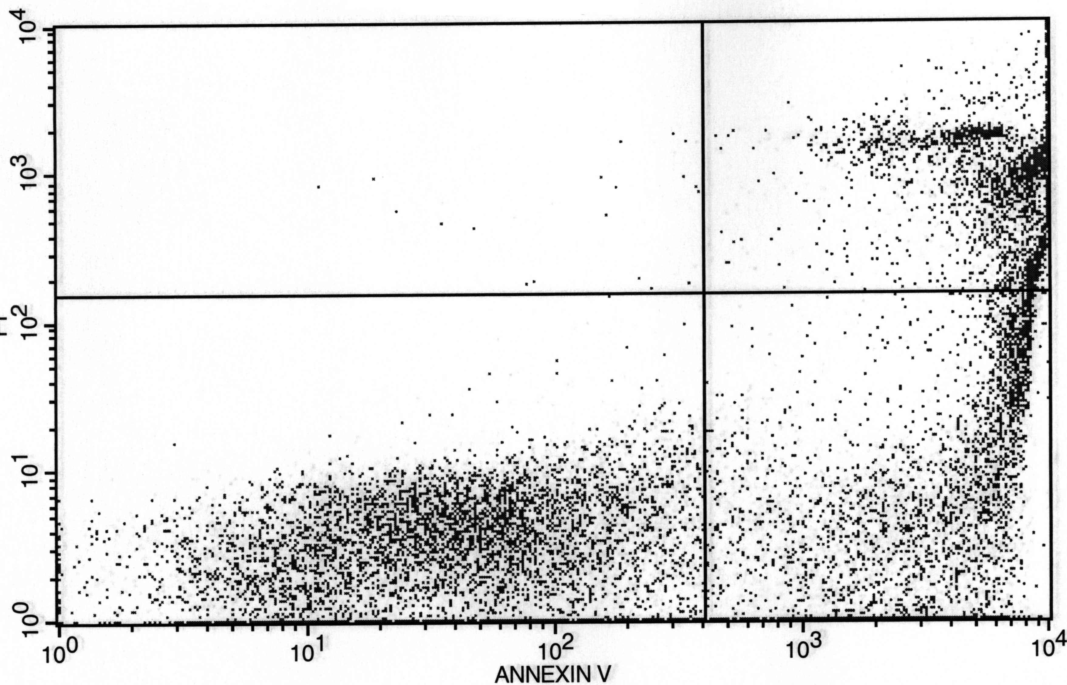
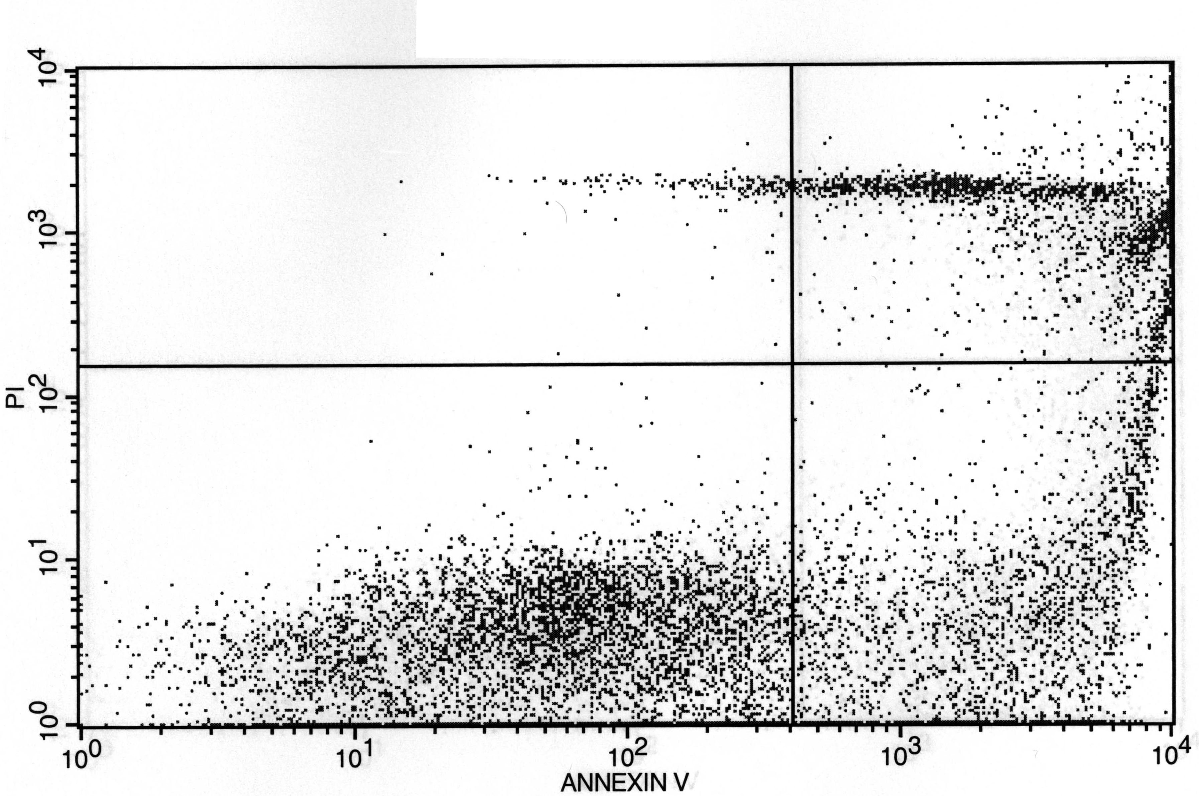
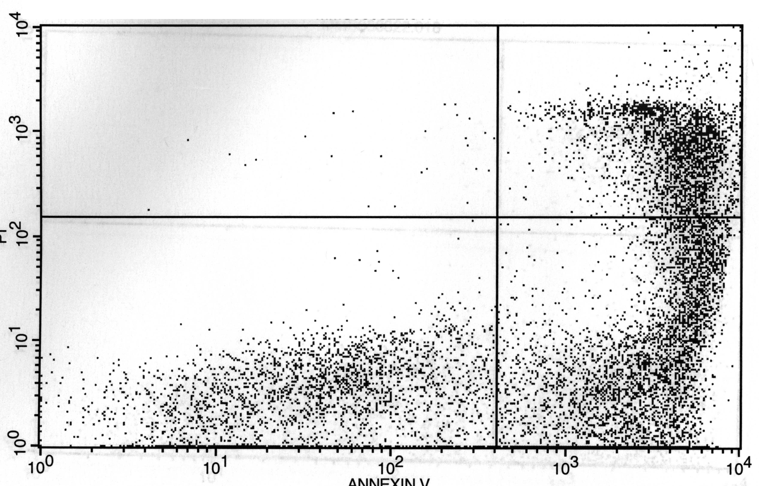
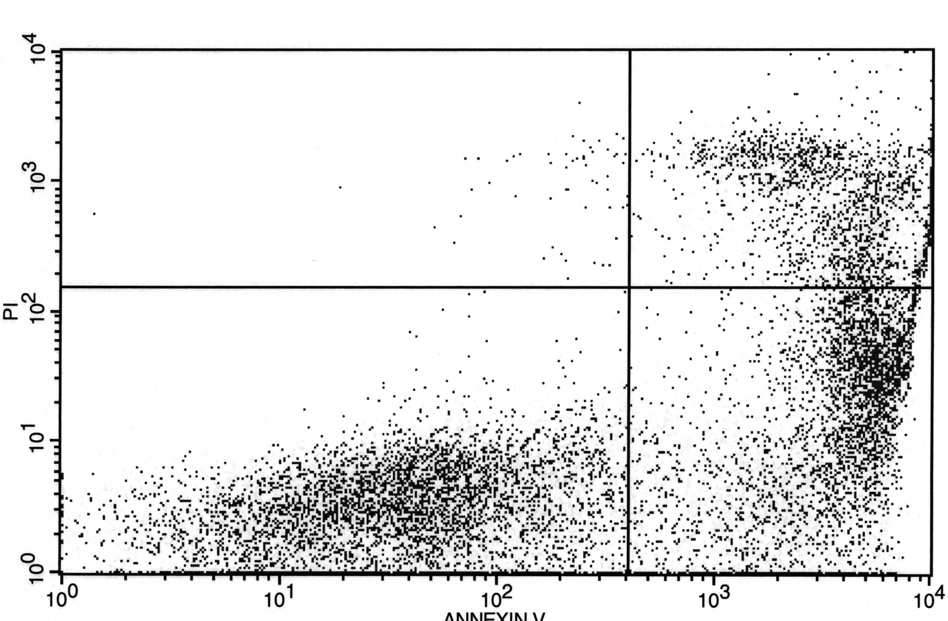
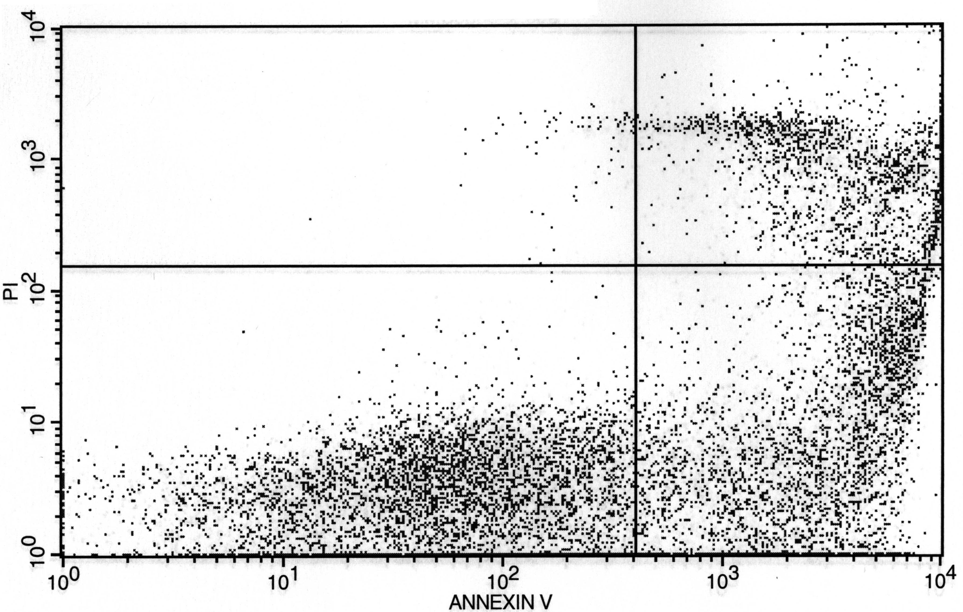
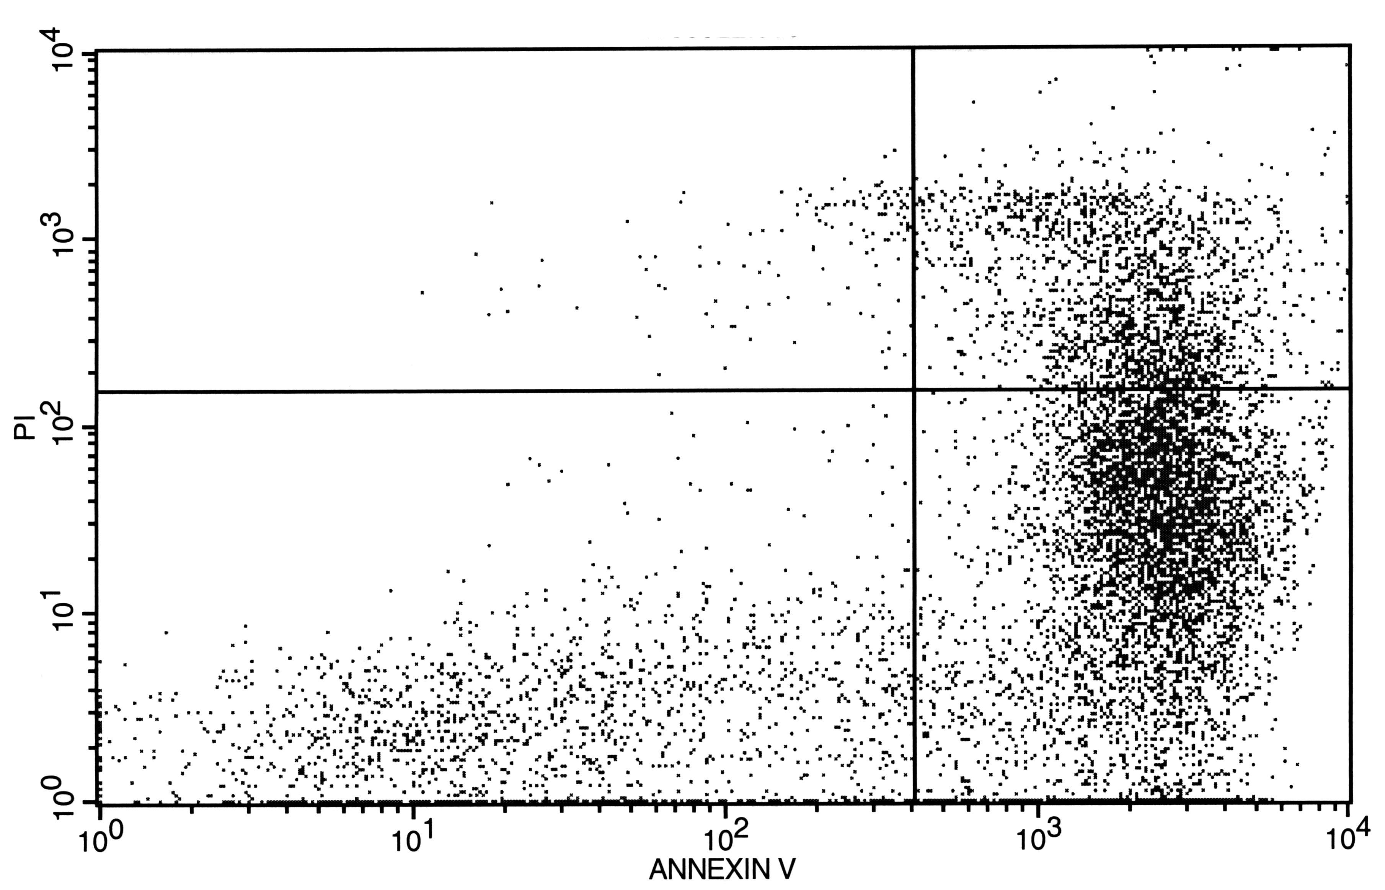
Ca²⁺ release from ER/SR through RyR channels modulates many processes, such as muscle contraction and neurotransmitter release etc. This same Ca²⁺ is also involved in the local control the very channel that mediated the flux (see previous part of the dissertation). In other words, RyR mediated Ca²⁺ flux appears to control RyR function (i.e. its open probability). The flux is defined by the permeation properties of the RyR pore that permit it to pass very large numbers of ions per unit time. These properties include the ion selectivity of the pore which is usually associated with the narrowest part of overall permeation pathway (i.e. selectivity filter). It also includes the conductance or rate of ion throughput. Intuitively, ion throughput will be defined by the selectivity filter as well as more peripheral elements (vestibules, charges, etc.) that may influence ion entry to or exit from the filter.
Sham
Burn
Sham
Burn
(−)
+ fMLP
+ Wortmannin
43.2%
44..3%
47..5%
31..9%
25..0%
40.5%
(−)
+ fMLP
+ Wortmannin
43.2%
44..3%
47..5%
31..9%
25..0%
40.5%
Current through the RyR pore will logically be a function of the electrochemical gradients and the permeable ions present. In a resting cell, the cytoplasm contains ~140 mM K⁺, ~1 mM free Mg⁺ and about 0.0001 mM free Ca²⁺ (Lodish, Berk et al. 2003). The intra-SR salt composition is less well established but is thought to contain similar K⁺ and Mg⁺ levels but ~1 mM free Ca²⁺ (Somlyo 1979). A Ca²⁺ gradient exists because the SR has an ATP driven pump and the Ca²⁺ exit pathway (the RyR channel) is closed at rest. There is not K⁺ and Mg⁺ gradients because the SR does not actively transport these ions. The high K⁺ permeability of the SR membrane is thought to keep the resting SR membrane potential at 0 mV (Abramcheck and Best 1989; Tang, Wang et al. 1989; Kamp, Donoso et al. 1998; Picard, Cote et al. 2002). Generally, the 3 RyR channel isoforms share the same pore structure and consequently have similar permeation characteristics (Williams, West et al. 2001; Fill and Copello 2002). So, better defining permeation in one of these channels very likely applies to all.
The RyR channel is permeable to several different divalent and monovalent cations (Tinker, Lindsay et al. 1992; Tinker and Williams 1992; Tinker and Williams 1993). In solutions containing only monovalent cations (e.g. ~200 mM K⁺, Na⁺, or .Cs⁺) as the main permeable species, the unitary RyR channel current-voltage relationship is linear with a slope conductance usually greater than 500 pS. In solutions containing only a divalent cation (e.g. ~50 mM Ca²⁺, Mg²⁺, Ba²⁺, or Sr²⁺ on the luminal side of the channel), the unitary current-voltage relationships typically has a maximum slope conductance near 100 pS. For comparison, the classic large conductance Ca²⁺-activated K⁺ channels (maxi-K_{Ca} channels) on the surface membrane of most cells has a maximal K⁺ conductance of near 250 pS and is very monovalent selective. The unitary Ca²⁺ conductance of the classic L-type Ca²⁺ channel on the surface membrane is no more than ~20 pS and it is very Ca²⁺ selective (e.g. P_{Ca}/P_{K} typically >1000).
The selectivity of the RyR pore has been experimentally defined. The pore shows very little selectivity between different monovalent cations (K⁺, Na⁺ or Cs⁺). It shows very little selectivity between different divalent cations (Ca²⁺, Mg²⁺, Ba²⁺ or Sr²⁺). However, the pore does modestly discriminate between mono- and divalent cations (e.g., P_{Ca}/P_{K} ~6) and highly discriminates against anions. Thus, the RyR is a very high conductance, relatively poorly selective Ca²⁺ channel.
Ryanodine is reported to change the conformation of the RyR channel and this conformational change results in modification of its cation conduction and selectivity. The selectivity changes from PCa/PK~6.5 to PCa/PK~3.4 after ryanodine modification and the conductance of the open pore is reduced in half (Tinker and Williams 1992; Lindsay, Tinker et al. 1994). The most notable aspect of ryanodine modified channels is that the transition to this state is sudden and prolonged. Some other pharmacological agents (ryanodol, IpTx, TFP, AMT and suramin) also generate long-lived RyR subconductance states. Although agents have qualitatively similar action on RyR permeation, these agents have very different chemical structures (Figure 17). My goal here is to determine if these diverse agents act by different mechanisms or whether their actions share a common mechanism. The results should increase our understanding of what determines RyR Ca²⁺ flux.
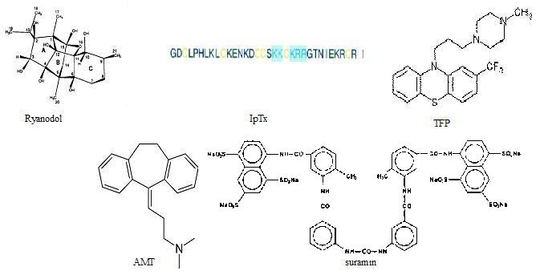

Figure 17. Structure of agents modifying conductance.

B. Specific Materials and Methods
Microsomes rich in cardiac RyR channels (RyR2) were isolated from rat ventricle muscle using standard methods. Planar lipid bilayers were prepared as the same as in method part. One compartment (trans) was filled with 250 mM HEPES and 50 mM Ca(OH)2 at (pH 7.4). The other compartment (cis) was held at virtual ground and initially contained HEPES-TRIS (pH 7.4). After currents were observed, the cis chamber was perfused at 4 ml/min (for 5 min) with a 100mM Cs-HEPES solution (pCa 6, pH 7.4).
All chemical and drugs were obtained from commercial sources. Ryanodol was generated from high purity commercially available ryanodine. The agents that modified RyR2 conductance were added to the cis solution. Single channel currents were digitized at 20 kHz and filtered at 1 KHz using a Bessel filter for analysis. Voltage ramps from –60 to 60 mV were applied and reversal potential (RP) determined. The PCa/PCs selectivity ratio was determined using equation mentioned in data analysis part.

C. Results

1. Conductance of drug modified channel
The trans chamber contained 50 mM Ca(OH)₂, and 250mM HEPES (pH=7.4). The cis chamber solution contained 250 mM HEPES-Tris (pH = 7.4). Pharmacological agents were added in cis chamber. The concentration of these agents are as follows: 50 µM for Ryanodol, 100 nM for IpTx-A, 10 mM for TFP
, 10 mM for AMT and 2 mM for Suramin. The holding potential is 0 mV due to subcondutance is voltage dependent. At 0 mV, both substate and normal full opening can be recorded.

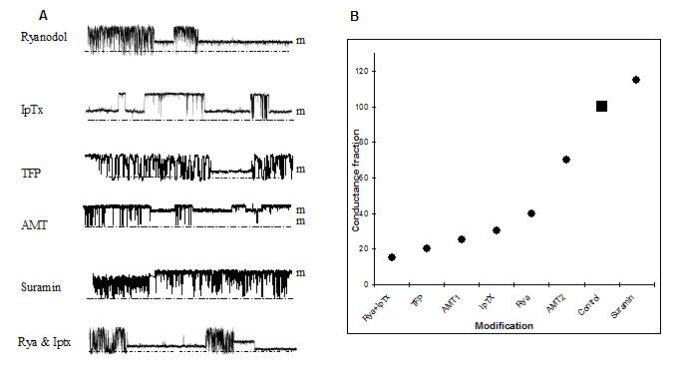
Figure 18. Example of subconductance induced by different agents at 0 mV holding potential.

50 μM Ryanodol induces about 50% normal conductance. IpTx induces about 35% normal conductance. Ryanodol and IpTx induces 3 subconductance with pure ryanodol or IpTx action and additional additive subconductance state (bottom trace). TPF induces about 22% of normal conductance. AMT induces 2 type of subconductance. One is 70% of full opening and the other is 30% of normal conductance. Suramin enlarges conductance to 110% of normal full opening.

Ryanoids, like ryanodine or ryanodol, modify the gating and permeation of single RyR channels. I chose to use ryanodol because of its low affinity for the RyR channel. Application of 50 µM ryanodol (a low affinity ryanodine derivative with K_{D} ~40 µM) induces intermittent long-lived subconductance states (Figure 18). Washout of ryanodol eliminates the intermittent substates (Figure 18 in part 1). Ryanodol is made from ryanodine in our laboratory.
Another pharmacological agent that changes RyR channel conductance is Imperatoxin A (IpTx). At the single RyR channel level, when 100 nM IpTx A was added into Cis chamber. The channel frequently entered a subconductance state and back normal open-close states. The subconductance is about 33% of normal full opening. Figure 18 top.
Figure 18 (bottom trace) shows Ryanodol was applied with Imperatoxin. In Figure 18, it shows there are 3 substates. Two are from ryanodol or IpTx, and the smallest one is the substate on substate. So the substates induced by these two drugs are additive, In other words, ryanodol will modify IpTx-modified channels and vice versa (induce a substate of a substate). This indicates that they use different mechanism to induce substate.
Trifluoperazine (TFP) is a typical antipsychotic drug of the phenothiazine group. It exerts its actions through a central adrenergic-blocking, a dopamine-blocking, and minimal anticholinergic blocking. It is a potent calmodulin inhibitor. It also has been reported that this agent can interact with calsequestrin (Park, Kim et al. 2005). Application of 10 mM TFP induced about 22% of full conductance (Figure 18).
Amitriptyline (AMT) is a tricyclic antidepressant drug. It inhibits serotonin and noradrenaline reuptake. AMT can induce 2 type of subconductance. One is 70% of full opening and the other is 30% of normal conductance (Figure 18).
Suramin is a symmetrical polysulfonated naphthylamine derivative of urea. Suramin has been widely used for the prophylactic treatment of human trypanosomiasis in Africa and for the treatment of the early stages of the disease before the nervous system is involved (Voogd, Vansterkenburg et al. 1993). Suramin has been reported that it could activate RyR channel activity and increase conductance (Sitsapesan and Williams 1996; Hill, Kingston et al. 2004). Here it showed that 2mM suramin could increase about 10% conductance comparing to normal openings (Fifth trace of Figure 18).

2. Reversal potential of drug modified channel
Above I showed that 5 agents can change RyR conductance to different levels. In molecular structure level, Ryanodine and Ryanodol are plant alkaloid; IpTx A is a scorpion toxin which is a 33 amino acid. long peptide, TFP has two benzene rings joined by a sulfur and nitrogen atom at nonadjacent positions. AMT has a tricyclic structure. Suramin is a symmetric molecule in the center of which lies urea. So all these 5 different agents have different molecular structures.
I want to test if the change of conductance is associated with a change in selectivity.
First, reversal potentials of different agents were generated to calculate the selectivity ratio. According to G-H-K equation, permeation ratio can be expressed by reversal potential (see Equation 3 and 4 in literature review). In the same salts, similar reversal potential suggest similar selectivity while a reversal potential difference may indicate a change in selectivity. The trans chamber contained 50 mM Ca²⁺ (OH)₂, and 250mM HEPES (pH=7.4). The cytosolic solution contained 100 mM CsHEPES (pH = 7.4). Cytosolic free Ca²⁺ was 10 mM to make channel keep open most time. Pharmacological agents were added in cis chamber. The concentrations of these agents are the same as above. Voltage ramp (-60mV to +60mV) was applied to get the reversal potential. Figure 19 and 20 show the reversal potential of substate induced by 5 different agents plus Ryanodol and IpTx together during voltage ramp recording. I found that conductance increased by suramin has the same reversal potential (~ -30 mV) as normal open state. The reversal potentials of other 6 substates induced by 4 agents (AMT induces 2 substates and Ryanodol plus IpTx A induces substate on substate) are all in the range of –25 to -18 mV range. Interestingly, the substate evoked by Ryanodol or IpTx A alone had the same reversal potential as the substate induced by these 2 agents together (Figure 20). Also, the 2 substates induced by AMT have exact same reversal potential (Figure 19C).

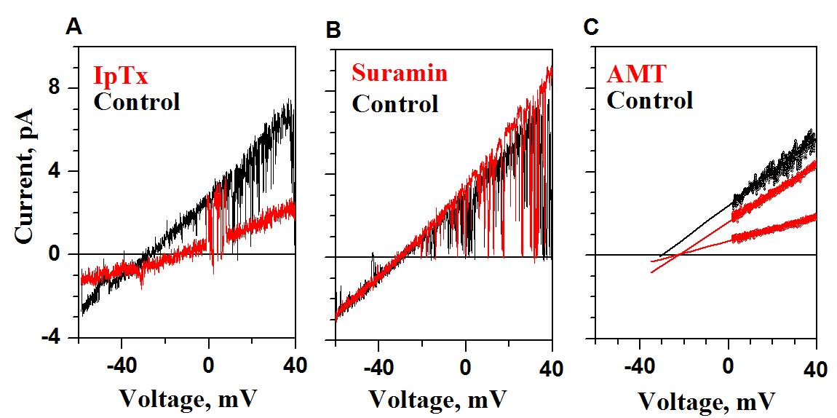
Figure 19. Reversal potential of modified conductance by different agents.
A. subconductance induced by IpTx reverse around –20 mV, where the control full open current reverses around –30 mV. B. superconductance induced by suramin has same reversal potential as normal full openings (~-30 mV). C. Two subconductances by AMT have same reversal potential (-20 mV) comparing normal full openings (-30 mV).

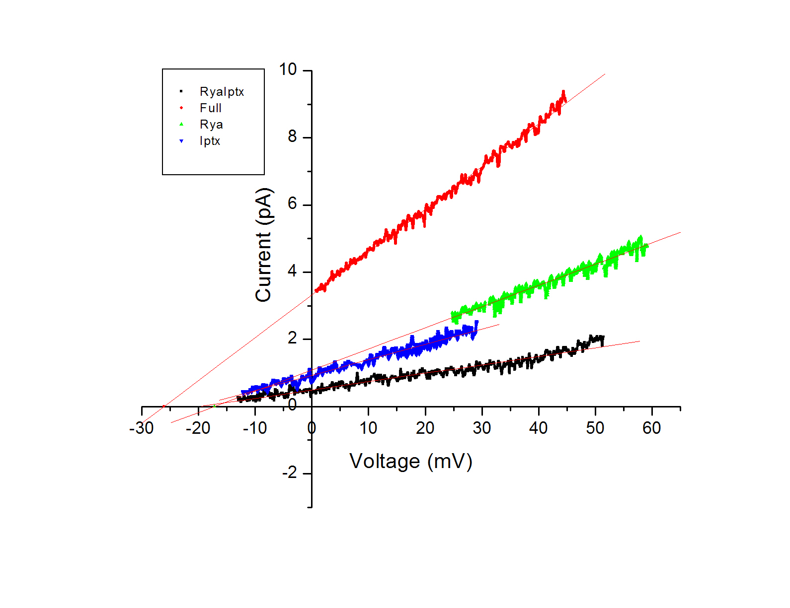
Figure 20. Reversal potentials of subconductances induced by ryanodol and IpTx
All 3 subconductance induced by ryanodol and IpTx together have same reversal potentials regardless theirs different conductances.

3. Selectivity of drug modified channel

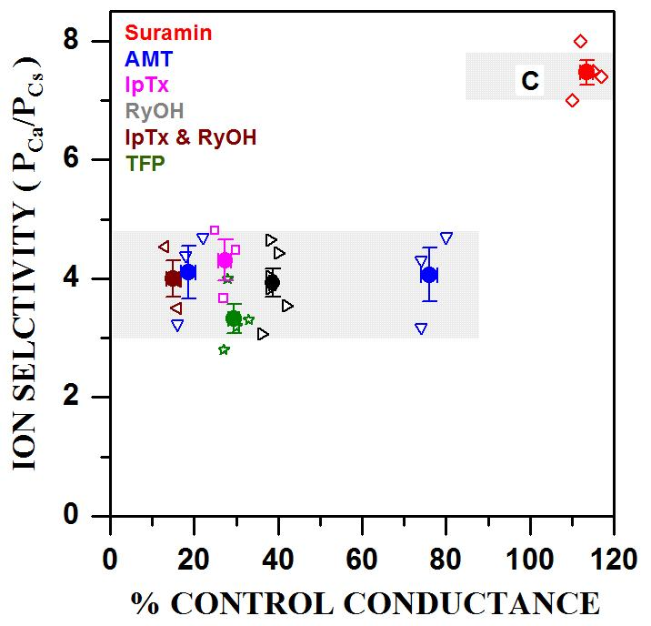
Figure 21. Summary of selectivity of different conductances induced by agents
All selectivity (PCa/PCs) fall into 2 ranges. Agents inducing subconductance modify RyR channel selectivity to ~4. Suramin increasing current has same selectivity as normal full opening (~7).

Using the Equation 4, I calculated the selectivity ratio under different drug induced subconductance condition. Results can be seen on Figure 21. From the Figure 21, all selectivity ratio of subconductance induced by agents are around 3-5 independent of their conductance. Suramin increased the conductance but had no effect on the selectivity ratio.
Take together, our results showed that several chemically diverse drugs evoke various conductance states ranging from 15 to 115% control.
All sub-conductance states had similar selectivity (P_{Ca}/P_{Cs} ~ 4). Selectivity of the super-conductance state was similar to control (~7).

CHAPTER VII

SUMMARY

This dissertation focused on defining the cytosolic Ca²⁺ regulation, the permeation properties of type II ryanodine receptors channels (RyR2) and how these two things are related (i.e. flux dependent regulation). These studies were done with RyR2 channels isolated from cardiac muscle because of the abundance of RyR2 in this tissue. The same RyR2 channel is also found throughout the brain where it is the predominant RyR isoform present. To define RyR2 function, the channels were reconstituted in planar lipid bilayers. Channel regulation studies were then done on individual channels.
The specific hypotheses tested here was: 1.Single RyR2 channels are modulated by Ca²⁺ feeding though their own pore. 2. Pharmacological agents that can alter the permeation of ryanodine receptor do so by changing the RyR pore to one of two conformations with different ion selectivity. I found that both parts of this hypothesis were true. Results from these studies are summarized briefly further below.
These studies are important because these aspects of RyR2 function are points where RyR2-mediated Ca²⁺ release can be modulated. This means they are potential sites of pathological failure (and possibly therapeutic intervention in the future). This particularly applies to neurological and cardiovascular disease because RyR2 channels are the predominant RyR isoform in brain and heart muscle,

A. Cytosolic single RyR2 channel Ca²⁺ sensitivity at quasi-physiological condition
In cells, cytosolic Mg²⁺ and ATP regulate RyR channel activity. I examined the cytosolic Ca²⁺ sensitivity with physiological Mg²⁺ and ATP in the presence of different luminal Ca²⁺ concentrations. With cytosolic Mg²⁺ and ATP present, RyR2 channel activity (Po) was significantly reduced at all steady state cytosolic Ca²⁺ concentrations tested. The overall cytosolic Ca²⁺ sensitivity curve was shifted to the right. This indicates that a larger cytosolic Ca²⁺ stimulus is needed to generate the same degree of channel activity if cytosolic Mg-ATP are present. So in cells like neurons, local cytoplasmic Ca²⁺ stimuli may need to reach the 1-10 micromolar range in order to activate RyR2 channels. Such high cytoplasmic Ca²⁺ levels are probably only reached near the pores of open Ca²⁺ channels. This means that RyR2 channels need to be very close to such channels. Once stimulated to open, the RyR2 channels can mediate a larger longer lasting and more widespread cytosolic Ca²⁺ elevation that can modulate other cellular processes.
The inhibitory action of Mg-ATP on cytosolic RyR2 Ca²⁺ activation observed here was interpreted as follows. Cytosolic magnesium is known to inhibit the RyR channel by binding to a low affinity cytosolic Ca-Mg nonspecific inhibitory site as well as interfering with Ca²⁺ binding to a high affinity cytosolic Ca²⁺ activation site. Cytosolic ATP is known to activate RyR channels generally, but this action on RyR2 is relatively small. Thus, the observed inhibition is most likely due to magnesium acting at cytosolic Ca²⁺ regulatory sites. This magnesium inhibitory action could not be compensated by the activating effects of ATP.
The action of 10 vs. 50 mM luminal Ca²⁺ on RyR2 cytosolic Ca²⁺ sensitivity was also determined. When the higher luminal Ca²⁺ was present, the cytosolic Ca²⁺ sensitivity was shifted to the left. The consequence is more RyR2 activity at lower cytosolic Ca²⁺ concentrations. This is not due to luminal Ca²⁺ interacting with or regulating the channel from its luminal side. Luminal Ca²⁺ levels greater than 5 mM are known to dissociate CSQ from the RyR2 channel. This means the RyR2 channels tested here where not subject to CSQ dependent luminal Ca²⁺ regulation. Qin et al. (2008) also showed that CSQ independent luminal Ca²⁺ regulation is largely saturated at 10 mM Ca²⁺. Thus, the interpretation is that the more Ca²⁺ passes through the open RyR2 pore when the higher luminal Ca²⁺ level is present. The increased lumen-to-cytosol Ca²⁺ flux has greater influence at cytosolic Ca²⁺ regulatory sites. The existence, nature and extent of flux dependent RyR2 regulation was determined in the next part of this dissertation.

B. Flux-dependent regulation of single RyR2 channels
In cells, Ca²⁺ release by RyR2 channels is activated by local Ca²⁺ stimuli. The inherent positive feedback of Ca²⁺-induced Ca²⁺ release is well controlled but exactly how is still unknown. Loss or inadequate control would have life threatening consequences for cells. The most fundamental form of Ca²⁺ induced Ca²⁺ release is Ca²⁺ triggering opening of a RyR2 pore then the Ca²⁺ passing through that open pore triggering further (or prolonging) opening of the pore. The nature and extent of such flux dependent RyR2 regulation was investigated here.
To define flux dependent regulation, single RyR2 channel studies were done using 3 different cations (Ca²⁺, Mg²⁺, & Cs⁺ as control) as the ion fluxed (lumen-to-cytosol direction) through the pore. Ca²⁺ and Mg²⁺ fluxes exhibit different regulatory patterns depending on flux amplitude. When Ca²⁺ as charge carrier, the Po is increased at small Ca²⁺ currents and then is decreased as the Ca²⁺ current got larger. When Mg²⁺ as charge carrier, the Po always reduced as the current became larger. These flux dependent regulatory effects were abolished or reduced by addition of a fast cytosolic buffer. Such flux dependent regulation was also found at physiological flux amplitudes, which implies that flux dependent Ca²⁺ regulation not only in bilayers but also in cells.. Flux dependent regulation was also examined by the nonlinear dynamical method-RQA. RQA analysis demonstrated that RyR2 open dwell time sequences have a deterministic component. This indicates that this channel’s gating is not a stochastic Markovian process when Ca²⁺ is the charge carrier with no fast cytosolic buffer present. This is because Ca²⁺ passing through the open channels influences future openings.
It was determined the flux passing through the channel can act on both cytosolic activation and inhibition sites. The cytosolic RyR2 inhibition site is found to be 4.1 nm from the pore or cytosolic point source of the Ca²⁺ flux. This inhibition site is affected by steady state bath Ca²⁺ and fluxed Ca²⁺ similarly. If this were also true for the cytosolic activation site, then the same calculations would predict that the activation site would be >100 nm from the pore. However, the radius of the RyR2 protein is only 18 nm. At this 18nm distance, even small fluxes through the pore will elevate local Ca²⁺ levels to a point that should saturate the cytosolic activation site and maximally activating the channel. Yet, this does not observed here (in bilayers) and clearly does not happen cells. This means that some mechanism allows RyR2 cytosolic activation to sense steady state bath and fluxed Ca²⁺ differently. The activation site could be protected from fluxed Ca²⁺ somehow. The activation site could change properties (affinity, efficacy, etc) when the channel open. Such possibilities were not ruled out or supported by my studies. However, the results here were used to generate an alternative explanation involving the existence of multiple cooperative and kinetically distinct cytosolic activation sites.

C. Selectivity of drug-induced RyR2 modified conductance states
The effectiveness of the RyR2 Ca²⁺ channel in modulating a process such as neurotransmitter release in brain (or EC-coupling in heart) is dependent on how well the channel mobilize/releases Ca²⁺ for the ER (or SR). This is determined by both the gating of the channel and the permeation properties of its pore. The steady state Ca²⁺ regulation of gating was defined in the first part of the dissertation. The flux dependent regulation of gating was defined in the second part. The regulating flux, of course, was mediated by the pore and its permeation properties. The third part of the dissertation focused on defining new aspects of these permeation properties.
To better understand the permeation properties of RyR2 pore, different pharmacological agents were used to modify its conductance and selectivity. Conductance refers to how fast ions pass through the pore. Selectivity refers to which ions pass through the pore. Intuitively, selectivity requires the pore to somehow discriminate between ions and this must take some time/energy. Thus, conductance and selectivity generally vary inversely. High conductance usually is correlated to low selectivity. Low conductance is correlated to high selectivity. The RyR2 channel is known to have a high conductance poorly selective poor.
The pharmacological agents mentioned above modified both RyR2 conductance and selectivity. These agents include ryanodine, ryanodol, AMT, TFP and Imperatoxin. Suramin (another agent tested) modified conductance but not selectivity. The results presented here showed no clear relationship between drug-modified conductance and selectivity. Conductance varied over a wide range while selectivity was either one of two values. All pores with drug-evoked conductances smaller than control (no drug) conductance had similar selectivity (PCa/PCs ~ 4). Pores with suramin evoked conductances greater than control had selectivity similar to control (PCa/PCs ~7).
The interpretation of this observation is the following. Selectivity and conductance of a pore need not be directly (inversely) related. Selectivity is likely defined by the charge in/near and size of the narrowest region of the overall permeation pathway through the channel protein (i.e. selectivity filter). Conductance depends on features (charge, dimension, shape) all along the permeation pathway (not just those in the selectivity filter). In this view, the different drugs tested evoke different changes in the RyR2 permeation pathway (outside the selectivity filter) that alter conductance to various degrees. These very same drugs (all the drugs but suramin) evoke a common change in the selectivity filter changing PCa/PCs from ~7 to ~4.

REFERENCE LIST
﻿Abramcheck, C. W. and P. M. Best (1989). "Physiological role and selectivity of the in situ potassium channel of the sarcoplasmic reticulum in skinned frog skeletal muscle fibers." J Gen Physiol 93(1): 1-21.
Ahern, G. P., P. R. Junankar, et al. (1994). "Single channel activity of the ryanodine receptor calcium release channel is modulated by FK-506." FEBS Lett 352(3): 369-74.
Almers, W. and E. W. McCleskey (1984). "Non-selective conductance in calcium channels of frog muscle: calcium selectivity in a single-file pore." J Physiol 353: 585-608.
Balshaw, D., L. Gao, et al. (1999). "Luminal loop of the ryanodine receptor: a pore-forming segment?" Proc Natl Acad Sci U S A 96(7): 3345-7.
Barg, S., J. A. Copello, et al. (1997). "Different interactions of cardiac and skeletal muscle ryanodine receptors with FK-506 binding protein isoforms." Am J Physiol 272(5 Pt 1): C1726-33.
Beard, N. A., M. G. Casarotto, et al. (2005). "Regulation of ryanodine receptors by calsequestrin: effect of high luminal Ca2+ and phosphorylation." Biophys J 88(5): 3444-54.
Beard, N. A., D. R. Laver, et al. (2004). "Calsequestrin and the calcium release channel of skeletal and cardiac muscle." Prog Biophys Mol Biol 85(1): 33-69.
Beard, N. A., M. M. Sakowska, et al. (2002). "Calsequestrin is an inhibitor of skeletal muscle ryanodine receptor calcium release channels." Biophys J 82(1 Pt 1): 310-20.
Bennett, M. R. (1999). "The concept of a calcium sensor in transmitter release." Prog Neurobiol 59(3): 243-77.
Berridge, M. J. (1995). "Calcium signalling and cell proliferation." Bioessays 17(6): 491-500.
Berridge, M. J. (1998). "Neuronal calcium signaling." Neuron 21(1): 13-26.
Bers, D. (2001). Excitation-Contraction Coupling and Cardiac Contractile Force, Kluwer Academic Press.
Bers, D. M. (2001). Excitation-contraction coupling and cardiac contractile force. Dordrecht; Boston, Kluwer Academic Publishers.
Bers, D. M., C. W. Patton, et al. (1994). "A practical guide to the preparation of Ca2+ buffers." Methods Cell Biol 40: 3-29.
Besch, H. R., C. H. Shao, et al. (2005). RYANOIDS, RECEPTOR AFFINITY AND RYR CHANNEL SUBCONDUCTANCE, Springer.
Bhat, M. B. and J. Ma (2002). "The transmembrane segment of ryanodine receptor contains an intracellular membrane retention signal for Ca(2+) release channel." J Biol Chem 277(10): 8597-601.
Bhat, M. B., J. Zhao, et al. (1997). "Functional calcium release channel formed by the carboxyl-terminal portion of ryanodine receptor." Biophys J 73(3): 1329-36.
Blinks, J. R., C. B. Olson, et al. (1972). "Influence of caffeine and other methylxanthines on mechanical properties of isolated mammalian heart muscle." Circ Res 30: 367-392.
Bouchard, R., R. Pattarini, et al. (2003). "Presence and functional significance of presynaptic ryanodine receptors." Prog Neurobiol 69(6): 391-418.
Brazhe, A. R. and G. V. Maksimov (2006). "Self-organized critical gating of ion channels: on the origin of long-term memory in dwell time series." Chaos 16(3): 033129.
Brillantes, A. B., K. Ondrias, et al. (1994). "Stabilization of calcium release channel (ryanodine receptor) function by FK506-binding protein." Cell 77(4): 513-23.
Bull, R. and J. J. Marengo (1993). "Sarcoplasmic reticulum release channels from frog skeletal muscle display two types of calcium dependence." FEBS Lett 331(3): 223-7.
Catterall, W. A. (2000). "Structure and regulation of voltage-gated Ca2+ channels." Annu Rev Cell Dev Biol 16: 521-55.
Chamberlain, B. K., D. O. Levitsky, et al. (1983). "Isolation and characterization of canine cardiac sarcoplasmic reticulum with improved Ca2+ transport properties." J Biol Chem 258(10): 6602-9.
Chen, D., L. Xu, et al. (1997). "Permeation through the calcium release channel of cardiac muscle." Biophys J 73(3): 1337-54.
Ching, L. L., A. J. Williams, et al. (2000). "Evidence for Ca(2+) activation and inactivation sites on the luminal side of the cardiac ryanodine receptor complex." Circ Res 87(3): 201-6.
Chopra, N., D. R. Laver, et al. (2007). "Amitriptyline Activates Cardiac Ryanodine Receptors Independently of its Action on Cardiac Calsequestrin - Role for Amitriptyline Linked Sudden Cardiac Death." Circulation 116: II_84.
Christie, B. R., L. K. Schexnayder, et al. (1997). "Contribution of voltage-gated Ca2+ channels to homosynaptic long-term depression in the CA1 region in vitro." J Neurophysiol 77(3): 1651-5.
Collin, T., A. Marty, et al. (2005). "Presynaptic calcium stores and synaptic transmission." Curr Opin Neurobiol 15(3): 275-81.
Copello, J. A., S. Barg, et al. (1997). "Heterogeneity of Ca2+ gating of skeletal muscle and cardiac ryanodine receptors." Biophys J 73(1): 141-56.
Copello, J. A., S. Barg, et al. (2002). "Differential activation by Ca2+, ATP and caffeine of cardiac and skeletal muscle ryanodine receptors after block by Mg2+." J Membr Biol 187(1): 51-64.
Coronado, R., J. Morrissette, et al. (1994). "Structure and function of ryanodine receptors." Am J Physiol 266(6 Pt 1): C1485-504.
Deisseroth, K., E. K. Heist, et al. (1998). "Translocation of calmodulin to the nucleus supports CREB phosphorylation in hippocampal neurons." Nature 392(6672): 198-202.
Dietrich, D., T. Kirschstein, et al. (2003). "Functional specialization of presynaptic Cav2.3 Ca2+ channels." Neuron 39(3): 483-96.
Donoso, P., P. Aracena, et al. (2000). "Sulfhydryl oxidation overrides Mg(2+) inhibition of calcium-induced calcium release in skeletal muscle triads." Biophys J 79(1): 279-86.
Doyle, D. A., J. Morais Cabral, et al. (1998). "The structure of the potassium channel: molecular basis of K+ conduction and selectivity." Science 280(5360): 69-77.
Du, G. G., X. Guo, et al. (2001). "Functional characterization of mutants in the predicted pore region of the rabbit cardiac muscle Ca(2+) release channel (ryanodine receptor isoform 2)." J Biol Chem 276(34): 31760-71.
Du, G. G. and D. H. MacLennan (1998). "Functional consequences of mutations of conserved, polar amino acids in transmembrane sequences of the Ca2+ release channel (ryanodine receptor) of rabbit skeletal muscle sarcoplasmic reticulum." J Biol Chem 273(48): 31867-72.
Eckmann, J.-P., S. O. Kamphorst, et al. (1987). "Recurrence Plots of Dynamical Systems." Europhysics Letters 5: 973–977.
el-Hayek, R., B. Antoniu, et al. (1995). "Identification of calcium release-triggering and blocking regions of the II-III loop of the skeletal muscle dihydropyridine receptor." J Biol Chem 270(38): 22116-8.
el-Hayek, R., A. J. Lokuta, et al. (1995). "Peptide probe of ryanodine receptor function. Imperatoxin A, a peptide from the venom of the scorpion Pandinus imperator, selectively activates skeletal-type ryanodine receptor isoforms." J Biol Chem 270(48): 28696-704.
Fabiato, A. (1985). "Effects of ryanodine in skinned cardiac cells." Fed Proc 44(15): 2970-6.
Fabiato, A. (1985). "Time and calcium dependence of activation and inactivation of calcium-induced release of calcium from the sarcoplasmic reticulum of a skinned canine cardiac Purkinje cell." J Gen Physiol 85(2): 247-89.
Fabiato, A. (1992). "Two kinds of calcium-induced release of calcium from the sarcoplasmic reticulum of skinned cardiac cells." Adv Exp Med Biol 311: 245-62.
Fill, M. and J. A. Copello (2002). "Ryanodine receptor calcium release channels." Physiol Rev 82(4): 893-922.
Fill, M., A. Zahradnikova, et al. (2000). "Ryanodine receptor adaptation." J Gen Physiol 116(6): 873-82.
Filligoi, G. and F. Felici (1999). "Detection of hidden rhythms in surface EMG signals with a non-linear time-series tool." Med Eng Phys 21(6-7): 439-48.
Fletcher, C. F., N. G. Copeland, et al. (1998). "Genetic analysis of voltage-dependent calcium channels." J Bioenerg Biomembr 30(4): 387-98.
Furuichi, T., D. Furutama, et al. (1994). "Multiple types of ryanodine receptor/Ca2+ release channels are differentially expressed in rabbit brain." J Neurosci 14(8): 4794-805.
Futatsugi, A., G. Kuwajima, et al. (1995). "Tissue-specific and developmentally regulated alternative splicing in mouse skeletal muscle ryanodine receptor mRNA." Biochem J 305 (Pt 2): 373-8.
Gao, L., D. Balshaw, et al. (2000). "Evidence for a role of the lumenal M3-M4 loop in skeletal muscle Ca(2+) release channel (ryanodine receptor) activity and conductance." Biophys J 79(2): 828-40.
Gasparini, S., A. M. Kasyanov, et al. (2001). "Presynaptic R-type calcium channels contribute to fast excitatory synaptic transmission in the rat hippocampus." J Neurosci 21(22): 8715-21.
Giannini, G., A. Conti, et al. (1995). "The ryanodine receptor/calcium channel genes are widely and differentially expressed in murine brain and peripheral tissues." J Cell Biol 128(5): 893-904.
Gillespie, D., L. Xu, et al. (2005). "(De)constructing the Ryanodine Receptor: Modeling Ion Permeation and Selectivity of the Calcium Release Channel." Journal of Physics Chemistry. B in press.
Gillespie, D., L. Xu, et al. (2005). "(De)constructing the ryanodine receptor: modeling ion permeation and selectivity of the calcium release channel." J Phys Chem B Condens Matter Mater Surf Interfaces Biophys 109(32): 15598-610.
Gillespie, D., L. Xu, et al. (2005). "(De)constructing the ryanodine receptor: modeling ion permeation and selectivity of the calcium release channel." J Phys Chem B 109(32): 15598-610.
Grunwald, R. and G. Meissner (1995). "Lumenal sites and C terminus accessibility of the skeletal muscle calcium release channel (ryanodine receptor)." J Biol Chem 270(19): 11338-47.
Gyorke, I. and S. Gyorke (1998). "Regulation of the cardiac ryanodine receptor channel by luminal Ca2+ involves luminal Ca2+ sensing sites." Biophys J 75(6): 2801-10.
Gyorke, I., N. Hester, et al. (2004). "The role of calsequestrin, triadin, and junctin in conferring cardiac ryanodine receptor responsiveness to luminal calcium." Biophys J 86(4): 2121-8.
Gyorke, S. and M. Fill (1993). "Ryanodine receptor adaptation: control mechanism of Ca(2+)-induced Ca2+ release in heart." Science 260(5109): 807-9.
Gyorke, S., I. Gyorke, et al. (2002). "Regulation of sarcoplasmic reticulum calcium release by luminal calcium in cardiac muscle." Front Biosci 7: d1454-63.
Hakamata, Y., J. Nakai, et al. (1992). "Primary structure and distribution of a novel ryanodine receptor/calcium release channel from rabbit brain." FEBS Lett 312(2-3): 229-35.
Hill, A. P., O. Kingston, et al. (2004). "Functional regulation of the cardiac ryanodine receptor by suramin and calmodulin involves multiple binding sites." Mol Pharmacol 65(5): 1258-68.
Iwasaki, S. and T. Takahashi (1998). "Developmental changes in calcium channel types mediating synaptic transmission in rat auditory brainstem." J Physiol 509 (Pt 2): 419-23.
Kaftan, E., A. R. Marks, et al. (1996). "Effects of rapamycin on ryanodine receptor/Ca(2+)-release channels from cardiac muscle." Circ Res 78(6): 990-7.
Kamp, F., P. Donoso, et al. (1998). "Changes in luminal pH caused by calcium release in sarcoplasmic reticulum vesicles." Biophys J 74(1): 290-6.
Kawasaki, T. and M. Kasai (1994). "Regulation of calcium channel in sarcoplasmic reticulum by calsequestrin." Biochem Biophys Res Commun 199(3): 1120-7.
Kocsis, J. D., M. N. Rand, et al. (1994). "Intracellular calcium mobilization and neurite outgrowth in mammalian neurons." J Neurobiol 25(3): 252-64.
Kubalova, Z., D. Terentyev, et al. (2005). "Abnormal intrastore calcium signaling in chronic heart failure." Proc Natl Acad Sci U S A 102(39): 14104-9.
Lai, F. A., M. Misra, et al. (1989). "The ryanodine receptor-Ca2+ release channel complex of skeletal muscle sarcoplasmic reticulum. Evidence for a cooperatively coupled, negatively charged homotetramer." J Biol Chem 264(28): 16776-85.
Lamb, G. D. (2000). "Excitation-contraction coupling in skeletal muscle: comparisons with cardiac muscle." Clin Exp Pharmacol Physiol 27(3): 216-24.
Lankford, K. L., M. N. Rand, et al. (1995). "Blocking Ca2+ mobilization with thapsigargin reduces neurite initiation in cultured adult rat DRG neurons." Brain Res Dev Brain Res 84(2): 151-63.
Lauri, S. E., Z. A. Bortolotto, et al. (2003). "A role for Ca2+ stores in kainate receptor-dependent synaptic facilitation and LTP at mossy fiber synapses in the hippocampus." Neuron 39(2): 327-41.
Laver, D. (2001). "The power of single channel recording and analysis: its application to ryanodine receptors in lipid bilayers." Clin Exp Pharmacol Physiol 28(8): 675-86.
Laver, D. R. (2007). "Ca2+ Stores Regulate Ryanodine Receptor Ca2+ Release Channels via Luminal and Cytosolic Ca2+ Sites." Biophys J 92(10): 3541-55.
Laver, D. R., T. M. Baynes, et al. (1997). "Magnesium inhibition of ryanodine-receptor calcium channels: evidence for two independent mechanisms." J Membr Biol 156(3): 213-29.
Laver, D. R., L. D. Roden, et al. (1995). "Cytoplasmic Ca2+ inhibits the ryanodine receptor from cardiac muscle." J Membr Biol 147(1): 7-22.
Lehnart, S. E., M. Mongillo, et al. (2008). "Leaky Ca2+ release channel/ryanodine receptor 2 causes seizures and sudden cardiac death in mice." J Clin Invest 118(6): 2230-45.
Lehnart, S. E., X. H. Wehrens, et al. (2004). "Sudden death in familial polymorphic ventricular tachycardia associated with calcium release channel (ryanodine receptor) leak." Circulation 109(25): 3208-14.
Liebovitch, L. S. and A. T. Todorov (1996). "Using fractals and nonlinear dynamics to determine the physical properties of ion channel proteins." Crit Rev Neurobiol 10(2): 169-87.
Lindsay, A. R., S. D. Manning, et al. (1991). "Monovalent cation conductance in the ryanodine receptor-channel of sheep cardiac muscle sarcoplasmic reticulum." J Physiol 439: 463-80.
Lindsay, A. R., A. Tinker, et al. (1994). "How does ryanodine modify ion handling in the sheep cardiac sarcoplasmic reticulum Ca(2+)-release channel?" J Gen Physiol 104(3): 425-47.
Liu, Q. Y., F. A. Lai, et al. (1989). "Multiple conductance states of the purified calcium release channel complex from skeletal sarcoplasmic reticulum." Biophys J 55(3): 415-24.
Llinas, R. and H. Jahnsen (1982). "Electrophysiology of mammalian thalamic neurones in vitro." Nature 297(5865): 406-8.
Lodish, H., A. Berk, et al. (2003). Molecular Cell Biology, W. H. Freeman.
Lohmann, C., K. L. Myhr, et al. (2002). "Transmitter-evoked local calcium release stabilizes developing dendrites." Nature 418(6894): 177-81.
Lokuta, A. J., A. Darszon, et al. (1998). "Detection and functional characterization of ryanodine receptors from sea urchin eggs." J Physiol 510 (Pt 1): 155-64.
Lukyanenko, V., I. Gyorke, et al. (1996). "Regulation of calcium release by calcium inside the sarcoplasmic reticulum in ventricular myocytes." Pflugers Arch 432(6): 1047-54.
MacLennan, D. H. and P. T. Wong (1971). "Isolation of a calcium-sequestering protein from sarcoplasmic reticulum." Proc Natl Acad Sci U S A 68(6): 1231-5.
Magee, J. C., G. Christofi, et al. (1995). "Subthreshold synaptic activation of voltage-gated Ca2+ channels mediates a localized Ca2+ influx into the dendrites of hippocampal pyramidal neurons." J Neurophysiol 74(3): 1335-42.
Mao, Z., A. Bonni, et al. (1999). "Neuronal activity-dependent cell survival mediated by transcription factor MEF2." Science 286(5440): 785-90.
Marziali, G., D. Rossi, et al. (1996). "cDNA cloning reveals a tissue specific expression of alternatively spliced transcripts of the ryanodine receptor type 3 (RyR3) calcium release channel." FEBS Lett 394(1): 76-82.
Matsuda, H. and A. Noma (1984). "Isolation of calcium current and its sensitivity to monovalent cations in dialysed ventricular cells of guinea-pig." J Physiol 357: 553-73.
McCall, E., L. Li, et al. (1996). "Effects of FK-506 on contraction and Ca2+ transients in rat cardiac myocytes." Circ Res 79(6): 1110-21.
McCormick, D. A. and T. Bal (1997). "Sleep and arousal: thalamocortical mechanisms." Annu Rev Neurosci 20: 185-215.
Meissner, G. (1984). "Adenine nucleotide stimulation of Ca2+-induced Ca2+ release in sarcoplasmic reticulum." J Biol Chem 259(4): 2365-74.
Meissner, G. (2002). "Regulation of mammalian ryanodine receptors." Front Biosci 7: d2072-80.
Meissner, G. (2004). "Molecular regulation of cardiac ryanodine receptor ion channel." Cell Calcium 35(6): 621-8.
Meissner, G., E. Darling, et al. (1986). "Kinetics of rapid Ca2+ release by sarcoplasmic reticulum. Effects of Ca2+, Mg2+, and adenine nucleotides." Biochemistry 25(1): 236-44.
Meissner, G. and J. S. Henderson (1987). "Rapid calcium release from cardiac sarcoplasmic reticulum vesicles is dependent on Ca2+ and is modulated by Mg2+, adenine nucleotide, and calmodulin." J Biol Chem 262(7): 3065-73.
Millan, C., R. Lujan, et al. (2002). "Subtype-specific expression of group III metabotropic glutamate receptors and Ca2+ channels in single nerve terminals." J Biol Chem 277(49): 47796-803.
Miller, C. (1986). Ion Channel Reconstitution. New York, Plenum.
Mintz, I. M., B. L. Sabatini, et al. (1995). "Calcium control of transmitter release at a cerebellar synapse." Neuron 15(3): 675-88.
Morais-Cabral, J. H., Y. Zhou, et al. (2001). "Energetic optimization of ion conduction rate by the K+ selectivity filter." Nature 414(6859): 37-42.
Morrissette, J., J. Kratzschmar, et al. (1995). "Primary structure and properties of helothermine, a peptide toxin that blocks ryanodine receptors." Biophys J 68(6): 2280-8.
Mueller, P., D. O. Rudin, et al. (1962). "Reconstitution of cell membrane structure in vitro and its transformation into an excitable system." Nature 194: 979-981.
Nakai, J., T. Imagawa, et al. (1990). "Primary structure and functional expression from cDNA of the cardiac ryanodine receptor/calcium release channel." FEBS Lett 271(1-2): 169-77.
Orlova, E. V., Serysheva, II, et al. (1996). "Two structural configurations of the skeletal muscle calcium release channel." Nat Struct Biol 3(6): 547-52.
Ouyang, Y., T. J. Deerinck, et al. (1993). "Distribution of ryanodine receptors in the chicken central nervous system." Brain Res 620(2): 269-80.
Ouyang, Y., M. E. Martone, et al. (1997). "Differential distribution and subcellular localization of ryanodine receptor isoforms in the chicken cerebellum during development." Brain Res 775(1-2): 52-62.
Park, H., I. Y. Park, et al. (2004). "Comparing skeletal and cardiac calsequestrin structures and their calcium binding: a proposed mechanism for coupled calcium binding and protein polymerization." J Biol Chem 279(17): 18026-33.
Park, I. Y., E. J. Kim, et al. (2005). "Interaction between cardiac calsequestrin and drugs with known cardiotoxicity." Mol Pharmacol 67(1): 97-104.
Pessah, I. N., R. A. Stambuk, et al. (1987). "Ca2+-activated ryanodine binding: mechanisms of sensitivity and intensity modulation by Mg2+, caffeine, and adenine nucleotides." Mol Pharmacol 31(3): 232-8.
Pessah, I. N. and I. Zimanyi (1991). "Characterization of multiple [3H]ryanodine binding sites on the Ca2+ release channel of sarcoplasmic reticulum from skeletal and cardiac muscle: evidence for a sequential mechanism in ryanodine action." Mol Pharmacol 39(5): 679-89.
Picard, L., K. Cote, et al. (2002). "Sarcoplasmic reticulum K(+) channels from human and sheep atrial cells display a specific electro-pharmacological profile." J Mol Cell Cardiol 34(9): 1163-72.
Qian, J. and J. L. Noebels (2001). "Presynaptic Ca2+ channels and neurotransmitter release at the terminal of a mouse cortical neuron." J Neurosci 21(11): 3721-8.
Qin, J., G. Valle, et al. (2008). "Luminal Ca2+ regulation of single cardiac ryanodine receptors: insights provided by calsequestrin and its mutants." J Gen Physiol 131(4): 325-34.
Radermacher, M., V. Rao, et al. (1994). "Cryo-electron microscopy and three-dimensional reconstruction of the calcium release channel/ryanodine receptor from skeletal muscle." J Cell Biol 127(2): 411-23.
Reid, C. A., J. M. Bekkers, et al. (1998). "N- and P/Q-type Ca2+ channels mediate transmitter release with a similar cooperativity at rat hippocampal autapses." J Neurosci 18(8): 2849-55.
Reid, C. A., J. D. Clements, et al. (1997). "Nonuniform distribution of Ca2+ channel subtypes on presynaptic terminals of excitatory synapses in hippocampal cultures." J Neurosci 17(8): 2738-45.
Rosales, R. A., M. Fill, et al. (2004). "Calcium regulation of single ryanodine receptor channel gating analyzed using HMM/MCMC statistical methods." J Gen Physiol 123(5): 533-53.
Rousseau, E., J. Ladine, et al. (1988). "Activation of the Ca2+ release channel of skeletal muscle sarcoplasmic reticulum by caffeine and related compounds." Arch Biochem Biophys 267(1): 75-86.
Rousseau, E. and G. Meissner (1989). "Single cardiac sarcoplasmic reticulum Ca2+-release channel: activation by caffeine." Am J Physiol 256(2 Pt 2): H328-33.
Rousseau, E., J. S. Smith, et al. (1987). "Ryanodine modifies conductance and gating behavior of single Ca2+ release channel." Am J Physiol 253(3 Pt 1): C364-8.
Saftenku, E., A. J. Williams, et al. (2001). "Markovian models of low and high activity levels of cardiac ryanodine receptors." Biophys J 80(6): 2727-41.
Samso, M., T. Wagenknecht, et al. (2005). "Internal structure and visualization of transmembrane domains of the RyR1 calcium release channel by cryo-EM." Nat Struct Mol Biol 12(6): 539-44.
Sather, W. A. and E. W. McCleskey (2003). "Permeation and selectivity in calcium channels." Annu Rev Physiol 65: 133-59.
Scholz, K. P. and R. J. Miller (1995). "Developmental changes in presynaptic calcium channels coupled to glutamate release in cultured rat hippocampal neurons." J Neurosci 15(6): 4612-7.
Schreiber, S. L. (1991). "Chemistry and biology of the immunophilins and their immunosuppressive ligands." Science 251(4991): 283-7.
Serysheva, II, S. L. Hamilton, et al. (2005). "Structure of Ca2+ release channel at 14 A resolution." J Mol Biol 345(3): 427-31.
Serysheva, II, E. V. Orlova, et al. (1995). "Electron cryomicroscopy and angular reconstitution used to visualize the skeletal muscle calcium release channel." Nat Struct Biol 2(1): 18-24.
Serysheva, II, M. Schatz, et al. (1999). "Structure of the skeletal muscle calcium release channel activated with Ca2+ and AMP-PCP." Biophys J 77(4): 1936-44.
Shannon, T., K. Ginsburg, et al. (2000). "Potentiation of fractional sarcoplasmic reticulum calcium release by total and free intra-sarcoplasmic reticulum calcium concentration." Biophys J 78(1): 334-43.
Sharma, M. R., L. H. Jeyakumar, et al. (2000). "Three-dimensional structure of ryanodine receptor isoform three in two conformational states as visualized by cryo-electron microscopy." J Biol Chem 275(13): 9485-91.
Sharma, M. R., P. Penczek, et al. (1998). "Cryoelectron microscopy and image analysis of the cardiac ryanodine receptor." J Biol Chem 273(29): 18429-34.
Sharp, A. H., P. S. McPherson, et al. (1993). "Differential immunohistochemical localization of inositol 1,4,5-trisphosphate- and ryanodine-sensitive Ca2+ release channels in rat brain." J Neurosci 13(7): 3051-63.
Sitsapesan, R. and A. J. Williams (1990). "Mechanisms of caffeine activation of single calcium-release channels of sheep cardiac sarcoplasmic reticulum." J Physiol 423: 425-39.
Sitsapesan, R. and A. J. Williams (1994). "Regulation of the gating of the sheep cardiac sarcoplasmic reticulum Ca(2+)-release channel by luminal Ca2+." J Membr Biol 137(3): 215-26.
Sitsapesan, R. and A. J. Williams (1995). "The gating of the sheep skeletal sarcoplasmic reticulum Ca(2+)-release channel is regulated by luminal Ca2+." J Membr Biol 146(2): 133-44.
Sitsapesan, R. and A. J. Williams (1996). "Modification of the conductance and gating properties of ryanodine receptors by suramin." J Membr Biol 153(2): 93-103.
Sitsapesan, R. and A. J. Williams (1997). "Regulation of current flow through ryanodine receptors by luminal Ca2+." J Membr Biol 159(3): 179-85.
Smith, J. S., R. Coronado, et al. (1985). "Sarcoplasmic reticulum contains adenine nucleotide-activated calcium channels." Nature 316(6027): 446-9.
Somlyo, A. V. (1979). "Bridging structures spanning the junctioning gap at the triad of skeletal muscle." J Cell Biol 80(3): 743-50.
Sorrentino, V., V. Barone, et al. (2000). "Intracellular Ca(2+) release channels in evolution." Curr Opin Genet Dev 10(6): 662-7.
Stern, M. D. (1992). "Buffering of calcium in the vicinity of a channel pore." Cell Calcium 13(3): 183-92.
Stern, M. D. and H. Cheng (2004). "Putting out the fire: what terminates calcium-induced calcium release in cardiac muscle?" Cell Calcium 35(6): 591-601.
Stricker, S. A. (1999). "Comparative biology of calcium signaling during fertilization and egg activation in animals." Dev Biol 211(2): 157-76.
Sutko, J. L., J. A. Airey, et al. (1997). "The pharmacology of ryanodine and related compounds." Pharmacol Rev 49(1): 53-98.
Szegedi, C., S. Sarkozi, et al. (1999). "Calsequestrin: more than 'only' a luminal Ca2+ buffer inside the sarcoplasmic reticulum." Biochem J 337 (Pt 1): 19-22.
Takeshima, H., S. Nishimura, et al. (1989). "Primary structure and expression from complementary DNA of skeletal muscle ryanodine receptor." Nature 339(6224): 439-45.
Tang, J. M., J. Wang, et al. (1989). "K+-selective channel from sarcoplasmic reticulum of split lobster muscle fibers." J Gen Physiol 94(2): 261-78.
Tanna, B., W. Welch, et al. (2005). "Voltage-sensitive equilibrium between two states within a ryanoid-modified conductance state of the ryanodine receptor channel." Biophys J 88(4): 2585-96.
Terentyev, D., A. Nori, et al. (2006). "Abnormal interactions of calsequestrin with the ryanodine receptor calcium release channel complex linked to exercise-induced sudden cardiac death." Circ Res 98(9): 1151-8.
Timerman, A. P., E. Ogunbumni, et al. (1993). "The calcium release channel of sarcoplasmic reticulum is modulated by FK-506-binding protein. Dissociation and reconstitution of FKBP-12 to the calcium release channel of skeletal muscle sarcoplasmic reticulum." J Biol Chem 268(31): 22992-9.
Timerman, A. P., H. Onoue, et al. (1996). "Selective binding of FKBP12.6 by the cardiac ryanodine receptor." J Biol Chem 271(34): 20385-91.
Tinker, A., A. R. Lindsay, et al. (1992). "A model for ionic conduction in the ryanodine receptor channel of sheep cardiac muscle sarcoplasmic reticulum." J Gen Physiol 100(3): 495-517.
Tinker, A., A. R. Lindsay, et al. (1993). "Cation conduction in the calcium release channel of the cardiac sarcoplasmic reticulum under physiological and pathophysiological conditions." Cardiovasc Res 27(10): 1820-5.
Tinker, A., J. L. Sutko, et al. (1996). "Electrophysiological effects of ryanodine derivatives on the sheep cardiac sarcoplasmic reticulum calcium-release channel." Biophys J 70(5): 2110-9.
Tinker, A. and A. J. Williams (1992). "Divalent cation conduction in the ryanodine receptor channel of sheep cardiac muscle sarcoplasmic reticulum." J Gen Physiol 100(3): 479-93.
Tinker, A. and A. J. Williams (1993). "Probing the structure of the conduction pathway of the sheep cardiac sarcoplasmic reticulum calcium-release channel with permeant and impermeant organic cations." J Gen Physiol 102(6): 1107-29.
Tripathy, A. and G. Meissner (1996). "Sarcoplasmic reticulum luminal Ca2+ has access to cytosolic activation and inactivation sites of skeletal muscle Ca2+ release channel." Biophys J 70(6): 2600-15.
Tripathy, A., W. Resch, et al. (1998). "Imperatoxin A induces subconductance states in Ca2+ release channels (ryanodine receptors) of cardiac and skeletal muscle." J Gen Physiol 111(5): 679-90.
Tripathy, A., L. Xu, et al. (1995). "Calmodulin activation and inhibition of skeletal muscle Ca2+ release channel (ryanodine receptor)." Biophys J 69(1): 106-19.
Tsien, R. W., D. Lipscombe, et al. (1988). "Multiple types of neuronal calcium channels and their selective modulation." Trends Neurosci 11(10): 431-8.
Tunwell, R. E., C. Wickenden, et al. (1996). "The human cardiac muscle ryanodine receptor-calcium release channel: identification, primary structure and topological analysis." Biochem J 318 (Pt 2): 477-87.
Unni, V. K., S. S. Zakharenko, et al. (2004). "Calcium release from presynaptic ryanodine-sensitive stores is required for long-term depression at hippocampal CA3-CA3 pyramidal neuron synapses." J Neurosci 24(43): 9612-22.
Valdivia, H. H., J. H. Kaplan, et al. (1995). "Rapid adaptation of cardiac ryanodine receptors: modulation by Mg2+ and phosphorylation." Science 267(5206): 1997-2000.
Valdivia, H. H., M. S. Kirby, et al. (1992). "Scorpion toxins targeted against the sarcoplasmic reticulum Ca(2+)-release channel of skeletal and cardiac muscle." Proc Natl Acad Sci U S A 89(24): 12185-9.
Varadi, G., Y. Mori, et al. (1995). "Molecular determinants of Ca2+ channel function and drug action." Trends Pharmacol Sci 16(2): 43-9.
Verkhratsky, A. (2005). "Physiology and pathophysiology of the calcium store in the endoplasmic reticulum of neurons." Physiol Rev 85(1): 201-79.
Voogd, T. E., E. L. Vansterkenburg, et al. (1993). "Recent research on the biological activity of suramin." Pharmacol Rev 45(2): 177-203.
Wagenknecht, T., M. Radermacher, et al. (1997). "Locations of calmodulin and FK506-binding protein on the three-dimensional architecture of the skeletal muscle ryanodine receptor." J Biol Chem 272(51): 32463-71.
Wang, S., W. R. Trumble, et al. (1998). "Crystal structure of calsequestrin from rabbit skeletal muscle sarcoplasmic reticulum." Nat Struct Biol 5(6): 476-83.
Wang, Y., L. Xu, et al. (2005). "Probing the role of negatively charged amino acid residues in ion permeation of skeletal muscle ryanodine receptor." Biophys J 89(1): 256-65.
Webber, C. L., Jr. and J. P. Zbilut (1998). Recurrent structuring of dynamical and spatial systems. Complexity in the Living: A Modelistic Approach, University of Rome “La Sapienza.”
Webber, C. L., Jr. and J. P. Zbilut (1994). "Dynamical assessment of physiological systems and states using recurrence plot strategies." J Appl Physiol 76(2): 965-73.
Webber, C. L. J. and J. P. Zbilut (2005). Recurrence quantification analysis of nonlinear dynamical systems. Tutorials in contemporary nonlinear methods for the behavioral sciences. M. A. Riley and G. V. Orden: 26-94.
Wehrens, X. H., S. E. Lehnart, et al. (2003). "FKBP12.6 deficiency and defective calcium release channel (ryanodine receptor) function linked to exercise-induced sudden cardiac death." Cell 113(7): 829-40.
Wehrens, X. H., S. E. Lehnart, et al. (2004). "Protection from cardiac arrhythmia through ryanodine receptor-stabilizing protein calstabin2." Science 304(5668): 292-6.
Weisskopf, M. G., E. P. Bauer, et al. (1999). "L-type voltage-gated calcium channels mediate NMDA-independent associative long-term potentiation at thalamic input synapses to the amygdala." J Neurosci 19(23): 10512-9.
Wheeler, D. B., A. Randall, et al. (1996). "Changes in action potential duration alter reliance of excitatory synaptic transmission on multiple types of Ca2+ channels in rat hippocampus." J Neurosci 16(7): 2226-37.
Williams, A. J., D. J. West, et al. (2001). "Light at the end of the Ca(2+)-release channel tunnel: structures and mechanisms involved in ion translocation in ryanodine receptor channels." Q Rev Biophys 34(1): 61-104.
Wu, L. G. and P. Saggau (1994). "Pharmacological identification of two types of presynaptic voltage-dependent calcium channels at CA3-CA1 synapses of the hippocampus." J Neurosci 14(9): 5613-22.
Wu, L. G., R. E. Westenbroek, et al. (1999). "Calcium channel types with distinct presynaptic localization couple differentially to transmitter release in single calyx-type synapses." J Neurosci 19(2): 726-36.
Xiao, B., M. T. Jiang, et al. (2005). "Characterization of a novel PKA phosphorylation site, serine-2030, reveals no PKA hyperphosphorylation of the cardiac ryanodine receptor in canine heart failure." Circ Res 96(8): 847-55.
Xiao, J., X. Tian, et al. (2007). "Removal of FKBP12.6 does not alter the conductance and activation of the cardiac ryanodine receptor or the susceptibility to stress-induced ventricular arrhythmias." J Biol Chem 282(48): 34828-38.
Xiao, R., H. Valdivia, et al. (1997). "The immunophilin FK506-binding protein modulates Ca2+ release channel closure in rat heart." J Physiol 500: 343-54.
Xu, L., G. Mann, et al. (1996). "Regulation of cardiac Ca2+ release channel (ryanodine receptor) by Ca2+, H+, Mg2+, and adenine nucleotides under normal and simulated ischemic conditions." Circ Res 79(6): 1100-9.
Xu, L. and G. Meissner (1998). "Regulation of cardiac muscle Ca2+ release channel by sarcoplasmic reticulum lumenal Ca2+." Biophys J 75(5): 2302-12.
Zahradnikova, A., M. Dura, et al. (2003). "Regulation of dynamic behavior of cardiac ryanodine receptor by Mg2+ under simulated physiological conditions." Am J Physiol Cell Physiol 285(5): C1059-70.
Zbilut, J. P. and C. L. Webber, Jr. (1992). "Embeddings and delays as derived from quantification of recurrence plots." Phys. Lett. A 171: 199-203.
Zhang, Y., H. S. Chen, et al. (1993). "A mutation in the human ryanodine receptor gene associated with central core disease." Nat Genet 5(1): 46-50.
Zhao, M., P. Li, et al. (1999). "Molecular identification of the ryanodine receptor pore-forming segment." J Biol Chem 274(37): 25971-4.
Zhou, M., J. H. Morais-Cabral, et al. (2001). "Potassium channel receptor site for the inactivation gate and quaternary amine inhibitors." Nature 411(6838): 657-61.
Zhou, Y., J. H. Morais-Cabral, et al. (2001). "Chemistry of ion coordination and hydration revealed by a K+ channel-Fab complex at 2.0 A resolution." Nature 414(6859): 43-8.
Zucchi, R. and S. Ronca-Testoni (1997). "The sarcoplasmic reticulum Ca2+ channel/ryanodine receptor: modulation by endogenous effectors, drugs and disease states." Pharmacol Rev 49(1): 1-51.

VITA

Yiwei Liu was born in Beijing, China, the third son of Bingzheng Liu and Hui Yang. After graduating from Changchun No. 8 High School in 1988, he attended the Norman Bethune University of Medical Sciences (now the Medical Center of Jilin University). It was here that he met his wife, Zhihong Hu, and both were awarded M.D. degrees in 1993. Following graduation Yiwei worked as an Instructor in the Department of Physiology at Norman Bethune University of Medical Sciences. He taught experimental physiology to medical students and did research work on the computer simulation of hormonal secretions.
He continued his graduate studies in the Beijing Heart, Lung and Blood Vessel Disease Institute in Bejing, where he received the degree Master of Clinical Medicine in 1998. His thesis research was done under Lin Han, MD. on the nonlinear analysis of heart rate variability in patients with congenital heart disease.
Yiwei entered the Neuroscience Graduate Program of Loyola University Chicago in August, 1998, and joined the laboratory of Dr. Charles L. Webber, Jr. In the middle of his studies he spent a full academic year earning his M.S. degree in computer science from the University of Chicago. Later he was also employed as a Programmer Analyst II for one year in the Department of Preventive Medicine and Epidemiology, Loyola University Medical Center. In 2003, Yiwei obtained his another Master of Science in the Neuroscience program at Loyola University Medical Center under the guidance of Dr. Charles Webber. In 2004, Yiwei joined the laboratory of Dr. Michael Fill. Since May 2007, Yiwei has been working as a stastiscal analyst at Eli Lilly in Indianapolis.
Yiwei Liu has been married to Zhihong Hu for thirteen years and has two children, Jinghan Joshua and Jingchun Matthew.
Publications
Papers

Y Liu, A Nani, C Webber, T Shannon and M Fill. Flux Dependent Regulation of Single Type-2 Ryanodine Receptor Channels.(in preparation)
Y Liu, M Kankaanpaa, J.P.Zbilut, C.L. Webber. EMG recurrence quantifications in dynamic exercise. Biological Cybernetics. 2004; 90(5):337-48
Liu B, Peng J and Liu Y. Chaotic Behavior of a Model of the Hypothalamo Pituitary Gonad Axis in Human Male. Communication of theoretical physics. 2003; 40(5):631-636
L Han, Y Liu, Y Luo, Pei Cheng. The analysis of nonlinear dynamics of the heart rate variability pre- and post-operation in congenital heart diseases. Chin. J. Pediatr. 2000; 38(3):166-170
Y Liu, L Han, C Yang. Relationship between the cardiac function and nonlinear dynamics analysis of the heart rate variability signal in rabbit with myocardial ischemia and reperfusion. China J. Contemp Pediatr. 1999; 281-284
Y Liu, Z Hu, B Liu. A Dynamical Model for the Pulsatile Secretion of the Hypothalamo-Pituitary-Adrenal Axis. Mathematical & Computer Modeling. 1999; 29:103-110
Y Liu, Zhihong Hu, Han L. Application of analysis of HRV by nonlinear dynamics in cardiovascular disease. J. of cardiovascular and pulmonary disease. 1998 (review)
Hu Z, Liu Y, Zhong C, Zhao G, Liu B. Nonlinear dynamic analysis of heart rate variability during exercise. Space Med Med Eng (Beijing). 1998 Apr;11(2):111-5.
Liu B, Peng J, Sun YC, Liu Y. A comprehensive dynamical model of pulsatile secretion of the hypothalamo-pituitary-gonadal axis in man. Comput Biol Med. 1997 Nov;27(6):507-13.
Li G, Liu B, Liu Y. A dynamical model of the pulsatile secretion of the hypothalamo-pituitary-thyroid axis. Biosystems. 1995;35(1):83-92
Liu B, Peng J, Liu Y. The concept of half-life of hormone. Med Biol Eng Comput. 1995 Nov;33(6):822-6 (Exhibit 7-10)
Y Sun, Y Liu, B Liu. A dynamical Model of the Pulsatile Secretion of Hypothalamo-Pituitary-Adrenal Cortex Axis. J. of Northeast Normal University. 1995; 43-48
Y Liu, B Liu, YX Liu, J Xie. A new mathematical model of hypothalamo-pituitary-thyroid axis. Mathematical and Computer Modeling. 1994;19(9):81-90
J Xie, Y Liu. 1993; A new Mathematical model of hypothalamo-pituitary Adrenal Cortex Axis Secretion Regulation System. Journal of Norman Bethune Univeristy of Medical Sciences. 1993; 19(1):33-36
Y Liu, B Liu. An improved mathematical model of Hypothalamo-Pituitary-Thyroid Axis. Progress of biochemistry and biophysics. 1992; (6)439-443

Abstracts
Y Liu, Alma Nani, Sarah Lucero, Andrew Fill, Dirk Gillespie, Josefina Ramos-Franco and Michael Fill. Diverse agents induce similar alteration in the ryanodine receptor selectivity filter. Biophysical Society Meeting. 2007 Baltimore
Liu, Y., M. Porta, P. Diaz-Sylvester, S. Fleischer, J.A. Copello, M. Fill. Physiological Significance of Ryanodine receptor channel subconductance states. Biophysical Society Meeting. 2005 Long Beach
Ramos-Franco, J., A.M. Goimez, A. Nani, Y. Liu, J.A. Copello and M. Fill. Ryanodol action on ryanodine receptor mediated calcium sparks. Biophysical Society Meeting. 2005 Long Beach
Porta, M., P. Diaz-Sylvester, Y. Liu, A. Nani, A. Escobar, J.A. Copello and M. Fill. Local calcium control of single Ryanodine Recptors Channels. Biophysical Society Meeting. 2005 Long Beach
Liu, Y., M Fill. Ryanodine receptor (type-2) activity in quasi-physiological resting conditions. Annual meeting of Society for Neuroscience. New Orleans, November, 2003
Ling Han, Yiwei Liu, Chuanri Yang etc. Relationship between the cardiac function with myocardial ischemia and reperfusion and nonlinear dynamics analysis of the heart rate variability signal. 10th Great Wall International Cardiology Conference. hosted by the Chinese Society of Cardiac Pacing & Electrophysiology (http://www.cspe.org.cn/conference/10GW-ICC/GW-ICC10-6.htm)
L Han, Y Liu, Y Luo, P Cheng, M Jin. Analysis of nonlinear dynamics of the heart rate variability pre- and post-operation in congenital heart diseases. Chinese Medical Journal (Internet version). 2001; 114(11):79-84
Y Liu, B Liu. Dynamical Model of Hypothalamo-Pituitary-Adrenal Axis. 8th Annual Conference of Chinese Medical Physics Society, 1994
DISSERTATION APPROVAL SHEET
The dissertation submitted by Yiwei Liu has been read and approved by the following committee:

Michael Fill, Ph.D, Dissertation Director
Professor
Department of Molecular Biophysics and Physiology
Rush University

Julio Copello, Ph.D.
Assistant Professor
Department of Pharmacology
Southern Illinois University

Edward J. Neafsey, Ph.D.
Professor and Director
Neuroscience Program
Department of Cell Biology, Neurobiology and Anatomy
Loyola University Chicago

Josefina Ramos-Franco, M.D., Ph.D.
Assistant Professor
Department of Molecular Biophysics and Physiology
Rush University

Charles Webber, Ph.D.
Professor
Department of Physiology
Loyola University Chicago
This final copies have been examined by the director of the dissertation and the signature which appears below verifies the fact that any necessary changes have been incorporated and that the dissertation is now given final approval by the committee with reference to content and form.

This dissertation is therefore accepted in partial fulfillment of the requirements for the degree of Doctor of Philosophy.

Date Director’s signature

