VOLUME 1: TECHNICAL STRONG MEMBRANE OF CHANNELS

Technical Appendix

Where are we now?

Ionic Membranes Progress Report

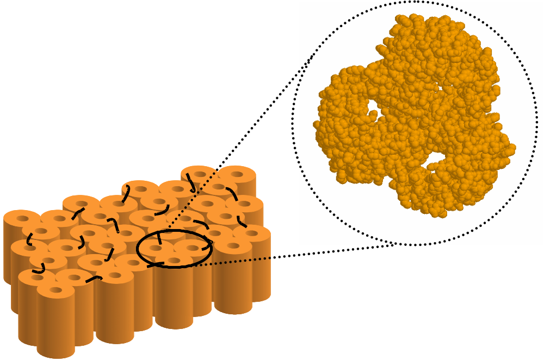

01 August 2002
with Addendum (see end) through Nov 27, 2002

Ionic Membranes Group BioMaDe
George Robillard, Director
Bob Eisenberg, Consultant
Wim Meijberg Project Leader

Henk Miedema Senior Researcher
Maarten Vrouenraets Researcher
Anita Meter-Arkema Technician

In close co-operation with the

Protein Engineering Support Group

Hans Hektor Project Leader
Barbara Lussenburg Researcher

Table of contents

Table of contents 3
1. Introduction 4
1.1 General Introduction 4
1.2 Outer Membrane Protein F 4
1.3 Why use OmpF? 6
1.4 Experimental approach 6
2. Results 8
2.1 Purification of OmpF. 8
2.2 Functionality of OmpF 9
2.2.1 Swelling assays 9
2.2.2 Electrophysiological characterisation 10
2.3 Membrane reconstitution and two-dimensional crystallisation 16
2.4 Cross-linking of OmpF containing membranes 18
2.4.1 A-specific cross-linking 18
2.4.2 Specific cross-linking 19
2.5 Manipulating the functionality of OmpF 24
2.5.1 Manipulating selectivity 24
2.5.2 Manipulating gating 25
Update 29
3. References 30
Appendix: registration numbers 40

Introduction

General Introduction

Ion channels in biological membranes are protein molecules that conduct ions (e.g. Na⁺, K⁺, Ca²⁺, and Cl⁻) through a narrow tunnel of fixed charge formed by the amino acid residues of the protein. The channels open and close stochastically, allowing the rectangular pulses of current to flow, and form a nearly one-dimensional ‘reaction path’ for solute movement. Biological systems use such channels for a variety of purposes, of which maintenance of the proper distributions of ions necessary for life, transmission of pulses in the nervous system and generation of the ion gradients responsible for ATP synthesis are just a few examples. From a technological point of view they can be described as natural nanotubes that link the solutions on each side to the electric field in the membrane that separates them. The tunnel dimensions vary, depending on the specific type of channel and the ‘substrate’ (the ion that is flowing through the channel), but they are typically around 5 nm long and 0.4 to 1 nm wide at their narrowest point.
Biological ion channels are not mere open pores or molecular sieves permeable to whatever ion species is available in the solutions on either site of the membrane. Instead they often show ion selectivity, i.e. they are able to discriminate between different ion species on the basis of their size and charge. In addition, ion channels show the characteristic of gating, i.e. the channel switches between a closed or non-conducting state and an open or conducting state. The three-dimensional structure of several ion-channels is known, for example the bacterial outer membrane proteins OmpF and PhoE¹, the mechanosensitive channel of large conductance MscL², the KcsA K⁺-channel³. A growing body of theoretical, chemical and mutagenesis data is now being applied to developing a molecular understanding of ion selectivity, gating and transport rates (see for recent developments e.g. ^{4,5}). Technological application of this newly acquired knowledge is hampered by the fact that the ion channels must be embedded in membranes that need to be both non-leaky (resistance in the GΩ range) and mechanically robust, a combination that is hard to attain. The main goal of the ionic membranes project is to develop such a mechanically strong, functional channel-containing membrane.
The potential of this new technology is large, since it would be possible to manipulate large ion flows on an atomic scale under the control of a macroscopic potential. Possible applications for ionic membranes include separation of anions and cations by a molecular monolayer to produce a nanometer scale battery for microelectronic and sensor technologies, ionic filters, molecular sieves for neutral molecules, filter components for artificial kidneys, or reaction vessels with specific binding sites whose accessibility and reactivity can be controlled by potential across the membrane.

Outer Membrane Protein F

To achieve our goal of a mechanically robust, ion-selective membrane we are using one of the most thoroughly studied channel proteins, the outer membrane protein F from E. coli to confer the desired selectivity to the membrane. Outer membrane proteins (collectively often referred to as porins) are found in the outer membrane of Gram-negative bacteria, mitochondria and chloroplasts. The dominant element of their three-dimensional structure is a large antiparallel β-sheet that closes on itself to form a β-barrel that traverses the membrane. The barrel can consist of as few as 8 transmembrane strands to as much as 22 (see for reviews ⁶⁻⁸) and their functions vary from transport (active or passive) to membrane bound hydrolase or defense against attack proteins. Many have been crystallized and their structure is known in detail, making them attractive objects for further study and technological application.
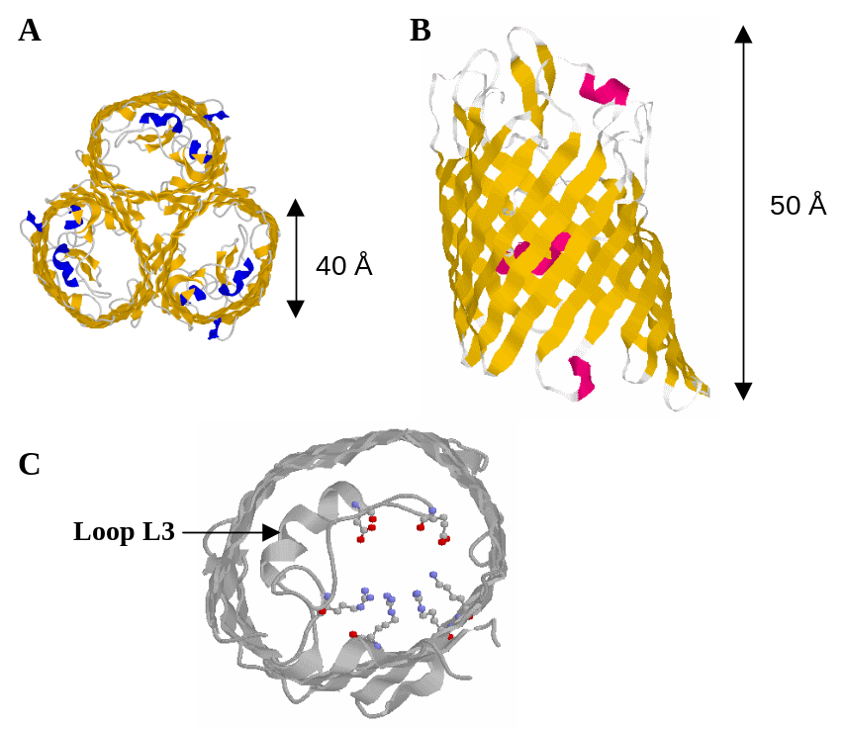
Outer membrane protein F (OmpF) is a β-barrel from Eschirichia coli and was one of the first porins to be crystallised. Its function is the exchange of nutrients, waste products and ions across the outer membrane of the bacterium via passive diffusion. The 340 amino acid polypeptide folds into a 16 stranded antiparallel β-barrel, forming a large, hollow, water-filled, transmembrane pore. Three monomers combine to form a trimer containing three more or less independent pores (Figure 1.1A). The monomers are approximately 50 Å in length and 40 Å in diameter at the widest point (Figure 1.1B). On the periplasmic side the β-strands are connected by tight turns, but on the extra-cellular side large loops exist between consecutive strands. Loop L3 folds back into the barrel, creating the eyelet region or constriction zone of the channel (Figure 1.1C). At its narrowest part halfway through the pore the cross-section of the channel is approximately 7 x 11 Å, effectively excluding substrates of >600 Dalton from transport.
Figure 1.1 Three dimensional structure of OmpF as determined by X-ray crystallography. A: top view from the extracellular side; the arrangement of the three monomers into a trimeris clearly visible. B: side view highlighting the 16 stranded β-barrel fold of the monomer. The periplasmic side of the protein is on the bottom C: top view showing the constriction zone in detail. The top part of the protein has been removed for clarity
The elementary properties of the channel such as selectivity, conductance and gating are determined by the size of the channel constriction, and the number, sign and distribution of charges in the proximity of the constriction zone ^{9,10}. Therefore, factors that influence the electrostatic potential in the channel pore such as the ionic strength of the solution^{11,12,13} affect channel behaviour. Among the most powerful tools to investigate structure-function relationships of proteins are site-directed and random mutagenesis methods since the substitution or deletion of one or more amino acids may significantly alter ion channel properties^{14,15}. In addition these methods allow the introduction of specific sites of attachment (e.g. sulfhydryls via cysteines) for ‘foreign’ functionalities such as binding motifs or molecular switches to influence gating. From a biophysical point of view these bacterial porin molecules seem to behave quite exceptional. Traditionally, gating and ion permeation are considered to be two independent phenomena, i.e. the flux of ions through the channel is thought not to influence the gating mechanism. Although this has been a paradigm in channel biophysics for more than five decades, a recent study on OmpC challenges this view¹⁶.

Why use OmpF?

Several factors have been important in selecting OmpF as the ion channel of choice for the construction of ionic membranes. First of all, the three-dimensional structure of this protein is known in great detail (¹ and see Figure 1.1). Secondly, porins are remarkably stable; OmpF, for example, does not denature below 70 ºC in the presence of 1% SDS (see e.g. ¹⁷), and consequently the protein is easy to handle. Moreover OmpF can reproducibly be crystallised in two dimensions using standard methods¹⁸, ensuring that a high density of channels in the membrane can be reached with relative ease. In addition, it has a high specific conductivity (e.g. ¹⁹, and see the section on electrophysiological characterisation (2.2.2) in this report), which makes it possible to pass microamps of current through a one micron squared area filled with porin molecules. The permeability and charge characteristics of the protein have been studied by a host of experimental and theoretical methods^{10,11,19-27} all of which can be used to our advantage. The protein can be readily modified using standard molecular biology methods so ‘custom-made’ proteins can be designed, produced and purified with comparative ease.

Experimental approach

There are a number of experimental approaches one can choose to create an ionic membrane of the type described above. One very important consideration, however, is that biological membranes consist of two main components, lipids and proteins, both of which are more or less mobile within the two-dimensional space defined by the membrane. It is exactly this mobility that allows the membrane to function as a highly effective barrier against the passage of ions other than through designated (and tightly controlled) channels, and therefore this property should be preserved as much as possible. With this condition foremost in our mind we have chosen to confer mechanical strength to the membrane by covalently cross-linking the least mobile component of the membrane, nl. the embedded protein molecules. This approach should allow the surrounding lipid to diffuse more or less freely around the protein scaffold, mimicking the architecture of the biological membrane as closely as possible. Nonetheless a thin sheet of foil created by this approach could in principle be as strong as the plastic film we buy in supermarkets (Saranwrap), since both are held together by the same molecular interactions.
On the experimental level a number of steps have to be taken to achieve the final goal of building a ion-selective membrane via protein cross-linking. These are:

- overexpression and purification in high yields of OmpF
- characterisation of the newly purified protein to ensure proper folding and functionality
- reconstitution in membranes and two-dimensional crystallisation
- development of cross-linking methods
- production of two-dimensional cross-linked sheets
- characterisation of the two-dimensional cross-linked membranes in terms of stability and ion transport.

Concomitantly the functional properties of the protein are manipulated by mutagenesis methods. Two strategies are being employed, rational design and random mutagenesis. In the first method specific changes are being made in the primary protein sequence to obtain the desired properties, based on the three-dimensional structure of the channel and/or results from calculations and simulation experiments. In the random method mutations are being introduced at random positions and the mutants with desired properties are selected from a large library by an appropriate screening procedure. The results of our investigations so far are described in the next section.

Results

Purification of OmpF.

Traditionally the purification of membrane proteins is achieved by expressing the protein in an appropriate host, separation of cell membranes and the cytosol, extracting the protein from the membranes and further purification of the extract, usually by column chromatography. A procedure following these general guidelines has been described for OmpF²⁸ and this seemed a good starting point to attempt to obtain the protein in pure form. An overexpression system, comprising of a plasmid bearing the OmpF gene under control of the T7 promoter (pGompF; ²⁹) and an especially adapted E. coli strain in which all known genes for outer membrane porins have been inactivated (E. coli Omp8; ²⁹) was kindly provided to us by Prof. Tilman Schirmer of the University of Basel, Switzerland. Using this system large amounts of protein could indeed be produced, but in our hands purification to homogeneity proved to be difficult. Two of the main components of the E. coli outer membrane, lipoprotein and lipopolysaccharide, co-purified with the protein and, despite our best efforts, proved to be very hard to separate from the native protein (Figure 2.1). The procedure yielded approximately 5 mg of pure protein per litre of bacterial culture, an amount that is not enough to meet our needs.
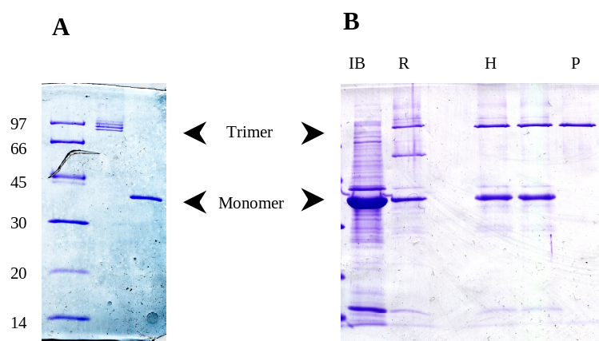
During the purification procedure it was noted that a large part of the overexpressed membrane protein was not associated with the membrane but appeared as aggregates in the cytoplasm of the cell. Aggregates of this kind are termed inclusion bodies and are not uncommon in bacteria if the production of overexpressed protein in the cell is very high. It was also noted that the size of the monomeric denatured protein in the inclusion bodies as determined from SDS PAGE is slightly larger than the size of the purified protein. This observation can be understood if the normal route of bacterial outer membrane protein processing is taken into account. To discern between membrane proteins destined to function in the inner and outer membranes, the latter are ‘tagged’ with a signal sequence of 20 amino acids on the N-terminal side of the mature protein. The sequence is recognised by a dedicated secretion system that in conjunction with a number of other proteins transports the polypeptide sequence to the periplasmic space and removes the signal sequence to yield the mature protein that can fold and insert in the outer membrane (see e.g. ³⁰ for a review). We concluded that the majority of the overexpressed protein is not being transported, most likely because the translocation machinery is overloaded, resulting in inclusion bodies containing unfolded polypeptide chains with the signal sequence still attached.
Figure ‎2.1 SDS PAGE analysis of the purification of OmpF from the outer membrane (A) and inclusion bodies (B). In the presence of 1% SDS the protein remains in the trimeric form unless the solution is heated to 100 ºC for several minutes, after which monomers are observed. The multiple bands observed for the trimer in A are caused by bound lipopolysaccharides that are not present in B. Molecular weight markers and trimer and monomer positions are indicated in the figureAbbreviations: IB, inclusion bodies; R, refolded; H, heat treated; P, protease treated.
On the basis of the results described above an alternative purification procedure was developed. To this end a new expression plasmid, pGompFmat, was constructed in which the sequence of the mature protein was placed directly behind the promoter (i.e. the DNA sequence coding for the signal peptide was removed) resulting in expression of large amounts (>300 mg OmpF per litre of culture) of the mature protein in inclusion bodies. The inclusion bodies can be separated easily from the rest of the cellular components and are already approximately 80% pure, but unfortunately the expressed protein is in an aggregated and unfolded form and therefore needs to be regenerated. To this end the inclusion bodies are dissolved in buffer containing 8M urea at a final protein concentration of 2 mg/ml and diluted 10-fold into a solution containing the detergent dodecylmaltoside (see ³¹). Approximately 30% of the protein forms native trimeric structures as determined from SDS-PAGE, the rest forms non-native monomeric and dimeric structures. The dimeric structures are converted to monomers by heating the solution to 70 ºC for 30 minutes, after which the monomeric structures are degraded by treatment with protease. Although both procedures are harsh treatments in terms of protein chemistry, they leave the native trimeric from of the protein completely unharmed (Figure 2.1 and see below). Concentration and final purification of the protein preparation is achieved by anion-exchange chromatography. The final yield is ca 50 mg per litre of culture medium.

Functionality of OmpF

Swelling assays

As indicated in the previous paragraph the purification procedure exposes the protein to harsh conditions and therefore it needs to be established whether the protein is still functional. In nature OmpF mainly functions as a passive diffusion pore embedded in the outer membrane, i.e. it allows the passage of molecules and ions across the outer membrane by diffusion through the channel. Two methods have been applied to test for this functionality, swelling assays and electrophysiological measurements in planar lipid bilayers.
The use of swelling assays to test the functionality porins was developed in the late 1970’s and early 1980’s^{26,32,33}. The method is based on the formation of multilamellar proteoliposomes that are filled with a solution containing a high concentration of a solute (dextran) that is too large to diffuse through the pore. These liposomes are diluted into an iso-osmotic solution of a compound that is small enough so that it can pass through the channel. This solute diffuses down the concentration gradient into the interior of the liposomes, resulting in an increase of the osmotic value on the inside. Consequently water is taken up, mostly directly through the membrane, causing the liposomes to swell. This process can be followed by simply monitoring the light scattering properties of the liposome containing solution in a spectrophotometer, where the rate of change in apparent absorption is a measure of the rate of transport through the protein pore. Unfortunately the method does not yield absolute results, since the rate of change varies with protein concentration and the exact composition of the liposomal solution (size, number and multilamellarity of the liposomes, reconstitution efficiency of the protein etc.), a variable that is hard to control. The relative rates of transport of compounds of similar structure but different size, however, are reproducible between preparations, and therefore results are compared in this way.
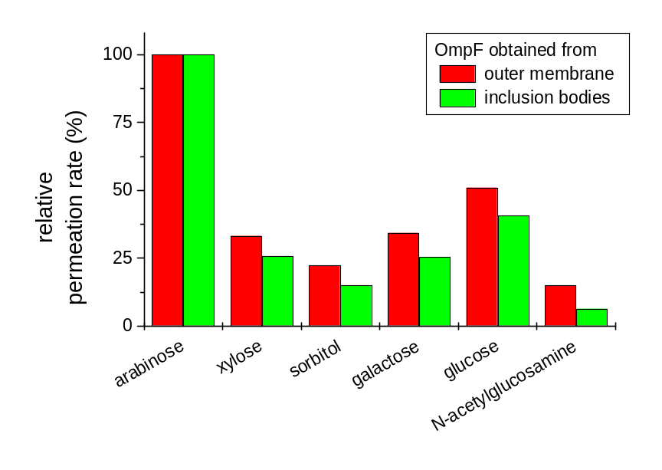
The functionality of the OmpF protein from inclusion bodies was determined by comparison with the same protein obtained directly from the outer membrane of E. coli. To this end the rates of swelling after exposure to iso-osmotic solutions of carbohydrates with molecular weights ranging from 150.1 to 221.2 Da were determined and normalised with respect to the result obtained for the smallest of the range, arabinose (Figure 2.2). Although there are small differences, the trend in both sets of data is clearly the same, leading us to the conclusion that OmpF from inclusion bodies and the bacterial outer membrane are functionally very similar.
Apart from non-charged molecules, OmpF also allows the diffusion of charged species through the lumen of its pore, i.e. it functions as an ion channel. This opens up the possibility to analyse functionality using electrophysiological techniques such as planar lipid membranes. This is discussed in some detail in the next section.
Figure ‎2.2 Permeation rates of a number of carbohydrates, relative to arabinose (MW 150.1). The Other molecular weights are 150.1 (xylose), 180.16 (sorbitol, galactose), 182.17 (glucose), 221.2 (N-acetylglucosamine).

Electrophysiological characterisation

Ion channels mediate fluxes of one or more ion species across biological membranes. Today’s electronic amplifiers are high precision instruments that allow the measurement of currents smaller than 1 pA (10⁻¹² ampere, corresponding to a flux of 10⁶ monovalent ions per second). This high resolution implies that even the ionic currents through individual channel molecules can easily be detected and from this point of view, these measurements belong to the most sophisticated techniques in molecular biology currently available. One way to study ion channels is to, first, isolate the channel, followed by the reconstitution of the channel in an artificial membrane or planar lipid bilayer (PLB). The advantage of this approach is an advanced level of control as far as lipid bilayer composition, choice of the solutions on either side of the membrane and chemical modification of the channel are concerned. It is this approach that we use here to characterise OmpF.
A schematic representation of a PLB set-up is shown in figure 2.3. The lipid bilayer, containing the reconstituted ion channel of interest, separates two electrically isolated compartments, by convention defined as the Cis and Trans compartment. The Cis compartment is connected to the measuring electrode and to the pre-amplifier in the headstage of the patch-clamp amplifier while the Trans compartment is electrically grounded. Most commonly, ionic currents through the ion channel in the PLB are measured at a constant voltage (V). However, current flow (I_{K}) arising from channel opening changes V. To actually voltage-clamp the potential at a certain desired or command potential (V_{com}) requires an electronic circuit as indicated with a central role for the operational amplifier (OA). The measuring electrode and V_{com} are connected to the - and + inputs of OA, respectively. Any difference between the two inputs causes a feedback current (I_{f}) through the feedback resistor (R_{f}). This ‘correcting current’ I_{f} is equal in magnitude but of opposite polarity to the current passing the membrane (I_{K}). The circuit operates like a current-to-voltage or IV-converter and the output of OA (V_{out}) is directly proportional to the current across the bilayer. Typically, R_{f} has a value of 1 GΩ; then, an input of 1 pA corresponds to a 1 mV output. By convention, potentials are referenced to the potential of the Cis compartment and a positive current (upward deflection) is defined as a net flux of positive charge from Cis to Trans.
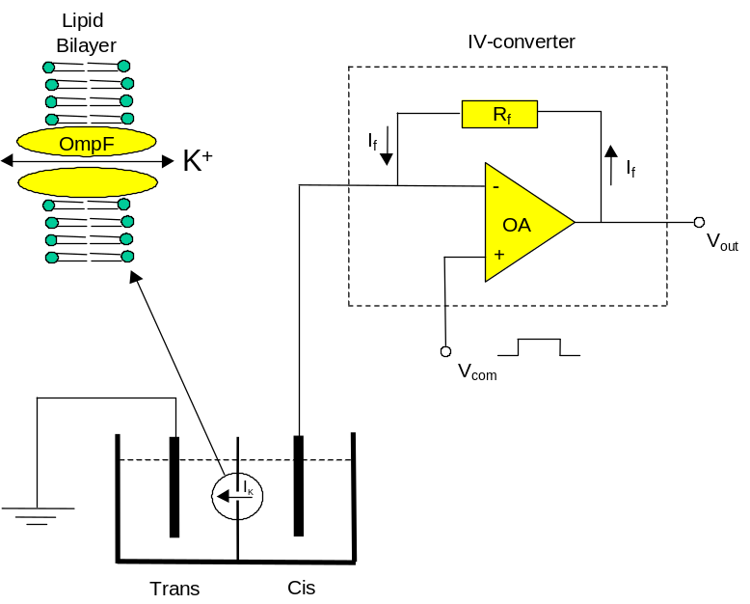
Essential to the use of the set-up described above is the ability to assemble a lipid bilayer in the hole that separates the two compartments, and to insert a channel into this membrane. This is done by dipping a ‘brush’ in an solution of lipids in organic solvent (we use mixture of phosphatidylethanolamine and phosphatidylcholine in an 8:2 ratio, dissolved in n-decane at 10 mg/ml) and ‘painting’ this solution over the aperture that is below the surface of the surrounding solution. In a few seconds, the lipid film thins out, a process that is thermodynamically controlled and results in the formation of a true lipid bilayer. The process can be followed by monitoring the electrical capacitance of the bilayer, since the specific capacity of a decane containing bilayer is around 0.4 μF/cm², about half the specific capacitance of a solvent free bilayer³⁴. Furthermore, after thinning the capacitance is a direct measure of its surface area, which is an important parameter because the larger the membrane surface area, the better the chances for ion channel reconstitution. A typical bilayer has a surface area of 0.005 mm² and a capacitance of 200 pF. Note that just part of the aperture (with a total surface area of 0.02 mm²) is covered by a bilayer but that most of the surface area is taken up by the so-called lipid annulus³⁵. The protein is reconstituted by adding a minute amount (final concentration < 1 ng/ml) to the Trans compartment while stirring. The channel inserts spontaneously into the membrane, but nonetheless the reconstitution is under experimental control, since turning off the stirring device effectively terminates the incorporation of more channels.
Figure ‎2.3 Schematic representation of a planar lipid bilayer set-up. For a detailed description see text
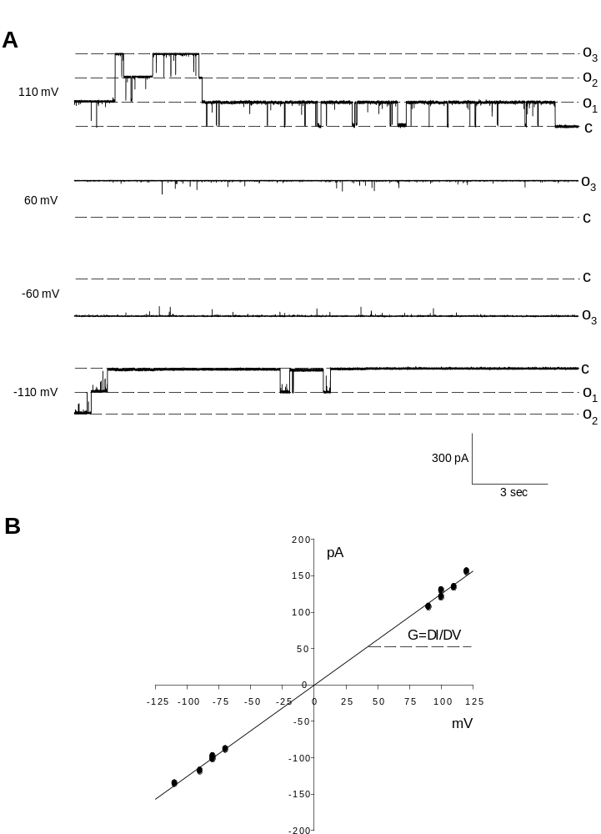
Figure ‎2.4 Single molecule current recordings of OmpF (A) under voltage clamp conditions. The different levels of conductance are indicated in the figure (C: closed, O₁ to O₃ open). The I-V curve was determined as described in the text

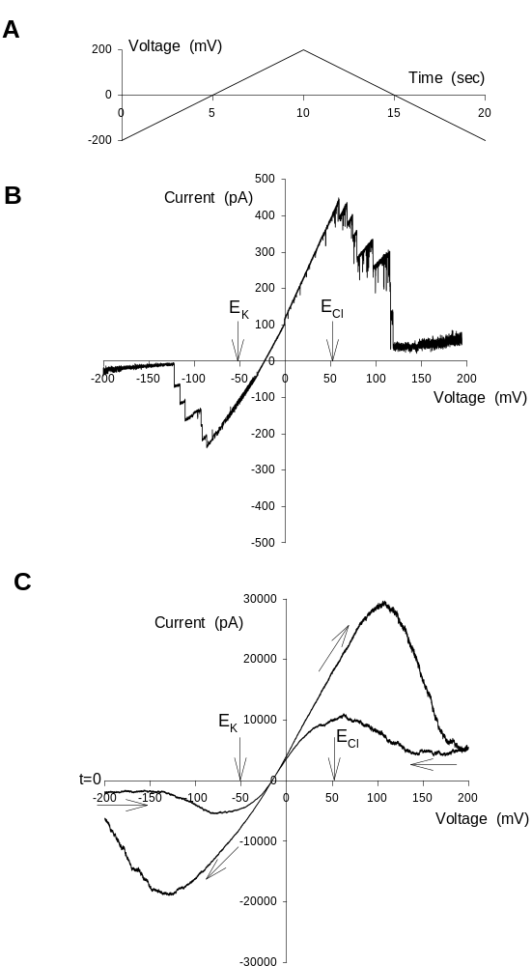
Following the procedures described above single channel current recordings of OmpF (purified as described above) can be obtained routinely. Figure 2.4A shows four current recordings under voltage-clamp condition with 1 M KCl in both the Cis and Trans compartments. The potential difference is indicated on the left hand side of the traces. At –110 and 110 mV the gating of the channels is obvious from the current jumps back and forth from the closed state (c) to current levels corresponding to one (o₁) or more open states (o₂ and o₃). Plotting these current jumps as a function of the potential renders the so-called
Figure ‎2.5 Current recordings obtained using the volta the voltage ramp protocol indicated in A with either a few channels embedded in the membrane (B) or a large number (C).

current-voltage or IV-curve in Fig. 2.4B. The single channel or monomeric conductance (G), defined as the slope of the IV-plot, was, on average, 1.2 nS. Equating ion channels to transport proteins (i.e. enzymes, see ³⁶), the conductance can be seen as analogous to the turnover number.
As is obvious from Fig. 2.4A, the recordings at 60 and –60 mV show hardly any gating and all three monomers remain open. Apparently, the gating process is sensitive to the applied potential. Figure 2.5 shows current recordings in response to a slightly different voltage protocol as the one applied in Fig. 2.4. Instead of clamping the potential at one particular level the potential was gradually increased from –200 to 200 mV, followed by a voltage ramp back to –200 mV, all in 20 seconds time. The voltage ramp protocol is shown in Fig. 2.5A. With only a limited number of OmpF channels reconstituted, the current trace in Fig. 2.5B shows channel openings and closings, as in Fig. 2.5A. At the start of the voltage ramp at –200 mV, channels are closed. Upon the change of potential in the positive direction, channels open but start to close again at potentials more positive than approximately 50 mV. (Note: for reasons of clarity, the current trace during the ramp back to –200 mV is not shown). To obtain a statistically more reliable picture of the voltage dependence of the gating process, one can either analyse multiple recordings on one or a few reconstituted channels or, alternatively, measure the response of many channels simultaneously. An example of the last option is shown in Fig. 2.5C. Note the difference in current magnitudes in Figs. 2.5B and C. By comparing the current levels at 110 mV in both panels, we can estimate the minimum number of reconstituted monomers in Fig. 2.5C to be around 30000/75=400, i.e., approximately 133 OmpF trimers. The recording of Fig. 2.5C started at –200 mV, indicated by t=0, and because this figure shows the entire trace, the direction of the current trace is indicated by arrows. Qualitatively, this figure shows the same voltage sensitivity of OmpF gating as Fig. 2.5B but single channel gating is no longer visible. As holds for an (ideal) electrical resistance (R) and according to Ohm’s law (V=IR or, with G=1/R, G=I/V), the IV-plot in Fig. 2.7B shows linearity. In contrast, the IV-plots of Figs. 2.5B and C are clearly non-linear. One should realise that the IV-plot of Fig. 2.4B refers to the IV-characteristic of an open channel. When recording on an ensemble of channels, the voltage-dependent gating may cause the IV-plot to be non-Ohmic and the recordings of Figs. 2.5B and C are outspoken examples. Despite an increase of driving force for ion movement at more negative and more positive potentials, the overall current magnitude decreases because channels tend to close in these voltage ranges and this is translated into a negative slope conductance. Both the activation (opening) and deactivation (closing) of OmpF might be voltage sensitive. The hysteresis observed in Fig. 2.5C is most likely an artificial effect due to the slow speed at which the ramp was applied ^{37,38}.
The voltage-dependent gating of OmpF can be used to demonstrate the fact that the protein is a trimer composed of three monomers which gate separately (but not independently). An example is shown in Figure 2.6. At a holding potential of 0 mV the trimer was fully open. A voltage step to 100 mV induced channel closure in three distinctive steps, reflecting the individual closure of the monomers (note that the initial current increase at the onset of the 100 mV pulse is caused by the instantaneous increase of the driving force for cation efflux from Cis to Trans). The current trace in Figure 2.6 nicely demonstrates the stochastic nature of the gating process. Despite the bias towards channel closure, two temporal openings of a single monomer were observed after the trimer had already completely closed.
Apart from the conductance and gating, another important aspect of the functionality of OmpF is the ion selectivity, i.e. which ions are preferentially allowed to flow through the lumen of the pore. The recordings described above were all obtained in symmetrical 1M KCl solutions, but in order to determine the ion selectivity of the channel, OmpF was exposed to an ion gradient of 1 M KCl in the Cis compartment and 0.1 M KCl in the Trans compartment. Under these conditions the potential of zero current is a measure of the ion selectivity of the channel or, in terms of ordinary enzymology, the substrate specificity of the channel. The zero-current potential is the also called the reversal potential (E_{rev}) because the current reverses its direction from outward or positive (upward deflections) to inward or negative (downward deflections). In electrophysiology, an ion selectivity measurement is nothing but a comparison of the measured E_{rev} with the calculated Nernst or equilibrium potentials of all permeable ion species. Based on ion activities, these solutions resulted in equilibrium or Nernst potentials for K⁺ and Cl⁻ of –52.7 and 52.7 mV, respectively. In Fig. 2.5, the equilibrium potentials of K⁺ (E_{K}) and Cl⁻ (E_{Cl}) are indicated. The fact that E_{rev} is located closer to E_{K} than to E_{Cl} already indicates that OmpF is more permeable to K⁺ than to Cl⁻. Note that the value of E_{rev} is independent of the number of open channels but only depends on the number of ion channels with different ion selectivity. A quantitative measure of the ion selectivity of an ion channel is the permeability ratio P_{a}/P_{b} for ion species a and b. An expression of P_{a}/P_{b} can be derived from the Goldman-Hodgkin-Katz or GHK-current equation for electro diffusion:

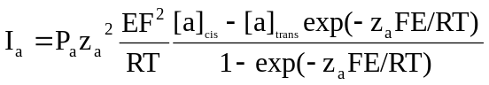 (1)

where E is the electrical potential and RT/F equals 25.3 mV at 20 °C. By definition, the total current at E_{rev} equals zero. Assuming that the current is explicitly carried by ion species a and b, implying I_{a}+I_{b}=0, P_{a}/P_{b} is given by:

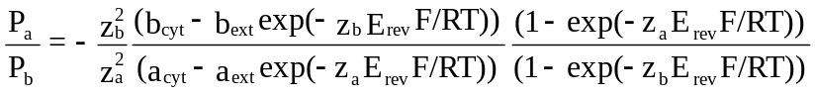 (2)

After substituting an average value for E_{rev} of –33 mV, we calculate a P_{K}/P_{Cl} of 6.6.
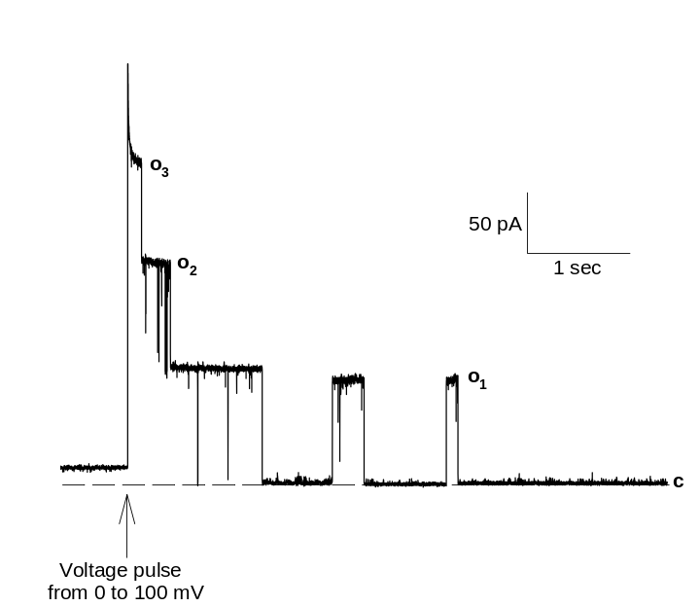
Figure ‎2.6 Current measurement of a single OmpF molecule. The stochastic opening and closing of the three channels from the trimer can be clearly observed

Membrane reconstitution and two-dimensional crystallisation

Ion channels normally function embedded into lipid bilayers, and therefore, after purification, they have to be put back in a similar environment to properly asses their properties. This process is called membrane reconstitution and several commonly used methods exist to achieve the goal (for a review see e.g. ³⁹). In most cases the methods consist of preparation of a mixture of membrane protein, detergent and lipid in an aqueous solution, followed by selective removal of the detergent. The remaining lipid and protein start to form aggregates during this process and eventually under the right conditions self-assemble into proteoliposomes, i.e. spherical structures where a single bilayer separates the inside from the outside and the membrane proteins are embedded in this bilayer. The selective removal of the detergent from the mixture is most commonly performed by a dialysis step. The tripartite mixture is dialysed against a large volume of buffer using a dialysis membrane with a molecular weight cut-off below the molecular weight of the protein, precluding passage of the protein to the other side. Because the critical concentrations for aggregation of the detergent and lipid are very different (mM and nM range, respectively) a sizeable part of the total amount of detergent will be present in monomeric form, whereas essentially all the lipid will be in some aggregated form. Only the monomeric species can pass through the dialysis membrane, leading to reduction of the detergent concentration, which in turn leads to further monomerisation of detergent micelles, and eventually removal of all detergent from the solution.
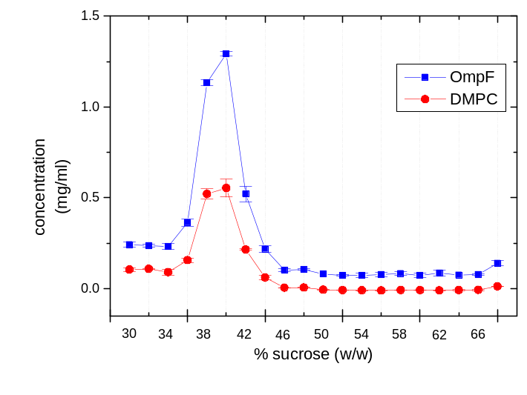
The method described above was also used to reconstitute OmpF using a protocol originally described by Dorset et al.¹⁸ who studied the reconstitution process and determined the optimal conditions for two-dimensional crystallisation of OmpF. In short, OmpF and lipid (usually 1,2-dimyristoyl-L-α−phosphatidylcholine (DMPC)), were solubilised in 20 mM HEPES, pH 7.4, containing 10 mM MgCl₂, 100 mM NaCl and 1% (v/v) of the detergent n-octyl-oligo-poly-oxyethylene (OPOE). This solution was dialysed at 37ºC for 16 h against the same buffer without detergent using a dialysis membrane with a molecular weight cut-off of 8 kD. The buffer was then changed and dialysis was continued for 8 h. Subsequently, dialysis was continued for 16 h against water. After changing the water and continuation of the dialysis for 2 h, water was cooled to 10ºC and the dialysis was ended. Depending on the intended use, samples were stored at 4 ºC or aliquoted and stored at –20 ˚C.
Figure ‎2.7 Sucrose gradient analysis of a reconstitution of OmpF in 1,2-dimyristoyl-L,a-phosphatidylcholine lipids. Protein and lipids colocalize on the gradient
After reconstitution, samples were analysed using sucrose gradient centrifugation, a method that allows separation of particles on the basis of their density. Since protein in general, and OmpF in particular (calculated density from the primary sequence ρ = 1.4 kg dm⁻³), has a higher density than lipid (ca 1 kg dm⁻³), the density of proteoliposomes increases with increasing protein content, and therefore a good indication of the result of a reconstitution experiment can be obtained from this method. In short, a centrifugation tube is filled with successive layers of sucrose solutions of decreasing concentration (and therefore density) so that a density gradient is formed in the tube. A sample is applied on top and a gravitational field is applied via centrifugation at high speed. Over time the particles (liposomes in this case) will position themselves in the sucrose layer with matching density.
Figure 2.7 shows a typical example of a sucrose gradient analysis of a sample of OmpF reconstituted into DMPC at high protein to lipid ratio. In this case a gradient with a total volume of 10 ml and a sucrose content ranging from 30 (at the top of the tube, equivalent to 1.11 kg dm⁻³) to 66% w/w (bottom; 1.32 kg dm⁻³) was used. After centrifugation the gradient was fractionated and the concentration of lipid and protein in each of the layers was determined and plotted as a function of the position in the gradient. It is clear that protein and lipid are found in the same fractions of the sucrose gradient, and since the density of these fractions is somewhere between the density of pure lipid and pure protein, this is good evidence that proteoliposomes have been formed.
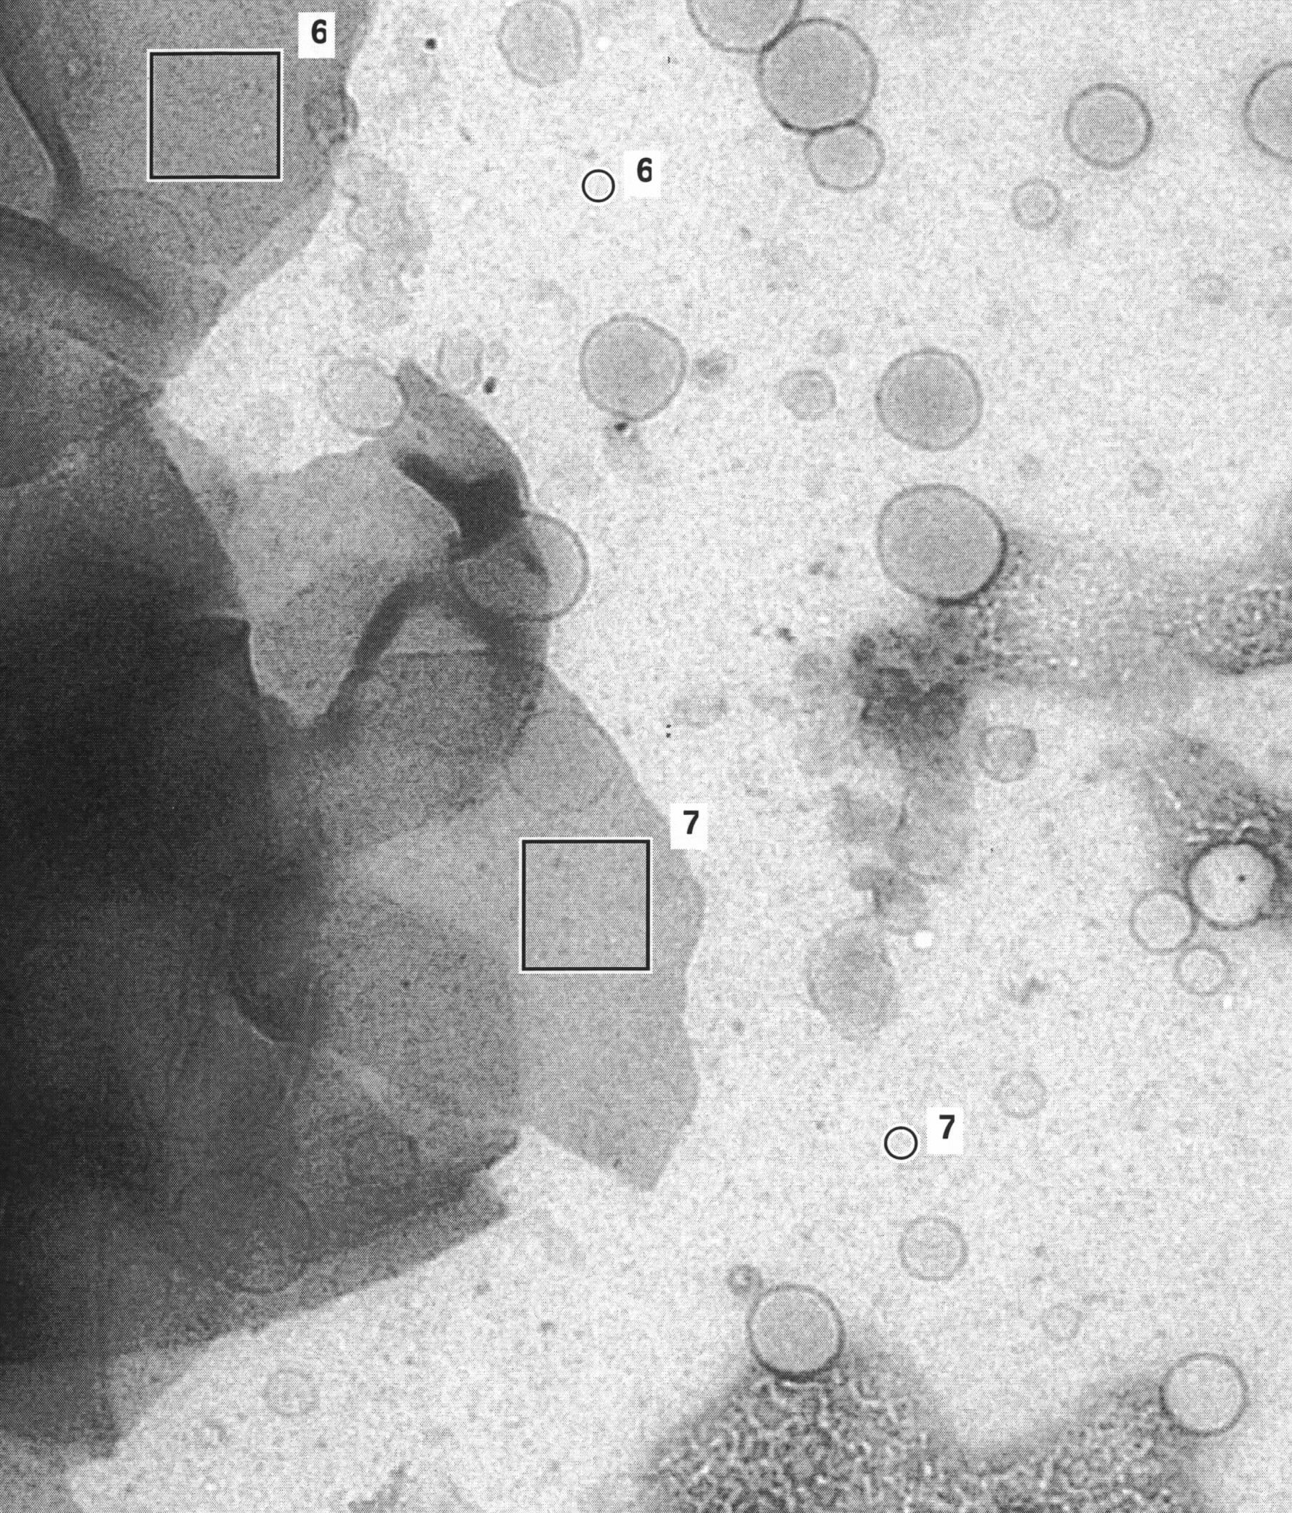
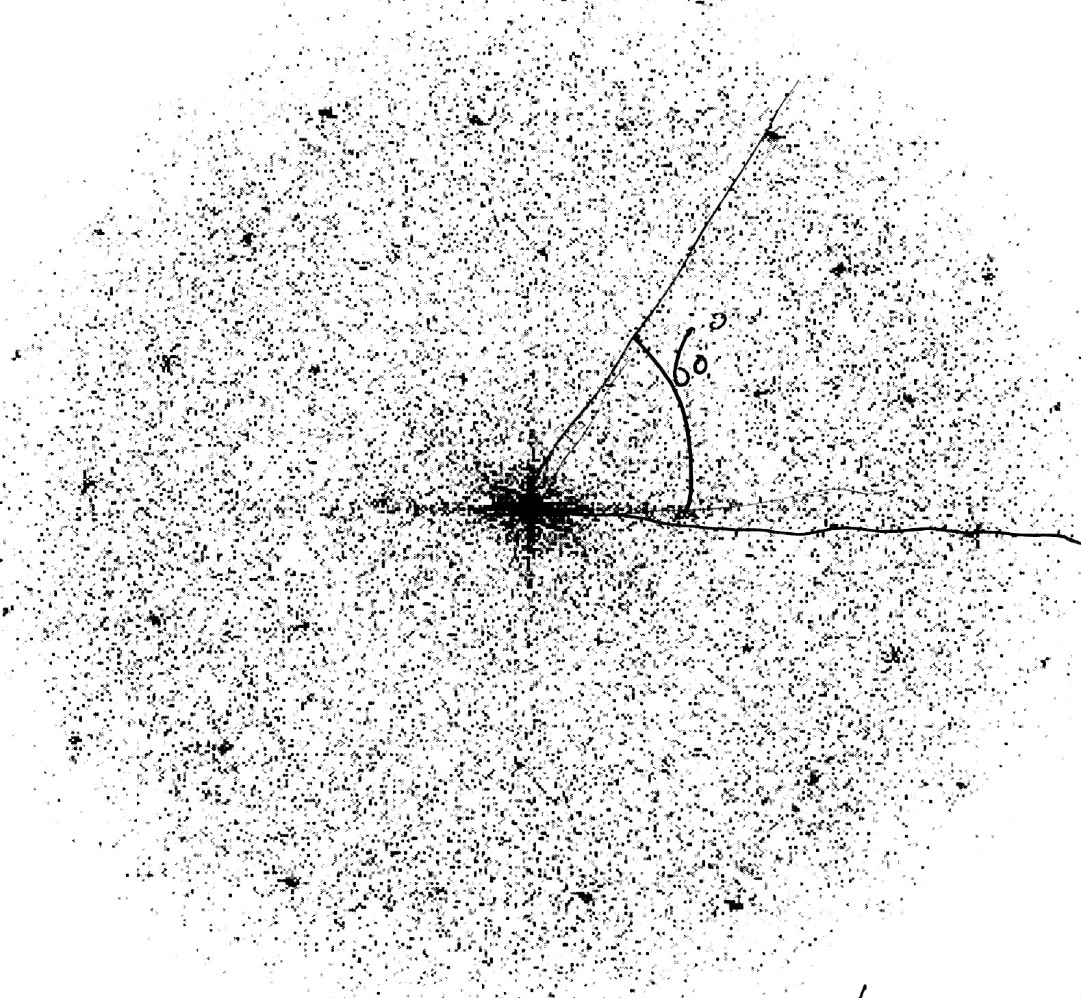
Further evidence for proper reconstitution was obtained from electron microscopy studies. Two methods were employed to obtain images, freeze-fracture and negative stain. In the former method the samples are rapidly frozen, fractured and stained with a heavy metal derivative. The fracture will seek the path of least resistance, which for bilayer membranes is between the two leaflets and therefore it is possible to observe transmembrane proteins directly, either as holes when the protein has remained associated with the leaflet that has been removed, or as protrusions in the opposite case. We obtained several images of this kind which showed large area’s covered with ice as well as irregular aggregates containing protein and lipid (not shown). The results improved when a cryo-protectant such as glycerol was added prior to the freezing step, although not to such a degree that a proper representation of the sample was obtained. Similar observations have been made for bacteriorhodopsin reconstituted into DMPC where freezing at a rate smaller than 10⁴ K s⁻¹ led to formation of protein rich and protein free patches⁴⁰. Therefore we conclude that the critical step in obtaining good images is the flash freezing of the sample, rather than the reconstitution protocol that we employ.
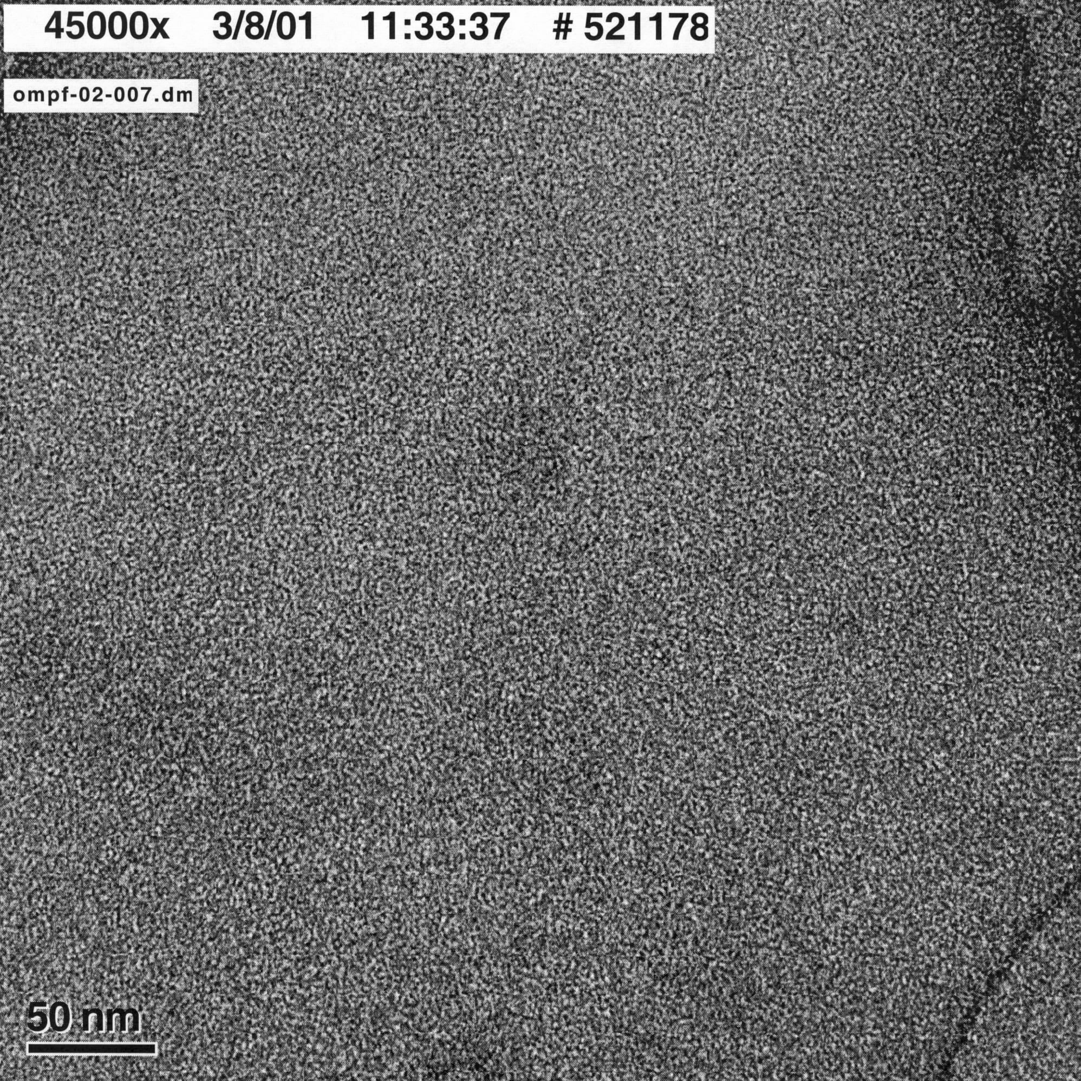
Figure ‎2.8 Electron microscopy images of OmpF 2D crystals, obtained after negative staining with uranyl acetate. On the left an overview of a preparation is shown; the large structures containing OmpF can clearly be seen. In the middle a magnification of one the squares (no. 7) is shown, which was used to calculate the diffraction pattern shown on the right. In this case the protein forms a hexagonal lattice with a = 9 nm.

To solve the problem described in the preceding paragraph a different method to prepare EM samples was employed, nl. negative staining. In this method the sample is briefly exposed to a solution containing a heavy metal salt (e.g. uranyl acetate) resulting in an imprint (or negative) of the surface of the vesicles that can be investigated by electron microscopy. Figure 2.8 shows the result of such an experiment. The reconstitution procedure leads to the formation of very large structures, up to 10 μm or even larger that exhibit sharp edges and folds, and also some smaller vesicles (A). Enlargement of the large assemblies (B) indicates that these are regularly ordered, a fact that is confirmed by the calculated diffraction pattern analysis (C). In this case a hexagonally ordered two-dimensional crystal with a lattice constant of 9 nm is formed, but other crystal forms are possible¹⁸.

Cross-linking of OmpF containing membranes

A-specific cross-linking
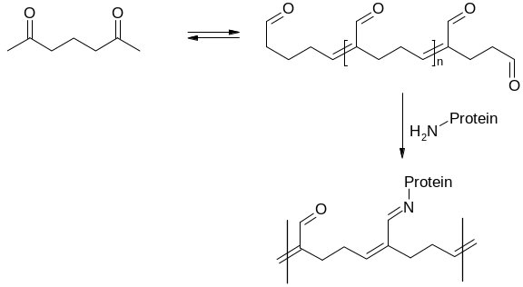
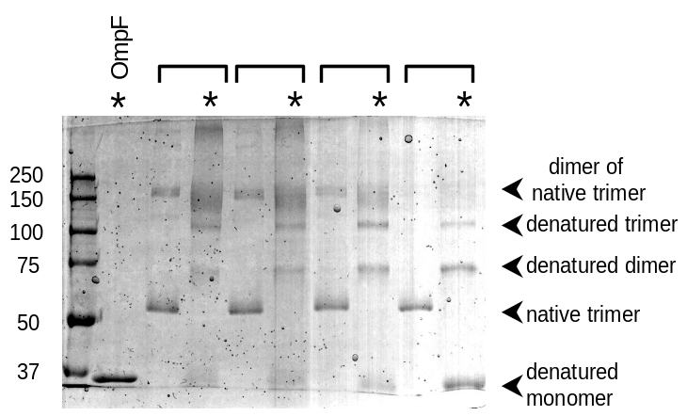
The two-dimensional crystals of OmpF are an ideal starting point for the formation of mechanically robust cross-linked membranes because of their very high density of protein. One of the oldest and best-known methods to covalently cross-link proteins is the use of glutardialdehyde (see e.g. ⁴¹). This small bi-functional compound readily polymerises in aqueous solutions and forms a range of molecules with different lengths and one reactive group (e.g. a keto moiety) per repeating unit. This reactive group can reacts with terminal amine groups such as those present in lysine residues to form a conjugated Schiff base (Figure 2.9). Using this method reconstituted OmpF membranes were cross-linked at room temperature (50 mM NaP_{i}, pH 7.0) for 3 h. The OmpF concentration was kept constant at 0.5 mg/ml (4.5 µM trimer), but glutardialdhyde was varied between 0.025-0.25% (4-40 mM). After incubation the samples were analysed by SDS-PAGE using 7.5% polyacrylamide gels as shown in figure 2.10. At 0.025% glutardialdehyde in untreated samples only native trimers are observed but after boiling for 10 min in 1% SDS unfolded monomers, dimers and trimers were observed. Apparently, intramolecular cross-linking occurred without formation of intermolecular bonds under these conditions. Similar observations have been made for glutardialdehyde cross-linking of porins in the detergent solubilised state⁴². At higher cross-linker concentrations intermolecular cross-linking are also formed, as can be concluded from the presence of dimers and trimers of trimers (all folded) in the non-boiled samples. After boiling, unfolded trimers and even higher molecular weight compounds were observed, although the resolution of the method goes down and bands became fuzzy.
Figure ‎2.10 A-specific cross-linking of OmpF analyzed on SDS PAGE. Reconstituted OmpF was treated with increasing amounts (from right to left) of glutaraldehyde. The samples were split and one half was boiled in the presence of SDS (labeled with a *), whereas the other half was left at room temperature. Samples originating from the same reaction mixture are indicated with a bracket. At low glutaraldehyde concentrations only intramolecular cross-linking occurs, at higher concentrations also intermolecular bonds are formed

Figure ‎2.9 Protein cross-linking via glutardialdehyde

Although the above described results are encouraging, the use of glutardialdehyde for cross-linking of OmpF has several major limitations. Since OmpF contains as much as 54 lysine residues per trimer, some of which are in the channel lumen, reaction with this moiety could easily lead to impairment of the functionality of the OmpF channel. Furthermore, the chemistry of glutardialdehyde is strongly dependent on the conditions of the experiment and therefore the reproducibility of this approach will be low. In conclusion, an approach where the cross-linking reaction is directed towards specific pre-determined sites is the method of choice.

Specific cross-linking

Protein cross-linking strategies in general use three moieties to attach a cross-linker to the protein, nl amines, sulfhydryls and carboxylates. Of these three both amines and carboxylates are abundant in OmpF and therefore not really suitable for site-specific attachment, but no sulfhydryl groups occur in the wild type protein. These can be easily introduced into the protein sequence (in the form of cysteines) using standard molecular biology techniques, and in combination with sulfhydryl-specific cross-linkers (many of which are commercially available), this approach allows exact control over the site of attachment.
Detergent mediated reconstitution and two-dimensional crystallisation of OmpF yields large vesicles in which the protein is uni-directionally embedded. The side of the protein that is exposed to the exterior of the vesicles and therefore readily accessible for cross-linkers is the periplasmic side, i.e. the side of the protein that contains the short β-turns between the strands that form the barrel. Of these four are pointing outward, i.e. away from the three-fold symmetry axis of the trimer (Figure 2.11). Single site mutants were created by introducing a cysteine residue in each of these, replacing leucine 147, glutamate 183, asparagine 223 or phenylalanine 267 in turns 4 to 7, respectively. All mutations were confirmed by DNA sequencing of the entire OmpF gene, and the proteins were purified as before, but dithiothreitol (DTT) was included in all buffers to avoid formation of disulphide bridges during the procedure.
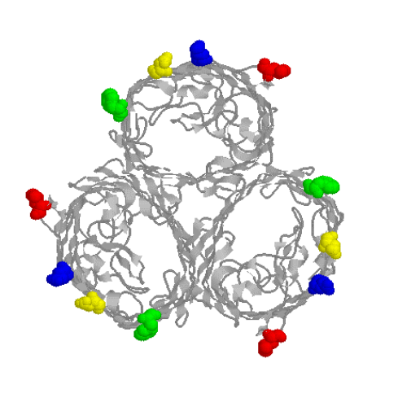
Initially reconstitution of the cysteine containing mutants was performed as for wild type OmpF in the presence of 1 mM DTT, but this resulted in aggregates of different morphology than the large vesicles normally observed. SDS-PAGE analysis after reconstitution revealed that dimers, trimers and higher molecular weight aggregates were formed, most likely due to disulphide bridge formation between different vesicles in the preparation. Apparently DTT is not potent enough to keep the cysteines reduced; in addition the two sulfhydryl moieties of DTT interfere with subsequent cross-linking and therefore a more suitable reductor had to be found. Tris(2-carboxyethyl)phosphine (TCEP) appeared an appropriate candidate, since according to the manufacturer and some early reports in the literature it is unreactive towards thiol-reactive compounds such as maleimides. Indeed no disulphide bridge formation was observed after reconstitution in the presence of 1 mM TCEP, but unfortunately preliminary experiments already showed that also the cross-linking reaction did not proceed. This is in agreement with more recent publications^{43,44}, that describe the interference of TCEP with reactions of protein thiols. To further our insight in the reaction we incubated TCEP with the dye 2-(4’-maleimidylanilino)napthalene-6-sulfonic acid (MIANS), a compound that exhibits an increase in fluorescence after reaction of the maleimido moiety. In the absence of protein we observed a rapid and large increase of fluorescence, strongly indicating covalent attachment of MIANS to TCEP. Since the reactive groups of the dye and the thiol-specific cross-linkers are the same, and TCEP is present in large excess in the cross-linking reaction mixture, this explains why the cross-linking reactions did not proceed. The problem was solved by decreasing the TCEP concentration in the dialysis buffers to 15 μM, a concentration that is still sufficient to keep the cysteines reduced during the reconstitution, even though the sulfhydryl concentration is around 25 μM. This apparent discrepancy can be explained by the large reservoir of TCEP provided by the large volume(at least 100-fold larger than the sample volume) and frequent changes of dialysis buffer that are used during the procedure.
Figure ‎2.11 The positions that were chosen to introduce single cysteines in the sequence: Leu147 (red), Glu183 (blue), Asn223 (yellow) and Phe267 (green).
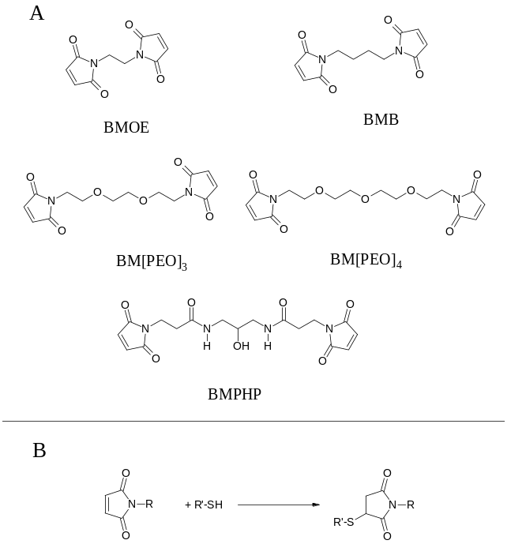
In order to test the accessibility and reactivity of the cysteine residues of both solubilised and reconstituted mutants OmpF L147C and E183C were treated with MIANS as described above. Subsequent analysis on SDS-PAGE yielded a clearly visible fluorescent band at the position of trimeric OmpF, which was confirmed by staining with Coomassie Brilliant Blue. We can conclude that the cysteines are both accessible and reactive towards sulfhydryl specific reagents.
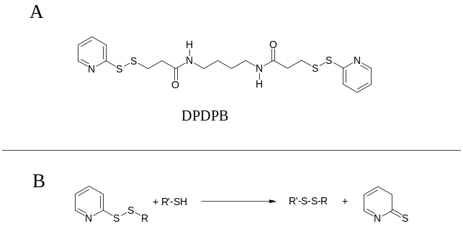
The results described above set the stage for site-directed cross-linking of OmpF to obtain robust membranes. The proteins can be reconstituted in high protein to lipid ratios in membranes and the chemistry is under control. For the cross-linking reactions, a set of homo-bifunctional sulfhydryl-specific cross-linkers was selected that varied in spacer arm length and water solubility. Five water soluble maleimide derivatives were used (Figure 2.12A): 1,2-bis-maleimidoethane (BMOE, spacer arm length 8.0 Å), 1,4-bis-maleimidobutane (BMB, 10.9 Å), 1,8-bis-maleimidotriethyleneglycol (BM[PEO]₃, 14.7 Å), 1,11-bis-maleimidotetraethyleneglycol (BM[PEO]₄, 17.8 Å), and N,N’-bis(3-maleimidopropionyl)-2 –hydroxy-1,3-propanediamine (BMPHP, about 18 Å). The use of maleimide derivatives for protein modification is described extensively in literature. Reaction with sulfhydryl groups at pH 6.5-7.5 generates a stable 3-thiosuccinimidyl ether linkage (Figure 2.12B). The 2-pyridyl-disulfide derivative 1,4-di[3’-2’-pyridyldithio)propionamido]butane (DPDPB, 19.9 Å, Figure 2.13A) is insoluble in aqueous buffers, and is therefore dissolved in ethanol. This cross-linker reacts with free sulfhydryl groups at pH 6.5-7.5 to form mixed disulphide conjugates with release of 2-pyridylthione (Figure 2.13B). The use of this compound has the advantage that the cross-linking product can be cleaved back to the original sulfhydryl groups with reducing agents such as DTT, and therefore offers an extra tool for cross-linking analysis. The cross-linker 1,6-hexane-bis-vinylsulfone (HBVS, 14.7 Å, Figure 2.14A) is also insoluble in water, and is dissolved in DMF before use. Conjugation chemistry is based on a Michael addition of the free sulfhydryl to the vinylsulfone moiety at pH 8.0 (Figure 2.14B), which is a slightly weaker electrophile than maleimide.
Figure ‎2.12 Chemical structures of maleimide-based homobifunctional sulfhydryl-specific cross-linkers (A) and their cross-linking chemistry (B).
Figure ‎2.13 Chemical structures of maleimide-based homobifunctional sulfhydryl-specific cross-linkers (A) and their cross-linking chemistry (B).
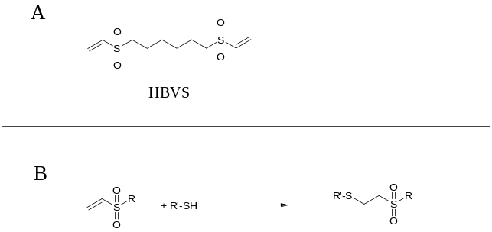
The general procedure for the cross-linking reactions was as follows: 20 μM of the bi-functional cross-linker was incubated with 0.5 mg/ml OmpF (corresponding to 13 μM of free sulfhydryls) in the presence of 25 μM TCEP at 37 °C for 3 h. Except for HBVS (pH 8.0), all reactions were carried out in 0.1 M NaP_{i} buffer, pH 7.0. After incubation, samples were analysed on 10% SDS-PAGE gels. This procedure was adopted after initial optimisation with two of the mutants, OmpF L147C and E183C.
Figure ‎2.14 Chemical structure of 2-pyridyl disulfide-based homobifunctional sulfhydryl-specific cross-linker DPDPB (A) and its cross-linking chemistry (B).
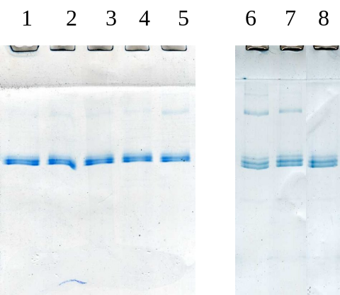
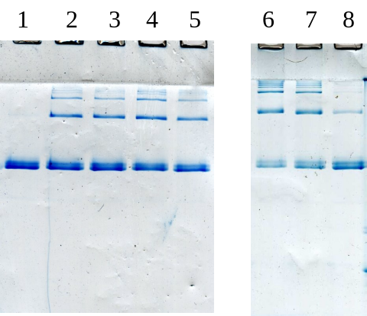
Figure 2.15 shows the results of cross-linking reactions of OmpF L147C and E183C mutants using the set of 7 cross-linkers. Data obtained with OmpF L147C mutant clearly showed that, except for the cross-linkers with a relatively short spacer arm (BMOE and BMB), cross-linking did not succeed. For the OmpF E183C mutant, results were significantly better. Reaction with all cross-linkers, except HBVS, resulted in the formation of higher molecular weight compounds (dimers of trimers, trimers of trimers, etc.). For OmpF N223C and F267C mutants, results were similar to those obtained with E183C (data not shown).
Figure ‎2.15 Cross-linking of the OmpF L147C (left) and E183C (right) mutants, analyzed on SDS-PAGE. The mutant (0.5 mg/ml) was treated with 20 µM of BM[PEO]₃ (lane 2), BM[PEO]₄ (lane 3), BMPHP (lane 4), DPDPB (lane 5), BMOE (lane 6), BMB (lane 7), and HBVS (lane 8). Lane 1 shows the control incubation.
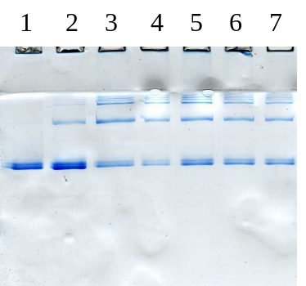
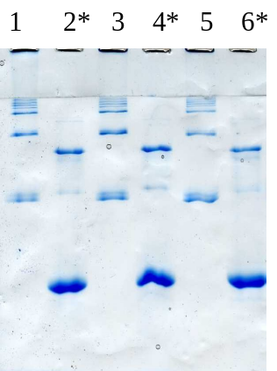
Further information on the nature of the cross-linking was obtained from determining the kinetics of the reaction and comparing the results before and after boiling in 1% SDS to break the non-covalent interactions that hold the trimers together. After cross-linking the mutants for 3 h, a significant amount of unreacted trimers is still present in the cross-linking mixture, but longer reaction times (up to 24 h) did not increase the cross-linking yield (not shown). Figure 2.16 shows the effect of boiling for 10 min in 1% SDS of cross-linked OmpF E183C mutant (reacted with BMOE, BMB and HBVS) before SDS-PAGE analysis. Both unfolded monomers and dimers can be observed, with the former being present in concentrations equal to the concentration unreacted trimers prior to boiling. This shows that no intramolecular cross-linking (i.e. between chains in the same trimer) occurs, since in that case a higher concentration of unfolded dimer would be expected. This is in agreement with the fact that the distances between individual cysteines in the trimer molecule (ca. 6 nm) are much larger than the length of the linker (≤ 2 nm)
Figure ‎2.16 Effect of boiling for 10 min in 1% SDS (labelled with a *) on BMOE- (lanes 1 and 2), BMB- (lanes 3 and 4), and HBVS-cross-linked OmpF E183C mutant, analyzed on SDS-PAGE.

Figure ‎2.17 Effect of BMOE concentration on cross-linking of OmpF E183C mutant, analyzed on SDS-PAGE. Lane 1: control, lane 2: 10 µM, lane 3: 20 µM, lane 4: 50 µM, lane 5: 112 µM, lane 6: 225 µM, lane 7: 450 µM BMOE.

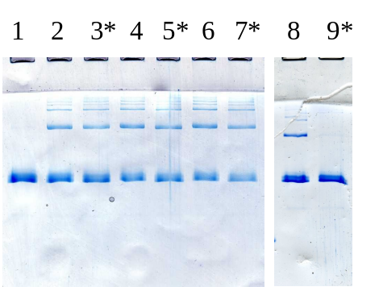
The effects of varying the concentration of cross-linker was tested using cross-linkers with either a relatively short (BMOE) a long spacer arm (BM[PEO]₄). Cross-linker concentrations ranging from 10 to 450 μM were used and the results were unexpected. Figure 2.17 shows the results obtained with BMOE. The cross-linking yield was about the same for 20-450 μM cross-linker (i.e. excess cross-linker), whereas 10 μM (excess sulfhydryl) clearly resulted in a lower yield, independent of the length of the linker. Apparently, the reaction kinetics are such that after reaction of a sulfhydryl with one maleimide of the bi-functional cross-linker, the second maleimide reacts much faster with a sulfhydryl in close proximity, excluding reaction with another cross-linker molecule.
Figure ‎2.18 SDS-PAGE analysis of the effect of 100 µM DTT after cross-linking of OmpF E183C mutant with BM[PEO]₃ (lanes 2 and 3), BM[PEO]₄ (lanes 4 and 5), BMPHP (lanes 6 and 7), and DPDPB (lanes 8 and 9). Lane 1: control.
The effects of varying protein (or rather, aggregate) concentration on the cross-linking yield was studied over the interval 0.25–0.75 mg/ml protein. SDS-PAGE analysis revealed that the yields were not significantly altered. Although the concentration interval is small, this is still an important observation, since higher yields at higher protein concentrations could indicate that unwanted intermembrane cross-linking occurs during the reaction.
In theory it is possible that the aggregates we observe after the cross-linking reaction result from oxidation of sulfhydryls to disulphide bridges, occurring after the reductor TCEP has reacted with the cross-linker. To eliminate this possibility, OmpF E183C was cross-linked with BM[PEO]₃, BM[PEO]₄, BMPHP and DPDPB and subsequently incubated with a large excess of DTT (100 μM). SDS-PAGE analysis (Figure 2.18) of these samples showed that only in the case of DPDPB, i.e. the covalent attachment via disulphide bridging, DTT was able to break the covalent links between the trimers. These results strongly suggest that in the case of the other three compounds thio-ethers have been formed between the protein and the cross-linker, a connection that is stable towards DTT.
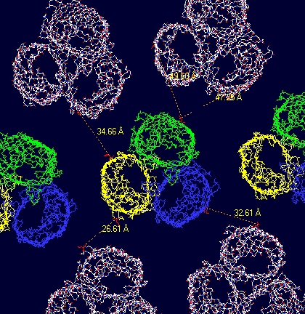
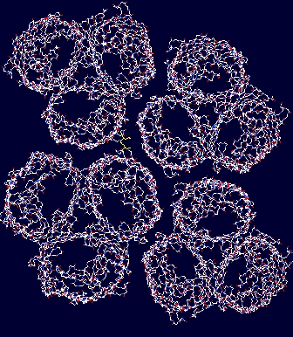
The results described above can be understood if the orientation and position of the trimer with respect to other trimer molecules in the two-dimensional crystal is taken into account. OmpF is known to crystallise in a number of different crystal forms of which the 9 nm hexagonal form we have found in our EM studies (see section 2.3) is only one (^{18,45,46}). Other crystal forms that have been observed are hexagonal crystals with lattice parameters of 8 and 7 nm respectively and a rectangular lattice with a = 7.9 nm and b = 13.7 nm. We have modelled a number of these and determined the distances between the different cysteines in the crystal. In the 9 nm hexagonal crystal the shortest cysteine-cysteine distance is 2.7 nm (Fig 2.19 A) and is found for the mutant at the 147 position. Nonetheless we find that this mutant is the most difficult to cross-link, and then only when we use short linkers (0.8 or 1.1 nm). Distances for the other mutants in this crystal form are all longer than 3 nm, so we conclude that cross-linking OmpF in this crystal form using these mutants and cross-linkers is impossible. However, it is known that under the conditions we use for the crystallisation a second, rectangular, lattice is also formed but at lower occurence¹⁸ (Fig. 2.19 B). In this crystal the distances between cysteines are not the same in all directions (like they are in the hexagonal lattices) but the shorter distances are roughly between 0.5 and 2 nm, i.e. in the range that can be bridged by the cross-linkers given their length. Moreover, the shortest distance (0.5 nm) is again found between positions 147 in different molecules, and this explains why cross-linking this mutant is more successful using the shorter rather than the longer linkers: the longer linkers are simply to long and bulky to sample the immediate surroundings of their primary attachment site efficiently enough to give a high yield for the secondary reaction to occur at high yield. On the basis of these considerations and results obtained by ourselves and others we tentatively conclude that the cross-links we observe occur in the rectangular crystal form. Unfortunately this lattice form is only present in a minority of the crystals being formed, but experimental methods to control the lattice formation are available to remedy this.
Figure ‎2.19 Models of the hexagonal (a = 9 nm, left) and rectangular crystal forms of (a= 7.9 nm, b = 13.7 nm, right) formed by OmpF. The distances between the individual molecules are are clearly larger in the hexagonal crystal form.
In conclusion, the above experiments have shown that we are able to cross-link OmpF reconstituted in membranes, using specific sites in the protein and commercially available sulfhydryl-specific -functional cross-linkers. The extent of cross-linking depends mainly on the position of the sulfhydryl in the protein structure, the type of chemistry, the length of the linker and (in all likelihood) the crystal form of the two-dimensional protein lattice. This evaluation is based mainly on results obtained by SDS-PAGE, but we are currently gathering more detailed information using different techniques.

Manipulating the functionality of OmpF

Apart from the stability and robustness of the membranes we are developing, we are also aiming for control of their functionality. This can be achieved by gaining control over the functionality of the channel, i.e. conductance, selectivity and gating. We are focusing on the last two of these issues, and although a separate section is devoted to each, in reality these aspects can not be separated so easily. For example, mutations that alter selectivity will also change the conductance and might very well affect the gating transition. The current layout of the text is however convenient since it reflects the rationale behind the experimental design and the methods that are used to reach the goal.

Manipulating selectivity

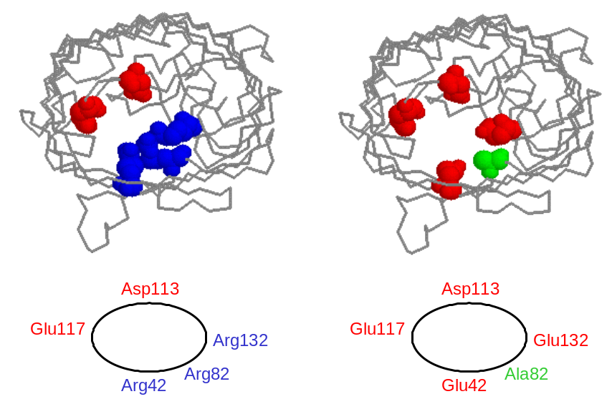
Recent calculations and simulations have yielded strong indications that selectivity of ion channels is to a large extent determined by the charge carried by the protein in the constriction area and the volume available to counterions in the same area to balance the total charge (see e.g.^{5,47,48}). For example, the first clues were obtained on a simplified model of L-type Ca²⁺-channels that have a very distinctive EEEE-locus, i.e. an area where four negative charges are packed together closely. Eight oxygens bearing a combined total charge of –4 where brought together in a limited volume comparable to the volume found in the lumen of naturally occurring channels. Four positive charges are needed to balance these in a very limited space, and since only two Ca²⁺-ions are needed to achieve this (which fits in the available space) but four Na⁺-ions (which doesn’t fit), the ‘channel’ can discriminate between these two species. To compare the results from these theoretical studies with an actual channel protein, we have designed an OmpF mutant based on this principle that is expected to have an increased selectivity for Ca²⁺.
Figure ‎2.10 Arrangement of charged groups in the constriction zone of wild type (left) and mutant OmpF designed for increased Ca²⁺-selectivity
The constriction zone of OmpF is a highly charged area where three arginines (positively charged, at positions 42, 82 and 132), an aspartate (113) and a glutamate (117) (Figure 2.20) are present in close proximity. To increase the selectivity of the channel for Ca²⁺ the three arginines are replaced by two glutamates (positions 42, 132) and an alanine (82) to create a constellation with an expected net charge of –4 and reminiscent of the EEEE-locus in Ca²⁺-channels mentioned above. In addition a mutant with a net charge of –2 (alanines at positions 42, 82 and 132) was designed for reasons of comparison.
The constructs for the expression and purification of these proteins have been obtained and the mutations were confirmed by DNA sequencing. Purification of these proteins by the method described in section 2.1 has so far been difficult, mainly due to problems with the expression system we are employing. We are currently in the process of solving these problems and expect to be able to test the selectivity and conductivity of the channels very soon.

Manipulating gating

Although both the structure of OmpF and the gating transitions (cf. Figure 2.6) have been known for a long time, the structural basis for the transition has remained elusive. A large number of mutants have been constructed and tested by electrophysiological means, focusing on three important areas: the constriction zone (^{11,13,15,49}), the interface between the eyelet loop and the β-barrel⁴⁹ and loop L2 in the subunit interface¹⁷. In all of these cases the critical voltage for closing V_{c}, i.e. the potential difference where the conductivity of an ensemble of OmpF molecules starts to deviate clearly from Ohmic behaviour, is above 100 mV and largely unaltered from the WT.
The only structural information on the gating transition of OmpF comes from atomic force microscopy studies of the extracellular side of two-dimensional OmpF crystals^{50,51}. Large changes in the morphology of the crystal surface were observed at low pH or after applying a large transmembrane potential compared to neutral pH. Reconstruction of the surfaces on the basis of the X-ray structure of the protein suggest a conformational change that can best be described as a rotation of the extracellular domain of the porin around a hinge on the rim of the barrel. In its new position the extracellular domain covers the access to the channel, much like the lid on a pedal bin, and presumably blocks solute transport through the protein.
Antibiotic resistance of Gram-negative bacteria (such as E. coli) is in general a combination of two factors: a permeability barrier separating the drug from its intended target, and when this barrier is breached, a degradation and/or efflux mechanism to neutralise or export the harmful compound⁵². In the case of E. coli in combination with β-lactam class antibiotics the barrier is the outer membrane (β-lactams interfere with cell wall synthesis in the periplasmic space) and permeability is regulated through the embedded porins. Since the kinetics of efflux or degradation of the antibiotic are usually much slower than transport across the outer membrane (i.e. removal of the antibiotic is the rate-determining step), selection of permeability mutants on the basis of antibiotic resistance is not possible. However, if the degradation or efflux is very efficient, as is the case for enzymatic degradation of many β-lactams, permeation of the outer membrane becomes the rate determining step that dictates the effective concentration of the antibiotic in the periplasmic space. So by using an E.coli strain that expresses OmpF as the only porin in the outer membrane in combination with a suitable antibiotic, conditions can be manipulated such that the viability of the cells depends critically on transport of the antibiotic through the lumen of OmpF, with a higher chance of survival if transport is impaired. This property can be used to select those molecules that have a high probability of being in a closed state (as opposed to open state normally encountered for the WT protein) from a library of randomly mutated clones of OmpF.
The method described above was implemented with the specific aim of finding mutants that are in the closed conformation, i.e. where the ‘lid’ is closed. The antibiotic we selected as most suitable for screening OmpF mutants is cephalotin (Figure 2.25). The minimum concentration of this antibiotic that blocks growth of E.coli (the minimal inhibitory concentration or MIC) decreases from 128 mg/ml for strains not expressing OmpF in the outer membrane to 4 mg/ml for strains expressing the protein⁵³. Unfortunately the resistance marker we use on the plasmid carrying the ompF gene in our system is for another antibiotic of the β-lactam class, ampicillin, and thus encodes for a β-lactamase. This fact complicates the implementation of the method and interpretation of our results to a large extent and therefore the ampicillin marker was exchanged for a tetracycline resistance marker, resulting in the plasmid pGompF-Tet. Selection is now performed in media containing both tetracycline (to ensure expression of OmpF) and cephalotin (to check the permeation), conditions for which the MIC of cephalotin were unknown. This was determined by plating out 5 μl of cell cultures of E.coli with (i.e. expressing OmpF) and without the plasmid (i.e. not expressing OmpF) on plates containing various concentrations of cephalotin, and counting the number of colonies that are able to grow. The results are shown in table 2.1 and clearly indicate that expression of OmpF in the outer membrane results in an increased sensitivity towards the antibiotic cephalotin and that media containing between 5 and 20 μg/ml cephalotin can be used for selection of OmpF mutants with the desired properties.

cell | Concentration cephalotin (μg/ml)
cell | 0 | 5 | 10 | 20 | 30 | 40 | 50
Omp8 | nd | lawn | 20 | 5 | 0 | 0 | 0
Omp8 + pGompF-Tet | lawn | 0 | 0 | 0 | 0 | 0 | 0
Table ‎2.1 Sensitivity of E. coli Omp8 cells towards the antibiotic cephalotin in the presence and absence of OmpF in the outer membrane

Random mutations were introduced into the OmpF sequence using error prone PCR. In this method the DNA encoding the protein sequence of OmpF is amplified using a DNA polymerase that has been tuned (by a combination of mutagenesis and reaction conditions) to make random errors during replication. These errors result in mutations in the DNA sequence that in turn, depending on the position of the nucleotide and the nature of the change, can lead to mutations in the primary protein sequence. The mutation frequency, but not position, can be controlled to some extent by varying the concentration of template and primers in the reaction, the number of amplification cycles, reaction temperature etc. The final result is a mixture of DNA molecules, some of them mutated in random (and unknown) positions.
The initial procedure we employed to arrive at the desired mutants consisted of five major steps:

- generate a mutation library by error prone PCR on the Ompf gene isolated from the expression plasmid,
- re-introduction (ligation) of the library into the expression plasmid pGompF-Tet,
- transformation of Omp8 cells with the plasmid library,
- selection of surviving clones on plates containing 5-20 μg/ml cephalotin and
- DNA sequencing to identify the mutations.

This method was used to screen clones obtained after one, two or three rounds of error prone PCR (in a consecutive round DNA obtained from the preceding round was taken as the template rather than WT-encoding DNA). The results indicated that there was a problem with our method, originating from the fact that cells that do not express OmpF in their outer membrane will also survive the screen. Consequently, the clones that were identified contained stop codons early in the sequence or were otherwise incomplete, so that full length protein was not produced and ‘gain of function’ mutants could not be identified.
To remedy the problem outlined above we introduced an additional step that allows us to select clones that express functional protein in the outer membrane. The method is based on the specific recognition of OmpF by antibodies raised against the protein in rabbits. The library of cells is treated with these antibodies and then magnetic beads coated with a secondary antibody are added. Only cells expressing OmpF will attach to the beads via the primary-secondary antibody interaction, and these can be simply separated from the rest by introduction of a magnetic field to hold the beads and removal of the supernatant. These cells can then be replated on selective plates, i.e. plates containing cephalotin, and mutants identified.
The first results of this method are currently becoming available. Seven selected mutants have been sequenced, but as a result of the extra selection step that was necessary not all colonies are unique. So far we have identified three unique sequences containing 9, 6 and 6 mutations, respectively, compared to the WT. Of these mutations 5, 2 and 2 were ‘silent’, meaning a mutation in the DNA, but not the protein sequence, arising from the redundancy in the genetic code. A preliminary analysis indicates that in all three cases at least one mutation is near the constriction zone of the channel, introducing bulky groups into the channel lumen to block the flow of the antibiotic. It is interesting to note that one of the mutations we found, Gly119Asp, is a well known modification influencing channel conductivity and was in fact also selected in an earlier and similar random mutagenesis and screening experiment²². Although this is not the result we are aiming for, it clearly shows that mutants with impeded flow of solutes through the OmpF channel can be selected by this method. We are currently sequencing other clones to obtain further information on the amino acids that are important for the permeability and gating transitions of the channel.

Ionic Membranes – Progress Update

Cysteine-specific cross-linking and selectivity studies of OmpF

Wim Meijberg, Maarten Vrouenraets, Henk Miedema, Anita Meter-Arkema,

Jenny Wierenga, George Robillard, Bob Eisenberg
November 27, 2002
Specific cross-linking. In order to obtain our goal of specifically cross-linking OmpF trimers embedded in a two-dimensional lattice, we have chosen to introduce cysteine residues in the polypeptide sequence at strategic positions that can be reacted with commercially available cross-linkers. Cross-linking yields using four different single site mutants, L147C, E183C, N223C and F267C, were too low to lead to a significant stabilisation of the membrane. On the basis of an analysis of the positioning of individual molecules in the crystal a strategy was devised to remedy the low yields. The strategy consists of a combination of two efforts:
an increase the number of attachment sites in the crystal, i.e. design and create double cysteine mutants and
a decrease of the intermolecular distances in the crystal by manipulating the crystal form.
Using the same models of the two-dimensional crystal mentioned above two double cysteine mutants were designed such that, once they are embedded in the crystal, the shortest sulfhydryl-sulfhydryl distance will be intermolecular rather than intramolecular. In addition each trimer now carries 6 cysteines and since there are 6 direct neighbours for each molecule in an hexagonal lattice this is in principle enough to produce a perfectly cross-linked crystal. The mutants we designed are N223C/F267C and S53C/E183C. The former of these two has been constructed and sequenced at the DNA level, expressed in E.coli and purified. Mass spectrometry analysis indicated a mass of 37031 Da, in excellent agreement with the expected mass of 37029 Da. The purified protein was reconstituted in two-dimensional crystals and cross-linked using 7 different commercially available cross-linkers of varying linker length. The yield of the cross-linking reaction was clearly increased compared to results obtained for single-site cysteine mutants as evidenced from SDS-PAGE and size exclusion chromatography. The crystals were further analysed by negative stain electron microscopy and a comparison was made before and after cross-linking. Before cross-linking most crystals were found to be in a weakly ordened state with a lattice constant of approximately 9 nm, but after treatment with cross-linkers this ordening disappeared. This observation led us to tentatively conclude that in this crystal form the cross-linking reaction puts a strain on individual molecules, which destroys the ordening and thus negatively influences the reaction yields, and consequently the membrane stabilisation, we can achieve.
The second of the two double cysteine mutants, S53C/E183C has been constructed and sequenced at DNA level, expressed in E coli, and is currently being purified. Crystallisation, cross-linking and analysis of the reactions, including electron microscopy will be performed as described above for the N223C/F267C mutant as soon as the protein is available.
The crystal form that is obtained after the crystallisation procedure can be manipulated in a number of ways. The most obvious way is by changing crystallisation conditions such as the protein/lipid ratio, concentrations of buffer and other salts, crystallisation temperature etc. Since the number of parameters is large we have adopted a different strategy to try and decrease intermolecular distances in the crystal, using the crystals we obtain from our established procedure as a starting point. The method is based on the removal of lipids from the crystal by enzymatic degradation using phospholipase A2 in combination with a dialysis procedure. The first results indicated that the tool we were using to determine the effect of this treatment, nl. the success of subsequent cross-linking reactions, did not yield enough information on the success of the treatment. To remedy this we have developed within the group the capability to perform electron microscopy, allowing is independent and regular access to this facility. These studies will be continued.
OmpF selectivity. Motivated by the results from theoretical studies on Ca2+-selectivity, we have set out to test the ideas in practice, using the OmpF channel as our working model. To this end three arginines were replaced by either alanine or glutamate to yield channels with a (theoretical) net charge of –2 (R42A/R82A/R132A or AAA) and –4 (R42E/R82A/R132A or EAE) in the channel constriction zone. Initial results were disappointing in the sense that it appeared that there was little difference in conductance and selectivity between wild type OmpF and our mutants. Since then we have learned that our initial preparations of the mutants were contaminated with wild type protein, an especially serious problem when studies at the single molecule level are performed. In the case of the AAA mutant a sufficiently pure sample has been prepared to allow selectivity and conductance studies to be performed reliably. The conductance of the AAA mutant is slightly larger than for the WT (4.6 ± 0.10 vs. 4.2 ± 0.12 nS), in keeping with the enlargement of the constriction zone of the pore. Also in accordance with our expectations is the increase of the cation over anion selectivity for the AAA mutant in asymmetric 0.1/1 M KCl solutions. The reversal potential changes from ca 28 ± 2 (WT) to ca 40 ± 2 mV (AAA), which translates into PK/PCl of 4.5 and 12.2, respectively. The same trend was observed in asymmetrical 0.1/1 M CaCl2 solutions where the reversal potential changed from 8 ± 2 mV (WT) to –13 ± 3 mV. Current efforts are directed towards performing a set of experiments to determine the Ca2+ over K+- selectivity for this mutant as well as obtaining the EAE mutant in sufficiently pure form to repeat these measurements with this protein.

References

1. Cowan,S.W. et al. Crystal structures explain functional properties of two E. coli porins. Nature 358, 727-733 (1992).
2. Chang,G., Spencer,R.H., Lee,A.T., Barclay,M.T. & Rees,D.C. Structure of the MscL homolog from Mycobacterium tuberculosis: a gated mechanosensitive ion channel. Science 282, 2220-2226 (1998).
3. Doyle,D.A. et al. The structure of the potassium channel: molecular basis of K+ conduction and selectivity. Science 280, 69-77 (1998).
4. Berneche,S. & Roux,B. Energetics of ion conduction through the K+ channel. Nature 414 , 73-77 (2001).
5. Nonner,W., Catacuzzeno,L. & Eisenberg,B. Binding and selectivity in L-type calcium channels: A mean spherical approximation. Biophysical Journal 79, 1976-1992 (2000).
6. Schulz,G.E. beta-Barrel membrane proteins. Curr. Opin. Struct. Biol. 10, 443-447 (2000).
7. Schirmer,T. General and specific porins from bacterial outer membranes. J. Struct. Biol. 121, 101-109 (1998).
8. Schulz,G.E. Porins: general to specific, native to engineered passive pores. Curr. Opin. Struct. Biol. 6, 485-490 (1996).
9. Samartzidou,H. & Delcour,A.H. E-coli PhoE porin has an opposite voltage-dependence to the homologous OmpF. Embo Journal 17, 93-100 (1998).
10. Van Gelder,P. et al. Voltage sensing in the PhoE and OmpF outer membrane porins of Escherichia coli: role of charged residues. J. Mol. Biol. 269, 468-472 (1997).
11. Schirmer,T. & Phale,P.S. Brownian dynamics simulation of ion flow through porin channels. J. Mol. Biol. 294, 1159-1167 (1999).
12. Ermishkin,L.N. & Mirzabekov,T.A. Redistribution of the electric field within the pore contributes to the voltage-dependence of mitochondrial porin channel. Biochim. Biophys. Acta 1021, 161-168 (1990).
13. Saint,N. et al. Structural and functional characterization of OmpF porin mutants selected for larger pore size. II. Functional characterization. J. Biol. Chem. 271, 20676-20680 (1996).
14. Van Gelder,P., Saint,N., van Boxtel,R., Rosenbusch,J.P. & Tommassen,J. Pore functioning of outer membrane protein PhoE of Escherichia coli: mutagenesis of the constriction loop L3. Protein Eng 10, 699-706 (1997).
15. Phale,P.S. et al. Role of charged residues at the ompf porin channel constriction probed by mutagenesis and simulation(,). Biochemistry 40 , 6319-6325 (2001).
16. Liu,N., Samartzidou,H., Lee,K.W., Briggs,J.M. & Delcour,A.H. Effects of pore mutations and permeant ion concentration on the spontaneous gating activity of OmpC porin. Protein Eng 13, 491-500 (2000).
17. Phale,P.S. et al. Stability of trimeric OmpF porin: the contributions of the latching loop L2. Biochemistry 37, 15663-15670 (1998).
18. Dorset,D.L., Engel,A., Haner,M., Massalski,A. & Rosenbusch,J.P. Two-dimensional crystal packing of matrix porin. A channel forming protein in Escherichia coli outer membranes. J. Mol. Biol. 165, 701-710 (1983).
19. Schindler,H. & Rosenbusch,J.P. Matrix protein from Escherichia coli outer membranes forms voltage- controlled channels in lipid bilayers. Proc. Natl. Acad. Sci. U. S. A 75, 3751-3755 (1978).
20. Bainbridge,G., Mobasheri,H., Armstrong,G.A., Lea,E.J. & Lakey,J.H. Voltage-gating of Escherichia coli porin: a cystine-scanning mutagenesis study of loop 3. J. Mol. Biol. 275, 171-176 (1998).
21. Iyer,R., Wu,Z., Woster,P.M. & Delcour,A.H. Molecular basis for the polyamine-ompF porin interactions: inhibitor and mutant studies. J. Mol. Biol. 297, 933-945 (2000).
22. Jeanteur,D. et al. Structural and functional alterations of a colicin-resistant mutant of OmpF porin from Escherichia coli. Proc. Natl. Acad. Sci. U. S. A 91, 10675-10679 (1994).
23. Karshikoff,A., Spassov,V., Cowan,S.W., Ladenstein,R. & Schirmer,T. Electrostatic properties of two porin channels from Escherichia coli. J. Mol. Biol. 240, 372-384 (1994).
24. Lou,K.L. et al. Structural and functional characterization of OmpF porin mutants selected for larger pore size. I. Crystallographic analysis. J. Biol. Chem. 271, 20669-20675 (1996).
25. Nestorovich,E.M., Winterhalter,M. & Bezrukov,S.M. Ampicillin translocation through OmpF studied on a single channel level. Biophysical Journal 80, 576 (2001).
26. Nikaido,H. & Rosenberg,E.Y. Porin channels in Escherichia coli: studies with liposomes reconstituted from purified proteins. J. Bacteriol. 153, 241-252 (1983).
27. Philippsen,A. et al. Imaging the Electrostatic Potential of Transmembrane Channels: Atomic Probe Microscopy of OmpF Porin. Biophys. J. 82, 1667-1676 (2002).
28. Garavito,R.M. & Rosenbusch,J.P. Isolation and crystallization of bacterial porin. Methods Enzymol. 125, 309-328 (1986).
29. Prilipov,A., Phale,P.S., Van Gelder,P., Rosenbusch,J.P. & Koebnik,R. Coupling site-directed mutagenesis with high-level expression: large scale production of mutant porins from E. coli. FEMS Microbiol. Lett. 163, 65-72 (1998).
30. Driessen,A.J., Fekkes,P. & van der Wolk,J.P. The Sec system. Curr. Opin. Microbiol. 1, 216-222 (1998).
31. Surrey,T., Schmid,A. & Jahnig,F. Folding and membrane insertion of the trimeric beta-barrel protein OmpF. Biochemistry 35, 2283-2288 (1996).
32. Nikaido,H., Nikaido,K. & Harayama,S. Identification and characterization of porins in Pseudomonas aeruginosa. J. Biol. Chem. 266, 770-779 (1991).
33. Luckey,M. & Nikaido,H. Specificity of diffusion channels produced by lambda phage receptor protein of Escherichia coli. Proc. Natl. Acad. Sci. U. S. A 77, 167-171 (1980).
34. Hanke,W. & Schlue,W.R. Planar lipid bilayers. Methods and applications. Academic Press, London, (1993).
35. Miller,C. Ion channel reconstitution. (1986).
36. Eisenberg,R.S. Channels as enzymes. J. Membr. Biol. 115, 1-12 (1990).
37. Mathes,A. & Engelhardt,H. Nonlinear and asymmetric open channel characteristics of an ion- selective porin in planar membranes. Biophys. J. 75, 1255-1262 (1998).
38. Mathes,A. & Engelhardt,H. Voltage-dependent closing of porin channels: analysis of relaxation kinetics. J. Membr. Biol. 165, 11-18 (1998).
39. Rigaud,J.L., Pitard,B. & Levy,D. Reconstitution of membrane proteins into liposomes: application to energy-transducing membrane proteins. Biochim. Biophys. Acta 1231, 223-246 (1995).
40. Watts,A. Bacteriorhodopsin: the mechanism of 2D-array formation and the structure of retinal in the protein. Biophys. Chem. 55, 137-151 (1995).
41. Peters,K. & Richards,F.M. Chemical cross-linking: reagents and problems in studies of membrane structure. Annu. Rev. Biochem. 46, 523-551 (1977).
42. Azem,A., Shaked,I., Rosenbusch,J.P. & Daniel,E. Cross-linking of porin with glutardialdehyde: a test for the adequacy of premises of cross-linking theory. Biochim. Biophys. Acta 1243, 151-156 (1995).
43. Getz,E.B., Xiao,M., Chakrabarty,T., Cooke,R. & Selvin,P.R. A comparison between the sulfhydryl reductants tris(2- carboxyethyl)phosphine and dithiothreitol for use in protein biochemistry. Anal. Biochem. 273, 73-80 (1999).
44. Shafer,D.E., Inman,J.K. & Lees,A. Reaction of Tris(2-carboxyethyl)phosphine (TCEP) with maleimide and alpha-haloacyl groups: anomalous elution of TCEP by gel filtration. Anal. Biochem. 282, 161-164 (2000).
45. Dorset,D.L., Massalski,A.K. & Rosenbusch,J.P. In-plane phase transition of an integral membrane protein: nucleation of the OmpF matrix porin rectangular polymorph. Proc. Natl. Acad. Sci. U. S. A 86, 6143-6147 (1989).
46. Hoenger,A., Gross,h., Aebi,U. & Engel,A. Localization of the lipopolysaccharides in metal-shadowed reconstituted lipid porin membranes. Journal of Structural Biology 103, 185-195 (1990).
47. Nonner,W. & Eisenberg,B. Ion permeation and glutamate residues linked by Poisson-Nernst- Planck theory in L-type calcium channels. Biophysical Journal 75, 1287-1305 (1998).
48. Nonner,W., Gillespie,D., Henderson,D. & Eisenberg,B. Ion accumulation in a biological calcium channel: Effects of solvent and confining pressure. Journal of Physical Chemistry B 105, 6427-6436 (2001).
49. Phale,P.S. et al. Voltage gating of Escherichia coli porin channels: role of the constriction loop. Proc. Natl. Acad. Sci. U. S. A 94, 6741-6745 (1997).
50. Muller,D.J. & Engel,A. Voltage and pH-induced channel closure of porin OmpF visualized by atomic force microscopy. J. Mol. Biol. 285, 1347-1351 (1999).
51. Schabert,F.A., Henn,C. & Engel,A. Native Escherichia coli OmpF porin surfaces probed by atomic force microscopy. Science 268, 92-94 (1995).
52. Nikaido,H. Prevention of drug access to bacterial targets: permeability barriers and active efflux. Science 264, 382-388 (1994).
53. Curtis,N.A., Eisenstadt,R.L., Turner,K.A. & White,A.J. Porin-mediated cephalosporin resistance in Escherichia coli K-12. J. Antimicrob. Chemother. 15, 642-644 (1985).
54. Mannella,C.A. Mitochondrial outer membrane channel (VDAC, porin) two-dimensional crystals from Neurospora. Methods Enzymol. 125, 595-610 (1986).
55. Sackmann,E. Supported membranes: scientific and practical applications. Science 271, 43-48 (1996).
56. Salafsky,J., Groves,J.T. & Boxer,S.G. Architecture and function of membrane proteins in planar supported bilayers: a study with photosynthetic reaction centers. Biochemistry 35, 14773-14781 (1996).
57. Bayley,H. & Cremer,P.S. Stochastic sensors inspired by biology. Nature 413, 226-230 (2001).
58. Pum,D., Neubauer,A., Gyorvary,E., Sara,M. & Sleytr,U.B. S-layer proteins as basic building blocks in a biomolecular construction kit. Nanotechnology 11, 100-107 (2000).
59. Schuster,B. & Sleytr,U.B. S-layer-supported lipid membranes. J. Biotechnol. 74, 233-254 (2000).
60. Schuster,B. et al. S-layer ultrafiltration membranes: A new support for stabilizing functionalized lipid membranes. Langmuir 17, 499-503 (2001).
61. Ide,T. & Yanagida,T. An artificial lipid bilayer formed on an agarose-coated glass for simultaneous electrical and optical measurement of single ion channels. Biochem. Biophys. Res. Commun. 265, 595-599 (1999).
62. Cornell,B.A. et al. A biosensor that uses ion-channel switches. Nature 387, 580-583 (1997).
63. Heyse,S., Stora,T., Schmid,E., Lakey,J.H. & Vogel,H. Emerging techniques for investigating molecular interactions at lipid membranes. Biochim. Biophys. Acta 1376, 319-338 (1998).
64. Stora,T., Lakey,J.H. & Vogel,H. Ion-channel gating in transmembrane receptor proteins: Functional activity in tethered lipid membranes. Angewandte Chemie-International Edition 38, 389-392 (1999).
65. Schuster,B. & Sleytr,U.B. The effect of hydrostatic pressure on S-layer-supported lipid membranes. Biochim. Biophys. Acta 1563, 29-34 (2002).
66. Ikkala,O. & ten Brinke,G. Functional materials based on self-assembly of polymeric supramolecules. Science 295, 2407-2409 (2002).
67. Nardin,C., Hirt,T., Leukel,J. & Meier,W. Polymerized ABA triblock copolymer vesicles. Langmuir 16, 1035-1041 (2000).
68. Nardin,C., Winterhalter,M. & Meier,W. Giant free-standing ABA triblock copolymer membranes. Langmuir 16, 7708-7712 (2000).
69. Meier,W., Nardin,C. & Winterhalter,M. Reconstitution of channel proteins in (polymerized) ABA triblock copolymer membranes. Angew. Chem. 39, 4599-4602 (2000).
70. Nardin,C., Thoeni,S., Widmer,J., Winterhalter,M. & Meier,W. Nanoreactors based on (polymerized) ABA-triblock copolymer vesicles. Chemical Communications 1433-1434 (2000).
71. Nardin,C., Widmer,J., Winterhalter,M. & Meier,W. Amphiphilic block copolymer nanocontainers as bioreactors. European Physical Journal e 4, 403-410 (2001).
APPENDIX

Registration numbers of the labbooks and binders of the researchers that have contributed to the Ionic Membranes Project.

Name researcher | Labbook no. | Binder no.
Wim Meijberg  Maarten Vrouenraets  Henk Miedema  Anita Meter-Arkema  Alex Jonker  Barbara Lussenburg  Hans Hektor | 0016  0027  0053  0043  0096  0100  0106  0059  0097  0065 | B0012-09  B0030-09  B0081-09  B0085-09  B0044-09  B0060-09  B0051-09

